Dishes and their allergen content: Pasta and Rice
Dishes | 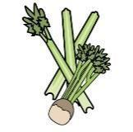 |  | 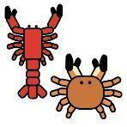 |  |  | 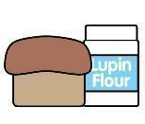 | 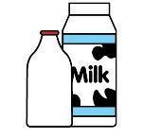 |  | 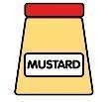 |  |  | 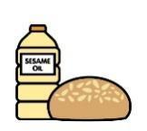 |  | 
V = Vegetarian  VG = Vegan  VGA = Vegan Available | Celery | Cereals containing gluten* | Crustaceans | Eggs | Fish | Lupin | Milk | Mollusc | Mustard | Nuts† | Peanuts | Sesame seeds | Soya | Sulphur Dioxide
White Rice
VVG
Rice Salad
VVG
Vegetable Rice
VVG

Wholegrain Rice
VVG
Flavoured Cous Cous
VVG
Spaghetti  VVG |  | Y  wheat
Fusilli  VVG |  | Y  wheat
Macaroni  VVG |  | Y  wheat
 | Reviewed by: S Masters  Review Date: July 2026

