Dishes and their allergen content: Gluten Free
Dishes | 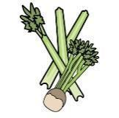 |  | 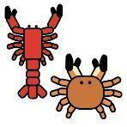 |  |  | 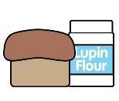 | 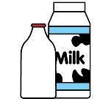 |  | 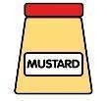 |  |  | 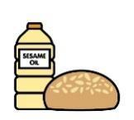 |  | 
V = Vegetarian  VG = Vegan  VGA = Vegan Available | Celery | Cereals containing gluten* | Crustaceans | Eggs | Fish | Lupin | Milk | Mollusc | Mustard | Nuts† | Peanuts | Sesame seeds | Soya | Sulphur Dioxide
 | These Items are individually sourced and purchased as required without excess stocks held and subject to availability  Allergens will be checked according to individual requirements as held on school files  Please make contact with school office to confirm specific requirements
  Gluten Free
  Fish Fingers
  Gluten Free
  Chicken
  Nuggets
  Goujons
  Gluten Free
  Sausage
  Beef Burger
  Gluten Free
  Pasta
  Gluten Free
  Wraps
  Gluten Free
  Bread/Rolls
  Gluten Free
  Yorkshire
  Pudding
  Gluten Free
  Pastry Items
 | Reviewed by: S Masters  Review Date: July 2026

