Dishes and their allergen content: Crackers and Cheese
Dishes | 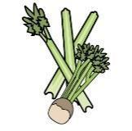 |  |  |  |  | 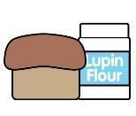 | 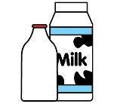 |  | 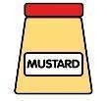 |  |  | 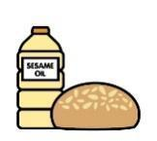 |  | 
V = Vegetarian  VG = Vegan  VGA = Vegan Available | Celery | Cereals containing gluten* | Crustaceans | Eggs | Fish | Lupin | Milk | Mollusc | Mustard | Nuts† | Peanuts | Sesame seeds | Soya | Sulphur Dioxide
Cream Crackers  V |  | Y  Wheat |  |  |  |  | May  Contain |  |  |  |  | May Contain
Assorted Cheese Portions  V |  |  |  |  |  |  | Y
Laughing Cow  V |  |  |  |  |  |  | Y
Cheddar – Mature sliced  V |  |  |  |  |  |  | Y
Cheddar – Mature grated  V |  |  |  |  |  |  | Y
Burger Cheese Slice  V |  |  |  |  |  |  | Y
Violife Cheese Alternative
VVG
 | Reviewed by: S Masters  Review Date: July 2026

