Dishes and their allergen content: Mains 1
Dishes | 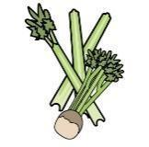 |  |  |  |  | 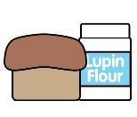 | 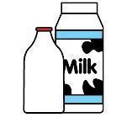 |  | 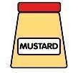 |  |  |  |  | 
V = Vegetarian  VG = Vegan  VGA = Vegan Available | Celery | Cereals containing gluten* | Crustaceans | Eggs | Fish | Lupin | Milk | Mollusc | Mustard | Nuts† | Peanuts | Sesame seeds | Soya | Sulphur Dioxide
Fish Fingers/  Battered fish Fillet  Fish Cakes |  | Y  wheat |  |  | Y
Salmon  Fish Cakes  Fingers |  | Y  wheat |  |  | Y
Roast
Chicken
Gammon/Ham
Pork
Beef
Pork Sausage
Chilli Con Carne
Chicken in Gravy Pie |  | Y  wheat
Bolognaise Sauce (Beef)
Sweet and Sour Chicken | Y
Beef Burger |  | Y |  |  |  |  |  |  |  |  |  |  | Y
 | Reviewed by: S Masters  Review Date: July 2026

