

HeadteacherChat’s Review of Education Technology
Read the full review below...

How does Education Technology describe their product?
“Technology can be a bewildering area for anyone in education, and for head teachers it can be yet another important item on the ‘To Do’ list that often doesn’t quite get the attention it needs!

Elementary Technology is here to help you understand and embrace the vast opportunities technology brings to schools - teaching, learning, SEND, safeguarding, workload, wellbeing, engagement and lots more.

As a leading specialist supplier of technology into schools, we will work with you on planning, choosing, buying and using the technology that suits your unique needs at your school. Classroom whiteboards, educational software, visualisers, classroom audio and similar is the biggest part of what we do, yet we also specify and install hundreds of school hall technology systems, sign-in technology, outdoor digital signage and lots more each year.
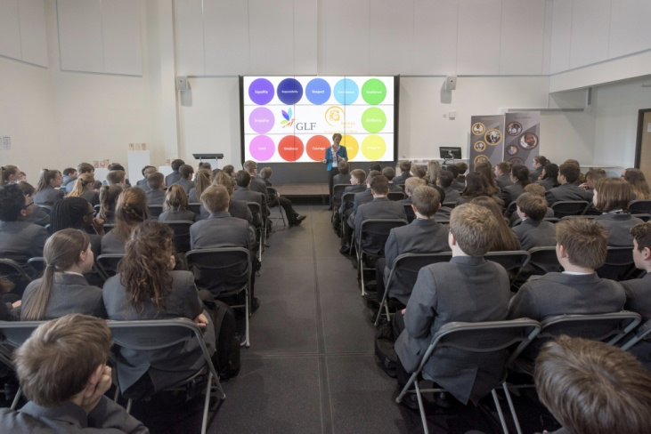

Getting the technology into your school is just the end of the beginning though. The company are then committed to helping you make the most of it with ongoing training and support driven by their new Elementary Technology Academy. Teachers embedding technology into their day-to-day practice, to be more effective and more efficient – that’s where the magic happens!”

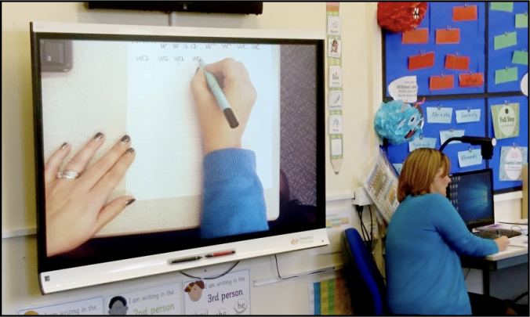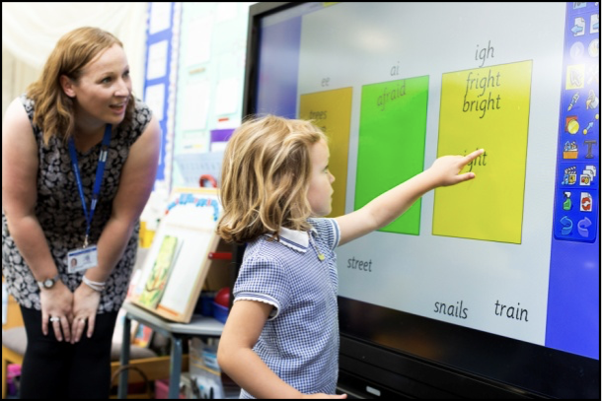

What does it enable you to do?
Elementary Technology work with schools on a simple, yet effective process of Planning – Choosing – Buying – Using to help them make the best choices for their IT provision. This is through the Classroom Healthcheck® and the Experience Centre.

What is Classroom Healthcheck®?

PLANNING
To establish a school’s technology baseline, Elementary Technology carries out a thorough Classroom Healthcheck® (free to the Headteacher Chat community), with no obligation to purchase. An Elementary Technology expert visits all rooms, not just classrooms, to check the provision currently in place and, importantly, the impact it is having on teaching and learning. This involves checking the hardware, the infrastructure, lighting levels of rooms, training needs of teachers and licence status of software. The check also considers differences in access to technology around the school, prioritises need and provides evidence to justify allocation of budget. Schools receive a detailed hard copy of the report that they can use to inform their IT development plan, rather than buying on an ad hoc basis as equipment breaks or becomes obsolete, resulting in a mixture of brands and models, and unequal provision across the school.

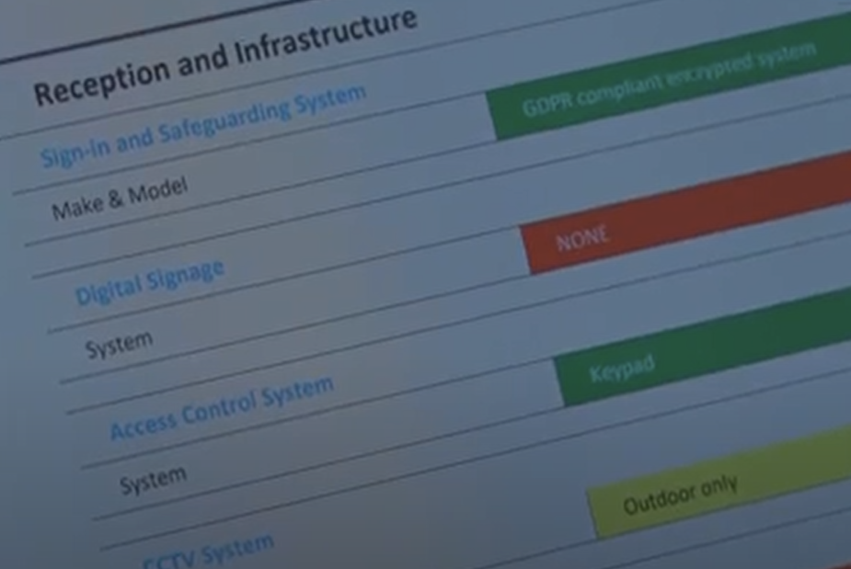
CHOOSING
Elementary Technology strongly believes in mutual transparency. Through a two-way, open and in-depth discussion, Elementary Technology can understand a school’s unique context and provide advice on the most suitable options. By working closely with the head teacher, realistic conversations linked to the available budget can be had. This allows decision-makers to make a fully informed choice on the technology that is best for their setting. As part of the ‘choosing’ process, school staff can visit the Experience Centre in Leeds where Elementary Technology will demonstrate, and school staff can try out, a range of equipment options. For those further afield, the range of technology can be demonstrated online from the Experience Centre.

BUYING
With their extensive product knowledge combined with the relationship they build with each school, the buying and project-managed installation process is efficiently completed. Launched in 2003 as LME Ltd, Elementary Technology is a leading supplier of technology in education. In 2019 their status as SMART Platinum Partner and Promethean Platinum Partner cemented their status as a leader in the sector.

USING
Included in any purchase is Elementary Technology’s basic training (‘Get Set Go) but further training can be provided, for example, ‘Making more of MS and Google’ and to highlight helpful techniques to maximise the equipment.

Experience Centre
The huge range of IT equipment available to schools can be overwhelming for busy head teachers but school staff can now visit Elementary Technology’s Experience Centre in Leeds to try out equipment they intend to buy, see new products and ask question, all in one space. Technology experts are on hand to provide advice, expertise, ideas, guidance and best pricing on interactive touchscreens, digital signage, the latest software, visualisers, projectors, a 3D printer, VR/AR technology, printers, sign-in and safeguarding and more.

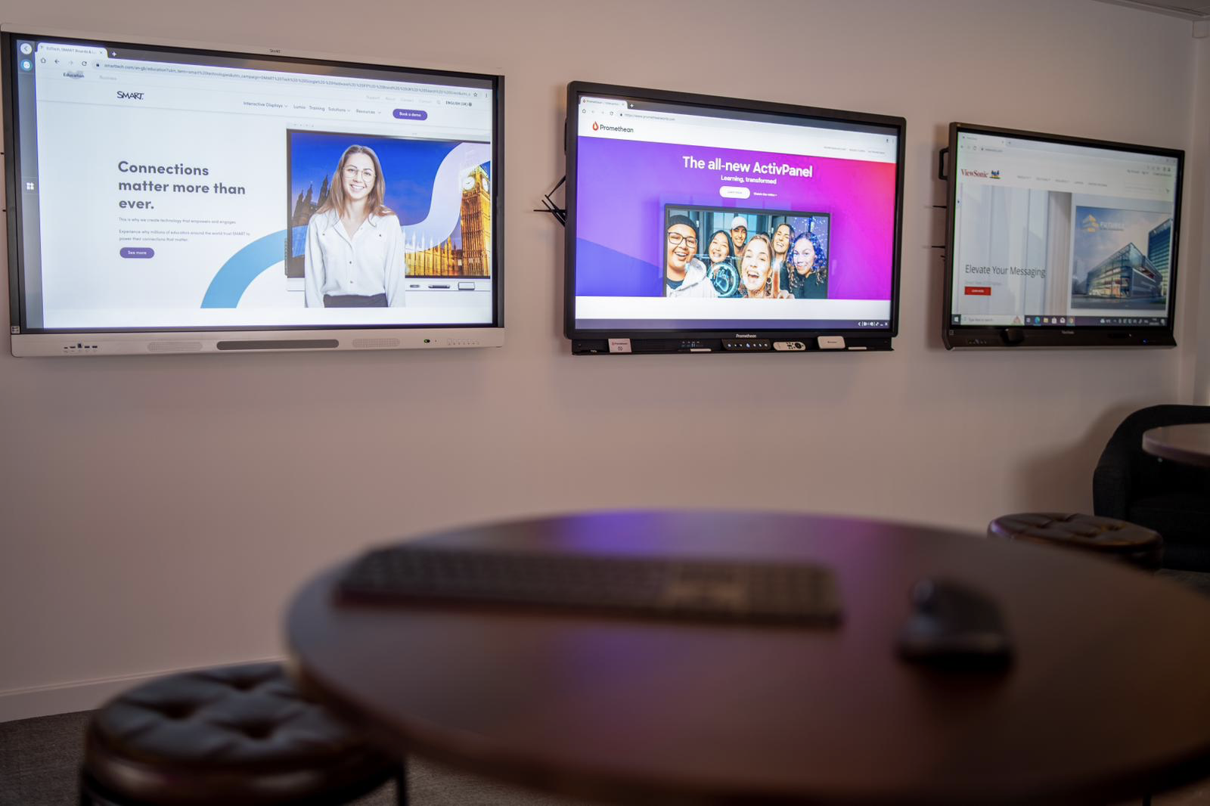
For schools unable to attend the Experience Centre in person, Elementary Technology can support schools with a personalised YouTube demonstration or schools can watch one live online.

With capacity for up to 20, the Experience Centre can also be used as a meeting venue, at no cost, with staff at the Centre setting up any technology needed for the meeting.
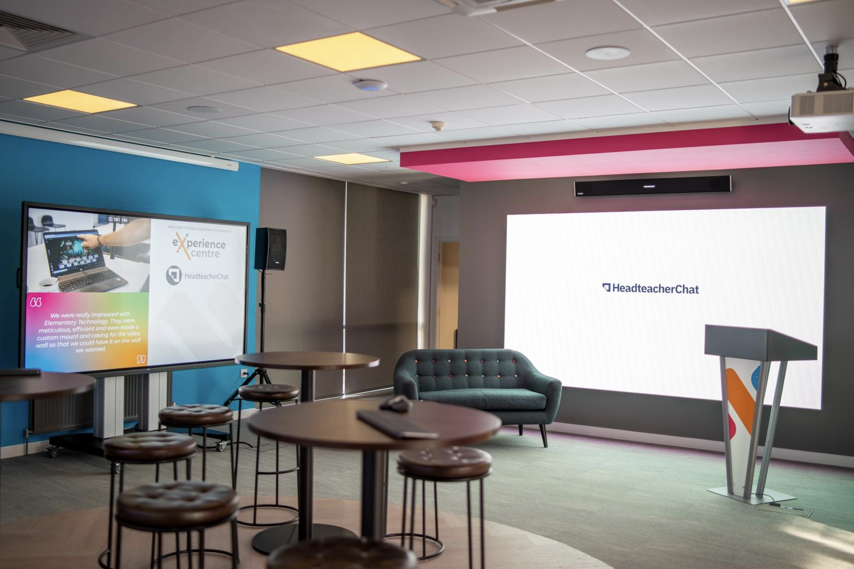

What are the benefits of using Elementary Technology?
- Free Classroom Healthcheck® provides a baseline report to help justify decisions, prioritise needs and standardise equipment
- Schools receive independent, detailed advice to allow a fully-informed decision to be made
- Access to provision is standardised, ensuring consistency and maximising teaching and learning opportunities
- School staff can ‘try before they buy’, discuss options with technology experts and attend training at the Experience Centre

Testimonials:
“Our partnership with Elementary Technology has been instrumental in transforming outcomes throughout my school. Our attendance is up, persistent absence is down and our Age Related and Greater Depth KS2 results are up across Reading, Writing and Maths.
Starting with our Classroom Healthcheck®, it’s clear to me implementation of new technology helped kick-start these improvements, supported by the fabulous training we’re still receiving.”
CRAIG FRASER, Pinders Primary School
Nant Caerau Primary School in Cardiff - https://youtu.be/6Gm_dyq5s7I
Pinders Primary School: https://elementaryuk.com/success-stories/edtech-upgrade-pinders-primary/

In summary, HeadteacherChat recommends Elementary Technology because:

Elementary Technology has a remarkable team that delivers exceptional customer service and support throughout the entire purchasing process using their ‘Planning, Choosing, Buying, Using’ approach.
They dedicate their time to understand your needs and priorities before making any recommendations. Even after your purchase, they provide continued support and training to ensure that you are making the best use of your purchase.
Lucy Coy, CEO, HeadteacherChat March 2023

