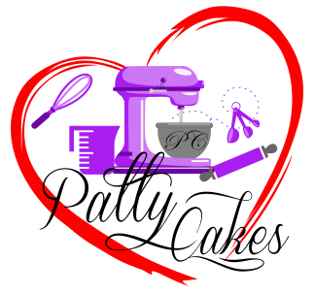
Thank you for considering Patty Cakes to satisfy your sweet treat craving
Menu Items

Please ask about anything that you don’t see listed

Regular Round - 6 inches up
Bundt Cakes
6 pack – Mini Bundt
Pineapple Upside Down Cake
Strawberry Shortcake
Oreo Cake
Coconut Pineapple
Lemon Drop
Chocolate w/Buttercream
Carrott Bundt
Salted Caramel Bundt (Salty Jan)
Kentucky Bourbon Bundt
7 Up Pound
Sweet Potato Pies (Seasonal)

Buttercream & Glaze Flavors:

Swiss Meringue American Buttercream Chocolate
Cream Cheese Lemon Vanilla Glaze
Orange Glaze Ganache Salted Caramel
Rum Glaze Lemon Glaze Pistachio

Pecans, Raisins and Walnuts are Optional

