
Why Alt Text Matters
Accessibility Demo Document | WCAG 2.2 AA and Section 508
Presented by Devin Crowley, Wood Rodgers

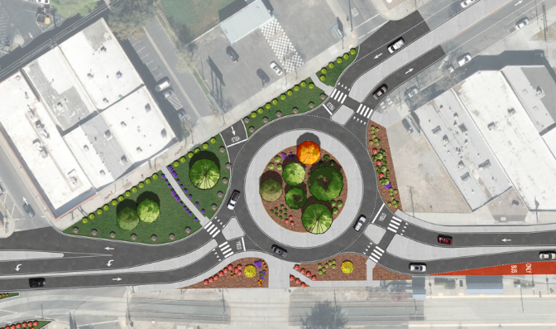
Many of the people who read our documents use assistive technology, such as a screen reader like NVDA. A screen reader works through a document in order, one piece at a time, and says out loud whatever it finds. This sample page is built the way plenty of real documents are built, and it has problems.
What is alt text?
DID YOU KNOW?
A floating text box can be read first, last, or not at all, depending on the software.
Alternative text (alt text) is a short written description attached to an image. A screen reader reads it aloud in place of the picture. Without it, a person using NVDA hears nothing useful, or hears the file name, which is worse. The site plan to the right carries important information, and a person who cannot see it gets none of that information from this page.
Why it matters
• WCAG 2.2 Success Criterion 1.1.1 (Non-text Content) requires a text alternative for images that convey information.
• Section 508 sets the same expectation for federal content, including documents we deliver to federal agencies.
• A map, site plan, or chart with no alt text is an empty space to someone using a screen reader.
• Purely decorative images should be marked as decorative so the screen reader skips them.

Why floating images and text boxes cause trouble
Word lets you drop images and text boxes anywhere on the page. That is handy for layout and rough on assistive technology. A floating object is tied to a paragraph but sits outside the normal text flow, so the order a screen reader follows can differ from the order a sighted reader sees. Text boxes may be skipped, read at the wrong moment, or exported to PDF with tags in the wrong order.
Keeping an image set to In Line with Text keeps it in the order the author intended. It also gives you a clear place to add alt text. If an object has to float for a good reason, check the reading order and test it with a screen reader before the document goes out the door.

This infographic shows crash data for Las Vegas, and nearly all of it is text. The alt text should repeat the text exactly as it appears in the graphic. If that is too much for alt text, put the content in the document as real text, or add a full description next to the graphic.

Good alt text | Bad alt text
Illustrative shows a proposed roundabout and roadway redesign. Landscaped medians, planting zones, and a central circular garden highlight traffic circulation and streetscape improvements. | image001.png
In Las Vegas, when compared to vehicular crashes, pedestrian crashes are 15 times more likely to result in a fatality. Motorcycle crashes are 10 times more likely result in a fatality. Bicycle crashes are 5 times more likely to result in a fatality. Source: NDOT Crash Data (2015-2019) | A chart

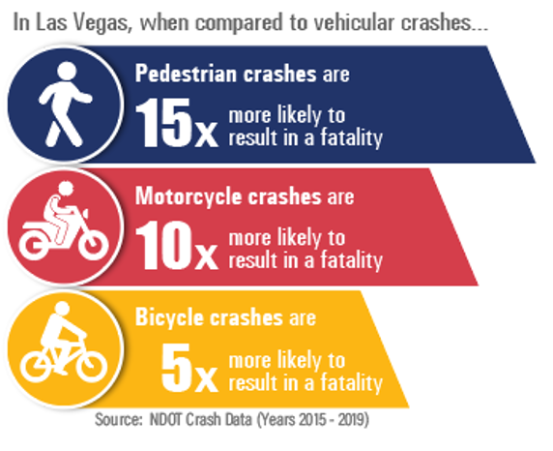
Click here for more information.
Document last updated October 2026

