Progression of Skills in Art and Design
Skills | EYFS | Year 1 | Year 2 | Year 3 | Year 4 | Year 5 | Year 6
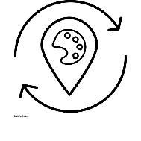  Exploring and developing ideas. | Frida Khalo: (All About Me)  Painting  A self-portrait, exploring differences and the shapes of our features. E.g. skin tone, eye colour etc.  Backgrounds – talking about animals who are special to us.  Vincent Van Gogh (Light and Dark)  Drawing  Creating a background with a water wash.  Choosing darker colours that will contrast with the background.  Rachel Isadora (Tell me a story)  Drawing  Learn about what an illustrator is.  Look at a range of illustrators in different story books.  To build up an image through smaller steps.  Yayoi Kusama (growth)  Sculpting  To learn that sculptures are a 3D piece of art. | - Record and explore ideas from first hand observation, experience and imagination.  - Ask and answer questions about the starting points for their work and develop their ideas.  - Explore the differences and similarities within the work of artists, craftspeople and designers in different times and cultures. | - Record and explore ideas from first hand observation, experience and imagination.  - Ask and answer questions about the starting points for their work and the processes they have used. Develop their ideas.  - Explore the differences and similarities within the work of artists, craftspeople and designers in different times and cultures. | - Select and record from first hand observation, experience and imagination, and explore ideas for different purposes.  - Question and make thoughtful observations about starting points and select ideas to use in their work.  - Explore the roles and purposes of artists, craftspeople and designers working in different times and cultures. | - Select and record from first hand observation, experience and imagination, and explore ideas for different purposes.  - Question and make thoughtful observations about starting points and select ideas to use in their work.  - Explore the roles and purposes of artists, craftspeople and designers working in different times and cultures. | - Select and record from first hand observation, experience and imagination, and explore ideas for different purposes.  - Question and make thoughtful observations about starting points and select ideas to use in their work.  - Explore the roles and purposes of artists, craftspeople and designers working in different times and cultures. | - Question and make thoughtful observations about starting points and select ideas and processes to use in their work.  - Explore the roles and purposes of artists, craftspeople and designers working in different times and cultures.
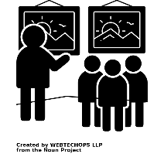  Evaluating and developing ideas. | To communicate what we are proud of within our finished art piece.  To present art work within our classroom displays. | - Review what they and others have done and say what they think and feel about it. E.g. Annotate sketchbook  - Identify what they might change in their current work or develop in their future work. | - Review what they and others have done and say what they think and feel about it. E.g. Annotate sketchbook  - Identify what they might change in their current work or develop in their future work.  - Annotate work in sketchbook. | - Review what they and others have done and say what they think and feel about it. E.g. annotate sketchbook  - Identify what they might change in their current work or develop in their future work.  - Annotate work in sketchbook. | - Compare ideas, methods and approaches in their own and others’ work and say what they think and feel about them.  - Adapt their work according to their views and describe how they might develop it further. | - Compare ideas, methods and approaches in their own and others’ work and say what they think and feel about them.  - Adapt their work according to their views and describe how they might develop it further | - Compare ideas, methods and approaches in their own and others’ work and say what they think and feel about them.  - Adapt their work according to their views and describe how they might develop it further.
Drawing  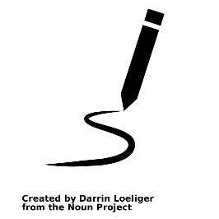  Link to Progression of drawing inset PPT | Autumn 2 Vincent Van Gogh  Oil pastels  I can distinguish between light and dark colours.  I can experiment with how to create different shades.  I can create shapes with my drawings.  Spring 2 Rachel Isadora  Pencils  Holding a pencil correctly with good control.  To look at the shapes of a desired drawing.  To use a range of drawing resources.  To follow ‘how to draw’ instructions to break it down into smaller steps. | - Use a variety of tools, inc. pencils, rubbers, crayons, pastels, felt tips, charcoal, ballpoints, chalk and other dry media.  - Use a sketchbook to gather and collect artwork.  - Begin to explore the use of line, shape and colour | - Layer different media, e.g. crayons, pastels, felt tips, charcoal and ballpoint.  - Understand the basic use of a sketchbook and work out ideas for drawings.  - Draw for a sustained period of time from the figure and real objects, including single and grouped objects.  - Experiment with the visual elements; line, shape, pattern and colour. | - Experiment with different grades of pencil and other implements.  - Plan, refine and alter their drawings as necessary.  - Use their sketchbook to collect and record visual information from different sources.  - Draw for a sustained period of time at their own level.  - Use different media to achieve variations in line, texture, tone, colour, shape and pattern. | - Make informed choices in drawing inc. paper and media.  - Alter and refine drawings and describe changes using art vocabulary.  - Collect images and information independently in a sketchbook.  - Use research to inspire drawings from memory and imagination.  - Explore relationships between line and tone, pattern and shape, line and texture. | - Use a variety of source material for their work.  - Work in a sustained and independent way from observation, experience and imagination.  - Use a sketchbook to develop ideas.  - Explore the potential properties of the visual elements, line, tone, pattern, texture, colour and shape. | - Demonstrate a wide variety of ways to make different marks with dry and wet media.  - Identify artists who have worked in a similar way to their own work.  - Develop ideas using different or mixed media, using a sketchbook.  - Manipulate and experiment with the elements of art: line, tone, pattern , texture, form, space, colour and shape.
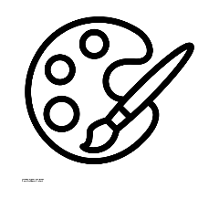  Painting | Frida Khalo Aut 1  Painting  A self-portrait, exploring differences and the shapes of our features. E.g. skin tone, eye colour etc.  Backgrounds – talking about animals who are special to us. | - Use a variety of tools and techniques including the use of different brush sizes and types.  - Mix and match colours to artefacts and objects.  - Work on different scales.  - Mix secondary colours and shades using different types of paint.  - Create different textures e.g. use of sawdust. | - Mix a range of secondary colours, shades and tones.  - Experiment with tools and techniques, inc. layering, mixing media, scraping through etc.  - Name different types of paint and their properties.  - Work on a range of scales e.g. large brush on large paper etc.  - Mix and match colours using artefacts and objects. | - Mix a variety of colours and know which primary colours make secondary colours.  - Use a developed colour vocabulary.  - Experiment with different effects and textures inc. blocking in colour, washes, thickened paint etc.  - Work confidently on a range of scales e.g. thin brush on small picture etc. | - Make and match colours with increasing accuracy.  - Use more specific colour language e.g. tint, tone, shade, hue.  - Choose paints and implements appropriately.  - Plan and create different effects and textures with paint according to what they need for the task.  - Show increasing independence and creativity with the painting process. | - Make and match colours with increasing accuracy.  - Use more specific colour language e.g. tint, tone, shade, hue.  - Choose paints and implements appropriately.  - Plan and create different effects and textures with paint according to what they need for the task.  - Show increasing independence and creativity with the painting process. | - Create shades and tints using black and white.  - Choose appropriate paint, paper and implements to adapt and extend their work.  - Carry out preliminary studies, test media and materials and mix appropriate colours.  - Work from a variety of sources, inc. those researched independently.  - Show an awareness of how paintings are created (composition).
Printing  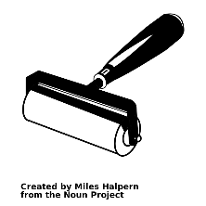 | -Printing a range of shapes.  (hands, fingers, sponges, negative space painting, vegetables, 3d shapes) | - Make marks in print with a variety of objects, including natural and made objects.  - Carry out different printing techniques e.g. monoprint, block, relief and resist printing.  - Make rubbings.  - Build a repeating pattern and recognise pattern in the environment. | - Use a variety of techniques, inc. carbon printing, relief, press and fabric printing and rubbings.  - Design patterns of increasing complexity and repetition.  - Print using a variety of materials, objects and techniques. | - Print using a variety of materials, objects and techniques including layering.  - Talk about the processes used to produce a simple print.  - To explore pattern and shape, creating designs for printing. | - Research, create and refine a print using a variety of techniques.  - Select broadly the kinds of material to print with in order to get the effect they want  - Resist printing including marbling, silkscreen and cold-water paste. | - Explain a few techniques, inc’ the use of poly-blocks, relief, mono and resist printing.  - Choose the printing method appropriate to task.  - Build up layers and colours/textures.  - Organise their work in terms of pattern, repetition, symmetry or random printing styles.  - Choose inks and overlay colours. | - Describe varied techniques.  - Be familiar with layering prints.  - Be confident with printing on paper and fabric.  - Alter and modify work.
Sculpting  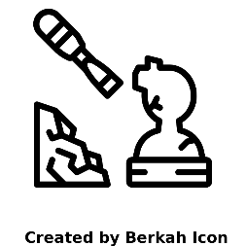 | To explore manipulating clay, playdough and plastercine independently.  To form shapes with clay, playdough or plastercine.  To join 2 pieces of clay, playdough and plastercine together. | - Manipulate clay in a variety of ways, e.g. rolling, kneading and shaping.  - Explore sculpture with a range of malleable media, especially clay.  - Experiment with, construct and join recycled, natural and man-made materials.  - Explore shape and form.  - Use a wide variety of media, inc. photocopied material, fabric, plastic, tissue, magazines, crepe paper, etc. | - Manipulate clay for a variety of purposes, inc. thumb pots, simple coil pots and models.  - Build a textured relief tile.  - Understand the safety and basic care of materials and tools. Experiment with, construct and join recycled, natural and man-made materials more confidently.  - Create textured collages from a variety of media. | - Join clay adequately and work reasonably independently.  - Construct a simple clay base for extending and modelling other shapes.  - Cut and join wood safely and effectively.  - Make a simple papier mache object.  - Plan, design and make models.  - Experiment with a range of media e.g. overlapping, layering etc. | - Make informed choices about the 3D technique chosen.  - Show an understanding of shape, space and form.  - Plan, design, make and adapt models.  - Talk about their work understanding that it has been sculpted, modelled or constructed.  - Use a variety of materials.  - Collect visual information from a variety of sources, describing with vocabulary based on the visual and tactile elements. | - Describe the different qualities involved in modelling, sculpture and construction.  - Use recycled, natural and man-made materials to create sculpture.  - Plan a sculpture through drawing and other preparatory work.  - Use a range of media to create collage. | - Develop skills in using clay inc. slabs, coils, slips, etc.  - Make a mould and use plaster safely.  - Create sculpture and constructions with increasing independence.  - Awareness of the potential of the uses of materials.  - Use different techniques, colours and textures etc when designing and making pieces of work.  - To be expressive and analytical to adapt, extend and justify their work.
Digital Art | See Computing planning
Artists | Frida Kahlo  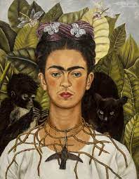  Vincent Van Gogh  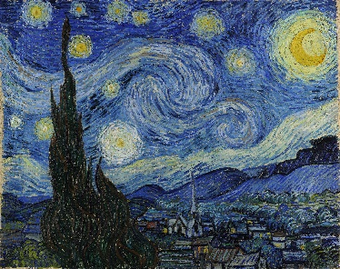  Yayoi Kusama  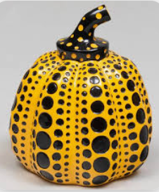  Illustrators- Rachel Isadora  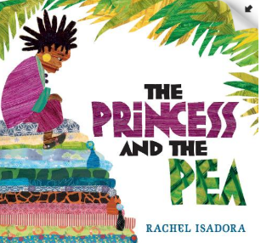 | William Morris - Autumn 1  (printing)  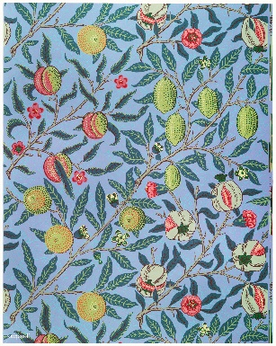  Esther Mahlangu – Spring 1 (Drawing and pastel)  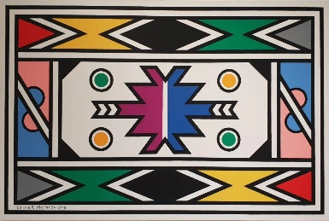  Pablo Picasso – summer 1  Collage and textiles and painting- colour mixing  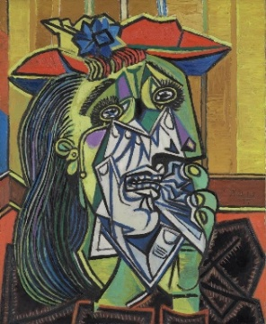 | Georges Seurat (Autumn 2- pointillism- winter scene painting)  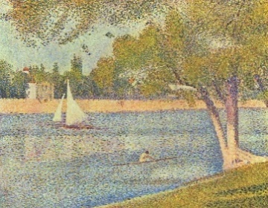  Patrick Mavros (Spring 2 and 2-sculptures)  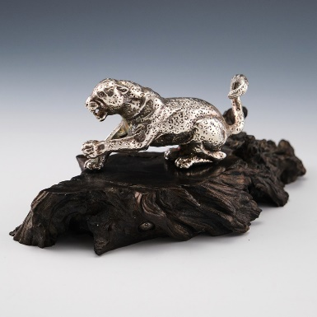  Ellsworth Kelly (Summer- line drawings) to be changed (Andy Warhol?)  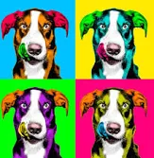 | Male:  Sophilos (Summer)  Female:  Cath Riley (Autumn)  Pandora Sellars (Spring)  Art Cath Riley drawing hyper-realism Stone Age artefacts  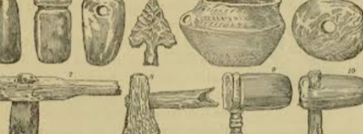  Art Pandora Sellars Watercolour painting, botanical art and photography of real plants to change in digital format  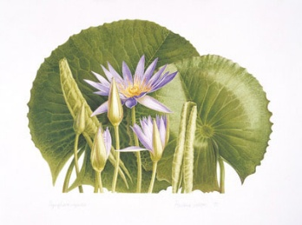  Art Sophilos Greek clay pot – Clay pot sculpting – use geometric designs and alternative colours  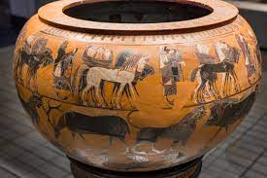 | Male:  Nikita Busyak (Autumn 1)  (Architectural sketching, one point perspective, ink, white/yellow light effect)  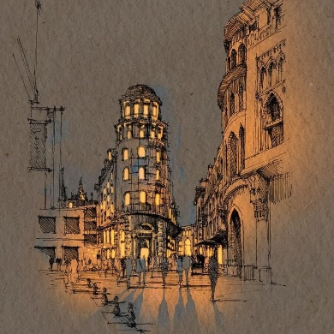  Female:  Osnat Tzadok (Spring 1)  (Abstract, pastels, watercolour background wash, highlights/shading)  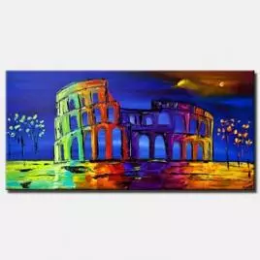  Maya civilization of ancient Mesoamerica (Summer 2)  (Ancient artefacts, sculpture/collage pattern)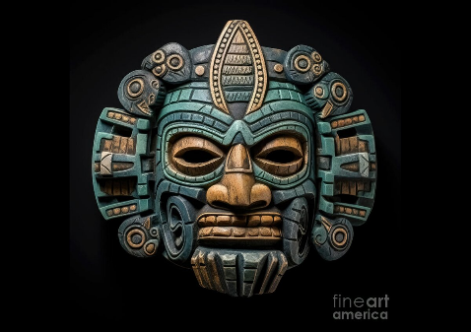 | Dragons in Art Autumn 1(multi media, fantasy art)  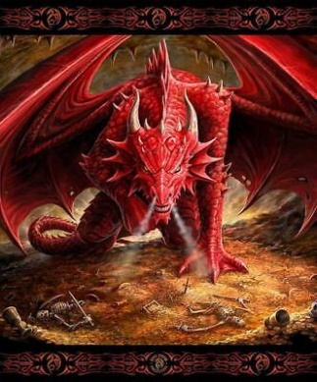  (Ann Stokes)  Chesley Bonestell Spring 2 (contemporary – printing, perspective, shade, depth)  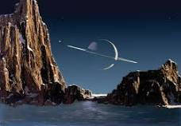  Elizabethan portraiture – Summer 2  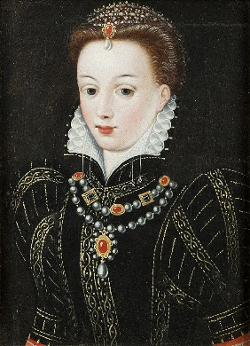 | Hokusai- Autumn 1  Painting  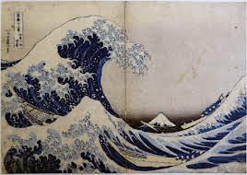  Henry Moore- Summer 1  Drawing  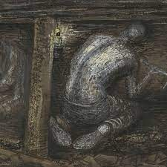  Troy Emery  Sculpture- Summer 2  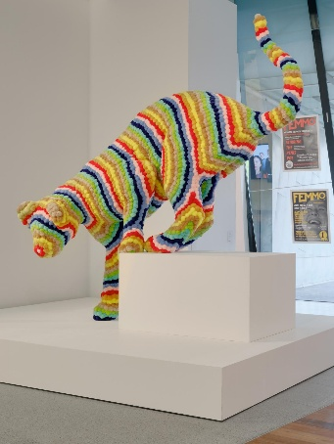
Vocabulary | Drawing  Painting  Sculpture  Artist  Illustrators  Art  Creative  Self-portraits  Collage  Texture  Tools:  pencils, pastel, chalk, paint, crayons  Colours  Dark  Light  Digital art  Christmas – to cover any other unhighlighted skills | Drawing: Thick, Thin, Soft, Broad, Narrow, Fine, Pattern, Line, Shape, Detail, Mirror image, Nature, Made environment.  Painting: Primary (colour), Light, Dark, Thick, Thin, Tone, Warm, Cold, Shade e.g. different shades of red, green, blue, yellow, Bright.  Printing: Print, Rubbing, Smudge, Image, Reverse, Shapes, Surface, Pressure, Decoration, Cloth.  Collage & Textiles: Fabric, Colour, Pattern, Shape, Texture, Glue, Stick, Scissors, Sew, Needle, Felt, Hessian, Scraps, Wool, Yarn, Thread, Fur, Tweed, Silk, Satin, Net, Weave.  Sculpture: Model, Cut, Stick, Fold, Bend, Attach, Assemble, Statue, Stone, Shell, Wood, metal.  Christmas – to cover any other unhighlighted skills | Drawing: Thick, Thin, Soft, Broad, Narrow, Fine, Pattern, Line, Shape, Detail, Nature, Made environment, Comparison, Still life.  Painting: Secondary (colour), Light, Dark, Thick, Thin, Tone, Warm, Cold, Shade e.g. different shades of red, green, blue, yellow, Bright, Pointillism, Colour wash.  Printing: Print, Rubbing, Smudge, Image, Reverse, Shapes, Surface, Pressure, Decoration, Cloth, Repeat, Rotate, Mon-print, Two-tone print.  Collage & Textiles: Fabric, Colour, Pattern, Shape, Texture, Glue, Stick, Scissors, Sew, Needle, Felt, Hessian, Scraps, Wool, Yarn, Mixed media, Collage, Appliqué, Layers, Combine, Opinion, Thread, Fur, Tweed, Silk, Satin, Net, Weave.  Sculpture: Sculpture, Structure, Assemble, Construct, Model, Fold, Bend, Attach, Statue, Stone, Metal, Curve, Form, Clay, Impress, Texture.  Christmas – to cover any other unhighlighted skills | Drawing: Frame, Cartoon, Comic strip, Map, Position, Boundary, Label, Line, Symbol, Practical, Impractical, Change, Improve.  Painting: Abstract, Natural, Bold, Delicate, Detailed, Colour descriptors e.g. scarlet, crimson, emerald, eau de nil, turquoise, Watery, Intense, Strong, Opaque, Translucent, Wash, Tint, Shade, Background, Foreground, Middleground.  Printing: Imprint, Impression, Mould, Monoprint, Background, Marbling, Surface, Absorb, Stencil, Pounce, Negative image, Positive image.  Collage & Textiles: Tie and dye, Natural, Synthetic, Vat, Bunching, Dip, Soak, Resist, Threading, Stitching, Embroidery, Cross stitch, Running stitch, Stem stitch, Shrunken, Wool tops, Carding, Tease, Matting.  Sculpture: Viewpoint, Detail, Decoration, Natural, Form, Two-dimensional, Three-dimensional, Tiles, Brick, Slate, Wood, Stone, Metal, Texture, Bronze, Iron. | Drawing: Plan, Distance, Direction, Position, Form, Texture, Tone, Weight, Pressure, Portrait, Past, Present, Appearance, Character, Personality.  Painting: Scenery, Rural, Urban, Townscape, Seascape, Representational, Imaginary, Impressionist, Abstract, Idealised, Natural, Swirling, Stippled, Transparent, Opaque, Foreground, Background, Middle ground, Horizon. Printing: Pounce, Linear, Register, Manipulate, Block, Repeat, Continuous, Cylinder. Collage & Textiles: Daub, Stamp, Emblem, Motif, Ornamentation, Geometric, Stylised, Abstract.  Sculpture: Form, Shape, Texture, Composition, Profile, Stylised, Proportion, Decoration, Ornate, Symbolic, Perspective.  Christmas – to cover any other unhighlighted skills | Drawing: Viewpoint, Distance, Direction, Angle, Perspective, Bird’s eye view, Alter, Modify, Interior, Exterior, Natural form, Vista, Panorama, Image, Subject, Portrait, Caricature, Expression, Personality.  Painting: Traditional, Representational, Imaginary, Modern, Abstract, Impressionist, Stippled, Splattered, Dabbed, Scraped, Dotted, Stroked, Textured, Flat, Layered, Opaque, Translucent, Intense.  Printing: Monotype, Printing plate, Inking up, Water-based, Oil-based, Overlap, Intaglio, Relief, Etching, Engraving, Indentation, Collograph, Pressure.  Collage & Textiles: Cloth, Fray, Taffeta, Organdie, Poplin, Tweed, Embellished, Manipulated, Embroidered, Warp, Weft, Replicate, Soft sculpture.  Sculpture: Realistic, Proportion, Surface texture, Balance, Scale, Relationship, Transform, Movement, Rhythm, Composition, Structure, Construct, Flexible, Pliable, Hollow, Solid, Surface, Plane, Angle, Slip, Attachment, Relief.  Christmas – to cover any other unhighlighted skills | Drawing: Action, Balance, Direction, Dynamic, Imbalance, Movement, Poised, Transition, Viewpoint, Weight.  Painting: Still life, Traditional, Modern, Abstract, Imaginary, Natural, Made, Inanimate, Composition, Arrangement, Complimentary, Tonal, Shading.  Printing: Aesthetic, Pattern, Motif, Victorian, Islamic, Rotation, Reflection, Symmetrical, Repetition. Collage & Textiles: Manipulation, Smocking, Ruching, Batik, Embellish, Accentuate, Enhance, Detract, Practicality, Aesthetic.  Sculpture: Line, Shape, Pose, Position, Gesture, Repetition, Sequence, Dynamic, Flowing, Motion, Rhythm, Proportion, Balance.  Digital art  Christmas – to cover any other unhighlighted skills
Knowledge |  | To describe what they can see and like in the work of another artist/ craft maker/ designer. | To be able to link colours to natural and man-made objects · To be able to say how other artist/ craft maker/ designers have used colour, pattern and shape · To be able to create a piece of work in response to another artist's work | To compare the work of different artists · To explore work from other cultures · To explore work from other periods of time · To begin to understand the viewpoints of others by looking at images of people and understanding how they | To developing Ideas by selecting and recording from first hand observation, experience and imagination, and explore ideas for different purposes. To question and make thoughtful observations about starting points and select ideas to use in their work. To explore the roles and purposes of artists, craftspeople and designers working in different times and cultures. To evaluate and develop work, compare ideas, methods and approaches in their own and others’ work and say what they think and feel about them. Adapt their work according to their views and describe how they might develop it further.

