

COMPUTING
Knowledge and Skills Progression Document

Computing Progression of Skills
At Widey Court, we teach computing using the NCCE Teach Computing Curriculum. The units for key stages 1 and 2 are based on a spiral curriculum. This means that each of the themes is revisited regularly (at least once in each year group), and pupils revisit each theme through a new unit that consolidates and builds on prior learning within that theme. This style of curriculum design reduces the amount of knowledge lost through forgetting, as topics are revisited yearly. It also ensures that connections are made even if different teachers are teaching the units within a theme in consecutive years.
The Teach Computing Curriculum uses the National Centre for Computing Education’s computing taxonomy to ensure comprehensive coverage of the subject. All learning outcomes can be described through ten strands, ordered alphabetically as follows:
■ Algorithms — Be able to comprehend, design, create, and evaluate algorithms
■ Computer networks — Understand how networks can be used to retrieve and share information, and how they come with associated risks
■ Computer systems — Understand what a computer is, and how its constituent parts function together as a whole
■ Creating media — Select and create a range of media including text, images, sounds, and video
■ Data and information — Understand how data is stored, organised, and used to represent real-world artefacts and scenarios
■ Design and development — Understand the activities involved in planning, creating, and evaluating computing artefacts
■ Effective use of tools — Use software tools to support computing work
■ Impact of technology — Understand how individuals, systems, and society as a whole interact with computer systems
■ Programming — Create software to allow computers to solve problems
■ Safety and security — Understand risks when using technology, and how to protect individuals and systems

Widey Court Primary School Long-Term ‘Teach Computing’ Plan and Skills
Here is an overview of the units taught across Key Stages 1 and 2 and the key skills covered in each
EYFS: EYFS does not follow the Teach Computing Scheme. In our Early Years computing curriculum, children develop essential life skills through age-appropriate technology experiences. They learn to communicate, collaborate, solve problems, and think creatively while exploring digital tools in a safe and supportive environment. Through practical activities, children build confidence, resilience, and independence, developing an understanding of how technology can support learning and everyday life. We also introduce the foundations of online safety, helping children make responsible choices and develop positive digital habits from an early age.

 | Year 1 | Year 2 | Year 3 | Year 4 | Year 5 | Year 6
Unit 1 | Technology All Around Us  Identify technology  Identify a computer and its aparts  Keyboard and mouse skills  Using technology responsibly | Information Technology Around Us  -Recognise features and uses of information technology  -Explain how to use information technology safely | Connecting Computers  -Explain how digital devices function  -Understand that devices have input and output  -Explore how devices can be connected and become a network | The internet  -Recognise how networks connect  -Understand that network create the internet  -Outline how websites can be shared on the world wide web  -Recognise that people create internet content and that is isn’t always reliable | Systems and Searching  -Explain that computers can be connected together to form systems  -Describe how search engines select results  -Recognise why the order of results is important, and to whom | Communication and collaboration  -Recognise how data is transferred across the internet  -Recognise how we communicate using technology  -Evaluate different methods of online communication
Unit 2 | Digital Painting  -Understand what different tools do  -Create my own picture using freehand tools  Compare my picture to a real drawing | Digital Photography  -Take a digital photograph  -Make choices when taking photographs  -Use tools to improve a digital photograph | Stop-frame Animation  -Relate animation with a sequence of images  -Plan and create an animation  -Review and improve animation | Audio Production  -Recognise that sounds can be recorded and edited  -Record and edit audio independently  -Combine audio to enhance project | Video Production  - Identify digital devices that can record video  -Capture video using a range of techniques  -Consider the impact of the choices made when making,editing and sharing a video | Webpage creation  -Review an existing website and consider its structure  -Consider the ownership and use of images (copyright)  -Recognise the implications of linking to content owned by other people
Unit 3 | Moving a Robot  -Explain what a command will do  -Combine commands to build a sequence  -Plan a simple programme  -Test and review my programme | Robot Algorithms  -Describe a sequence of instructions  -Understand the order of a sequence  -Design and debug an algorithm | Sequencing Sounds  -Identify that commands have an outcome  -Recognise that commands have a start and an order  -Create a project from a description | Repetition in Shapes  -Identify that accuracy in programming is important  -Create a repeating programme in text based language  -Modify a count controlled loop  - To create a program that uses count-controlled loops to produce a given outcome | Selection in Physical Computing  -Control a simple circuit connected to a computer  -Write a program that includes count-controlled loops  -Explain that a loop can be used to repeatedly check whether a condition has been met  -Create a program that controls a physical computing project | Variables in games  -Define a ‘variable’ as something that is changeable  -Choose how to improve a game by using variables  -Design, create and evaluate a project that builds on a given example
Unit 4 | Grouping Data  -Label objects  -Group objects in different ways  -Answer questions about groups of objects | Pictograms  -Use tally charts and pictures to count data  -Create a pictogram  -Use a computer to represent data | Branching Databases  -Identify attributes needed to collect data  -Create a branching database  -Independently create an identification tool | Data Logging  - -Explain that data gathered over time can be used to answer questions  -Use a digital device to collect data automatically  -Recognise how a computer can help us analyse data  -Use data from sensors to answer questions | Flat File Databases  -Outline how you can answer questions by grouping and then sorting data  -Explain that computer programs can be used to compare data visually  -Use a real-world database to answer questions | Introduction to Spreadsheets  - Build a data set in a spreadsheet  -Explain that formulas can be used to produce calculated data  -Create a spreadsheet to plan an event  -Choose suitable ways to present data
Unit 5 | Digital Writing  -Use a computer to write  -Change text on a computer  -Make careful choices about how text looks  -Compare paper and digital writing | Digital music  -Identify patterns in music  -Create a musical pattern using a computer  -Review and refine our creation | Desktop Publishing  -Recognise that text and layout can be edited  -Add content to a desktop publication  -Consider how layouts can suit varying purposes | Photo Editing  -Explain that the composition of digital images can be changed  -Explain how cloning can be used in photo editing  -Combine images for a purpose | Introduction to Vector Graphics  -Create a vector drawing by combining shapes  -Recognise that vector drawings consist of layers  -Group objects to make them easier to work with | 3D modelling  -Recognise that you can work in three dimensions on a computer  -Recognise that objects can be combined in a 3D model  -Plan and create a 3D model for a given purpose
Unit 6 | Programming Animations  -Choose a command for a purpose  -Join commands together  -Use an algorithm to create a project | Programming Quizzes  -Explain that a sequence of commands has a start and an outcome  -Create a programme using my design  -Decide how my project can be improved | Events and Actions in Programmes  -Programme a sprite to move  -Develop a programme  -Debug my programme  -Design and create a maze based challenge | Repetition in Games  -Develop the use of count-controlled loops in a different programming environment  -Explain that in programming there are infinite loops and count controlled loops  -Modify an infinite loop in a given program | Selection in Quizzes  -Relate that a conditional statement connects a condition to an outcome  -Explain how selection directs the flow of a program  -Design, create and evaluate a program which uses selection | Sensing movement  -Create a program to run on a controllable device  -Explain that selection can control the flow of a program  -Design a project that uses inputs and outputs on a controllable device

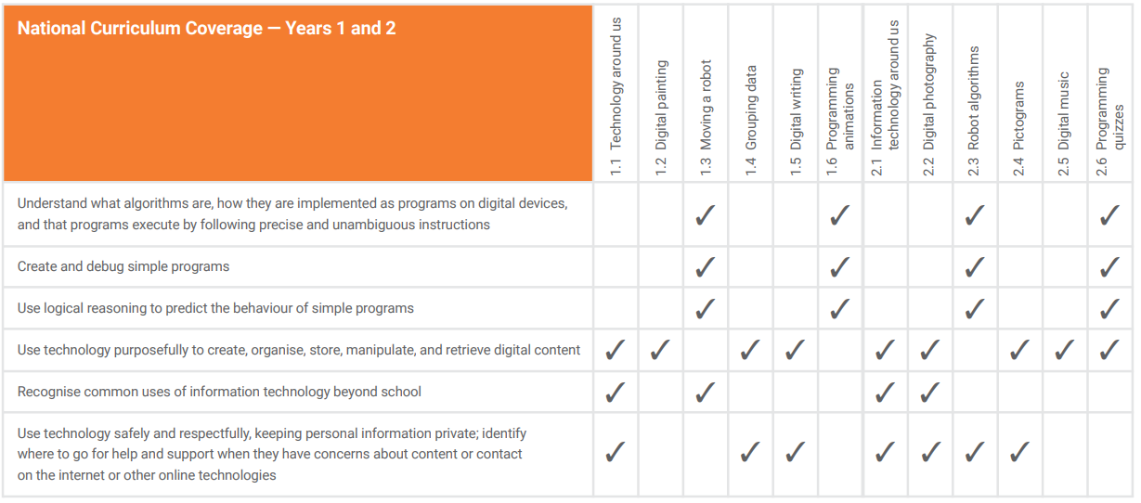
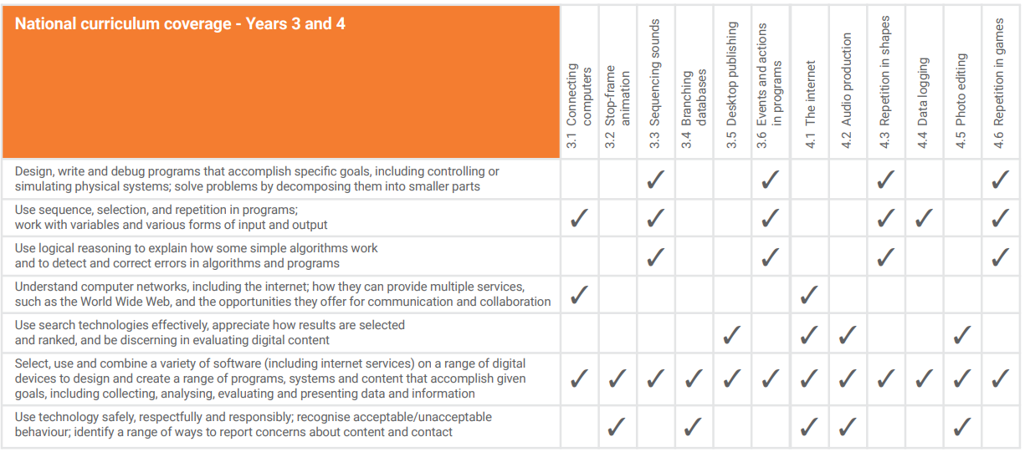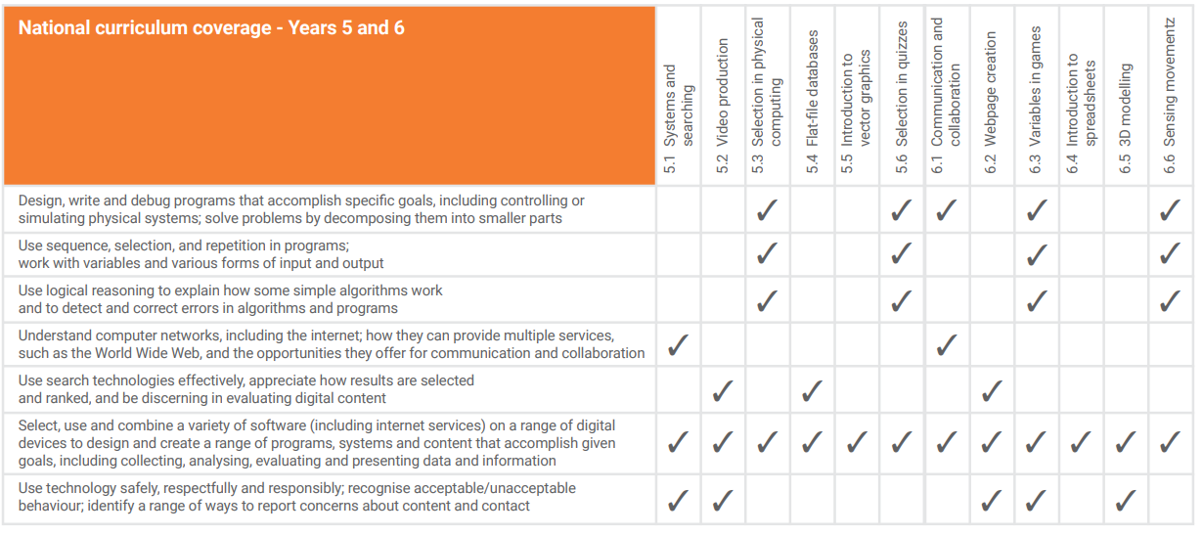

Vocabulary Progression by Year Group
