Widey Court Transition Booklet 2026
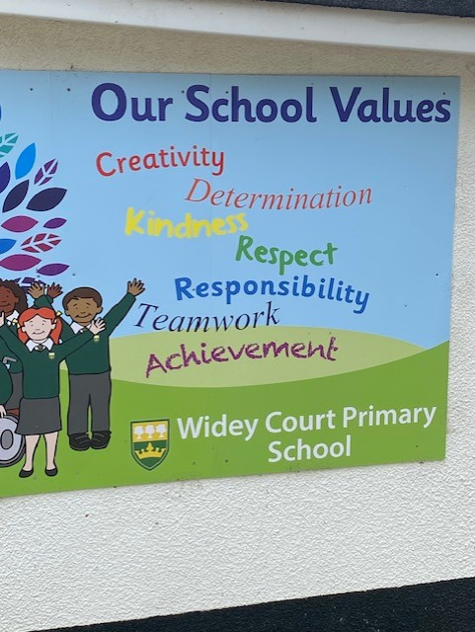

Oak Class September 2026


In September I will be in Oak class.

I will be in Year 1 in September.
This is a book about my new class.

This is Mrs Jones.
She will be my class teacher.


My Year 1 HLTAs will be Mrs Mulcahy and Mrs Stockwell.


My Y1 teaching assistants will be Mrs Brown, Mrs Jewell and Mrs Hitchcock,

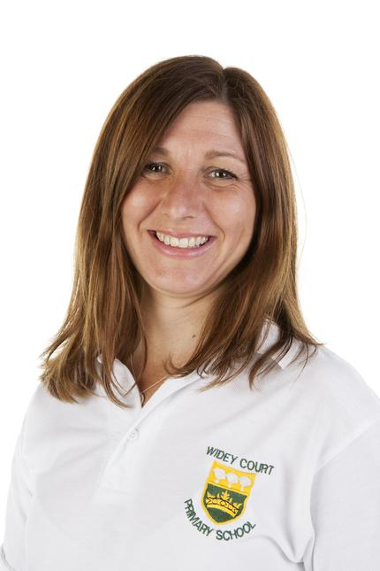



This will be my classroom in September.
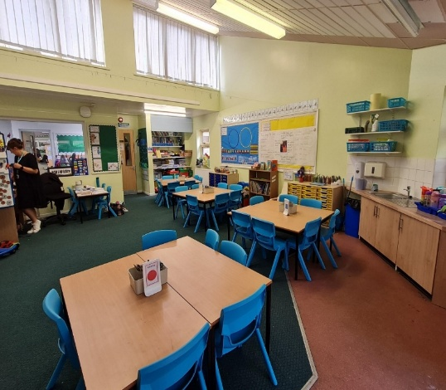

I will come into the class using this door and leave at the end of the day by the same door.
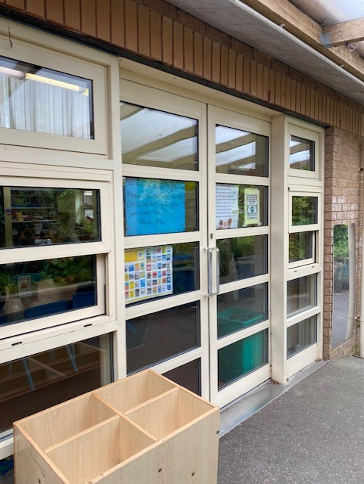

This is where I will hang my coat and put my lunchbox.
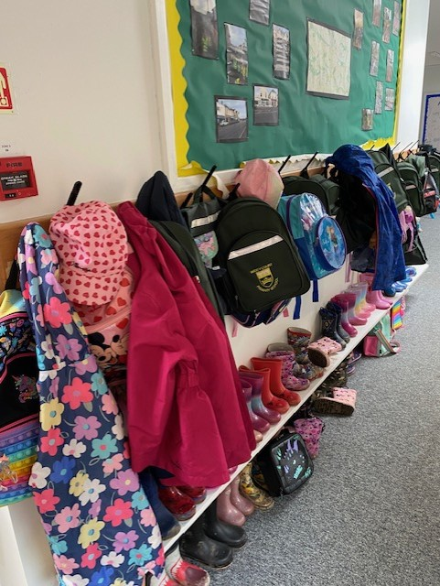

At morning break, I will play on this playground.
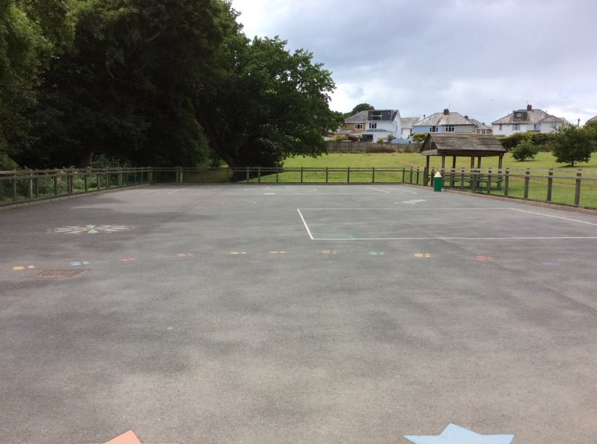

At Lunchtime we share this playground with Year 2.

I will use these toilets.
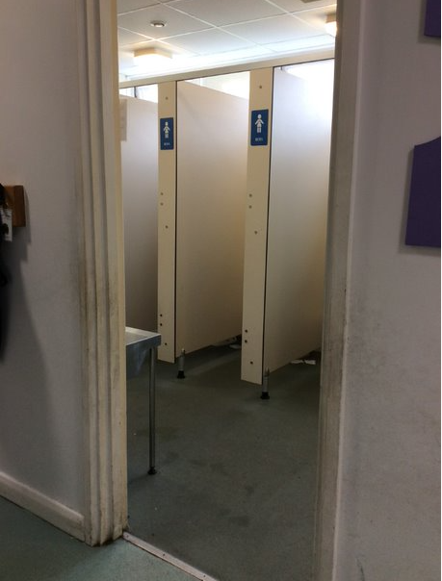
There is a hand dryer in the toilet. It makes a noise but it does not hurt me.
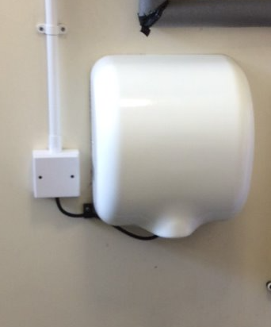

Other people that work at Widey Court that can help me and my family.



Mr Nicholls - Headteacher
Mrs Llewellyn - Deputy Headteacher
Mrs Hogden - Family Support Advisor
Miss Taylor - SENCO
Miss Williams - Inclusion Support

