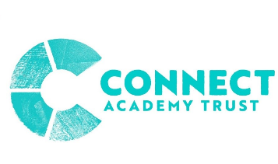
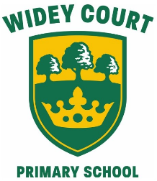
Widey Court Primary School
Termly Curriculum Overview
Year Group: 6 Term: Autumn 1 Theme: Great Adventures
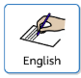 English |  | 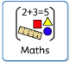 Maths
• I can use a question or interesting opening statement to hook the reader.  • I can use appropriate language to persuade the reader.  • I can write in the present and past tense.  • I can use parenthesis to add additional information.  • I can include precise, descriptive language and technical terms.  • I can recognise the key features of a non-chronological report.  • I can build a character profile based on what I have read.  • I can use evidence from a text to support answers.  • I can develop dictionary skills - spellings and definitions.  • I can develop understanding of using a range of sentence types.  • I can link ideas using a range of conjunctions.  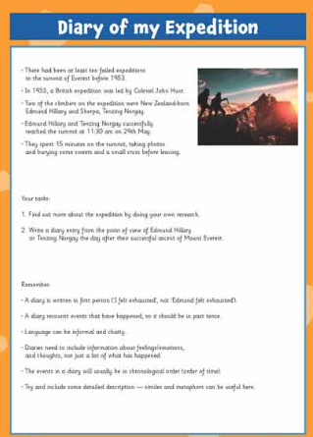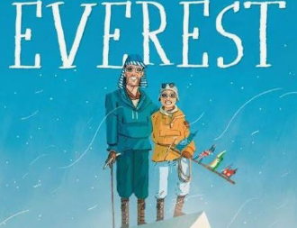 |  | • I can revisit and review basic mathematical skills.  • I can recognise multiplication facts up to 12x12.  • I can know the value of each digit within a 6-digit number.  • I can solve addition, subtraction, multiplication and division problems.  • I can develop my skills of long division.  • I can recognise patterns within numbers.  • I can know efficient strategies to solve arithmetic problems.  • I can add and subtract fractions with different denominators  • I can convert mixed numbers into proper fractions.  • I can use negative numbers.  • I can round any number.  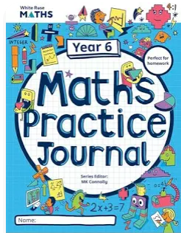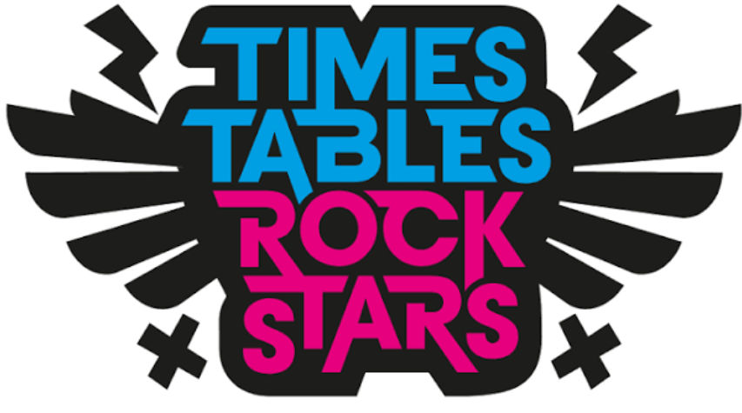
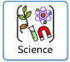  Science |   Geography  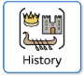  History |  | 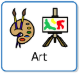  Art  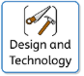  Design + Technology
Living things:  • I can understand how to classify objects and the characteristics of a living thing.  • I can classify animals.  • I can sort vertebrates and invertebrates.  • I can observe, research and record features of a range of leaves found in my local environment.  • I can understand how food chains and webs work.  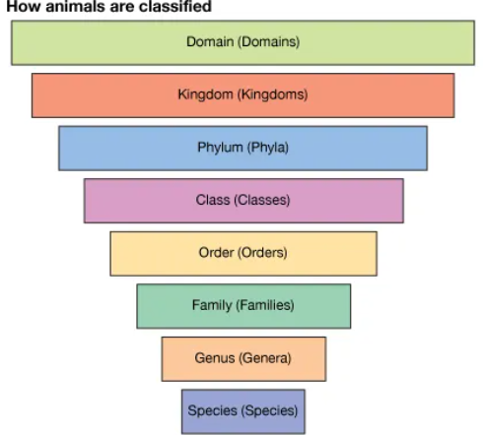 | Geography:  • I can identify key mountain ranges around the world, say where they are located in terms of countries and continents.  • I can use an OS map to identify the key features of mountains.  • I can describe the key features of a mountain range. 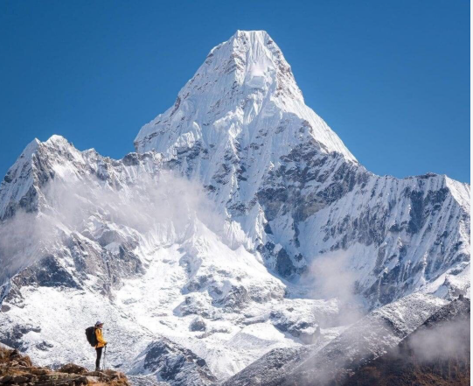  • I can explain how different types of mountains are formed.  • I can describe a mountainous climate.  • I can compare a mountain in the UK e.g. Ben Nevis and Mount Everest in Nepal/Tibet.  • I can use maps and online resource to find out about tourism resources in these locations.  • I can compare the tourism at each of these locations. |  | • I can research an artist.  • I can analyse an artist’s work.  • I can develop my skill of sketching.  • I can create my own final piece.  • I can evaluate my own art.  
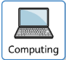  Computing | 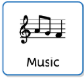  Music |  |   RE
• I can understand how networks talk to each other.  • I can explain what an IP address is.  • I can understand data packets.  • I can collaborate online using a network.   | Not taught in this term. |  | • I can interpret the book of Genesis, Chapter 1.  • I can understand the scientific belief about how the world was created.  • I can recognise that people have different views and interpretations of Genesis.  • I can recognise the main ideas about Christian beliefs about God as Creator.  • I can understand some different Christian views about the relationship between science and religion.  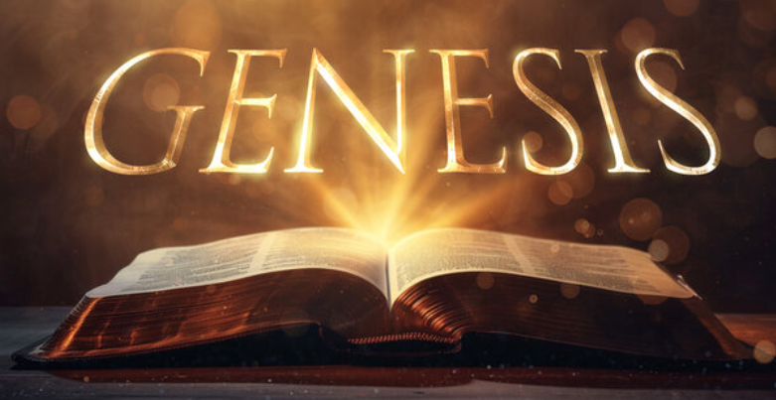
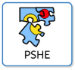  PSHE | 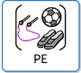  Physical  Education |  | 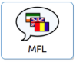  Languages:  French
• I can identify my goals for this year and understand my fears and worries about the future.  • I can understand the difference between my wants and needs.  • I can understand that there are universal rights for all children but for many children these rights are not met.  • I can create a class charter.  • I can understand how an individual’s behaviour can impact on a group.  • I can understand how democracy and having a voice benefits the school community.   | Tag Rugby  • I can pass a rugby ball using the correct technique.  • I can tag an opponent.  • I can understand the rules of tag rugby.  • I can apply tactics to a game scenario.  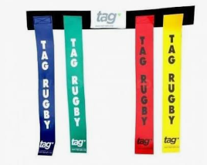  Gymnastics:  •I can demonstrate control in my body.  •I can control my jump.  • I can add a travel in between each move.  •I can create a sequence of gymnastics moves.  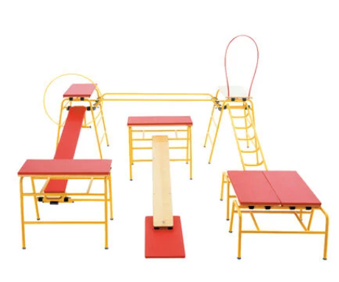 |  | •I can revise the ‘I’ ‘in’ ‘ille’ ‘ique’ sounds in French.  •I can use regular verbs .  • I can revise the ‘ch’, ‘oi’, ‘on’ ‘ou’ sounds in French.  •I can revise verb endings.  

