Widey Court Transition Booklet 2026

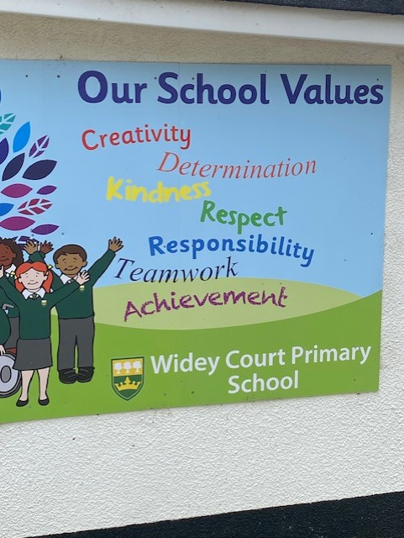

Burrator Class September 2026

In September I will be in Burrator class.



I will be in Year 5 in September.
This is a book about my new class.

Miss Carney and Mrs O’Connor will be my class teachers.


Mrs Bridges will be the Y5 HLTA.


My Y5 teaching assistants will be
Mrs Lambourne and Ms. Sinfield.

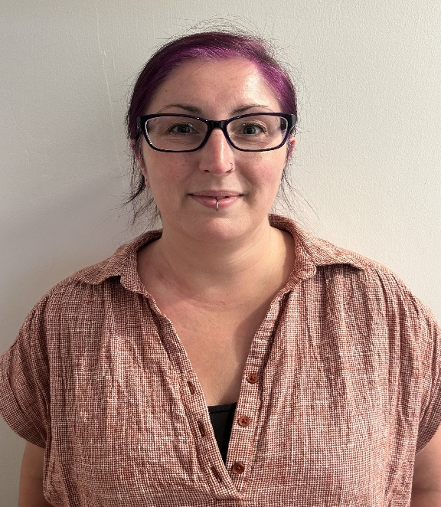

This will be my classroom in September.
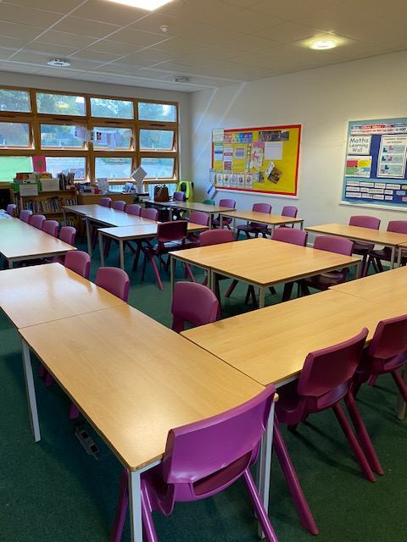

I will come into the class, and leave using the door over the bridge in the 3/4 playground.
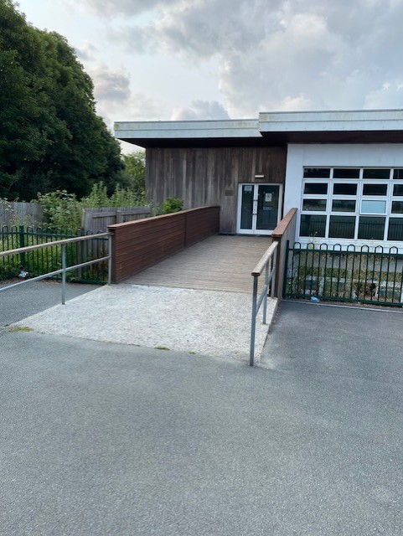
We sometimes have PE lessons on this playground too.

I will use the separate boys and girls toilets in the corridor.

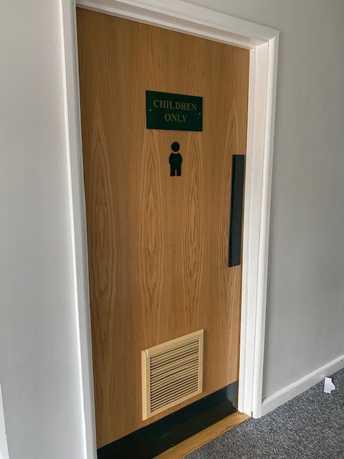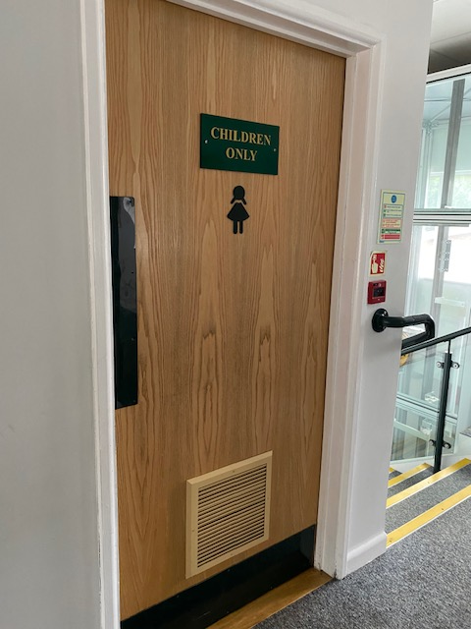

Other people that work at Widey Court that can help me and my family.

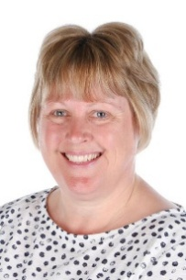

Mr Nicholls - Headteacher
Mrs Llewellyn - Deputy Headteacher
Mrs Hogden - Family Support Advisor
Miss Taylor - SENCO
Miss Williams - Inclusion Support

