
earthlawportal.org

GETTING TO 30X30: A Roadmap for States
Exhibit C: Model State 30x30 Legislation

Provided by: Defenders of Wildlife
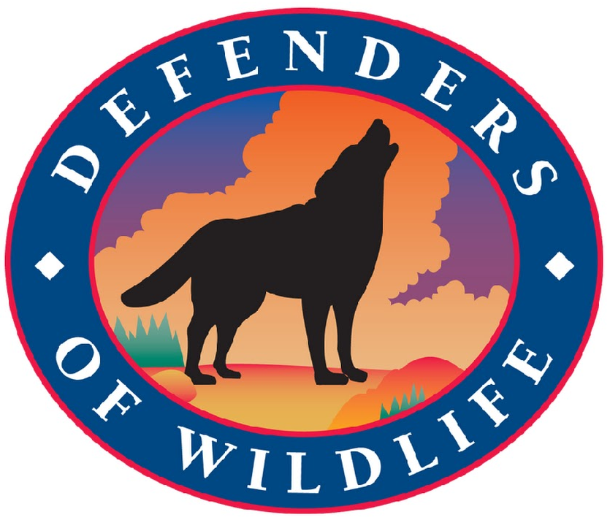

https://defenders.org

These are open source templates, not universally applicable solutions. We acknowledge that laws and policies should be adapted to differing cultural and political situations. These templates are not legal advice. If you desire legal support, please reach out to a licensed attorney.

BIODIVERSITY AND CLIMATE PROTECTION ACT

SECTION 1. SHORT TITLE. This Act may be cited as the Biodiversity and Climate Protection Act.

SECTION 2. DEFINITIONS.

(a) “30X30” means the goal of protecting at least 30% of the earth’s terrestrial, marine, and aquatic resources by 2030 in order to protect and restore biodiversity and to mitigate the impacts of climate change.

(b) “Biodiversity” means the variability among living organisms from all sources including terrestrial, marine, and other aquatic ecosystems and the ecological complexes of which they are a part, including diversity within species, between species, and of ecosystems.

(c) “Carbon sequestration” means the capture of carbon dioxide through terrestrial, geological, biological, or other natural means, which prevents the release of carbon dioxide into the atmosphere. This includes, but is not limited to, the process by which atmospheric carbon dioxide is taken up by trees, grasses, and other plants through photosynthesis and stored as carbon in biomass (trunks, branches, foliage, and roots) and soils.

(d) “Ecosystem services” means the benefits people derive from ecosystems, such as the provisioning of
services or goods like food, wood and other raw materials, plants, animals, fungi, and micro-organisms that provide essential regulating services such as pollination of crops, prevention of soil erosion, and water purification.

(e) “Environmental equity” means the distribution of environmental risks and benefits regardless of race, income, ethnicity, nationality, or other characteristics, and the inclusion of all stakeholders in environmental decision-making that impacts them, particularly historically underrepresented and marginalized groups.

(f) “Natural and nature-based solutions” means features that are natural, restored to a natural state, or that use non-built elements to mimic natural processes in order to preserve, enhance, and/or protect biodiversity, protect human and non-human communities from hazardous events, and preserve or enhance ecosystem services, including carbon sequestration.

(g) For the purposes of 30x30, “protect” or “conserve” means the establishment of enduring measures that support thriving biodiversity, contribute to climate resilience, and provide ecosystem services, such that the natural character, resources and functions of lands and waters are maintained or enhanced now and into the future, both individually and as part of an interconnected network of healthy lands and waters.

SECTION 3. FINDINGS, GOALS AND POLICIES.

1. The people of [STATE] have an important relationship with their local environment and have demanded its government preserve and protect our natural policies.

2. It is therefore the goal of [STATE] to protect at least 30 percent of lands and waters in the state by 2030 for the purposes of conserving biodiversity and mitigating the impacts of climate change, hereafter referred to as “30X30.”

SECTION 4. STATE COMMISSION ON BIODIVERSITY AND CLIMATE.

1. To reach 30x30 there is established a State Commission on Biodiversity and Climate to be convened and co-chaired by [PRINCIPAL NATURAL RESOURCES MANAGEMENT AGENCIES]. Additional members of the Commission shall include the heads of [LIST OF RELEVANT STATE AGENCIES, E.G. TRANSPORTATION, AGRICULTURE] or their designees. This Commission is established to develop and implement an overall strategy to address the biodiversity and climate crises in [STATE] and to implement the goals of 30x30.

2. The co-chairs of the Commission shall develop internal procedures to carry out the Commission’s work. [APPROPRIATE NATURAL RESOURCES MANAGEMENT AGENCY] shall provide the
Commission with funding and administrative support.

3. The Commission shall create a science advisory committee, made up of appropriate scientific experts from federal and state agencies, tribes, academia, the private sector, and non-governmental organizations, to advise the Commission on its work.

4. The Commission shall consult with relevant stakeholders in carrying out its responsibilities, including federal agencies with land management or species conservation responsibilities, local governments, local
communities, tribes, private businesses, private landowners, land trusts, hunting and fishing groups, and conservation groups.

5. The Commission, with the assistance of the science advisory committee shall carry out the following
activities:

a. Establish a baseline assessment of [STATE’s] biodiversity status and trends that builds upon
existing data and information, and uses the best available science, including where appropriate,
traditional indigenous and local knowledge.

b. Identify research gaps in implementing 30x30 in [STATE] and develop proposals to address those gaps through the [STATE’S] university system and other appropriate institutions.

c. Establish a baseline assessment of carbon flux and sequestration in all lands and waters within [STATE’S] borders.

d. Analyze and project the impact of climate change and other current and future stressors on
[STATE’s] biodiversity, adaptive capacity, and ecosystem services.

e. Establish a baseline assessment of the value of ecosystem services within [STATE’S] borders and the ecosystem service benefits derived from and provided to other states.

f. Develop a framework for identifying and protecting public and private lands for inclusion in a 30x30 system in a way that balances the need for biodiversity protection, carbon sequestration, environmental equity, and public access.

g. Inventory current biodiversity protection efforts across all sectors and land managers and identify opportunities for additional action to preserve, restore and enhance biodiversity through state actions, including through partnerships with local governments, federal agencies, private landowners, academia, and others.

h. Identify funding needs for full 30x30 implementation, including but not limited to funding needed for adequate land acquisition, land management including restoration, and to meet scientific research needs.

i. Identify current gaps in state agency authority to fully implement the goals of 30x30 and offer possible legislative and regulatory changes that could address these gaps.

j. Within one year of the date of this order, submit to the legislature and the governor’s office a
report on the information generated through the activities listed above.

6. Within either two years of the date of the passage of this law or the issuance of an executive order requiring a substantially similar process, whichever is earlier, the Commission shall develop and submit to the legislature and governor’s office a comprehensive strategy that sets forth the steps needed to protect biodiversity and achieve 30x30 in [STATE] in a manner that:

a. Protects and restores biodiversity across all regions and habitat types across the state.

b. Safeguards [STATE’S] economic sustainability and food security.

c. Offers a rigorous methodology for prioritizing lands for protection, taking into account current and future biodiversity needs, carbon stocks and sequestration capacity, ecosystem services, economic sustainability, environmental equity, compatible recreational access, and the status of adjacent lands.

d. Enables enduring conservation measures through a broad range of landscapes, including natural areas and working lands, in partnership with land managers and natural resource user groups.

e. Ensures that state efforts to implement 30x30 complement other state and federal 30x30 initiatives.

f. Builds climate resilience, ensures and improves carbon sequestration, reduces risk from extreme climate events and contributes to [STATE’S] efforts to combat climate change.

7. To advance efforts to conserve biodiversity, and beginning immediately, all state agencies identified in item (2) above are also directed to take the following actions within existing authority and resources:

a. Strategically prioritize investments in cooperative, high value actions that promote biodiversity protection, habitat restoration, climate adaptation and mitigation, sustainable management, and other conservation outcomes.

b. Implement actions to increase the pace, scale, and effectiveness of environmental restoration and land management efforts by streamlining permitting approval processes for restoration and other conservation activities.

c. Communicate the importance of biodiversity protection and 30x30 in [STATE] to agency staff, the regulated community, and the public

d. Collaborate with federal, state, academic research institutions and tribes to develop and/or utilize advanced monitoring technology, research, and traditional indigenous and local knowledge to better understand the status of biodiversity in [STATE] and the threats to it.

e. Coordinate with appropriate state agencies in other states to optimize biodiversity protection, reduce adverse ecosystem fragmentation, and create or maintain functional wildlife corridors.

f. Participate as appropriate in global, national, regional, and local efforts to advance biodiversity protection and help stem extinctions across the world.

g. Engage with federal land management agencies, and advocate for federal decision-making that prioritizes protecting and conserving biodiversity through formal and informal partnerships, and public comment and hearing opportunities.

