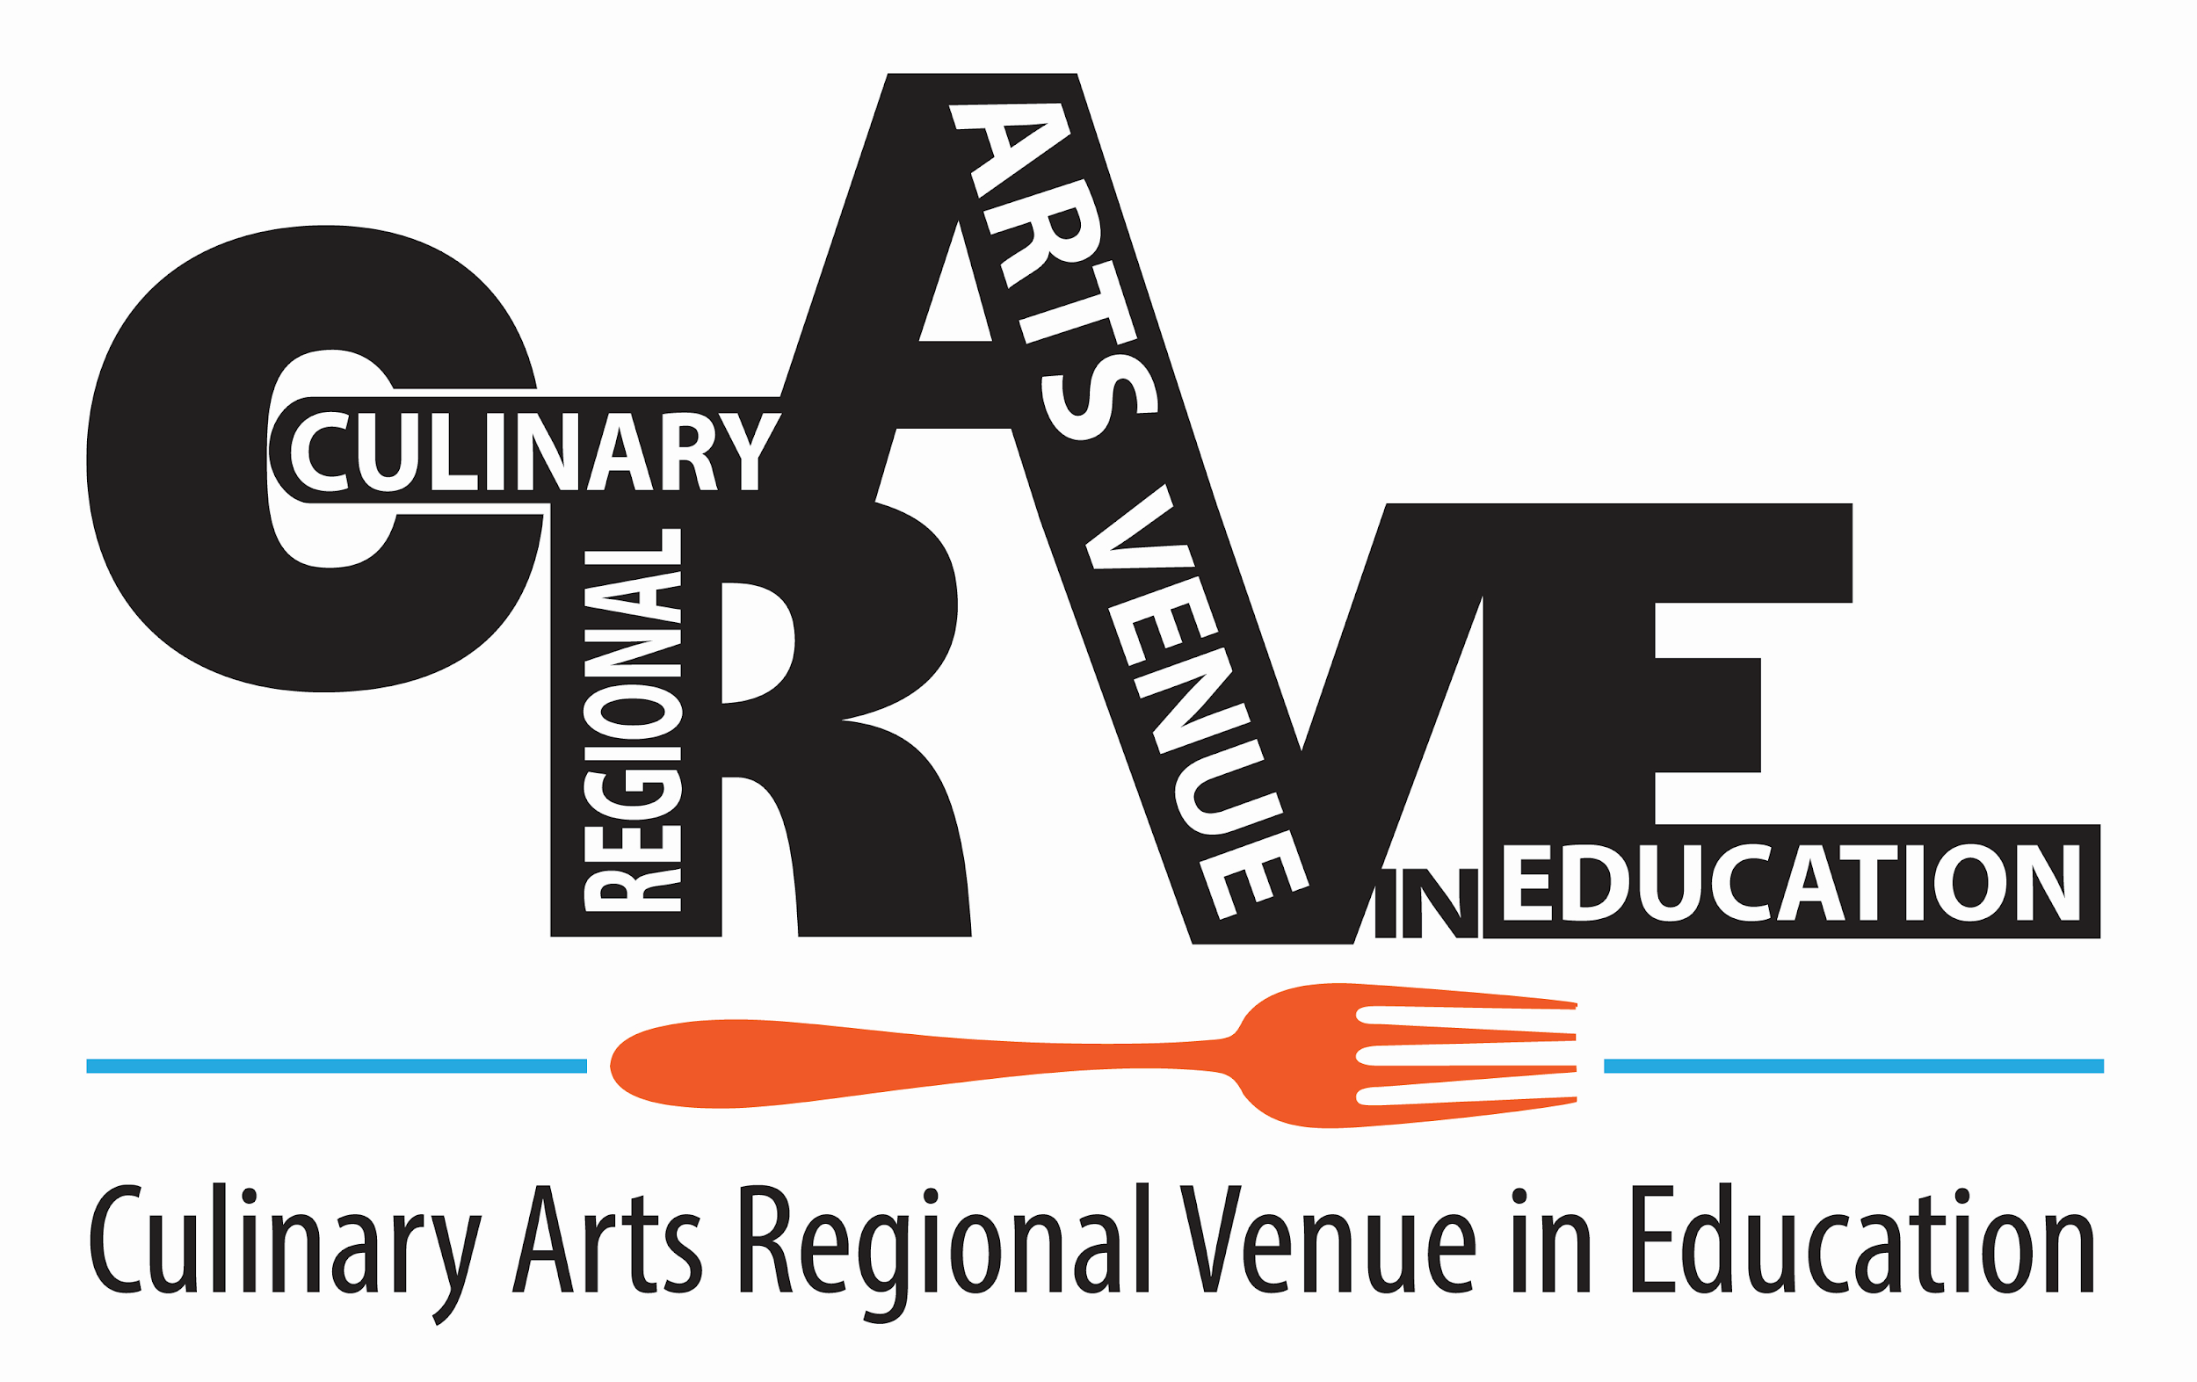

Knife Skills

Individual Competition

Multiple students from the same district can compete in the same category. Indicate which category students will compete in on student registration.

Activity to be completed:

Students should be prepared to demonstrate all four of the following knife cuts but will draw two cuts from a hat and prepare them for the judges.

Students will have 45 minutes to complete all four cuts and clean their work area.

Cut | Size | Quantity of product
Medium Dice | ½” x ½” x ½” | ½ cup
Batonnet | ¼” x ¼” x 2 ½” | ½ cup
Julienne | 1/8” x 1/8” x 2” | ¼ cup
Brunoise | 1/8” x 1/8” x 1/8” | ¼ cup

Bring four pre-washed potatoes for each competitor.

Students will be provided with a small work area.

Students should be prepared to answer the judge’s questions.

Bring portion cups/display plates to display each knife cut and waste for judging.

Judges will give feedback during and immediately after this event, but results will not be revealed until the awards ceremony.

Completed knife cuts should be transported to the designated display area and left there until at least right before the awards ceremony.

Ice water will be provided

Continue Page 2

Materials Students Need to Bring to the Event:

Knives
- Portion cups and/or display plates

Cutting board
- Non-slip mat or wet towel

Ruler

Four pre-washed potatoes, per competitor

Appropriate safe food handling materials or clothing- apron or chefs coats, gloves, hair covering such as chef hat or cap

