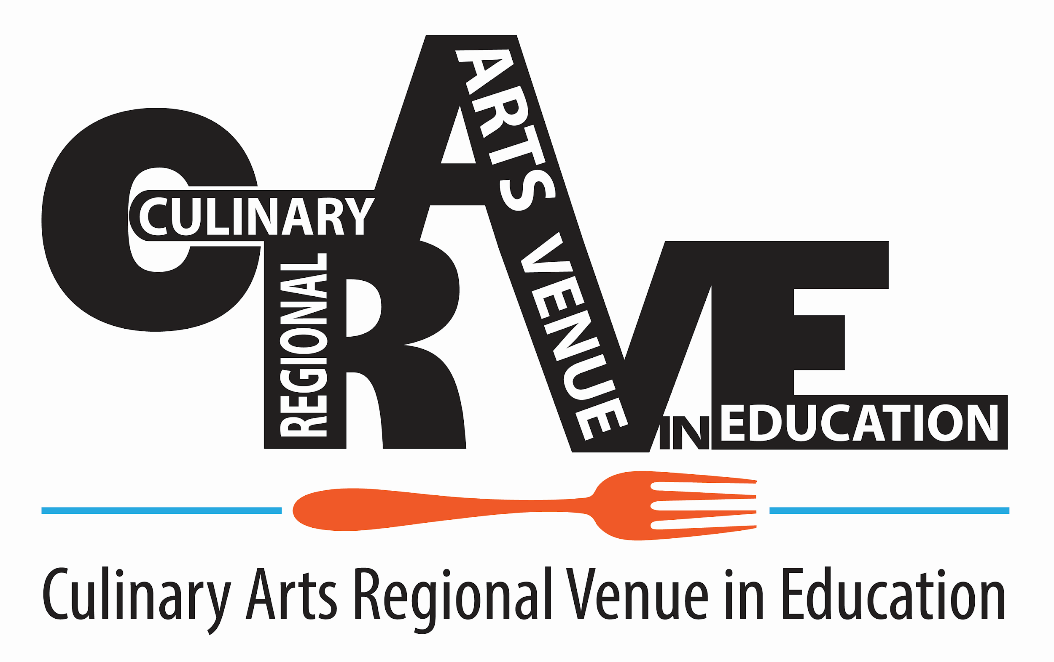

Tablescaping

Individual or Team: Team of 2.

Activity to be completed:

Students will design a themed 5’ round table space and assemble a table setting for a minimum of two people.

Each setting will include at a minimum: one dinner plate, one salad plate, water glass, other beverage glass, appropriate flatware, and a napkin. A bread-and-butter plate is optional. A small centerpiece and/or an individual place setting decoration (like a party favor) is allowed provided it fits within the allotted 5’ round space.

Students will choose one style of napkin fold and incorporate it in their setting.

Table setting must be completed in the presence of the judges.

Students will present their theme to the judge and explain how their tablescape encompasses the chosen theme.

Students will be expected to demonstrate their napkin fold for the judges. A schedule will be posted with the time listed for each competitor to demonstrate their napkin fold and complete their place setting. (Spectators will NOT be allowed in the display area while the judges are doing the reviews.)

Students will supply three printed copies of the napkin fold design description for the judges. The description shall be no longer than one page in length, which must include drawings or photos. Judges should be able to understand how to make the napkin design from the student’s printed description.

The completed table settings must be left for display purposes throughout the day and removed at the end of the event. Students should not disassemble their table setting until right before the awards ceremony. If any student needs to leave the event early, advisors should make event organizers aware of the reason ahead of time so all projects are available for judging, etc.

Continue on Page 2

Materials Students Need to Bring to the Event:

Napkins in their choice of material (one for the display and one for the demonstration to the judge.) No restrictions on material used.

Cloth to polish off fingerprints on plate.

Three printed copies of napkin fold design descriptions for judging.

Place setting items to enhance and display the use of their napkin, other required setting items (at a minimum: one dinner plate, one salad plate, water glass, other beverage glass, and appropriate flatware), placemat, etc. for each place setting.

Students should dress in a professional manner.

