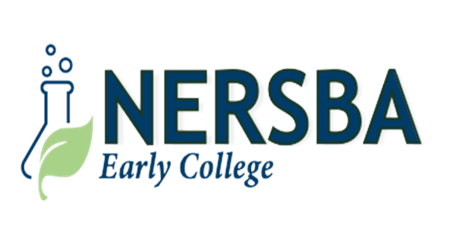

NERSBA Board of Directors “Preliminary” Meeting Agenda
Wednesday, November 19, 2025
4:30 PM

- OPEN SESSION – 4:30 PM _________ _______________
  - Call to Order/Welcome: Mr. Benjie Forrest, Chair
  - Invocation/United States Pledge of Allegiance: Mr. Julius Walker
  - Roll Call: Mrs. Inga Stotesberry
  - Approval of November 19, 2025 NERSBA Board Meeting Agenda: Mr. Benjie Forrest, Chair
  - Public Comments: Mr. Benjie Forrest

- NERSBA Scholastic Report: Ms. Lisa Smith/Dr. David Jenkins______________________________________________________
  - NERSBA Early College 2025-2026 Scholastic Update: Mrs. Lisa Smith/Dr. David Jenkins
  - US Army Physical Conditioning Test: Mr. Travis Wester
  - Walk Across America Project: Mr. Travis Wester/Mrs. Lisa Smith
  - National FFA Convention Review: Mrs. Lisa Smith, Mr. Kendall Paramore, Mrs. Maria Dickinson, FFA Members
  - North Carolina State FFA Landjudging Contest Results: Mrs. Maria Dickinson

- NERSBA Financial Report: Mr. Michael Hardy___________________________________________________________________
  - 2025-2026 NERSBA Fiscal Budget Presentation: Mr. Michael Hardy

- NERSBA Informational Items: Dr. David Jenkins/Mr. Hal Davis_____________ _________ ______________
  - COGNIA Accreditation Candidacy Visit Review: Mrs. Lisa Smith, David Jenkins
  - NERSBA FFA Alumni Review/FFA Alumni Fundraiser: Mrs. Lisa Smith
  - NERSBA Roofing Repairs: Mr. Hal Davis
  - UMO/MCC/NERSBA Early College Articulation Agreements: Mrs. Lisa Smith
  - THANK YOU!!!

- NERSBA Action items: Mr. Benjie Forrest ____________ ______________
  - NERSBA September 17, 2025 Board Meeting Minutes Approval: Mr. Benjie Forrest
  - NERSBA Stronger Connections Grant Budget Amendment: Mr. Hal Davis
  - NERSBA 2025-2026 Budget Approval: Mr. Michael Hardy, Mr. Hal Davis
  - UMO/MCCNERSBA Early College Articulation Agreement/NERSBA Student Enrollment Approval: Mr. Hal Davis

- Closed Session: Closed Session: NCGS 143.318.11 (5)/Personnel___________________________________________________

- Announcements: Mrs. Lisa Smith______________________________________________________________________________
7.1 November 25th NERSBA Fall Dance and Social, 7:00 PM (@Deadwood)
7.2 November 26th-28th NERSBA Scholar Holidays/Optional Annual Leave (November 26th)
7.3 November 12th Conclude Martin Community College Fall Semester
7.4 December 12th-18th NERSBA Fall Semester Final Exams
7.5 December 22nd-31st NERSBA Christmas Holidays
7.6 January 1st New Years’ Day Holiday
7.7 January 2nd Designated Faculty Workday
7.8 January 5th First Day Of NERSBA Early College 2026 NERSBA Spring Semester
7.9 January 19th National Martin L. King Jr. Holiday
8.0 January 21st NERSBA Board of Directors Meeting, 4:30 PM

- Motion To Adjourn________________________________________________________________________________________

