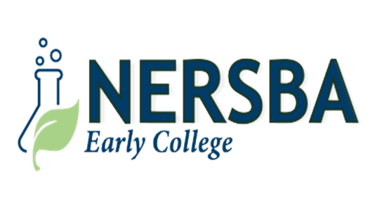

NERSBA Board of Directors Preliminary Meeting Agenda
Wednesday, January 21, 2026
4:30 PM

- OPEN SESSION – 4:30 PM _________ _______________
  - Call to Order/Welcome: Mr. Benjie Forrest, Chair
  - Invocation/United States Pledge of Allegiance: Mr. Julius Walker
  - Roll Call: Mrs. Inga Stotesberry
  - Approval of January 21, 2026 NERSBA Board Meeting Agenda: Mr. Benjie Forrest, Chair
  - Election of NERSBA Board Officers For 2026
  - Introduction: Mrs. Christy Twiddy, NERSBA Math Faculty Member
  - Public Comments: Mr. Benjie Forrest

- NERSBA Scholastic Report: Ms. Lisa Smith/Dr. David Jenkins______________________________________________________
  - NERSBA Early College 2025-2026 Scholastic Update: Mrs. Lisa Smith/Dr. David Jenkins

- NERSBA Financial Report: Mr. Michael Hardy___________________________________________________________________
  - 2025-2026 NERSBA Fiscal Budget Update: Mrs. Renee Dunn, Mr. Hal Davis
  - Review of NERSBA Local Chart of Accounts: Mr. Hal Davis

- NERSBA Informational Items: Dr. David Jenkins/Mr. Hal Davis_____________ _________ ______________
  - NERSBA Roofing Update: Mr. Hal Davis, Mr. Kip Mr. Kip Brandenburg, The Garland Company
  - NERSBA Policy Updates/North Carolina School Boards Association: Dr. David Jenkins/Mr. Hal Davis
  - 2026-2027 NERSBA Scholastic Calendar Proposal: Mr. Hal Davis

- NERSBA Action items: Mr. Benjie Forrest ____________ ______________
  - NERSBA November 19, 2025 Board Meeting Minutes Approval: Mr. Benjie Forrest
  - NERSBA Stronger Connections Grant (Contract Approval W/Martin County Sheriffs’ Department): Mr. Hal Davis
  - North Carolina State FFA Convention/Request For Overnight Approval: Mr. Hal Davis

- Closed Session: Closed Session: NCGS 143.318.11 (5)/Personnel___________________________________________________

- Announcements: Mrs. Lisa Smith______________________________________________________________________________
7.1 February 4th NERSBA Class of 2026 Applications Due, 3:00 PM
7.2 February 5th State FFA Tractor & Truck Driving Contest, Southern Farm Show/Raleigh, NC
7.3 February 16th Presidents Day/Virtual Instructional Event
7.4 February 16th-21st National FFA Week
7.5 February 18th NERSBA Board of Directors Meeting, 4:30 PM
7.6 February 22nd NERSBA @ Syracuse University vs NC State Women’s Basketball Game, 2:00 PM

- Motion To Adjourn________________________________________________________________________________________

