RapidDeploy Radius Mapping
Sample Policies and Procedures for Use

Document Change Log
Date | Author | Change | Reason
2/9/2024 | RapidDeploy | Original release – v1.0 | N/A
6/28/2024 | RapidDeploy | Updated – v2.0 | Added sections for:  Panic Buttons, Critical Incident Boards, ECC Messaging, Data Download, ECC Lookup
8/15/2025 | RapidDeploy | Updated – v3.0 | Updated images to reflect new buttons for RapidVideo and RapidLocate  Added sections for:  Closing a Call, Map Markups, Disciplines, Indoor Floor Plans (Floor Filter)
1/23/2026 | RapidDeploy | Updated – v4.0 | User Interface (UI) re-design updates

Usage Disclaimer:
This sample policies and procedures document represents RapidDeploy’s recommendations for our customers around the use of Radius Mapping as part of their operational workflows. RapidDeploy does not represent that these policies and/or procedures are sufficient in form, content, or defensibility in any legal action. The policies and procedures set forth in this document are provided for informational purposes only and on an “as is” basis with no warranty, whether express, implied, or statutory to the maximum extent permitted by law. RapidDeploy will not be liable for any damages, losses, or causes of action arising from any use of this document. It is recommended you consult with your legal counsel before implementing this policy in either part or whole.

Confidentiality Notice:
This document is proprietary and confidential. No part of this document may be disclosed in any manner to a third party without the prior written consent of RapidDeploy, Inc.

Introduction 4
Radius – General Use Policy 5
Radius Feature Use – Procedures 5
Improved Location Accuracy 5
Signals 7
Handling Signals 9
Using Signals when 911 Lines are Down 9
Using Disciplines in Radius 9
Location Timeline 10
NENA ECC Lookup 11
RapidLocate 12
Additional Data 13
SMS Chat 15
Reasons to initiate an SMS Chat session 15
Language Translation 16
Acceptable Use of SMS Chat 16
Closing SMS Chat Sessions 16
Use of Slang, Shortcuts, Emojis, etc. 17
Non-emergency Use of SMS Chat 17
RapidVideo 18
When to use RapidVideo 18
Telecommunicator Wellness 20
Non-response from Caller in SMS Chat or RapidVideo Session 20
Retention of SMS Chat Messages and Video 20
Closing a Call 20
Shift Change 21
Manual Call Creation 21
Benefits of Create Call Feature 21
Map Search 22
Authoritative GIS Services in Radius 23
Map Layers 23
Basemaps 24
ECC Messaging 24
ECC Messaging Workflow 25
Discrepancy Reporting 27
Map Discrepancy 27
Call Discrepancy 28
Additional Data Sources in Radius 28
Vehicle Telematics – Crash Data 28
Handling Vehicle Telematics Signals 29
Rave Smart911 31
Panic Button Integrations 33
Audible Notifications in Radius 35
Data Download 36
What Can Be Downloaded 37
Critical Incident Boards (CIBs) 38
Map Markups 40
Indoor Floor Plans (Floor Filter) 41
Contacting Support 43
Appendix A – Pre-configured Message List for PSAPs 47

Introduction
As the leading cloud-native Next Generation primary call taking map, Radius Mapping solves challenges with siloed 911 data and communications by connecting and visualizing real-time critical information in a single, resilient pane of glass. Our unified map transforms the way telecommunicators engage with callers, reducing response time, enhancing situational awareness and driving better emergency response outcomes. The key features of Radius include:
Direct integration with all call handling systems – Automatically displays the location of wireless, wireline, VoIP, and telematics 9-1-1 calls, obtained automatically from 9-1-1 CPE/CHE ANI/ALI using the patented RapidDeploy Emergency Data Gateway (EDG) device.
Supplemental caller handset location – Automatically displays supplemental 9-1-1 locations dynamically for wireless 9-1-1 calls from handset location data, even before the call rings.
Intelligent correlation of data sources – Correlate location information and supplemental data from different data sources, such as ALI, device-based hybrid locations, and what3words so that the Telecommunicator sees the correct information at the right time, without having to check multiple screens.
RapidLocate – Support requesting the location of 9-1-1 callers via text message when there is no 9-1-1 information available, with no mobile application required.
SMS Chat with automatic language translation – Initiation of two-way SMS text chat sessions (initiated by the Telecommunicator) with 9-1-1 callers and real-time language detection and translation in over 110 different languages.
RapidVideo – Supports on-scene live video streaming (initiated by the Telecommunicator), allowing Radius users to view what is happening around the 911 caller, increasing situational awareness.
Rich additional data from the most trusted sources – Integrate relevant information such as language, health history and additional caller data (e.g., Rave Smart911), and crash data (incl. OnStar and Bosch).
Real-Time Data – Includes live data feeds such as real-time traffic and incidents from TomTom and Waze.
Deep GIS Integration – Leverages the Esri ArcGIS platform and authoritative GIS data. Supports integration and visualization of your agency’s authoritative custom base maps, map layers, geocoding services, and web maps.
NENA Enhanced PSAP Registry and Census (EPRC) integration – Allows telecommunicators to view the geographic boundaries and contact information of all PSAPs in the U.S. directly within their Radius map.

Radius – General Use Policy
Telecommunicators must log in to Radius at the start of every shift and keep the application running throughout the duration of each shift. It is the policy of AGENCY NAME to make all reasonable efforts to verify the location of the emergency based on the circumstances of each 9-1-1 call received via the Radius application.
Upon login to Radius, the telecommunicator is responsible for setting their Agent Position number to match the agent position of 9-1-1 CPE phone system (e.g., VESTA, VIPER, etc.). Radius pre-populates and auto-suggests valid agent position numbers in a drop-down (numbers that match the PSAP's CPE position numbers.) These numbers are pulled from the last 7 days of phone calls through the CPE. A number can be manually entered, if needed. If a telecommunicator has any issues logging into Radius (e.g., locked account, unsure of Agent Position number, etc.), they should contact their immediate supervisor upon starting their shift.
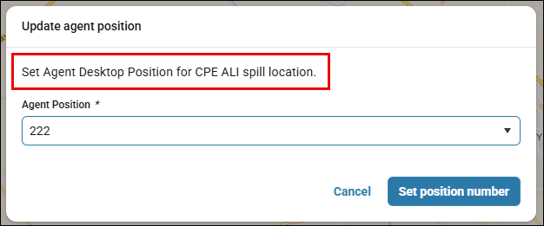
At the end of each shift, all telecommunicators must log out of Radius and close the browser window or tab where Radius was running. This ensures that the next telecommunicator at that workstation does not continue using the same Radius session or attempt to unknowingly initiate a second session on the same workstation.
Refer to the Radius Quick Start Guide for more information on accessing and using the basic functions of Radius.

Radius Feature Use – Procedures

Improved Location Accuracy
Radius provides additional sources of location data beyond the ALI information that is provided with every call from your Call Handling system. Telecommunicators should use this information to assist in obtaining the most accurate location of a caller whenever possible. When viewing a call in Radius, the location timeline displays cards for the location updates received for the active call. The location update cards will display the Most Accurate Location** update at the top and sequentially the previous location updates for the call. Each location update indicates the source of the location information, e.g., WPH2, Apple, Google, RapidLocate, etc. To see the previously received location updates on the map for the selected active call, Breadcrumbs should be enabled by clicking on the toggle Location Breadcrumbs option in the map controls .
**Radius will always focus on the most accurate location, rather than the most recently updated location, ranked by priority according to class of service. Priority ranking:
- Manually entered locations, RapidLocate (RapidVideo will also produce a RapidLocate), Apple or Google locations, Telematics, and Emergency Alert Signals/Panic Buttons, Apple or Google locations
- Configured WPH2
- Configured WPH1
- Unknown

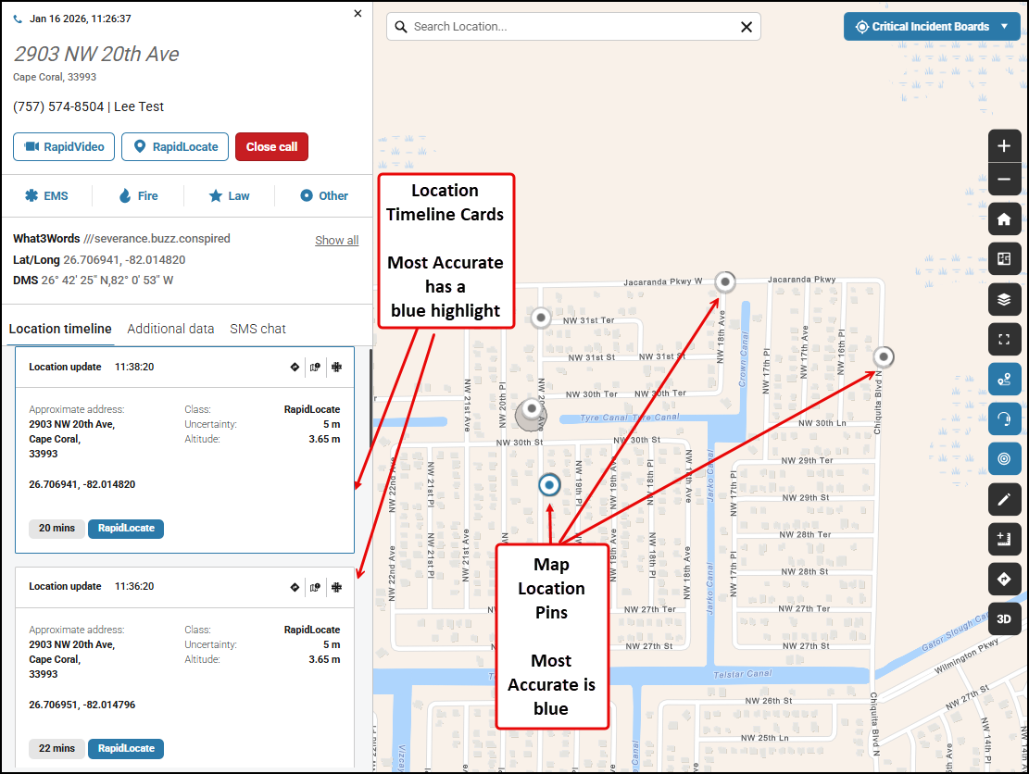

Supplemental Caller Device Locations (Apple and Google)
The supplemental locations for wireless calls (from mobile devices) are received and attached to active calls automatically in Radius. These updates are received throughout the course of wireless calls and update automatically on the map and within the location timeline.
Telecommunicators shall consider the most recent supplemental (device) location update to be the most accurate for call handling and dispatching purposes, unless otherwise indicated by the uncertainty and/or confidence values of the location update.
What3Words
What3Words has given every 10 feet (3 meter) square in the world a unique three-word address. The three-word location is automatically provided for every call in Radius. This location can be provided to responders to assist in navigating to the caller’s location. The Search function within the Radius map also allows searching based on What3Words addresses, which can be used if a caller provides a W3W address verbally or via SMS Chat.

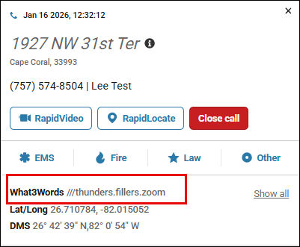

Signals
A Signal is an indication of a request for emergency assistance from sources other than the 911 phone system. In Radius, a Signal is typically an indication that someone called 911 at a certain location, but that the Call has not been received by the Telecommunicator's agency yet. This is possible because Radius receives information from Apple and Google about all 911 calls placed in the agency’s jurisdiction through a robust, modern data path that’s separate from the 911 phone system. A Signal appears on the map as a Signal pin with an icon relevant to the provider, and an uncertainty radius.
Signals provide additional benefit to the 911 center in certain situations, including:
- Someone tried to make a call, but the phone line never connected due to network outages or long queues caused by high call volumes;
- Someone tried to make a call, but the E911 ALI/ANI doesn’t show the correct phone number or location (Non-Service-Initialized phones a.k.a. NSI phones which are typically phones with expired contracts, without SIM cards, or phones in roaming scenarios);
- Someone tried to make a call, but the call was misrouted somewhere else like a neighboring agency or Statewide agency.
Signals may also be received, and display in the queue, for events received via third-party integrations, including Vehicle Telematics Crash Events from OnStar and Bosch, and Panic Button signals from providers like Rave and Raptor.
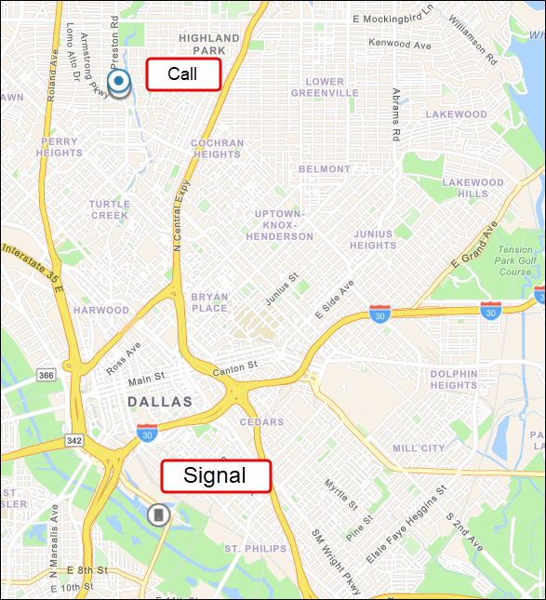

The Signals queue component in Radius will show a list of Signals which have come into the ECC's/PSAP’s jurisdiction.
The Accept button in the Signals queue will be disabled when the Signal comes into Radius. The Signal can be converted to a call once 10 seconds has elapsed - this is the equivalent of manually creating a call. Once you convert the Signal into a Call, the blue Signal pin (that indicates the type of signal)  will change to a Map Call Pin and move into your My Calls list.

Handling Signals
In many cases, a Signal will turn into a Call after a brief period. This means that the 911 Call that corresponds to the Signal is received and answered by the Telecommunicator's agency.
- When the Telecommunicator's agent position assigned the Call (based on answering position), the Signal will simply turn into a Call. It will display on the My Calls list and on the Call Detail Drawer. The Signal pin representing the Signal will change and appear as a Call pin, since it is treated as a supplemental location.
- When someone else at the Telecommunicator's agency is assigned the Call, the Signal’s pin will disappear from the Telecommunicator's map, unless the Telecommunicator has the All Calls layer activated. If the Telecommunicator has the All Calls layer activated, the Signal will appear as someone else’s Call (e.g., with the All Calls pin design ).
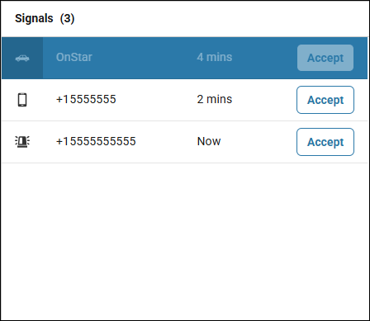
If a Signal appears in the Signals Queue and is not correlated to the 911 voice call automatically or indicated as “Answered by another PSAP”, the telecommunicator shall follow AGENCY NAME’s Abandoned Call policy. In the event a Signal requires follow-up, the Telecommunicator shall click the Accept button to convert the Signal to a call in Radius. The Telecommunicator can then determine if a voice call or an SMS Chat is the appropriate course of action, per the Abandoned Call policy.

Using Signals when 911 Lines are Down
If the 911 phone lines or the call handling system is non-operational, and telecommunicators are not able to receive E911 calls, Radius will continue to provide caller location and call information for wireless calls via the Signals functionality, so long as the workstation has an active Internet Connection. In this situation, telecommunicators shall use Radius to locate and establish a line of communication with callers wherever possible, as described above. The telecommunicator shall provide instructions to the caller on how to contact 911, including providing an admin line telephone number, if available.

Using Disciplines in Radius
NOTE: The functionality of Disciplines in Radius is only applicable if you are using the Lightning Mobile App.
Disciplines in Radius function like a triage system for emergency calls. With Telecommunicators categorizing calls based on discipline (Fire, Police, Medical or Other). Field Responders can quickly identify those calls that pertain to their assigned discipline(s).
When the Telecommunicator manually creates or accepts a call or signal, the available disciplines configured in Radius Admin for the ECC will automatically be assigned to the call in the Call Details Drawer.
Disciplines turn blue when they are selected or assigned. Telecommunicator’s can un-select a discipline by clicking once on the button.
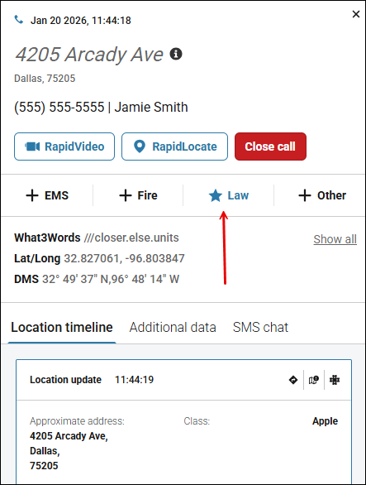

Location Timeline
The Location Timeline is the first tab on the "Call Detail Drawer".
The location timeline displays cards for the location updates received for the active call. The location update cards will display the latest location update at the top and sequentially the previous location updates for the call.
To view location pins on the map, you must toggle on the "Show Breadcrumbs" .
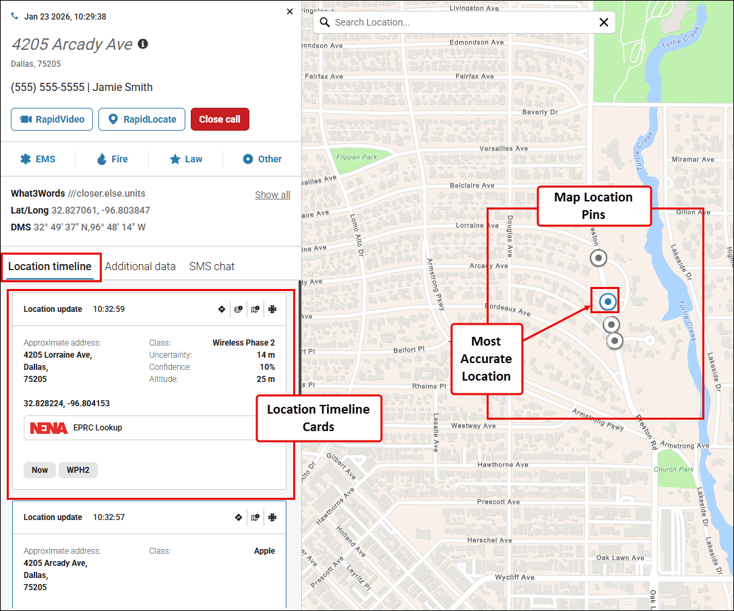

NENA ECC Lookup
The NENA ECC Lookup feature in Radius provides support during emergencies that span multiple jurisdictions. When an emergency transitions to another ECC, this feature seamlessly displays the contact details and critical information of the new ECC taking over the response. It acts as a reliable “handover tool”, ensuring smooth coordination and continuity of response efforts. Telecommunicators shall leverage the information provided within the ECC Lookup tool to confirm the Primary and/or Secondary PSAP responsible for a call in the following scenarios:
- Suspected or confirmed call misroute
- Caller and/or incident location crosses into another PSAP’s jurisdiction
- Mutual aid request is required as part of an incident response
The data contained in the NENA EPRC is managed by NENA directly and not controlled by RapidDeploy. It is important you verify your PSAP boundaries are accurate and consider providing your authoritative boundaries to incorporate into the EPRC. To provide updates to your PSAP boundaries please contact 911eprc@nena.org. The EPRC requires the support of the PSAP community to be fully successful.
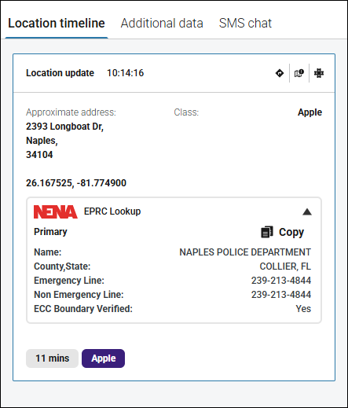

RapidLocate
RapidLocate allows telecommunicators to send an SMS (text) message to a mobile number to request the mobile device’s current location (via a clickable hyperlink embedded in the SMS message). Once the caller clicks on the link the device’s most current location (lat/long) is shared with Radius and automatically attached to the active call in Radius. Sent and received messages will display under the SMS Chat window. For RapidLocate to work correctly, the caller must have their Location Services enabled on their device.
If a location cannot be obtained from a wireless caller (e.g., the caller does not know where he/she is, the line is open with no response etc.), the telecommunicator shall initiate a RapidLocate request via Radius unless other circumstances dictate this would not be appropriate.
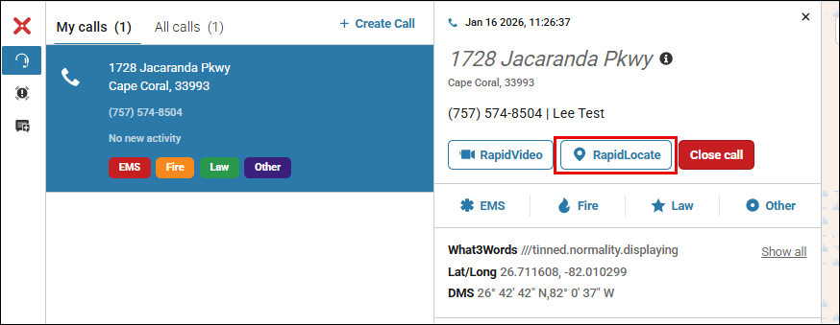

Additional Data
Radius provides direct access to supplemental information from electronic devices, referred to as Additional Data. Additional Data may contain important health information, emergency contacts, telematic information, or other details entered by the owner of the device. Telecommunicators shall use this information as needed to provide relevant information to responding units or to assist in determining level of response.
When working with Additional Data in Radius, it is recommended to verify that the device information applies to the caller and their emergency (since the calling party may not be the person with an emergency themselves).

Additional Data can be viewed in two different workflows within Radius:
- As part of an active call, by clicking on the ‘Additional data’ tab
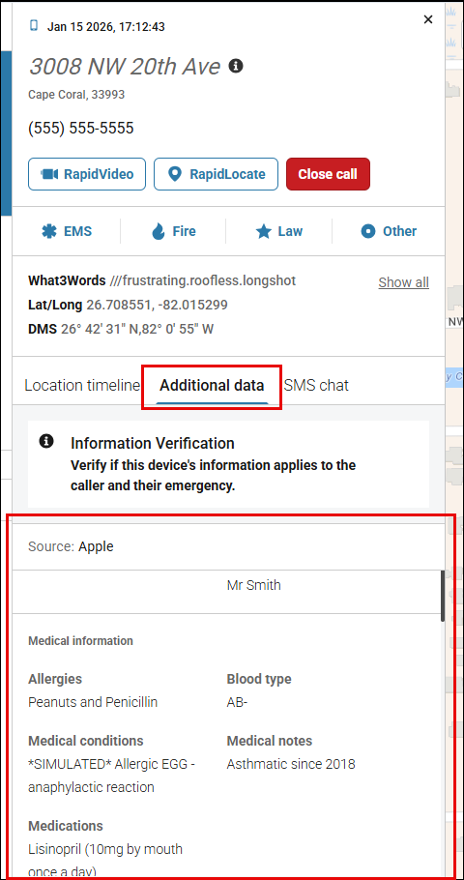
- When viewing the details of a Signal pin on the map, by clicking on the ‘Request additional information’ button
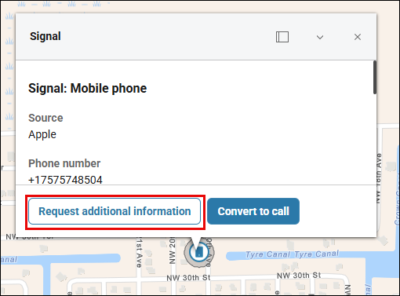
Since this information is highly sensitive, there are restrictions to be aware of, as follows:
- Additional data will not be automatically displayed for every call; the telecommunicator must specifically request it by clicking on the Additional data tab
- Additional data will not be stored in RapidDeploy’s databases, nor is it accessible by RapidDeploy staff. It is encrypted end-to-end and only visible to the telecommunicator who requested it.

SMS Chat
SMS Chat functionality within Radius allows telecommunicators to initiate communication with a Caller via the SMS Chat window to the number provided by ANI/ALI or by a caller. When viewing or handling an active call, selecting the SMS Chat tab will show the SMS Chat window, allowing the telecommunicator to send and receive SMS messages with the caller.
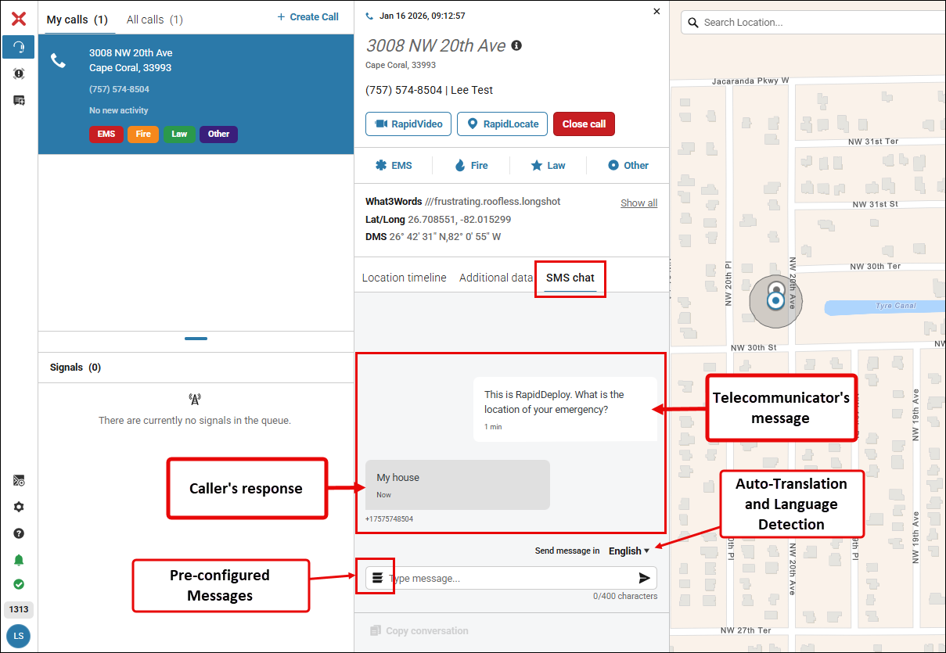

Reasons to initiate an SMS Chat session
There are many scenarios in which initiating an SMS Chat session during a call is necessary and/or beneficial, including but not limited to the following:
- Caller is hiding and cannot safely communicate verbally
- Caller called on the non-emergency line and could not provide their location
- The caller disconnects on a 9-1-1 call
- During 9-1-1 telephony outages (see “Using Signals when 911 Lines are Down” section above)
- Open 9-1-1 line with audible indications of an emergency situation (e.g., struggle, yelling, etc.)
- Cell phone has inadequate call service/reception but can still receive text messages
- You receive a credible report of a possible citizen in need of assistance (e.g., possible suicidal subject) and need to locate the person and/or communicate via SMS chat
- Other similar emergencies when communicating via SMS chat may provide resources to the citizen in need
- Other similar emergencies when using RapidLocate will assist in locating citizens in need
If any of these circumstances are present, the telecommunicator shall initiate an SMS Chat session in Radius and attempt to contact the caller using the same language you would for a voice call. If unsuccessful, telecommunicator shall take whatever action they deem appropriate for the situation, as dictated by established agency policy and/or procedure.

When initiating an SMS Chat session, the telecommunicator shall use the following initial message:
“This is AGENCY NAME. Do you have an emergency?” (This will be configured as a pre-configured message within Radius – see Appendix A)

Language Translation
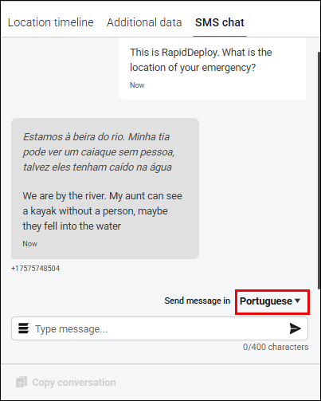
Radius provides language translation within the SMS Chat feature, including automatic recognition of the native language of text calls. If a text is received in a non-English language, Radius will translate it to English for the telecommunicator and automatically send messages back to the caller in the identified language. This is the preferred method for processing non-English calls where SMS is available (i.e., wireless calls).

Acceptable Use of SMS Chat
All communications within the SMS Chat feature should be work related and conducted in a professional manner in accordance with AGENCY NAME’s code of conduct.

Closing SMS Chat Sessions
In situations where SMS Chat is the only open line of communication with the caller, prior to closing the call in Radius, the telecommunicator must notify the caller that the session is being closed and the caller will need to call or text 9-1-1 for any future emergencies. The telecommunicator shall use the following message:
“This chat session is ending. If you need further assistance, please dial 9-1-1 again, as any further text messages will not be received.” (This will be configured as a pre-configured message within Radius – see Appendix A)

Use of Slang, Shortcuts, Emojis, etc.
At no time will a Telecommunicator use 'texting' slang, shortcuts, acronyms, or emojis. All correspondence from the telecommunicator will be in full-length form, except for common acronyms, which include, but are not limited to:
- St for Street
- Rd for Road
- Hwy for Highway
- EMS for Emergency Medical Services
- 2-character State abbreviations
- US for the United States
- l-XX for Interstate Highways

Autocorrect may change words the caller did not intend to type, so clarification is only necessary if the message's meaning cannot be determined. If a caller uses emojis, it sometimes comes in skewed characters or symbols.
The caller should be encouraged not to use 'texting' slang, shortcuts, acronyms, or emojis to help eliminate any confusion on the part of both parties; however, callers are not required to oblige. If it becomes difficult to understand a caller's need due to the use of these shortcuts, the telecommunicator will ask the caller if they can call in by voice.

Non-emergency Use of SMS Chat
Telecommunicators and field personnel may use SMS Chat to communicate information that is not of an emergency nature, in accordance with the guidelines outlined below. This can be accomplished by creating a manual call using the field personnel’s mobile phone number – see the Manual Call Creation section below for more information on this workflow.
- Dispatchers may reach out to field personnel via Radius, using SMS Chat, only on agency-issued cell phones
- Personal cell phones will only be contacted with permission of the owner or in case of emergency as requested by a supervisor. The phone number shall only be shared on a need-to-know basis.
- Conversations will be retained by RapidDeploy, according to the defined data retention policy, and may be requested for investigative, prosecutive, or according to public record request guidelines.
- All text messages are considered public record.

RapidVideo
RapidVideo is a one-way video chat service. RapidVideo allows Radius users to initiate a video call and view what is happening around the 911 caller so that the call taker can gain the necessary information to increase situational awareness. This function is available for any active call in Radius from a mobile/wireless device. The caller cannot see the telecommunicator, and the video feed is NOT two-way.

Note: Only one RapidVideo session is allowed at a time with a Radius user’s session. The RapidVideo icon will be greyed out on active calls in Radius when another RapidVideo session is in progress, preventing multiple video session attempts.

RapidVideo is not intended to be used for evidentiary purposes.

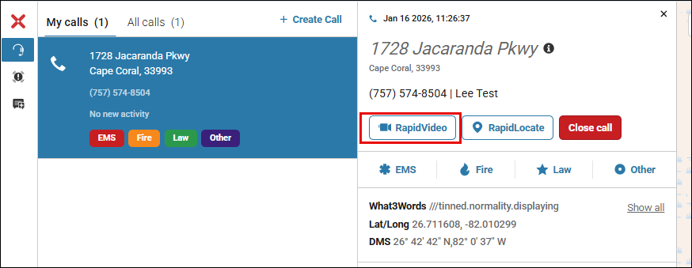

When to use RapidVideo
Telecommunicators have the discretion to request a RapidVideo connection with the caller for any call type they believe would benefit first responders or help them gain situational awareness. Such call types might include:
- Traffic accidents
- Childbirth
- Active Attacker Situation
- Structure fire
- Child callers

Additional reasons to utilize video might include:
- At the request of a supervisor or field unit, to assist in getting descriptions of suspects or vehicles (improved situational awareness)
- Silent 9-1-1 calls
- Calls in which there is an inability to determine an accurate location
- Calls in which the caller indicates they are unable to speak for any reason
- Calls that go silent mid-call
- When callers are confused or having a difficult time communicating
- Prank call or hoaxes
- 911 hang-up or dropped call that requires additional follow-up or verification
If the need to activate RapidVideo arises, the telecommunicator shall do the following:

- Relay the following message verbally or via SMS Chat to the caller:
“I will be sending a link via text message to your phone. If it is safe to do so, please click the link if you are willing to allow us to view the scene through your camera. The phone call/text is already being recorded, and the video will also be. This will help our responders better prepare before arriving on the scene.”

Note: RapidVideo Blur – the telecommunicator has the option to blur the incoming video feed, if desired. The telecommunicator can toggle the ‘Blur video’ button on/off, as needed, to control what is viewable to the telecommunicator within the RapidVideo session.

- The telecommunicator shall notify the officer(s) involved if a video is obtained, if applicable.

- Immediately following the video call, the telecommunicator shall document in the corresponding CAD incident/entry that video was activated and notify the on duty 911 Supervisor in case there is a need to obtain a copy in the future for after-action review and/or reporting purposes.
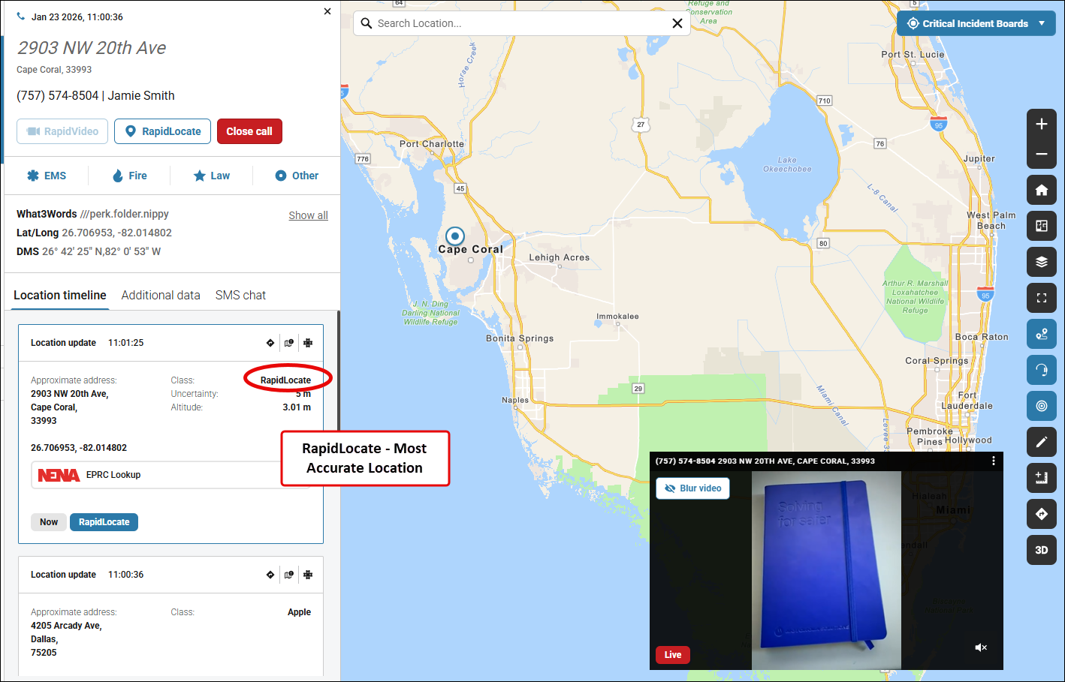

Telecommunicator Wellness
Telecommunicator Health and Wellness is the utmost priority. Graphic images may be viewed. If you are struggling with any call, SMS chat or imagery from RapidVideo, contact your supervisor and/or other available resources (peer support, EAP, etc.).

Non-response from Caller in SMS Chat or RapidVideo Session
In the event the caller becomes non-responsive during an SMS Chat or RapidVideo session, the telecommunicator should follow agency policy for hang-up or silent 911 calls.

Retention of SMS Chat Messages and Video
The content of all chat messages and video feeds to/from the 911 Center are subject to public record request. All communication from the 911 Center shall be professional and work-related. The retention of all SMS Chat messages and RapidVideo recordings is indefinite, per RapidDeploy policy. If agency has specific policy for access to historical data, insert here.
RapidVideo session recordings can be downloaded via the Data Download feature – see additional details on this feature in the Data Download section below.
SMS Chat transcripts are available within Closed Calls in Radius, which contains the last 24 hours of calls. Video is not stored locally or accessible directly in Radius after a video session has been terminated. To access SMS Chat transcripts outside of the 24-hour window or to access RapidVideo recordings, you will need to make a formal request through the AT&T Resolution Center or RapidDeploy Support to obtain the files from RapidDeploy. Requests must include the date/time of the inquiry, phone number of the caller, agent ID, and workstation console number/ID.
See the ‘Contacting Support’ section below for more information.

Closing a Call
It is important for the Telecommunicator to always click the Close Call button in Radius when the call has ended. Closing the call will remove it from the Telecommunicator's "My Call" list and the "All Calls" list in Radius. Doing this ensures that the Telecommunicator will see new call information quickly and that there isn't the appearance of more open or active calls in the ECC.
Calls will automatically close after 30 minutes. Closing the call in Radius does not affect or close the call in the ECC's Call Handling Equipment (CHE) or CAD systems.

Shift Change
During shift changes, telecommunicators shall follow agency policy for handing off in-progress calls. Specific to calls in Radius where SMS Chat and/or RapidVideo sessions are in progress, telecommunicators must include all relevant information related to the open sessions in their handoff. All queues within Radius must be checked at shift change.

Manual Call Creation
Telecommunicators can manually create new calls in Radius. The manual creation process supports the ability for telecommunicators to manually enter a cellular phone number into Radius and begin the process of locating and communicating with the device. This feature can also be used to re-establish communications and/or follow up on abandoned or dropped 911 calls.

Benefits of Create Call Feature
- Once a manual call has been created, the SMS Chat function can be used to establish a line of communication (wireless phone numbers only) (see the SMS Chat section above for more details).
- If there is an emergency or need for field responders, the telecommunicator can activate the Radius RapidLocate feature to determine a caller’s location (see the RapidLocate section above for more details).
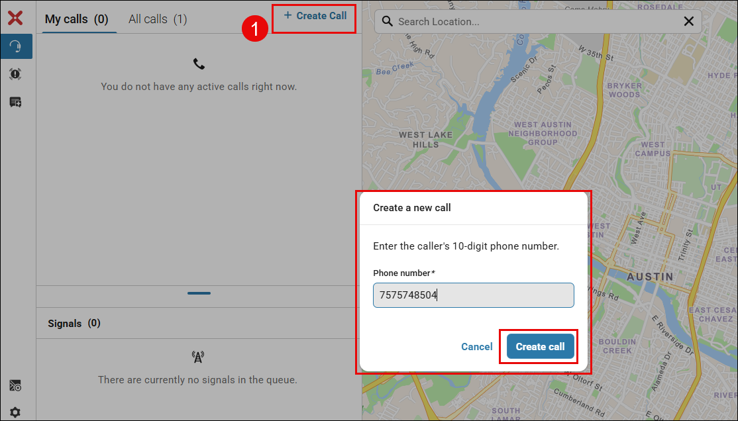

Map Search
At any time, a telecommunicator can manually search for a 9-1-1 call address during an active call to obtain a more accurate address for the call. This is done by typing the address into the search function which is in the top left-hand side of the map and displays as a floating search box. The search function will only search in the pre-configured search radius specified by the customer.
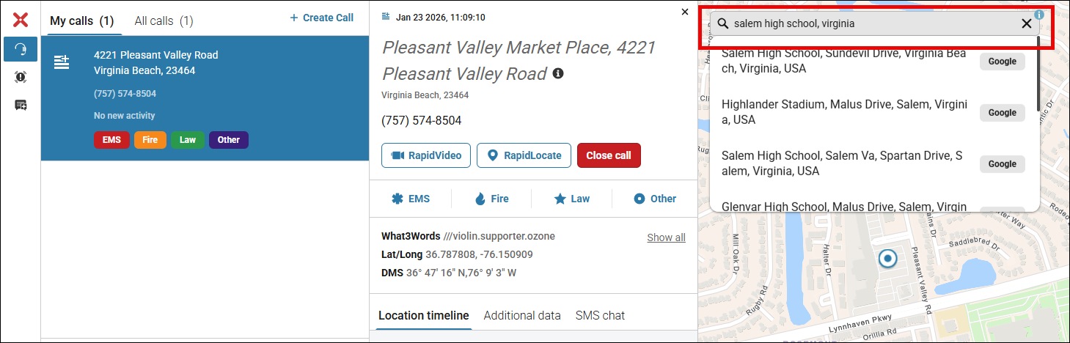

The telecommunicator will have the option to clear the search result or to attach the address to the call.
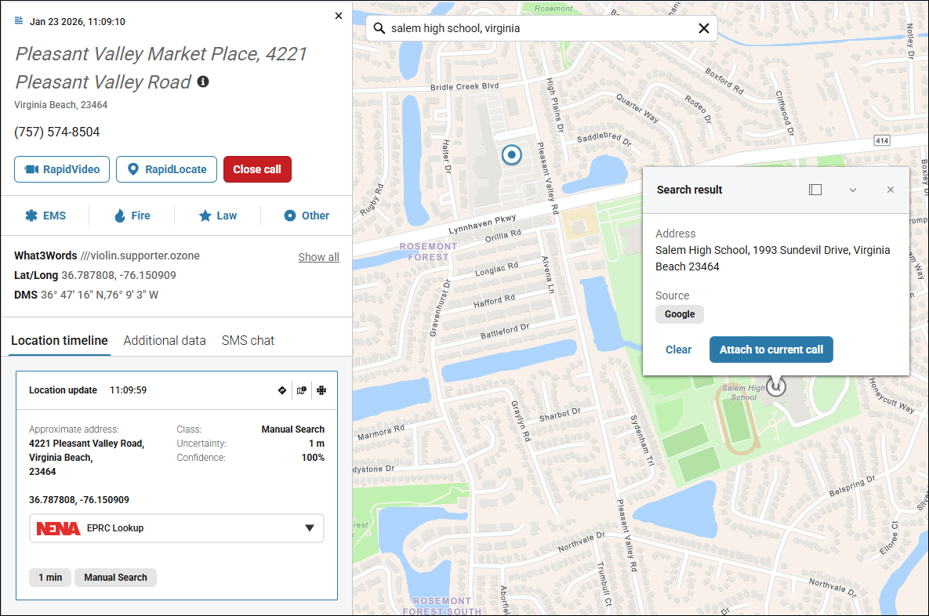

Authoritative GIS Services in Radius

Map Layers
AGENCY NAME has provisioned a set of authoritative map layers for use in Radius. These layers provide significantly more map data directly within Radius, which can aid in locating callers and in directing responders to incident locations in the most effective and efficient way possible. This can include address points, road centerlines, points of interest, response zones, etc. Available map layers can be viewed, enabled and disabled within the Esri tab when clicking on ‘Select map layers’ in the map controls.
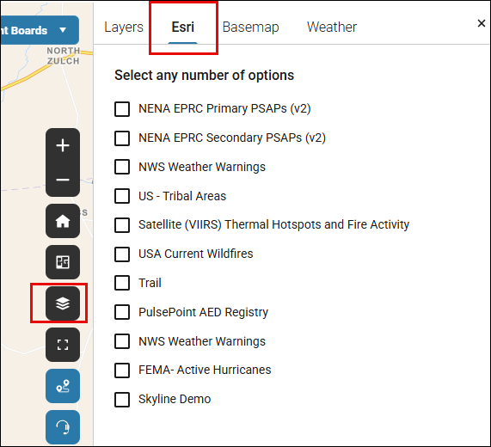
The following map layers are required to be enabled within Radius at all times:
- List of required map layers
The following map layers are available within Radius and can be used at the discretion of the telecommunicator, as needed:
- List of optional map layers
Note: For the NENA EPRC layer, PSAPS should contact NENA at 911eprc@nena.org to register and update their information, as needed, to ensure the data is correct and authoritative. This data and the corresponding map layers are not maintained or controlled by RapidDeploy.

Basemaps
AGENCY NAME has provisioned the following authoritative basemaps within Radius. These shall be used as the primary basemap within Radius unless a situation warrants changing to a different basemap. The appropriate basemap can be selected within the Basemap tab when clicking on ‘Select map layers’ in the map controls.
- List of authoritative basemaps, in order of priority

ECC Messaging
ECC Messaging in Radius enables real-time communication and collaboration among ECCs, allowing the sending and receiving of messages between ECCs to support seamless and secure inter-agency collaboration. A blue dot indicates a new message has been received from another ECC. Agencies electing to use ECC Messaging must add (configure) the ECC(s) they wish to message within Radius Admin. Telecommunicators must request and receive approval from <AGENCY CONTACT> before adding a new ECC to the list of available ECCs within ECC Messaging. Please refer to <AGENCY POLICY> for guidance on communicating with other ECCs.
Capturing or disclosing CJIS data or information within ECC Messaging is strictly prohibited.
When ECC messaging is enabled, Telecommunicators will see a speech-bubble icon on the left-hand navigation bar . ECC Messages are displayed on the right-side of the screen in a message panel. Action can then be taken to create a “New Message”, reply to a current message, or “Accept” and begin correspondence with another ECC.

ECC Messaging Workflow
- A new message is created, and the fields are populated: ECC(s) (multiple can be selected), subject, message, and service (multiple can be selected: Law, Fire, EMS or Other)). The message i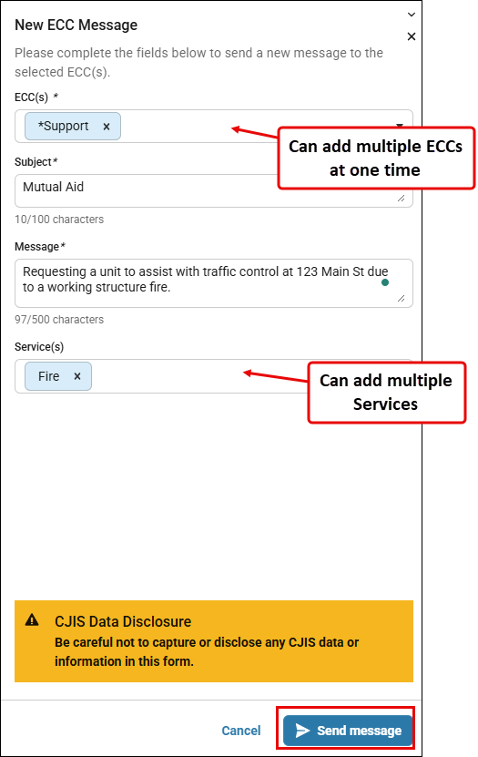s sent to the selected ECCs.

- The message is received in the ECC Messages pane. It must be accepted, and then a response can be sent.
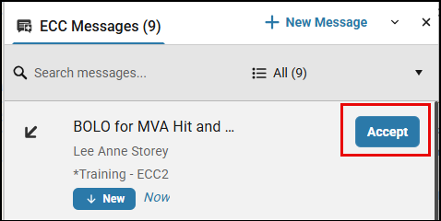
- Messages are captured with messages, Telecommunicator names and time stamps.
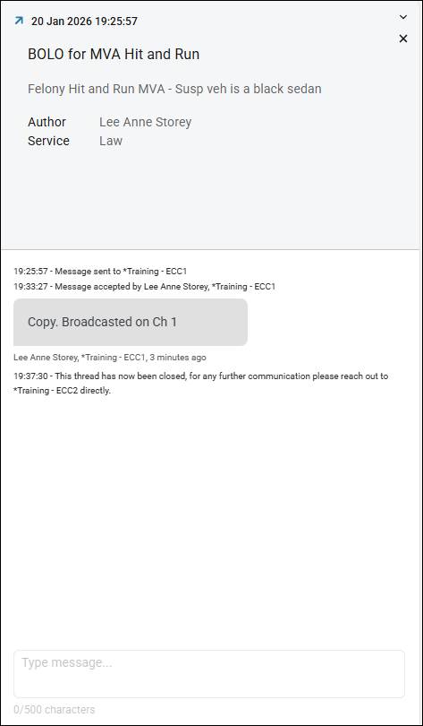
- ECC Messages should be archived when no longer active/needed. Any Telecommunicator at the originating ECC can archive a message. The message is displayed in the ECC Messages pane for 12 hours before it is removed from the list. During the 12-hour time span, a message can be read but not reopened.
Note: Archived messages are automatically deleted from ECC Messaging after 12 hours. However, RapidDeploy retains archived messages indefinitely to facilitate supervisors in downloading historical ECC Messages, including archived ones. In addition, ECC Messaging transcripts can be downloaded via the Data Download feature – see additional details on this feature in the Data Download section below.

Discrepancy Reporting
Discrepancy Reporting functionality in Radius offers a means for telecommunicators to submit discrepancy reports. This feature allows a PSAP to take control of managing Call and map-related issues and avoid issues from staying unreported and undiscovered. The telecommunicator can report:
Call Errors | Map Errors
- Call misroutes | - Missing address points
- No record found | - Missing roads
- Incorrect ALI | - Incorrectly labeled map features
 | - Jurisdictional boundary errors
AGENCY NAME has configured a set of administrator users that will receive these reports and action them accordingly. Telecommunicators shall submit map and Call discrepancy reports in any instance where a discrepancy is identified.

Map Discrepancy
Map Discrepancy reporting is accessed by hovering over the Support icon on the Navigation Bar and selecting ‘Report map discrepancy’. It can also be accessed via the Location Timeline, by clicking the Map Discrepancy icon for a specific timeline card.
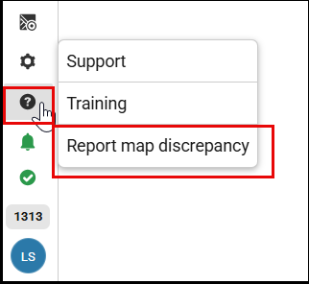 | 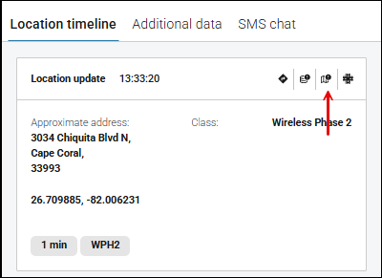

Call Discrepancy
Call Discrepancy reporting is accessed via the Location Timeline, by clicking the Call Discrepancy icon for a specific timeline card that contains Call data (if there is no Call data associated with the Location timeline card, the Report Call discrepancy button will not display).
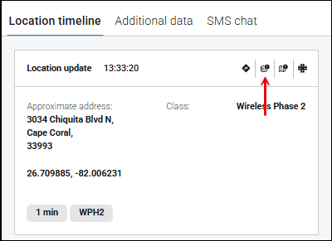

Additional Data Sources in Radius

Vehicle Telematics – Crash Data
Radius is directly integrated with OnStar and Bosch OEM crash notification services, which automatically appear in Radius as Signals and plot on the map as Signal Pins (Vehicle icon). Vehicle Telematics Signals are an indication of a request for emergency assistance due to a car crash event. Vehicle Telematics Signals appear on the map before a 911 call is received and display the vehicle data associated with the car crash event.
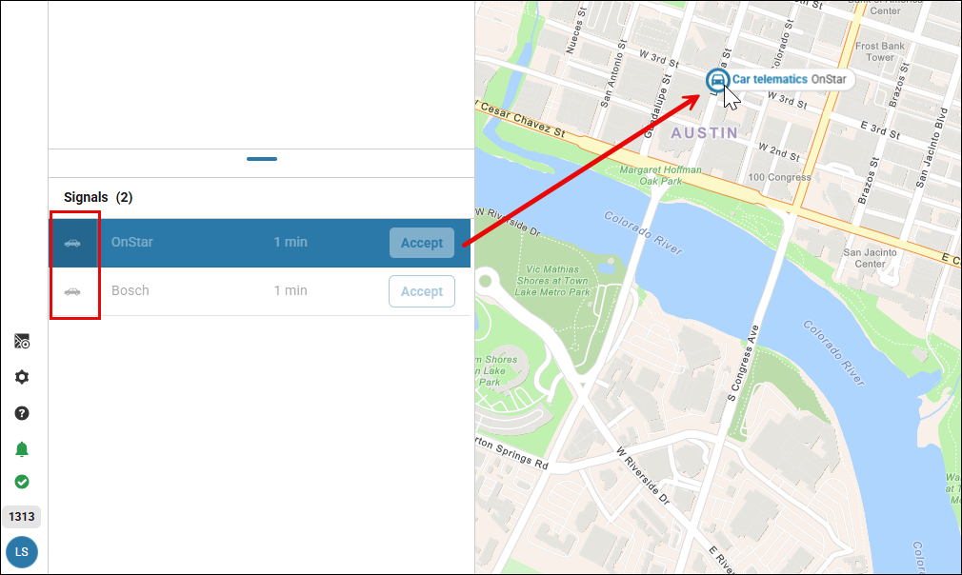

Handling Vehicle Telematics Signals
Once the 911 voice call is received in the ECC/PSAP, which comes from the provider call center, the Signal will automatically be associated to the active Call in Radius. Once the Signal has been correlated to the 911 call, the vehicle crash data (additional information) will show under the ‘Additional data’ tab for that active call. If the Signal has not yet been correlated to a 911 call, you can request additional information via the map pin.

- Click on the Vehicle Telematics Signal in the Queue component to zoom and center on the Signal pin on the Radius map.
- Click on the Vehicle Telematics Signal pin to view the full Signal pop-up with information related to the Signal.
- Click on ‘Show additional information’ to get additional crash event information.
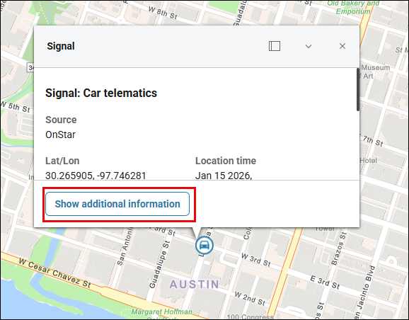
Telecommunicators shall access and review the additional data provided with a Vehicle Telematics Signal or Call, whenever available. When additional data is available, it should be relayed to dispatch by ADD AGENCY WORKFLOW.
Important workflow notes:
For Vehicle Telematics Signals:
- The Signal cannot be manually converted to a call since this Signal comes from the call center.
For Vehicle Telematics Calls:
- The Radius telecommunicator cannot use SMS Chat as the call originates from the call center. The SMS Chat tab will be disabled.
- The Radius telecommunicator will not be able to use RapidLocate as the call originates from the call center and not a mobile phone. The RapidLocate button will be disabled.
- The Additional Data tab automatically opens in the Call Details drawer for the telecommunicator to instantly view the high-priority vehicle telematics additional data.
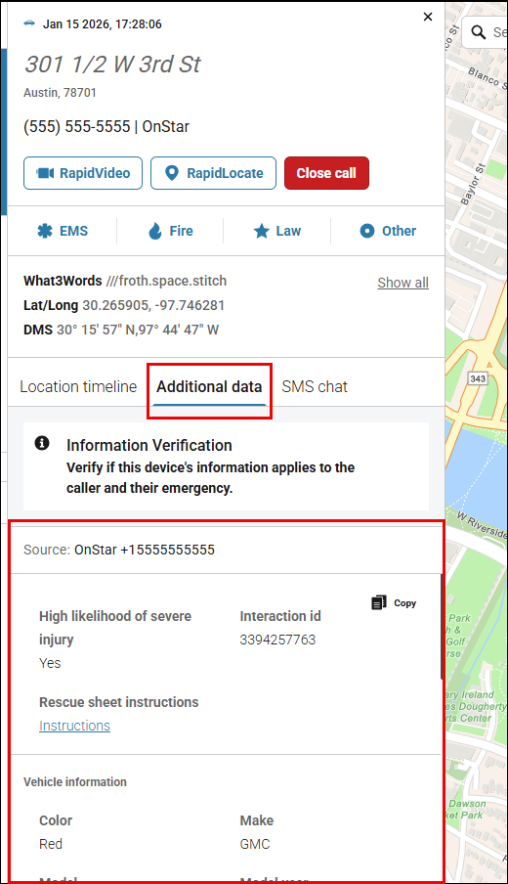

Rave Smart911
RAVE Mobile Safety allows people to create a Safety Profile (Smart911) for their household that includes any information they want 911 and response teams to have in case of an emergency. When a person makes an emergency call, their Safety Profile is made available to the telecommunicator in Radius. Responders can be made aware of many details relevant to the response effort, examples include:
- Fire crews can arrive at a house fire knowing how many people live in the home and the location of the bedrooms
- EMS can be advised of allergies or specific medical conditions, and
- Police can have the photo of a missing child in seconds rather than minutes or hours.
When a caller's number or location is associated with either one of the following RAVE Mobile Safety profiles,
- Smart911 Profile
- Facility Profile
the ‘View in RAVE’ button appears on the ‘Additional data’ tab for the active call in Radius. When clicked, the caller’s RAVE profile will open in a new browser tab to access the additional RAVE data.
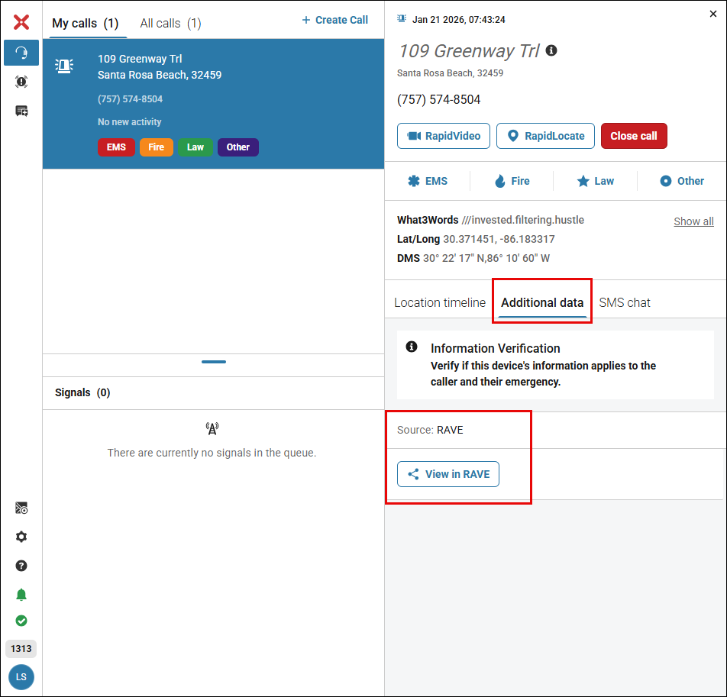
Note: There is no notification indicating to the Telecommunicator when there is additional RAVE data available for the call. The Telecommunicator must navigate to the ‘Additional data’ tab on the Call Detail drawer to see if the ‘View in RAVE’ button is available.
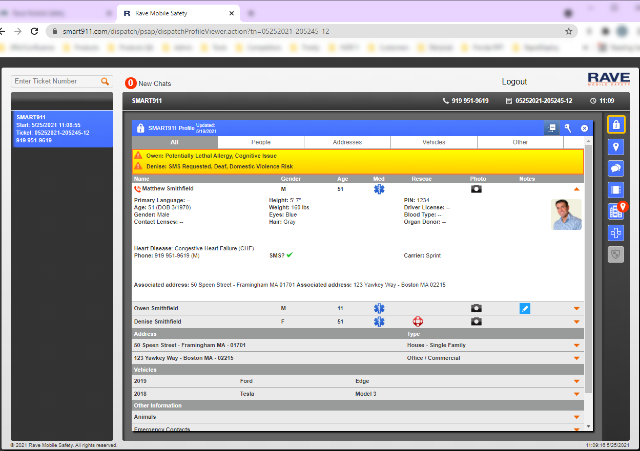

Panic Button Integrations
RapidDeploy provides the ability for an authorized panic button provider to transmit emergency panic button data via the Common Alerting Protocol (CAP) to Radius users. Panic Button Signals can be configured to transmit to the PSAP with or without a traditional 9-1-1 voice call.

The table below outlines the available Panic Button origination types and associated descriptions as well as recommended Radius workflow for each. Each agency will select the appropriate scenario(s) referenced in the table below as it applies to the services provided by the in-scope Panic Button vendor(s) and shall adjust their operating procedures/workflows to meet their specific operational environment. If certain scenarios are not applicable, those should be removed from the table.

Audible Notifications: For Panic Button events, an audible notification must be configured with a distinct audible tone and at a volume suitable to be heard within the PSAP environment.

Origination Type | Description & Workflow
Panic Button with 9-1-1 Call | Panic Button with 9-1-1 Call from a mobile device. This is most frequently seen as a Mobile App that users have on their phone. There are typically multiple pre-configured scenarios that can trigger workflows within the facility or that launch a 9-1-1 call from the device.  Radius Workflow:  - An Alarm icon will appear in the Signals Queue, indicating that a Panic Button activation has been received in Radius.  - Click on the Signal to zoom in on the corresponding Signal Pin on the map and view associated data, including location.  - To convert a Panic Button Signal into a call, the Radius user can take one of two actions:  - Click on ‘Accept’ next to the Panic Button in the Signals Queue  - Click on ‘Convert to Call’ on the Signal Pin pop-up  - Once the 9-1-1 call is received, the Signal will automatically associate to the Call under ‘My Calls’ based on the position number that receives the call.  - The Panic Button data will show under the ‘Additional data’ tab for that active call  - The standard Radius feature set is available for use
Human Triaged Panic Events | Emergency events such as camera detection or physical panic buttons that route signals to a monitoring center that triages the event and determines if emergency services are required. If the Panic Vendor’s monitoring center deems the alert to be an event that requires emergency response, they will transmit a panic signal separately from the call to 911; the signal and 911 call will not be associated and will be seen as two separate events in the Radius call/signals queue.  Radius Workflow:  - Monitoring center receives an alert of a possible event  - Monitoring center determines type and severity of event and sends alert to Radius  - An Alarm icon will appear in the Signals Queue, indicating that a Panic Button activation has been received in Radius.  - Click on the Signal to zoom in on the corresponding Signal Pin on the map and view associated data, including location.  - To convert a Panic Button Signal into a call, the Radius user can take one of two actions:  - Click on ‘Accept’ next to the Panic Button in the Signals Queue  - Click on ‘Convert to Call’ on the Signal Pin pop-up  - Once converted to a call, the Telecommunicator can view the location information as well as the additional data information by clicking on the Additional Data tab in the Call Details Drawer  - Once converted to a call, the standard Radius feature set is available for use
Panic Button without 9-1-1 Call | Panic buttons that may be worn by a user, physically mounted within facilities, configured withing computers or tablets used within a facility can all trigger a panic event but a 9-1-1 call is not placed from the user at that time to 9-1-1. A panic signal will transmit from Panic Button vendor to Radius as soon as the trigger is activated by the Panic Button user. (Note: In some cases, an operations center or facility administrator may be set up to review the trigger signal to determine if it should be transmitted to the PSAP. If this applies to your agency, please add those workflow details below)  Radius Workflow:  - An Alarm icon will appear in the Signals Queue, indicating that a Panic Button activation has been received in Radius.  - Click on the Signal to zoom in on the corresponding Signal Pin on the map and view associated data, including location.  - To convert a Panic Button Signal into a call, the Radius user can take one of two actions:  - Click on ‘Accept’ next to the Panic Button in the Signals Queue  - Click on ‘Convert to Call’ on the Signal Pin pop-up  - Once converted to a call, the Telecommunicator can view the location information as well as the additional data information by clicking on the Additional Data tab in the Call Details Drawer  - Once converted to a call, the standard Radius feature set is available for use

Audible Notifications in Radius
Audible notifications are real-time notifications in Radius Mapping allowing Telecommunicators and Supervisors increased awareness of critical events. A sound will play through the computer’s speakers to alert the Radius user of the event to help them stay informed even when they are not looking at the screen. Radius Administrators can enable and customize audible notifications, including the tone and volume for individual event types. Audible notifications are available for the following events:
- Call Taking:
  - Location updates
  - Additional Data Updates
  - Two-Way SMS Chat New Message Received
  - ECC Messaging:
    - New Message Received
    - Reply to Message Received
- Signals:
  - Panic Buttons
  - Apple
  - Google
  - Vehicle Telematics crash events
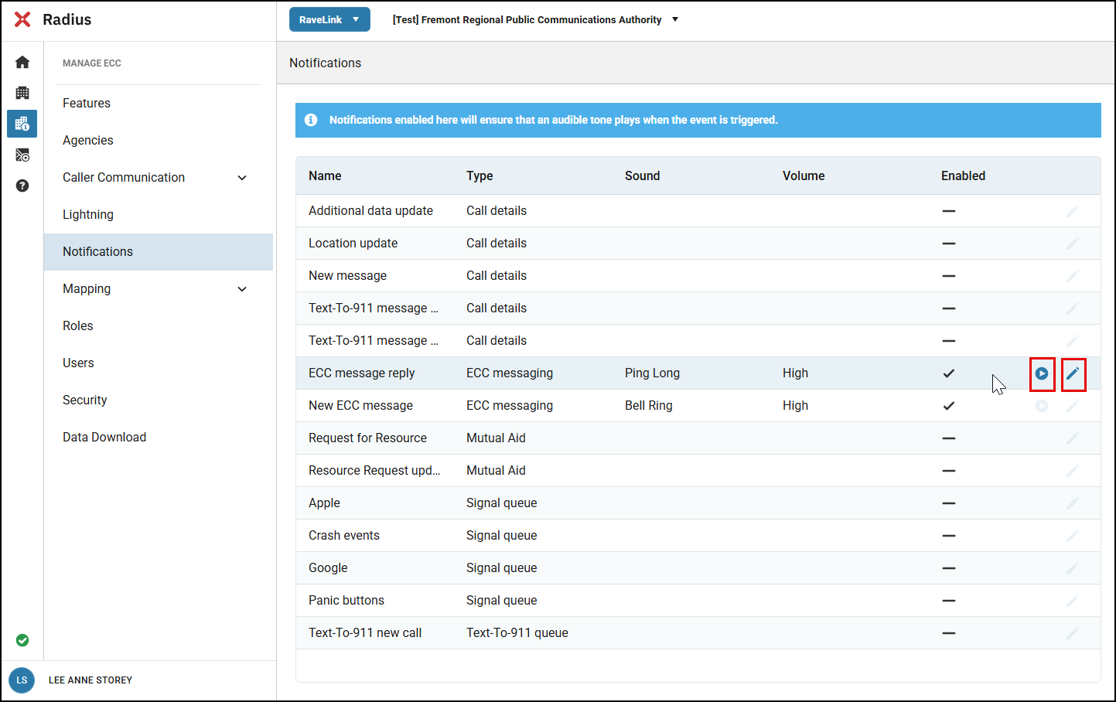
For any event in Radius that is deemed “critical”, e.g. Panic Button events, an audible notification must be configured with a distinct audible tone and at a volume suitable to be heard within the PSAP environment.

Data Download
The Data Download feature in Radius allows ECC Administrators to manage and download critical data such as ECC Messaging transcripts and RapidVideo sessions directly from Radius Admin to a local computer download folder.
When the Data Download feature is used, the user accepts all responsibility for the data, including protecting it and handling it within ECC regulations and protocol. Refer to <Agency Policy> for guidance on proper handling of sensitive data.
Data Downloads can be performed only in Radius Admin by users who have been given the “Manage Data Downloads” permission. Once the permission is assigned, a “Data Download” menu option will appear in the Radius Admin menu.
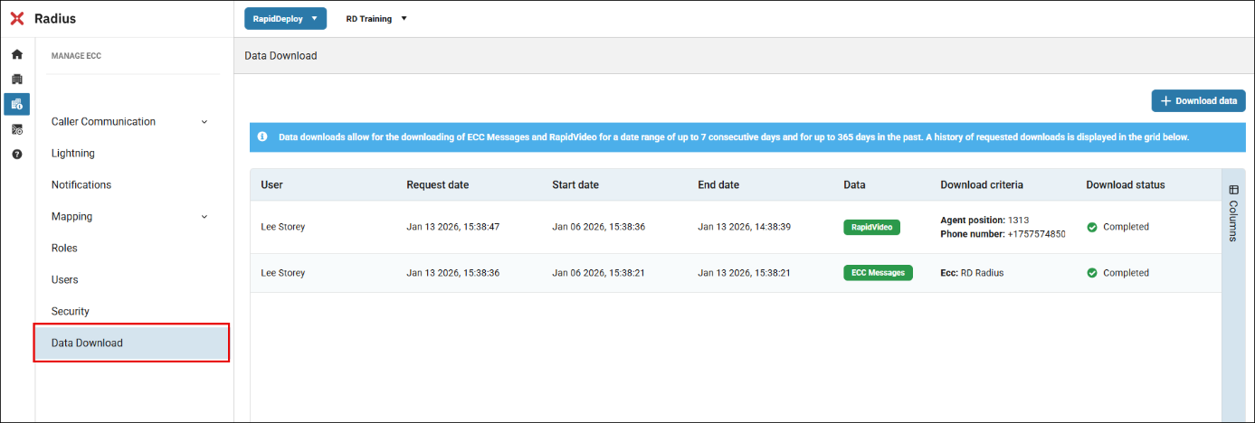
The Data Download Grid will display when Data Download is selected from the ‘Manage ECC’ pane. The grid will show a list of activity of past user downloads.
- User: Displays the user's credentials
- Request Date: Shows the date and time when the download was requested
- Start Date: Indicates the start date of the selected date range
- End Date: Displays the end date of the selected date range
- Data: Specifies the type of data downloaded, (i.e., ECC Messages or RapidVideo)
- Download Criteria: Identifies the criteria used for downloading the data
- Download Status: Indicates whether the download was successful or failed
  - Downloading – Data is currently being downloaded
  - Canceled – The user has canceled the download
  - Failed – The download failed, possibly due to size or system limits
  - Completed – The data download was successful
  - Download again – This button appears if the download does not start within 10 seconds; click on it to restart the download

What Can Be Downloaded
Administrators can download the following:
- ECC Messages – by selecting the ECC for which a conversation exists from the alphabetical list
- RapidVideo – by selecting the agent position and/or entering the phone number

A date and time range must be defined; by default, the date and time will be set to 7 days in the past.

Note: Users cannot choose a date range exceeding 7 days, and the system limits the selection to the past 365 days.

If the data is downloaded successfully, a zip file will be downloaded on the local computer of the requester. ECC Messages will be downloaded in a PDF format. RapidVideo will be downloaded as an MP4 file.
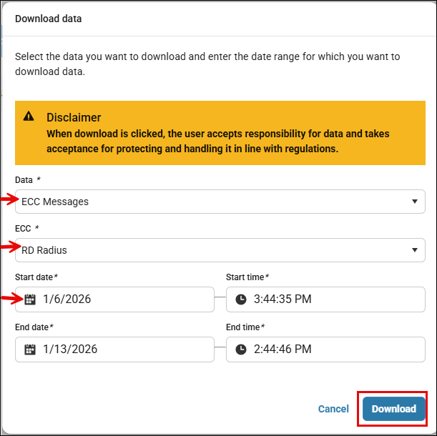

Critical Incident Boards (CIBs)
Radius Critical Incident Boards (CIB) provide a centralized visual of media streams from CCTV cameras and RapidVideo to facilitate streamlined decision-making, rapid responses, and improved coordination during critical situations or planned events (e.g., festivals, sporting events, protests, etc.). A CIB displays real-time, live media streams automatically with a pre-defined geofence area.
CIBs are visible to any Telecommunicator for which the ‘ViewCriticalIncidentBoards’ permission is assigned. The following individuals may create CIBs in Radius:
- <ADD USER TYPES> (e.g. Supervisor)
Whenever a CIB is created, the user creating the CIB must provide notification to on-shift telecommunicators that a new CIB has been activated for use.
At shift change, the Supervisor must provide briefing to the Supervisor coming on shift related to any active CIBs in Radius.
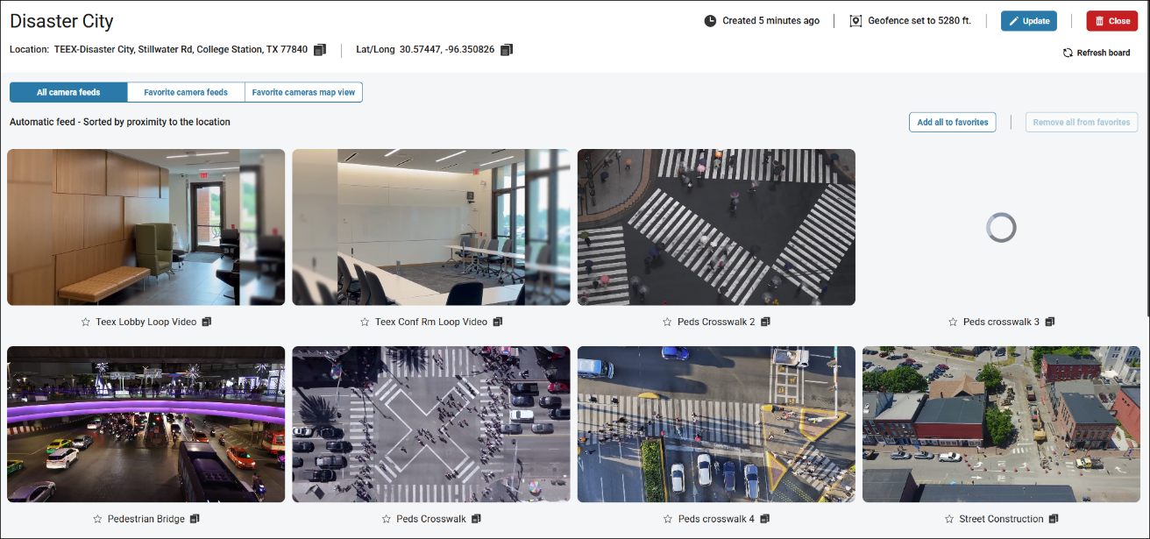
Note: RapidVideo within a CIB will have the same capabilities as configured by the ECC for Radius general use, such as Blurring. If the caller stops streaming their video, the feed will freeze until the Telecommunicator ends the session which will remove it from the CIB.
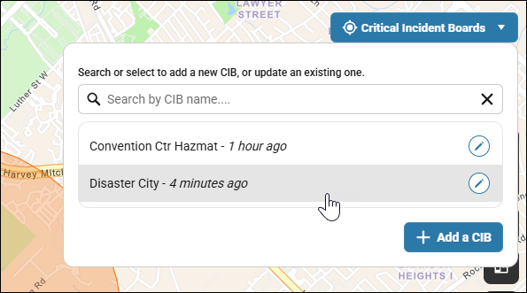
CIBs are created as a geofence on the map. A Map Layer must be selected to see the geofence displayed on the Radius Map for the coverage area. Without enabling the layer, a Critical Incident Board map pin will indicate the location, but not show the geofenced area of CIB coverage.
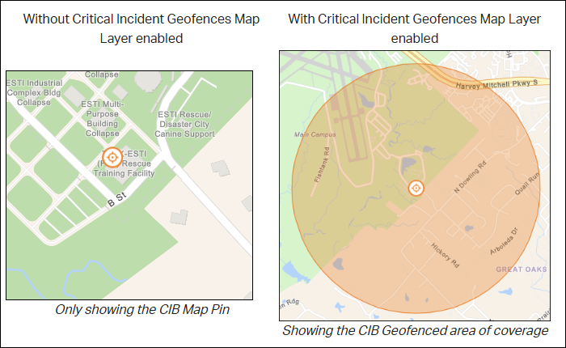

Map Markups
A Telecommunicator can create map markups within the Radius Map to indicate the locations/areas of temporary events or circumstances. This feature allows the Telecommunicator to create:
- Circles
- Lines
- Areas (Polygons)
- Points

When creating a markup on the map, the Telecommunicator can add the following details:
- A name to display on a label.
- The map markup category.
- Additional information such as coordinates, or area size, is auto populated and captured as the map markup's parameters.
- Set an expiration date - once reached, the markup will automatically disappear from the layer.
All Radius users within the ECC/PSAP have instant access to the Map Markups feature and the map layer, driving increased situational awareness.
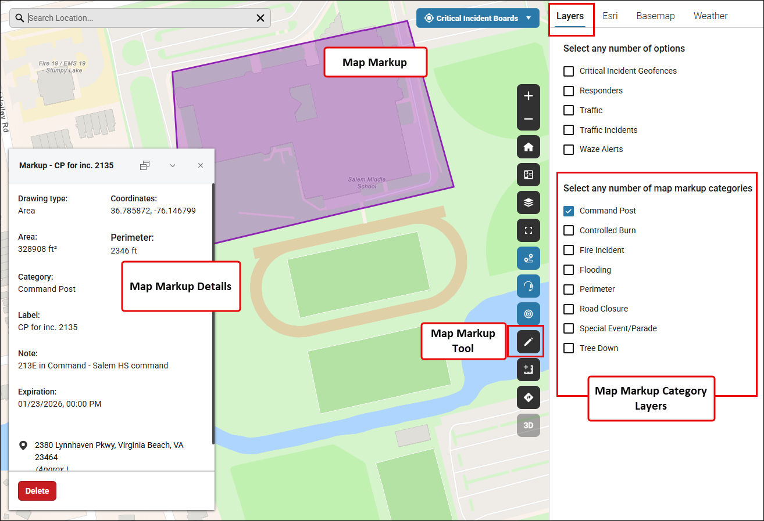
- The Radius map displays these temporary map markings when the user selects the Map Markups map layer and the markup categories.
- Map Markup Categories are created by ECC Administrators within Radius Admin, which are then available for selection when creating new markups.

Indoor Floor Plans (Floor Filter)
Radius Mapping allows users with an indoor floor plan partnership(s) to view the indoor floor plans of buildings on the Radius map, improving response accuracy, efficiency, and communication between the Telecommunicator, their 9-1-1 callers, and field responders.
If a floor plan is available for use within the users map extent, the Floor Filter button (on the map toolbar) will blink with a blue outline. Clicking the button will list all the buildings in the map view extent that have a floor plan available.
Clicking on a building will expand the drop-down and display the floor list, allowing for easy switching between available floors within the selected building. On the map, the first floor will automatically be displayed on the map.
- Zoom in on the floor plan to display the details (entrances, exits, store names, offices, etc.). Note: Floor plan markings and specifications may vary based on the floor plan provider/vendor.
- Call and Signal location pins will be visible and displayed on top of the floor plan.
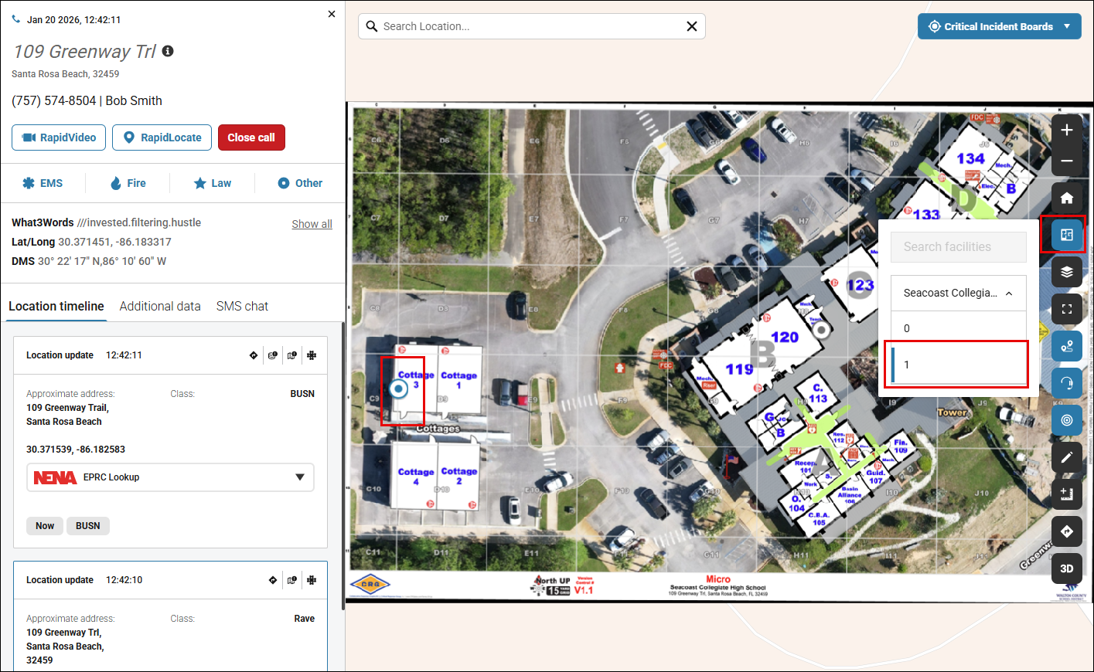

Contacting Support
AT&T Resolution Center as Tier 1 Support:
All support requests should be directed to the AT&T Resolution Center at 866-722-3911. Any questions or issues related to Radius will be passed to the RapidDeploy Support Team, as required. The AT&T Resolution Center operates 24/7/365.
Global Blue as Tier 1 Support (California Only):
All support requests should be directed to the Global Blue support team:
- Via email at RDSupport@gbdvbe.com
- Via Phone at 866-200-3292
The Global Blue support team operates 24/7/365.
RapidDeploy Support as Tier 1 Support:
RapidDeploy Support can be reached via the following methods. RapidDeploy Support operates 24/7/365.
- Via Email at Support@RapidDeploy.com
- Via Phone at 512-488-6420
- Directly within Radius by hovering over the Question Mark icon in the Navigation Bar, clicking Support, and selecting ‘Submit a request’ from the top menu of the RapidDeploy Help Center.
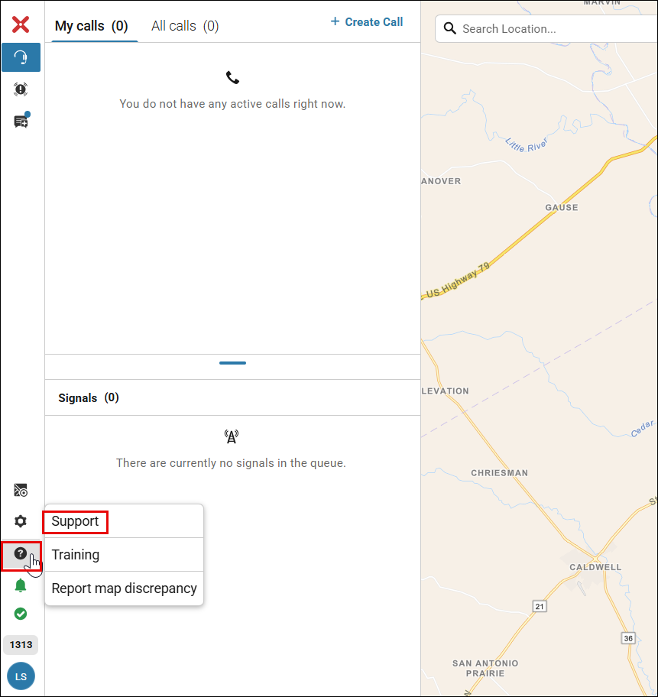
The RapidDeploy Help Center can also be accessed via the ‘Support’ link in Radius, which contains an on-demand knowledge base of reference materials, instructional guides, and training documents for Radius Mapping. The Help Center also contains the latest Release Notes, where customers can read about product updates, new features, enhancements, and bug fixes.
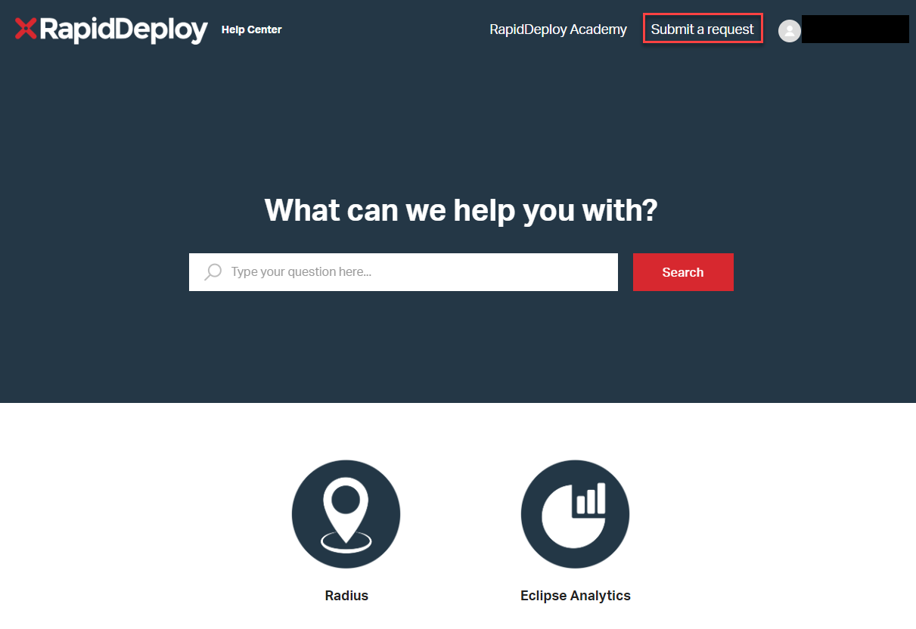
The RapidDeploy Academy can be accessed directly from Radius via the ‘Training’ link, which contains on-demand knowledge-based videos of training guides for Radius. The RapidDeploy Academy allows training to be completed directly from the Telecommunicator’s console.
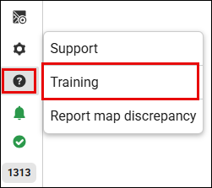
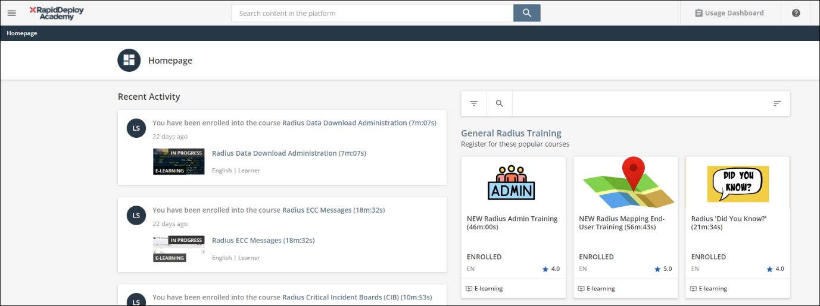

Appendix A – Pre-configured Message List for PSAPs
Radius provides a pre-configured messages capability for use with SMS Chat by selecting the Pre-configured Message Icon to the left side of the “Type message…” input box.
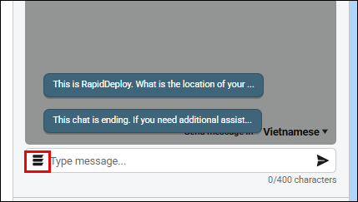

First Canned Questions
This is AGENCY NAME. Do you have an emergency?
What is the address of your emergency?
What City?
What is your Emergency?
What is your Phone Number?
What is your Name?
What is happening now?
Instructional Canned statements
If you have an emergency, text or call 911
Please use full, simple words
Do not use abbreviations
Please do not text and drive. Pull over before sending text messages.
If it’s safe to do so, wait outside for First Responders
Please wait. You are being transferred
Help is on the way, but I need to gather some information from you to relay to the responders.
Please call our non-emergency number to report this non-emergency (XXX)XXX-XXXX
Secure or put away your animals
Unlock the door
Turn the outside light on
This chat session is ending. If you need further assistance, please dial 9-1-1 again, as any further text messages will not be received.
Subsequent Canned Questions
Are you driving?
Are you traveling on foot?
Are you on public transportation?
Are you in a vehicle?
Location of the suspect?
Are there any weapons?
Is anyone hurt?
What does the person look like?
What are they wearing?
What is the nature of the injuries?
Is the person breathing?
Is the person awake?
How old is the person?
What kind of house?
Where is the fire?
What floor is on fire?
Are there any people inside?
Do you need the police?
Do you need Fire Trucks?
Do you need an Ambulance?
Do you have any further information or need additional help?
An ambulance will be/has been dispatched.
A fire/rescue crew will be dispatched.
Law enforcement will be dispatched.

