**ANGELA FERRANTES ICE CREAM MENU**

| SINGLE 99’ FLAKE | **£4.50** |
| --- | --- |
| DOUBLE 99’ FLAKE | **£6** |
| TUB WITH FLAKE | **£5** |
| OYSTER, SCREWBALLS | **£6** |
| OYSTER, SCREWBALLS WITH FLAKE | **£5.50** |
| WAFFLE CONE WITH FLAKE | **£5.50** |
| SPECIAL WAFFLE CONE WITH FLAKE  CHOCOLATE, SALTED CARAMEL OR CHOCOLATE SPRINKLE RAINBOW | **£6** |
| NOUGAT WAFER | **£6.50** |
| CALIPPO ORANGE OR COLA | **£4** |
| MAGNUM (VEGAN) | **£4.50** |
| TWISTER | **£4** |
| OREO SANDWICH | **£4.50** |
| FEAST | **£4** |
| SMALL SLUSH PUPPY | **£3.50** |
| LARGE SLUSH PUPPY | **£5** |
| WATER | **£3** |
| SOFT DRINKS | **£3.50** |

**ALLERGEN STATEMENT**

**Our ice cream is processed on equipment that manufacturer products containing wheat, peanuts, tree nuts (almonds, cashews, pecans, brazil nuts), and soy. Please let us know if you have an allergy before ordering.**

**GREEK TRADITIONAL SOUVLAKI MENU**

All dietary options

All chargrilled

All freshmade

| **CHICKEN SOUVLAKI**  CHICKEN SKEWER WITH TOMATOES, ONIONS, ICEBERG LETTUCE, HOMEMADE TZATZIKI SAUCE WRAPPED IN 95% PITTA. ADD HALLOUMI OR CHARGRILLED VEGGIES FOR **£2** | **ASK FOR PRICE**  Small / regular / giant |
| --- | --- |
| **LAMB SOUVLAKI**  LAMB SKEWER WITH TOMATOES, ONIONS, ICEBERG LETTUCE, HOMEMADE TZATZIKI SAUCE WRAPPED IN 95% CORN PITTA BREAD. ADD HALLOUMI OR CHARGRILLED VEGGIES FOR **£2** | **ASK FOR PRICE**  Small / regular / giant |
| **PORK SAUSAGE SOUVLAKI**  PORK SAUSAGES WITH GRUYERE CHEESE WITH TOMATOES, ONIONS, ICEBERG LETTUCE, HOMEMADE TZATZIKI SAUCE WRAPPED IN 95% CORN PITTA BREAD. ADD HALLOUMI OR CHARGRILLED VEGGIES FOR **£2** | **ASK FOR PRICE**  Small / regular / giant |
| **VEGETARIAN SOUVLAKI**  CHARGRILLED HALLOUMI CHEESE, CHARGRILLED VEGETABLES (COURGETTE, PEPPERS, AUBERGINES) WITH TOMATOES, ONIONS, ICEBERG LETTUCE, HOMEMADE TZATZIKI SAUCE WRAPPED IN 95% CORN PITTA BREAD. | **ASK FOR PRICE**  Small / regular / giant |
| **VEGAN SOUVLAKI**  FALAFEL, CHARGRILLED VEGETABLES (COURGETTE, PEPPERS, AUBERGINES) WITH TOMATOES, ONIONS, ICEBERG LETTUCE WRAPPED IN 95% CORN PITTA BREAD. SAUCES: SWEET CHILLI OR HOT CHILLI OR KETCHUP. | **ASK FOR PRICE**  Small / regular / giant |
| **DOUBLE MIXED SOUVLAKI**  MIX 2 SKEWERS OF YOUR CHOICE WITH TOMATOES, ONIONS, ICEBERG LETTUCE WRAPPED IN 95% CORN PITTA BREAD. CHOOSE FROM: CHICKEN, LAMB, PORK SAUSAGE, HALLOUMI, FALAFEL, CHARGRILLED VEGETABLES | **ASK FOR PRICE** |
| **THE GIANT MIXED SOUVLAKI**  MIX 3 SKEWERS OF YOUR CHOICE WITH TOMATOES, ONIONS, ICEBERG LETTUCE WRAPPED IN 95% CORN PITTA BREAD. CHOOSE FROM: CHICKEN, LAMB, PORK SAUSAGE, HALLOUMI, FALAFEL, CHARGRILLED VEGETABLES | **ASK FOR PRICE** |
| **GREEK BOX/ALL IN A BOX**  A BOX WITH ICEBERG LETTUCE SALAD, TOMATOES, ONIONS, CHARGRILLED VEGETABLES, 1 CHARGRILLED 95% CORN PITTA BREAD AND SAUCE ON THE SIDE. CHOOSE FROM: MEAT BOX, CHARGRILLED HALLOUMI BOX, FALAFEL BOX | **ASK FOR PRICE** |
| SMALLER PORTIONS AVAILABLE! | **ASK FOR PRICE** |

**AQUA PIZZAS MENU**

| **MARGARITA**  TOMATO SAUCE, FIOR DI LATTE, PARMESAN, BASIL (v) | **£1O** |
| --- | --- |
| **SWEET & SPICY**  NDUJA PASTE, CHORIZO, SWEET PICANTE PEPPERS, HOT HONEY | **£11** |
| **CHESTNUT MUSHROOM**  BLUE CHEESE, PICKLED RED ONION, BLACK TRUFFLE OIL (V) | **£11** |
| **BBQ CHICKEN**  SMOKED SWEET BACON, SWEETCORN, PICKLED RED ONION | **£11** |
| **FOUR CHEESE**  FIOR DI LATTE, BLUE CHEESE, PARMESAN, GOATS CHEESE | **£11** |
| **DOUBLE PEPPERONI**  SWEET & SMOKEY, HOT HONEY | **£11** |

**FLYING FILLET MENU**

| **FILLET LOADED FRIES**  SEASONED FILLET STEAK, FRIES, CHIMICHURRI, ASIAN SLAW & CHIPOTLE MAYO | **ASK FOR PRICE** |
| --- | --- |
| **FILLET TACO**  ONE SEASONED FILLET STEAK TACO, CHIMICHURRI, ASIAN SLAW & CHIPOTLE MAYO SERVED WITH FRIES | **ASK FOR PRICE** |
| **VEGGIE LOADED FRIES**  SEASONED FRIES WITH OUR SIGNATURE FLYING FILLET HERBS & SPICES, CHIMICHURRI & ASIAN SLAW | **ASK FOR PRICE** |
| **FILLET & FRIES**  SEASONED FILLET STEAK & FRIES | **ASK FOR PRICE** |
| **HOT HONEY WINGS**  FIVE SEASONED DRY RUB WINGS, SERVED WITH OUR SIGNATURE HOT HONEY! | **ASK FOR PRICE** |

**JUST LOVE NIBBLES EVENTS CATERING BRISTOL MENU**

**JERK**

**BBQ**

**LEMON PEPPER**

**£6.00**

**£11.00 MEAL**

**JERK CARAMEL**

**CINNAMON SUGAR**

**CARAMEL**

**SWEET CHILLI**

**JERK CHICKEN £11.00**

**CURRIED GOAT £12.50**

**CHICKPEA & PLANTAIN CURRY £11.00**

**CHICKEN WINGS £11.00**

**SERVED WITH RICE N PEAS**

**FAB FOOD CO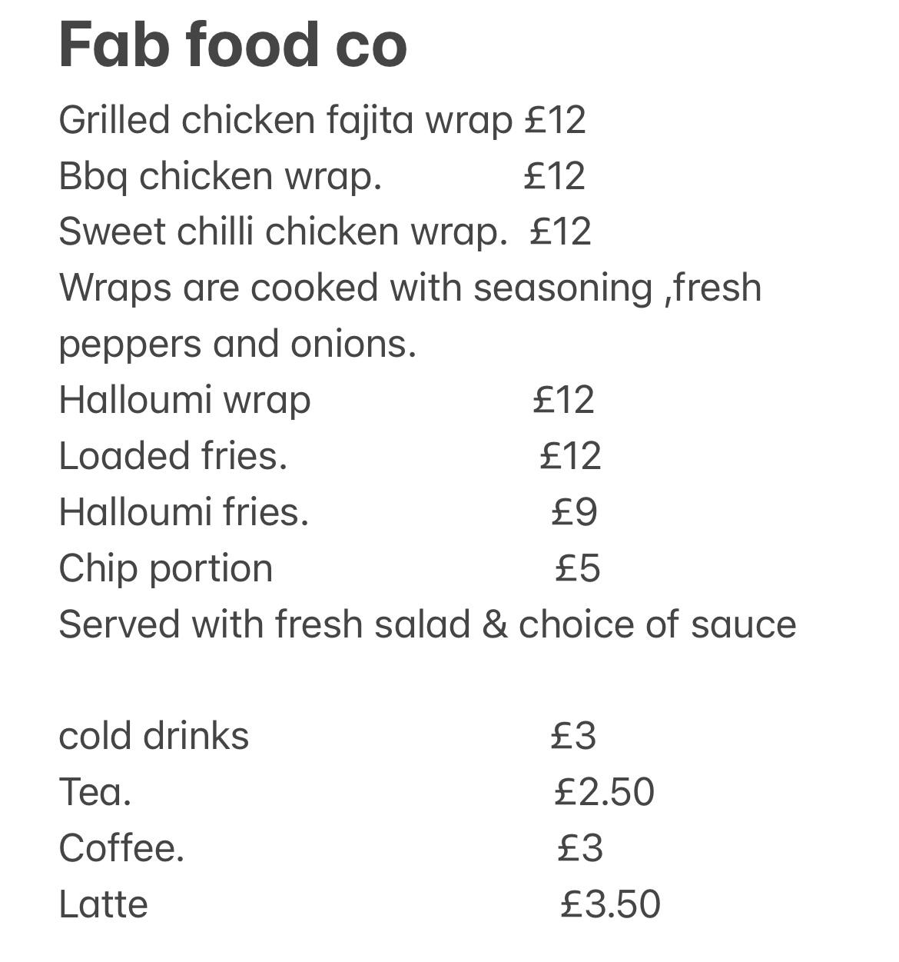~CARVERY~**

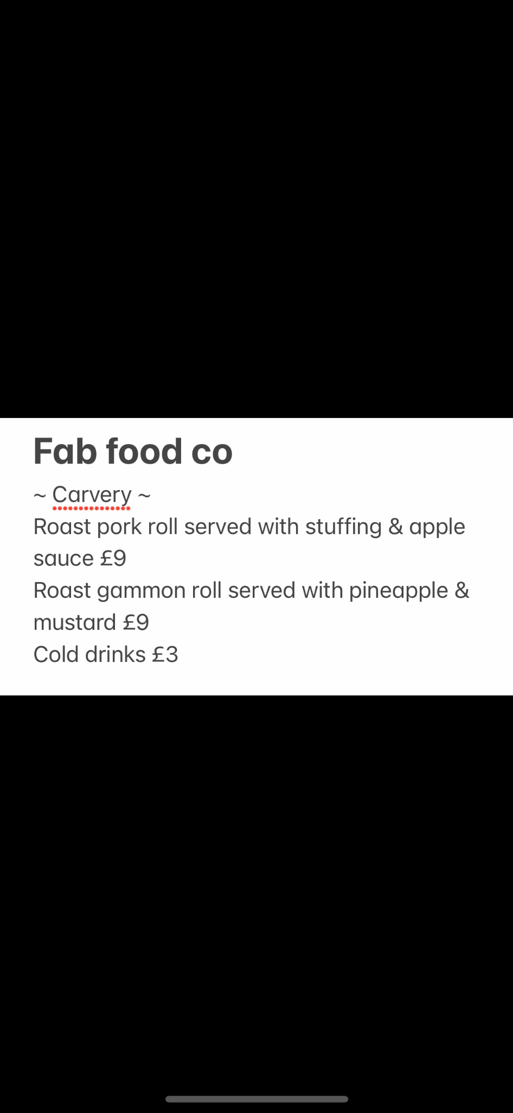

**FOOD ON THE MOVE - FISH AND CHIPS MENU**

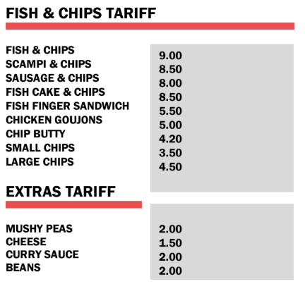

**FOOD ON THE MOVE**

Burger Tariff - **ASK FOR A PRICE**

“The Original”

6oz Beef burger, Caramelized

onion, lettuce, and tomato.

“Oink & mooo”

6oz Beef burger, streaky maple

flavoured bacon Caramelized

onion, lettuce, and tomato.

“EL DIABLO”

6oz Beef burger,

jalapenos, chilli con

carne Caramelized

onion, lettuce, and

tomato.

“HOLY CLUCK!”

SOUTHERN FRIED CHICKEN

BURGER, PIRI PIRI PULLED

CHICKEN, JALAPENOS, AND

MONTEREY JACK.

“THE BIG CHEESY”

DOUBLE MONTERY JACK

6OZ CHEESE BURGER,

MAPLE BACON, LETTUCE,

AND GHERKINS.

“this little piggy”

BBQ PULLED PORK,

BURGER.

PULLED CHICKEN BUN

PIRI PIRI PULLED CHICKEN

HOT DOG TARIFF - **ASK FOR A PRICE**

“LONG & MEATY”

FOOT LONG FRANKFURTER, CARAMELIZED ONIONS.

“Holy cluck! Dog”

foot long frankfurter, piri piri pulled chicken.

“Damn dirty dog”

Foot long frankfurter,

BBQ PULLED PORK.

“CHILLI WILLY dog”

foot long frankfurter,

chilli con carne,

jalapenos.

“the big cheesy dog”

foot long frankfurter,

melted nacho cheese.

SIDES TARIFF - **ASK FOR A PRICE**

French fries

potato wedges

onion rings

EXTRA COLESLAW

extra pulled pork

extra piri piri pulled

chicken

extra cheese

Extra mac & cheese

DRINKS Tariff **- ASK FOR A PRICE**

COca Cola

Diet Coke

Fanta

sprite

oasis summer fruits

oasis citrus punch

minerial water

fruit juices

tetley tea to go

americano

latte

Cadbury’s hot choc

**CATERICO MENU**

| **CHICKEN FAJITA WRAP**  CHICKEN, ONIONS, GARLIC, PAPRIKA, TOMATO & CHILLI SERVED IN A WRAP | **£1O** |
| --- | --- |
| **VEGETARIAN NOODLES**  ONION, PAPRIKA… WITH BAMBOO SHOOTS, SOYA SAUCE AND WHEAT NOODLES | **£9 / MIX BOX £11** |
| **BEEF AND BEAN ENCHILADAS**  BEEF MINCE, RED KIDNEY BEAN, TOMATO, PAPRIKA, CHILLI, GARLIC, POTATO WITH TORTILLA | **£10** |

**THE MAGIC MUSHROOM MENU**

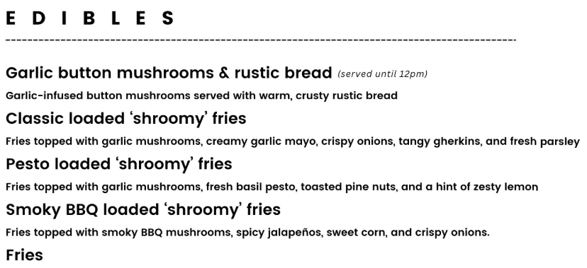

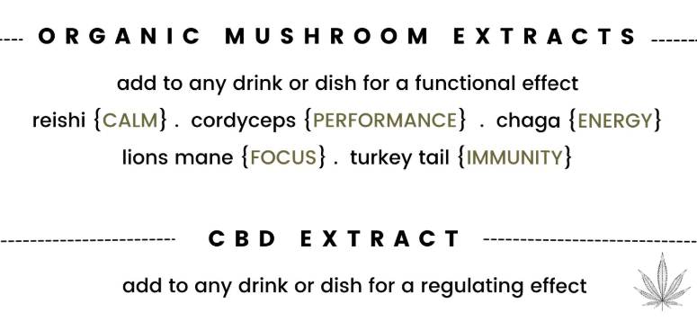

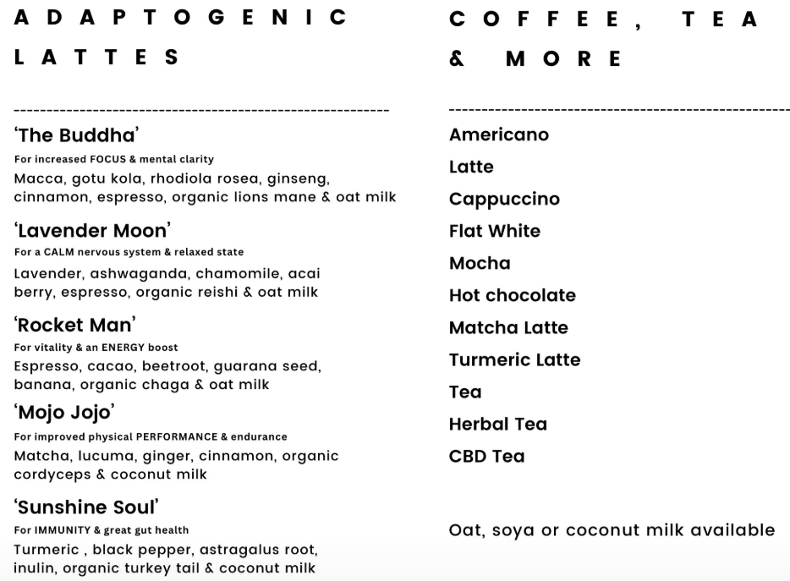

**MR DUMPLING MENU**

**CHRISPY CHICKEN OR VEGETARIAN DUMPLINGS**

| **7 DUMPLINGS** | **£1O** |
| --- | --- |
| **10 DUMPLINGS** | **£14** |
| **MR DUMPLING’S SPECIAL CHILLI SAUCE** | **£1** |

**TERIYAKI TAIWANESE BAO BUNS**

**CHOOSE FILLINGS FROM:**

**12-HOUR OAK SMOKE PULLED PORK / PULLED BEEF / PORK BELLY / CHICKEN KATSU**

| **SINGLE BAO BUN** | **£8** |
| --- | --- |
| **A PAIR OF BAO PUNS**  **(CAN BE A MIX AND MATCH OF FILLINGS)** | **£15** |

**ABABO’S CUISINE MENU**

**All main dishes are served with red cabbage and fluffy basmati rice.**

**Meat Options**

**Doro Wat**

A worldwide famous Ethiopian dish. Boneless chicken marinated with spiced butter, medium spice, (GF, H, DF, NF) **£12**

**Siga Alicha**

Finely cut beef and potato slowly cooked in spices simmered in garlic and caramelised onions, (GF, H, DF, NF) **£13**

**Gomen**

Beef and chopped collard greens slowly cooked in spices and caramelised onions, (GF, H, DF, NF) **£13.50**

**Vegetarian Options**

**Misir Wat**

Red lentil seasoned with Ethiopian spices and Berbere (GF, Ve, DF, NF) **£11**

**Kik Alicha**

Mild yellow split pea stew made with spices, simmered in a turmeric and ginger-based spice (GF, Ve, DF, NF) **£11**

**Tikil Gomen**

Thinly cut cabbage and carrots infused in turmeric and garlic with a pinch of ginger (GF, Ve, DF, NF) **£11**

**Extras:**

Vegetable Samosa - Spiced brown lentil with vegetables.

**Large £4,**

**small £2.5**

**Ethiopian Salata -** side salad, chopped tomatoes, with red onion, fresh green chili and spices **£2**

**Injera -** Fermented Ethiopian Flatbread, **£2 (serves 1)**

**Dessert:**

**Carrot Cake - £3.50/slice**

**Victoria Sponge - £3.50/slice**

**EMA CATERING - DONUTS AND CHURROS MENU**

**DONUTS - BAG OF 5**

| **Icing Sugar** | **£8** |
| --- | --- |
| **Premium Belgian Chocolate** | **£9** |

**CHURROS**

| **Icing Sugar** | **£8** |
| --- | --- |
| **Premium Belgian Chocolate** | **£9** |

**HOT DRINKS**

| **Filter Coffee** | **£3.5** |
| --- | --- |
| **Americano** | **£3.5** |
| **Cappuccino** | **£4** |
| **Latte** | **£4** |
| **Espresso** | **£3.5** |
| **Hot Chocolate** | **£4.5** |
| **Tea** | **£3** |

**For allergen information please contact a member of staff.**

**EMA CATERING - KEBABS AND BURGERS MENU**

**SHISH KEBAB**

**Tortilla Wrap/Box**

Premium Quality Meat marinated in a traditional homemade blend of spices and herbs and grilled to

perfection with fresh peppers and onions.

Served with a crispy fresh Mediterranean salad and topped with our signature Yogurt & Garlic sauce.

**Chicken Shish £9**

**Lamb Shish £10**

**Mixed Shish £12**

**DONER KEBAB**

**Tortilla Wrap/Box**

Authentic Turkish Doner prepared with a special home made mix of spices and herbs.

Served with our freshly made Mediterranean Salad, Gherkins, Fries and sauces of your choice.

**Chicken Doner £9**

**Lamb Doner £10**

**Mixed Doner £12**

**VEGETARIAN WRAPS**

**Tortilla Wrap/Box**

Traditional Middle Eastern Chickpea Falafel , soft and flavourful on the inside and perfectly

crispy on the outside served with our hand made tahini sauce on a bed of freshly made

Mediterranean Salad.

**Crispy Falafel £9**

**Grilled Halloumi £9**

**Mixed £12**

**SAUSAGES**

**DIRTY SAUSAGE £7**

Delicious Pork Sausage flame-grilled and smothered with onions.

**DIRTY SAUSAGE CHEESE £7**

Delicious Pork Sausage flame-grilled, topped with melted cheese and smothered with onions.

**BURGERS**

**The Almighty £7**

Made to order with two Beef Patties, crispy bacon,

Cheddar cheese and grilled onions on toasty, classic style buns.

**Cheese Burger £8**

Made to order with a medium grilled Beef Patty,

Cheddar Cheese, Tomatoes, Salad on toasty classic

style buns

**Chicken Burger £8**

Made to order with flame grilled herby chicken, Salad,

crispy onions and Peri Peri sauce toasty classic style

buns

**Veggie Burger £8**

Made to order with home made Veggie Patty, Salad,

grilled onions and BBQ Sauce on toasty classic style buns

**SIDES & TOPPINGS**

FRIES **£4**

CHEESY FRIES **£5**

CURRY FRIES **£5**

**Sweet Chilly Sauce**

**Garlic Mayo**

**BBQ**

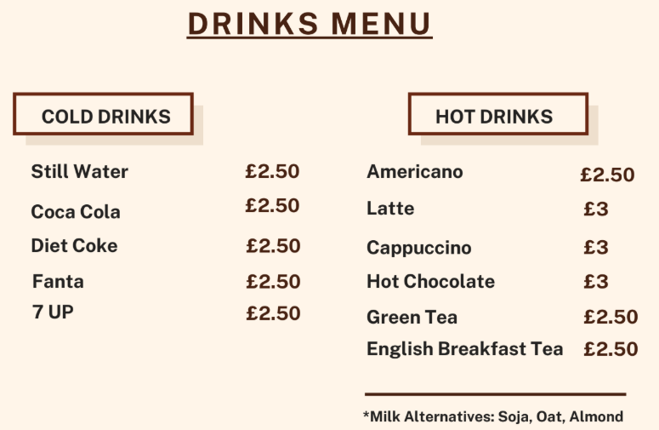

**FOR ALLERGEN INFORMATION PLEASE CONTACT A MEMBER OF STAFF.**