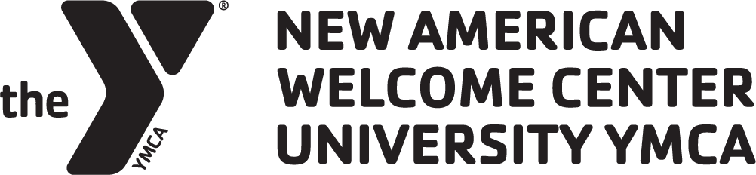

University YMCA
New American Welcome Center

POSITION TITLE: Community Worker
POSITION CLASSIFICATION: Part-Time, Non-Exempt
SUPERVISORY RELATIONSHIP. Immigrant Family Services Coordinator

UNIVERSITY YMCA & NEW AMERICAN WELCOME CENTER
The University YMCA, founded in 1873, develops campus and community leaders committed to social justice, environmental
protection, interfaith cooperation and global engagement by fostering dialogue, reflection and action. Established in 2017, the Y’s
New American Welcome Center (NAWC) works to co-create a community where all immigrants can thrive and flourish by engaging
local institutions and mobilizing community resources to ensure equitable access to services, economic opportunity, and meaningful
belonging.

JOB DESCRIPTION
The University YMCA seeks a mission-driven professional to develop and implement outreach programs for immigrant communities served by NAWC. The Outreach Worker will be responsible for connecting with local immigrant communities and equipping emerging leaders. They will work closely with the Immigrant Family Services Manager and NAWC staff.

WAGE & BENEFITS
This is an at-will, part-time position averaging 20 hours per week. The hourly wage range is $17.00 - $20.00, negotiable and commensurate with experience. This is a grant-funded position through June 30, 2026.While long-term continuation is expected, all NAWC positions are dependent on available grant funding and satisfactory job performance.

REQUIREMENTS
- A bachelor’s degree or equivalent work experience is preferred.
- Fluency in both written and spoken Chinese is required.
- Ability to work a flexible schedule at times, including some evenings and weekends.
- Valid driver’s license, good driving record and access to a reliable vehicle.
- Technical proficiency in all Microsoft Office applications and Google Suite.
- Experience using Adobe, Canva, Facebook, Salesforce, Slack and WhatsApp.
- Organize events to disseminate vital information for the community.

JOB DUTIES & RESPONSIBILITIES
- Provide limited scope case management.
- Track client data accurately and precisely with attention to detail.
- Build and maintain trusting relationships with underserved communities by providing frequent face-to-face opportunities to meet where community members live, work, and spend time.
- Build and maintain trusting relationships with community organizations, leaders, and partners who are immersed and involved in the Champaign County immigrant community.
- Identify barriers and enact strategies to overcome access to community resources and civic engagement opportunities for the immigrant community.
- Contribute to outreach and education programs and advocate for the rights of immigrants.
- Work with NAWC staff and volunteers to provide seamless and effective continuity of service for program participants.
- Perform other duties as assigned.

ESSENTIAL KNOWLEDGE & SKILLS
- Strong commitment to the enfranchisement and empowerment of immigrant communities
- Ability to work with people across diverse personalities, lifestyles, cultures, political orientations, and faiths
- Impeccable integrity, positive attitude, mission-driven, and self-directed

HOW TO APPLY

Interested applicants should send a cover letter, a current resume, and three references to welcome@universityymca.org. Interviews will be conducted on a rolling basis until the position is filled.

STATEMENT OF EQUAL OPPORTUNITY
The University YMCA is committed to equal opportunity for the employment and advancement of an inclusive and diverse staff. The University YMCA will not engage in any discrimination or harassment against any person because of race, color, religion, religious preference or opinion, sex (including pregnancy), gender identity, national origin, ancestry, age, family responsibilities, marital status, disability, sexual orientation, personal appearance, political affiliation, unfavorable discharge from the military, status as a veteran of military service, prior arrest or conviction record, source of income, or any other discrimination based on categorizing or classifying a person which is not based upon factual data about the persons or group and is not related to the purpose for which it used.

