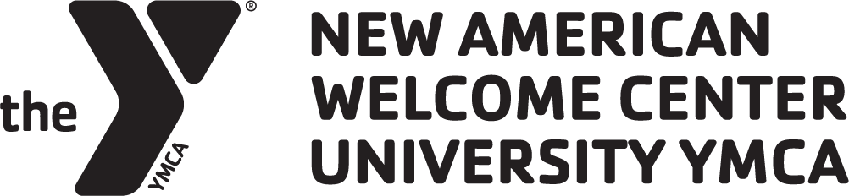

**POSITION TITLE:** Intake Specialist

**STATUS & CLASSIFICATION:** Full Time, Exempt

**REPORTS TO:** Immigrant Family Services Manager

# UNIVERSITY YMCA & NEW AMERICAN WELCOME CENTER

The University YMCA, founded in 1873, develops campus and community leaders committed to social justice, environmental protection, interfaith cooperation and global engagement by fostering dialogue, reflection and action. Established in 2017, the Y’s New American Welcome Center (NAWC) works to co-create a community where all immigrants can thrive and flourish by engaging local institutions and mobilizing community resources to ensure equitable access to services, economic opportunity, and meaningful belonging.

# JOB DESCRIPTION

The University YMCA seeks a detail-oriented, people person to provide intake and limited case management services for the New American Welcome Center. The Intake Specialist will speak directly with immigrant individuals and their families to determine what services may be needed, make internal referrals, schedule appointments, and provide limited case management. Supervises the Intake Assistant, if filled.

# WAGE & BENEFITS

This is an at-will, full-time position averaging 37.5 hours per week, with approximately 75% of work performed in-person. The salary range is $36,540 to $38,000, negotiable based on experience. This position is grant-funded through June 30, 2026, with anticipated continuation through June 30, 2027. While long-term continuation is expected, employment is based on funding availability and performance.

# REQUIREMENTS

* A bachelor’s degree or equivalent work experience is preferred.
* Bilingual proficiency, written and oral, is **required** in Spanish.
* Ability to work a flexible schedule at times, including some evenings and weekends.
* Valid driver’s license, good driving record and access to a reliable vehicle.
* Technical proficiency in all Microsoft Office applications and Google Suite.
* Ability to learn and demonstrate proficiency with Salesforce to track client and activity data.
* At least 75% in-person; remote work subject to supervisor approval.

# JOB DUTIES & RESPONSIBILITIES

* Greet clients when they come to the center and conduct comprehensive intake.
* Answer and make phone calls, schedule appointments for NAWC services and enroll program participants.
* Provide clear referrals and limited case management to ensure seamless and effective continuity of service for all clients.
* Track client data accurately and precisely with attention to detail using Salesforce and related applications.
* Work closely with the Case Worker and other NAWC staff to ensure continuity of services for clients.
* Proactively mitigate or resolve issues as they arise. This requires daily responses to emails.
* Supervise Intake Assistant(s), if filled.
* Perform other duties as assigned.

# ESSENTIAL KNOWLEDGE & SKILLS

* Strong commitment to the enfranchisement and empowerment of immigrant communities.
* Strong written and verbal communication skills to effectively interact with clients and their families.
* Ability to work with people across diverse personalities, lifestyles, cultures, political orientations, and faiths.
* Impeccable integrity, positive attitude, mission-driven, and self-directed.
* Strong computer skills in all Microsoft Office applications and Google Suite.
* Experience with case management systems and/or grant reporting is strongly preferred.
* Knowledge of trauma-informed service provision and practices.

# HOW TO APPLY

Interested applicants should send a cover letter, a current resume, and three references to [welcome@universityymca.org.](mailto:welcome@universityymca.org) Interviews will be conducted on a rolling basis until the position is filled.

# STATEMENT OF EQUAL OPPORTUNITY

The University YMCA is committed to equal opportunity for the employment and advancement of an inclusive and diverse staff. The University YMCA will not engage in any discrimination or harassment against any person because of race, color, religion, religious preference or opinion, sex (including pregnancy), gender identity, national origin, ancestry, age, family responsibilities, marital status, disability, sexual orientation, personal appearance, political affiliation, unfavorable discharge from the military, status as a veteran of military service, prior arrest or conviction record, source of income, or any other discrimination based on categorizing or classifying a person which is not based upon factual data about the persons or group and is not related to the purpose for which it used.