Academic Advising and Mentoring Manual
Empowering students to reach and exceed their full potentials.


2026

Table of content

- Academic advising program vision and mission 1
- Academic advising core values 2
- Introduction 3
- Program goal and objectives 4
- Advisor responsbilities 6
- Advisee responsibilities 7
- Planning and preparation for academic advising program 8
- Implementation of academic advising program 8
- Best practices for advising 11
- Meeting your advisor 13
- Monitoring and evaluation 16
- References 24

Vision and Mission

Vision
“Empowering students to achieve academic excellence, personal growth, and professional readiness through holistic, and student-centered advising.”

Mission
“To Provide high-quality, personalized, and comprehensive advising that supports students in defining, planning, and achieving their academic, professional, and personal goals.”

Core values

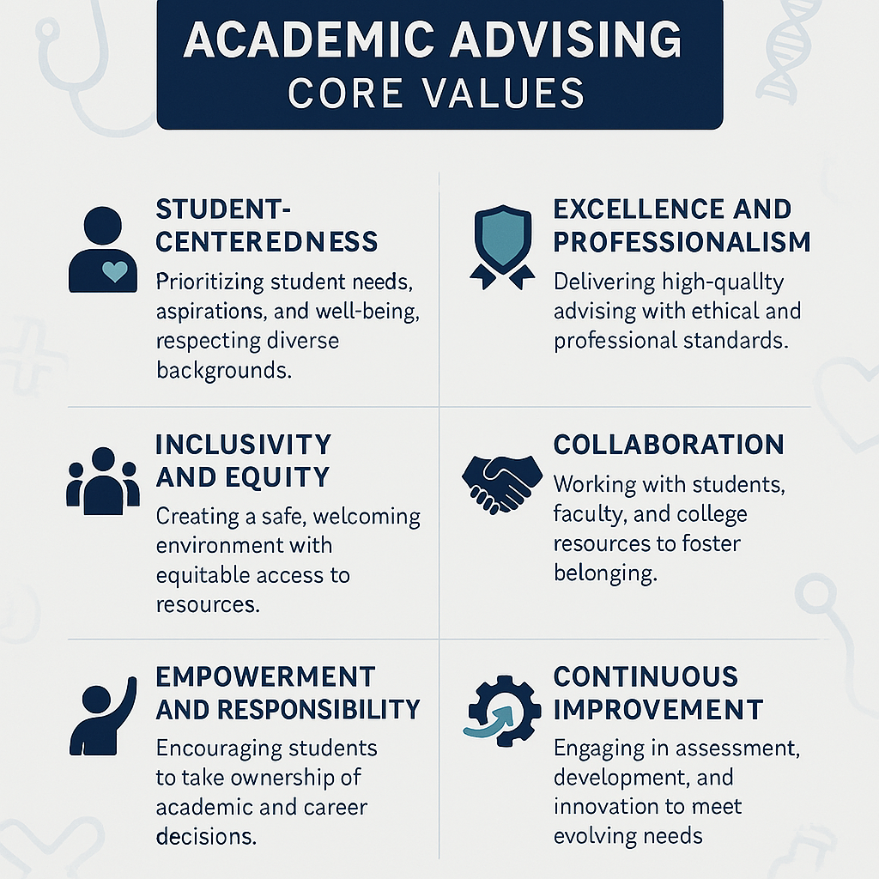

INTRODUCTION

Academic advising is a collaborative partnership between students and advisors. It serves as a comprehensive support system designed for student success. Additionally, it is a part of the educational experience, where students are supported by faculty in making appropriate choices from a wide range of opportunities towards achieving realistic academic and professional goals. Academic advisors directly contribute to the educational mission of the institution through intentional, organized conversations that help students reflect on their academic decisions along with their learning experiences.

The advising process can influence the advisees' personal and educational growth that will lead to productive engagement with others. By engaging in the advising process, students become more informed, autonomous, empowered, and successful in achieving their intellectual and professional goals. Moreover, students will be equipped to make decisions and solve problems specific to their academic progress. Academic advising is a personalized service tailored to meet the unique needs of each student. Through this process, students gain clarity on their path towards graduation while developing essential skills for lifelong learning and career readiness.

Inline, academic advising fosters an environment where students can discuss challenges, explore opportunities, and develop critical life skills such as communication skills, time management, study strategies, and self-advocacy. Furthermore, it fosters student engagement by encouraging participation in co-curricular activities that complement their educational experience.

As the Students are the cornerstone of any educational process. It is of great value to get support to have a successful experience. Therefore, this manual is developed to serve as a guide for both students and academic advisors. It provides a clear understanding of the academic advising program, highlighting its purpose, benefits, the roles and responsibilities of students and advisors, key activities involved and the evaluation process that takes place throughout the students’ learning journey.

- Goal and Objectives

Goal
The academic advising program aims to support students successfully navigating their academic journey by providing personalized guidance that promotes high quality, timely degree completion, fosters academic and professional development, and enhances student well-being.

Objectives

Academic advising program is structured to achieve the following objectives:

- Provide an open environment which fosters self-awareness, self-exploration, and self-evaluation which lead to encouraging a sense of professional identity.
- Assist students understand their roles and responsibilities toward themselves and their society
- Explore students’ abilities and interests leading to creation of relevant academic and professional goals.
- Guide students and help them develop educational plans that help timely completion of educational goals.
- Counsel the most appropriate choices to make in order to achieve goals (e.g., module or major choices).
- Foster the students’ critical thinking, problem-solving, and independent decision-making skills to accept commitment for academic decisions.
- Assist students in the exploration of possible short- and long-range consequences of decisions.
- Help students recognize and accept the reality of possible successes and failures, thereby encouraging a sense of confidence and maturity.
- Encourage students to develop their talents and explore their creativity.
- Improve the quality of Academic Advising through good practices.

- Advisor skills and responsibilities

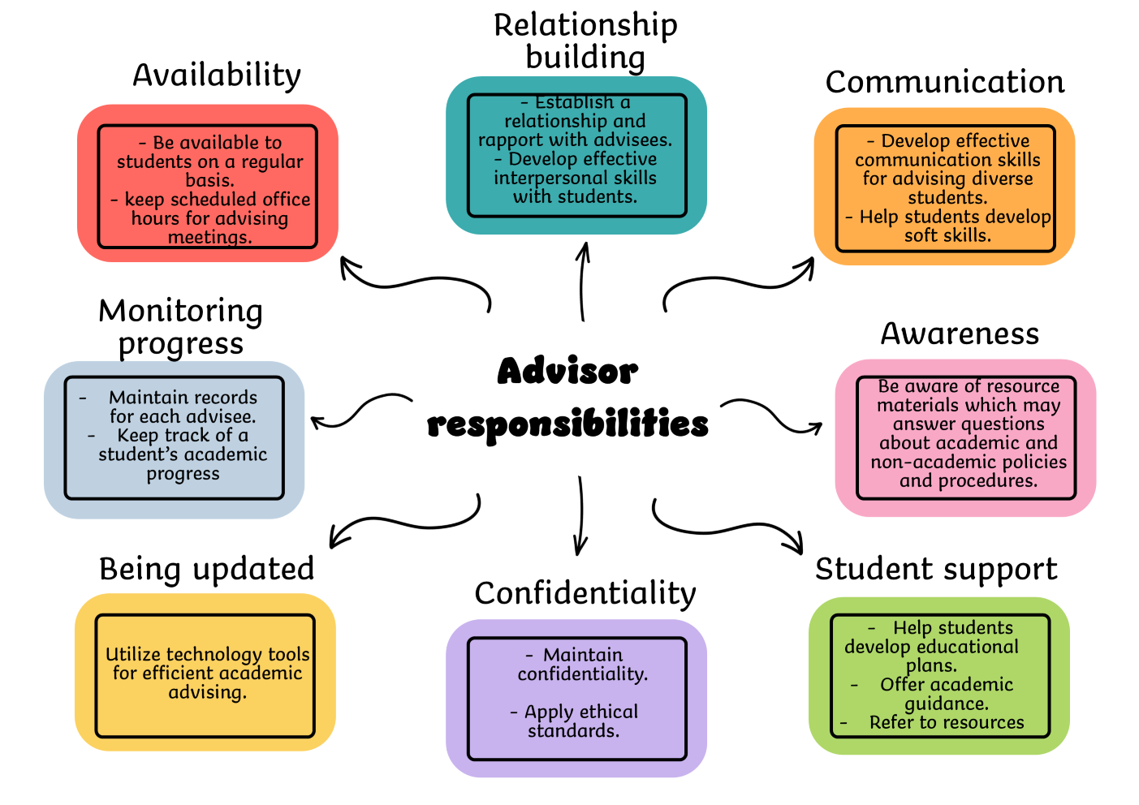

- Advisee Responsibilities

Students have the main responsibility in the advising system and should take the initiative to seek advisement and develop close relationships with their advisors. To accomplish this effectively, advisees should:

- Be prepared for the advising sessions during the scheduled times and be able to discuss their interests and goals with their academic advisor.
- Be committed to attend, on time, the advising appointments.
- Become familiar with curriculum, graduation and other requirements.
- Have realistic and reasonable expectations about their academic workload.
- Commit to being involved and active learners.
- Assume responsibility for their choices, studies, and achieving the program requirements.
- Explore their abilities, interests, values, and goals to understand how they intersect with educational pathways.
- Be aware of learning and implementing new strategies for academic success.
- Follow the academic advisor’s recommendations.
- Seek research volunteer, and education opportunities that complement their studies and support long-term goals.
- Consult their advisors if they are experiencing academic difficulty.
- Seek their academic advisors' feedback and guidance in accomplishing their educational and personal goals.
- Express concerns, openly and honestly, about issues that may affect their ability to perform their best.
- Be committed to fulfilling all academic requirements and achievements.

- Planning of advising program
In the planning phase of academic advising program, the following steps are followed:
- Developing a manual/guide for providing awareness to students and advisors.
- Planning for academic advisors training and students’ orientation.
- Planning for the tools and strategies for implementation, monitoring and evaluation of the advising program.
- Formulate satisfaction surveys to assess students’ satisfaction towards academic advising

6. Implementation of Advising program

Implementing the academic advising program and encouraging students to actively participate in requires application of awareness, student support and engagement strategies.

  - Awareness & Communication
Orientation Programs for both advisors and advisees will be conducted at the beginning of and along the academic year about the academic advising program process, providing clear benefits and success stories.

Target Audiences | - Academic advisors. Provide continuous training for advisors on best practices in academic advising and effective communication skills. Emphasize the importance of their role as student supporters, not just academic guides.  - Students in all academic and postgraduate levels.
Orientation Activities (at least once per year) | Training programs about:  - Academic advising system  - Metacognition and Self-Regulated Learning  - Study strategies  - Problem-solving and decision making  - Time management  - Academic planning
Distribute guiding brochures. | Distribute guiding brochures explaining the system's importance. E-mails, social media, and student portals will be utilized to highlight how advising helps with course planning, career goals, and overcoming academic challenges.
Disseminating schedules for advising appointments. | Sharing and disseminating the schedules for advising meetings along with the staff office hours to students through different formal and informal channels of communication.

  - Relationship Building and Support

The availability and support of advisors is an essential contribution to the success of the academic advising program. This will be achieved through:

- Each student will be assigned to a faculty advisor. The number of advisees for each advisor depends on the student/faculty ratio in the current academic year.
- Flexible Scheduling: Offering advice on appointments on-site and allowing virtual meetings.
- User-Friendly Systems: Simplify booking and communication through mobile apps of my Knowledge map platform.
- Regular Check-ins: Schedule mandatory advising sessions at key academic milestones (e.g., after registration, before midterms).
- Inclusive services provide tailored advising for students with special needs, academic struggles, or career uncertainties.

  - Engagement & Incentives

- Attendance of at least one advising session per semester is linked to course registration for the next semester or obtaining a specific certificate.
- Advising Events: Interactive advising sessions with discussion of “Success” stories and discussions of their future careers help raising students’ enthusiasm.
- Feedback Channels: Students will evaluate their advising experience and suggest improvements using different feedback channels.
- Certificates & rewards: Outstanding students will be recognized with certificates and electronic badges for completing advising milestones.
- The completion of student personal development/learning plan, in the portfolio, and being evaluated by the academic advisor is prerequisite to semester exam entry.

- STUDENT PORTFOLIO
Each student should prepare a simple professional portfolio which contains the following:
- The student ꞌs CV
- Other templates of student counseling file.
- Copy of academic record of the student
- Minutes of meetings with the advisor
- Any extracurricular, training, research, or volunteer achievements by the student or any other activity with attached evidence for these activities.
- Any warnings received or referral minutes
- Any other relevant information about the student

7.Best practices of academic advising
(Tips for advisors)

7.1. Build trust and rapport
- Establish a welcoming and respectful atmosphere.
- Foster open communication to make students feel safe discussing academic and personal concerns.
- Safeguard sensitive information and maintain confidentiality.

7.2. Practice active and empathetic listening
- Listen attentively to students’ concerns and aspirations.
- Show empathy and ask clarifying questions to ensure understanding.
- Recognize non-verbal cues and respond with care.

7.3. Personalize the advising experience
- Acknowledge each student’s unique strengths, goals, and challenges.
- Tailor guidance to individual needs to promote academic and personal growth.

7.4. Stay informed and resourceful
- Keep being aware of institutional policies, degree requirements, and available academic resources.
- Provide accurate and timely information to support informed decision-making.

7.5. Promote student responsibility
- Encourage students to take ownership of their academic journey.
- Guide them in setting goals, making decisions, and developing problem-solving skills.

7.6. Ensure accessibility and responsiveness
- Be available through multiple communication channels (email, virtual meetings, in-person, etc.).
- Respond promptly to student inquiries and concerns.

7.7. Offer inclusive advising opportunities
- Provide both individual and group/hybrid advising sessions.
- Ensure students receive adequate notice and flexible scheduling options.

7.8. Practice proactive advising
- Anticipate potential challenges and intervene early.
- Refer students to appropriate support services when needed.
- Schedule follow-ups to monitor progress and provide continued support.

7.9. Celebrate student achievements
- Recognize and appreciate students’ efforts and accomplishments.
- Use positive reinforcement to boost confidence and motivation.

7.10. Utilize technology effectively
- Leverage digital tools to streamline advising processes.
- Use data insights to enhance advising strategies and track student progress.

7.11. Evaluate and improve
- Give constructive feedback to students.
- Collect feedback through surveys and evaluations.
- Follow up with students who missed sessions or appeared to need additional support

    - Meeting Your Advisor
(Tips for advisees)

Students should meet with their academic advisor regularly and whenever they need help.

1. Purpose of Meeting Your Advisor
- To review academic progress and degree requirements.
- To discuss course selection, registration, and academic planning.
- To explore majors, minors, and career pathways.
- To address academic challenges or personal concerns impacting success.
- To connect students with campus resources and support services.

2. Scheduling an Appointment
- Appointments must be scheduled monthly, and at least twice per semester.
- Appointments are scheduled for 30 minutes in length, and you can use as much of that time as you wish for a productive advising conversation
- Appointments can be scheduled online by email, or through a scheduling system.
- Students can typically choose between in-person, virtual, or phone appointments, depending on availability.
- On-call advice may be available for quick questions.
- During peak periods, students should book appointments well in advance to ensure availability.

3. Preparing for the Meeting
- Consider what other commitments might be involved in your academic day.
- Be prepared to discuss and address academic problems or concerns, make decisions about the upcoming semester, and explore major/minor options
- Review your program and degree requirements, university policies, and any relevant deadlines before the meeting.
- Set clear objectives for the meeting.
- Bring necessary documents: unofficial transcripts, previous advising notes, and a notebook for taking notes.
- Research potential courses or extracurricular opportunities in advance to maximize the meeting’s effectiveness.
- Be ready to discuss your academic and career goals, challenges, and any changes in your interests or circumstances.
- Prepare a list of questions or topics to discuss with your advisor.
For example,
- What are my degree requirements, and how am I progressing toward graduation?
- Which courses should I take next semester to stay on track?
- How can I improve my academic performance if I am struggling in a course?
- What resources (tutoring, writing center, counseling) are available to support my academic success?
- Can you help me develop a long-term academic plan?
- How can I get involved in research, internships, or extracurricular activities related to my field?
- What career paths are available with my major, and how can I prepare for them?
- How can I balance my course load with work or personal commitments?
- What are the expectations for academic integrity and student conduct?
- What opportunities exist for leadership, volunteering, or campus involvement?
4. What is expected during the meeting?
- Arrive on time for your advising appointment.
- Advisors will review your academic progress, answer your questions, and help you develop or revise professional development plan.
- The meeting is a two-way conversation during which students should share their goals, interests, and concerns openly.
- Advisors will help clarify policies, deadlines, and degree requirements to ensure timely graduation.
- Advisors will provide students with feedback concerning their overall performance
- Advisors will provide students with suggestions and strategies for their improvement in individual courses (e.g. class attendance, completion of assignments, individual conference with instructor, etc.)
- Advisors may make a referral if they have a student with academic issues such as:
- Failed exams and/or quizzes
- Missing or incomplete assignments
- Attendance issues (tardiness, multiple missed classes)
- Lack of participation
- Time management challenges

5. Best Practices for a Successful Advising Relationship
- Be proactive: Schedule regular meetings, not just when required or in crisis.
- Listen attentively to your advisor and peers.
- Ask questions to ensure understanding.
- Communicate openly: Share academic and personal challenges honestly so advisors can provide appropriate support.
- Take notes: Record advice, recommendations, and next steps during the meeting for future reference.
- Take responsibility: Use the advisor’s guidance to make informed decisions, but understand that students are ultimately responsible for their academic choices and progress.
- Follow up: Send a thank-you email or follow up with additional questions as needed.

6. After the Meeting
- Review any action items or recommendations provided by the advisor.
- Update your academic plan or degree audit as needed.
- Register for courses or complete other tasks discussed during the meeting.
- Schedule follow-up appointments as necessary, especially if you encounter new challenges or need additional guidance.

7. Special Considerations
- Group advising sessions may be offered, especially for first-year students or during orientation; individual follow-up is recommended for personalized support.
- Participation in advising sessions should be documented in advising notes for future reference.

- Monitoring and evaluation

Effective advising incorporates regular check-ins, goal setting, and the use of technology to track progress. It fosters an environment where students feel supported and empowered to take ownership of their educational journey.

Effective monitoring and evaluation of academic advising programs are essential for ensuring quality, accountability, and continuous improvement. This process should be systematic, involving ongoing, process-oriented assessments, and should gather feedback from students and advisors. These measures are for the student's benefit to ensure proper planning of their academic path.

A robust monitoring and evaluation system for academic advising should utilize structured checklists, feedback forms, and both formative and summative assessment strategies. This ensures that programs remain aligned with institutional missions, meet student needs, and foster continuous improvement
To effectively implement proactive support, advisors can utilize the following strategies:
- Maintaining regular check-ins with students.
- Implementing a system of alerts for academic performance help advisors keep track of students who may be struggling.
- Fostering strong relationships with students helps them to seek help before problems become unmanageable.
Key Components of Monitoring and Evaluation
- Formative Evaluation: Focuses on ongoing monitoring, identifying immediate issues, and making real-time improvements. Methods include observation, staff discussions, and reviewing records.
- Multi-source Feedback: Incorporates input from students, advisors, and program directors to provide a comprehensive view of program strengths and areas for improvement.
- Alignment with Mission: Evaluation should be guided by a clear mission statement that aligns with institutional goals and the purpose of academic advising.
- Use of Metrics and Rubrics: Employs qualitative and quantitative measures, including surveys, checklists, and rubrics, to assess both processes and outcomes.
Academic Advising Form - Group Meeting
To be filled by the academic advisor

Semester: ……….. Program: ……….. Level: ……….. Date: / / 2025
ID | Student Name |  | ID | Student Name
 |  | 7. |  |  | 1.
 |  | 8. |  |  | 2.
 |  | 9. |  |  | 3.
 |  | 10. |  |  | 4.
 |  | 11. |  |  | 5.
 |  | 12. |  |  | 6.
A - Teaching Methods and Resources
Please Write the NUMBER of student for each question
 | Teaching & Learning (Sessions, Strategies, Assessment, Facilities) | Strongly Agree | Agree | Neutral | Dis-Agree | Strongly Disagree | Comments
 | I benefit from:
A. | (Sessions)
1. | Theory
2. | Laboratory / Practical
3. | Clinical Sessions
4. | Tutorials
B. | (Strategies)
1. | Interactive Lecture
2. | Whole or Small group discussion
3. | Case study / problem solving
4. | Student prepared presentation (SPP)
5. | Student dependent learning (SDL)
6. | Problem Based Learning (PBL)
7. | Team Based Learning (TBL)
8. | Assignment (Individual / group)
9. | Projects (Individual / group)
10. | Lab demonstration
11 | Role Play / Clinical Scenario
12 | Clinical Simulation
C. | (Assessment)
1. | Formative
2. | Summative (Quizzes, Mid / Final Exam)
3. | Assignment Evaluation
D. | (Facilities)
1. | Classrooms are suitable
2. | Audiovisuals (projector, microphone, etc.) are suitable.
3. | Laboratories are well equipped.
4. | I.T & English Labs are well equipped.
5. | Library Facilities (Books, Printer, Copier)
6. | I.T Resources (Saudi Digital Library, People Soft, Website, and Black Board) are suitable.
7. | Cafeteria is suitable.

B-Student participation in extracurricular activities
 | Activities | Participation | Non-participation | I do not know about | Comments
1. | Scientific & Cultural Committee
2. | Sports & Health Committee
3. | Social & Art Committee
4. | Religious & Islamic Awareness Committee
5. | Lectures and workshops
6. | Community Service
7. | Research
8. | Other activities

C- General Comments

…………………………………………………………………………………………………………………………

…………………………………………………………………………………………………………………………

…………………………………………………………………………………………………………………………

…………………………………………………………………………………………………………………………

…………………………………………………………………………………………………………………………

…………………………………………………………………………………………………………………………

…………………………………………………………………………………………………………………………

…………………………………………………………………………………………………………………………

Academic Advisor:
Name…………………………. Signature………………………

استمارة حالة إرشادية فردية
Academic Advising Form

اسم الطالب  Student’s Name |  | الرقم الجامعي  FCMS ID |  | المعدل الفصلي  Semester GPA
البرنامج  Program |  | المستوى الدراسي  Level |  | المعدل التراكمي  Cumulative GPA
عدد الساعات المجتازة  No. of Cr.Hrs.  passed |  | عدد الساعات المسجلة  No. of Cr.Hrs.  registered |  | عدد الساعات المتبقية  No. of Cr.Hrs.  Remaining
عدد الإنذارات (إن وجدت)  No. of warning letter (if any) |  | هل تم فصله أكاديمياً سابقاً  Previous academic dismissal

موضوع اللقاء الإرشادي بين المرشد الأكاديمي والطالب
The subject of the meeting between the academic advisor and the student

( ) التسجيل للمقررات الدراسية  Courses registration ( ) | ( ) الاعتذار/ التأجيل عن فصل دراسي /سنه دراسيه  Postponement for semester/year ( ) |  | ( ) إعادة قيد  Re-enrollment ( )
( ) الانقطاع/الانسحاب عن الدراسة Interruptions/withdrawal ( ) | ( ) مراجعة الخطة الدراسية  Review the study plan ( ) |  | ( ) مراجعة التقدم في المقررات الدراسية  Follow up student progress ( )
( ) مراجعة وتقييم المواظبة والحضور  Review and evaluate attendance  ( ) | ( )اخرى  Others ( )
بعض المشكلات التي تعوق التقدم الدراسي
Problems that may hinder the Student progress
( ) مشكلة دراسية  Academic problem ( ) | ( ) انخفاض المستوى الدراسي  Poor /low performance ( ) |  | ( ) مشكلة نفسية  Psychological problem ( )
( ) مشكلة أسرية  Family problem ( ) | ( ) مشكلة اجتماعية  Social Problem ( ) | ( ) مشكلات أخرى  Other problem ( )

ملخص الحالة
Status Summary

الأساليب الإرشادية المتبعة
Advisor Action to Help the Student

توصيات المرشد الأكاديمي
Academic Advisor Recommendations

توقيع الطالب
Student’s Signature .........................................

اسم المرشد الأكاديمي  Student’s Academic Advisor  .........................................Name  . | التوقيع  Signature .....................................  التاريخ  Date ....................................

Student evaluation checklist

This checklist is designed for academic advisors to systematically assess student engagement, progress, and readiness during advising sessions. It covers academic performance, planning, resource utilization, and personal development.
Student name: …………………………….. Semester: ……………………………..
Program: ……………………………………… Level: ……………………………….
Date: / / 2025

Item | Always (3) | Sometimes (2) | Never (1)
- Demonstrates understanding of degree requirements and academic policies.
- Brings necessary documents (e.g., transcripts, degree audit) to advising meetings.
- Actively participates in advising sessions and discussions.
- Articulates academic and career goals clearly.
- Follows through on previously agreed-upon action items.
- Selects appropriate courses in line with degree plan.
- Seeks help or clarification when facing academic challenges.
- Utilizes campus resources (tutoring, writing center, counseling) as needed.
- Maintains satisfactory academic progress (GPA, credits completed).
- Meets important academic deadlines (registration, add/drop, graduation application).
- Demonstrates time management and organizational skills.
- Engages in co-curricular or extracurricular activities relevant to goals.
- Shows initiative in exploring career or internship opportunities.
- Reflects on academic performance and identifies areas for improvement.
- Communicates effectively and respectfully with advisor and faculty.
- Demonstrates responsibility and autonomy in academic decision-making.
- Is open to feedback and willing to adjust plans as necessary.
- Understands the impact of personal issues on academic progress and seeks support when needed.
- Has a realistic understanding of workload and course expectations.
- Plans for future semesters, including long-term academic and career pathways.

Academic Advisor:
Name…………………………. Signature………………………
Feedback Form

For Students:

- What aspects of academic advising have been most helpful to you?
……………………………………………………………………………………………………………………………………………………………………………………………………………………………………………………………………………………………………………………………………………………………………………………
- What challenges have you experienced in accessing advising services?
……………………………………………………………………………………………………………………………………………………………………………………………………………………………………………………………………………………………………………………………………………………………………………………
- How could the advising process be improved?
……………………………………………………………………………………………………………………………………………………………………………………………………………………………………………………………………………………………………………………………………………………………………………………
- Are there additional topics you wish your advisor would discuss with you?
……………………………………………………………………………………………………………………………………………………………………………………………………………………………………………………………………………………………………………………………………………………………………………………
- Any other comments or suggestions?
……………………………………………………………………………………………………………………………………………………………………………………………………………………………………………………………………………………………………………………………………………………………………………………

For Advisors:

- What resources or support would help you advise more effectively?
……………………………………………………………………………………………………………………………………………………………………………………………………………………………………………………………………………………………………………………………………………………………………………………
- What barriers do you face in your advising role?
……………………………………………………………………………………………………………………………………………………………………………………………………………………………………………………………………………………………………………………………………………………………………………………
- How could the advising program be improved from your perspective?
……………………………………………………………………………………………………………………………………………………………………………………………………………………………………………………………………………………………………………………………………………………………………………………
- Are there professional development topics you would like to pursue?
……………………………………………………………………………………………………………………………………………………………………………………………………………………………………………………………………………………………………………………………………………………………………………………
- Any additional feedback or recommendations?
……………………………………………………………………………………………………………………………………………………………………………………………………………………………………………………………………………………………………………………………………………………………………………………

References

- Goemans, M., & Kapinos, B. (2024). A quantitative study of community college student-advisor appointments and student success metrics. NACADA Journal, 44(1), 38-54. https://doi.org/10.12930/NACADA-23-31
- NACADA. An End to Checklist Thinking: Learning-Centered Advising [Internet]. Manhattan (KS): National Academic Advising Association; [last accessed 2025 Jun 22]. Available from: https://nacada.ksu.edu/Resources/Clearinghouse/View-Articles/An-End-to-Checklist-Thinking-Learning-
- Afzal, A., Sami, A., & Munawar, S. (2024). The Role of Academic Advising and Mentoring in Promoting Student Success and Retention. International Journal of Human and Society (IJHS), 4(1), 110-123. (PDF) The Role of Academic Advising and Mentoring in Promoting Student Success and Retention
- NACADA: The Global Community for Academic Advising. (2006). NACADA concept of academic advising. Retrieved from https://www.nacada.ksu.edu/Resources/Pillars/Concept.aspx
- Schneider, K., & Kranzow, J. (2022). Strengths-based academic advising: Supporting diverse populations. National Resource Center for the First-Year Experience and Students in Transition, 8. 1651247957_0.pdf
- Museus, S. D. (2021). Revisiting the role of academic advising in equitably serving diverse college students. The Journal of the National Academic Advising Association, 41(1), 26-32. https://doi.org/10.12930/NACADA-21-06
- Sharma, S. (2023). Supporting student engagement with technology. Retrieved from Edutopia: https://www.edutopia.org/article/using-technology-support-student-engagement
- Braun, E. (2024). Academic Advising Best Practices: A Busy Advisor’s Cheat Sheet. NACADA. Academic Advising Best Practices: A Busy Advisor’s Cheat Sheet
- Plumb, M. (2024). The Road to Success for Transfer Students: Best practices and innovative approaches to transfer pathways. Trellis Strategies. Faculty Involvement in Student Recruitment and Enrollment
- Academic Advising Framework: Resources & Materials [Internet]. Minneapolis (MN): University of Minnesota; [last accessed 2025 Jun 22]. Available from: https://advisor.umn.edu/resources/framework#materials

