  WELCOME TO HOLY TRINITY  GIVE ONLINE  LIVE STREAMING AT HOLY TRINITY  PLEASE NOTE | MASS | THE TRANSFIGURATION OF OUR LORD  Sunday, February 15th 2026  The Evangelical Lutheran Church of the Holy Trinity is a congregation of the Evangelical Lutheran Church in America (ELCA), the largest progressive Lutheran body in the United States. As Lutherans, we go about Christianity in a Lutheran way, emphasizing that we are reconciled with God (justified) not by anything we do, but through and because of God’s love, freely given (grace). We love questions more than quick fixes (paradox), and we read the Bible in a way that honors it as the source and norm of faith, but not as a literal handbook. As Lutherans, we also lift up the gifts and capacity for ministry (vocation) that every person unquestionably holds.  As a Reconciling in Christ (RIC) congregation (and the first in the Metropolitan New York Synod), Holy Trinity welcomes all persons, including all sexual orientations, gender identities, and gender expressions. Holy Trinity is also committed to practicing racial equity, learning anti-racism, and modeling radical hospitality and inclusion across age, class, national origin, physical and mental health and ability, family configuration, and language.  With a heart for the city, a passion for justice, and a commitment to the arts, we seek to be a place where all God’s people will know they are loved. Welcome. We’ve been waiting for you. There is a place for you here.  If you contribute to the mission and ministry of Holy Trinity through online giving, please pick up an “I give online” card from an usher to participate in the offering as the offering plates are passed.  Please be aware that worship this morning is being filmed, photographed, and live streamed on our YouTube channel. Your likeness and/or voice may be captured by our equipment. Please alert an usher at the entrance if you have any concerns. Selections from this live stream may be used on our website and in our public relations materials.  Weapons, including firearms, knives, scissors, aerosols such as pepper spray and mace, and any hazardous materials are strictly prohibited on church property. All bags are subject to inspection upon entry into the sanctuary.

ASSISTING MINISTERS & ALTAR GUILD  LECTOR  USHERS  DIGITAL SACRISTAN  COFFEE HOUR  DIRECTOR OF MUSIC  PASTOR | SPECIAL THANKS TO  Tim Cage & Robert Crumb  Jean Silliman  Joseph Gedeon & Sonja Wermager  Tom Barritt  Michelle Peranteau & Jenn Nelson  Austin Philemon  The Reverend Timothy Weisman

G A T H E R I N G  prelude | Transfiguration Frederick Frahm (b. 1964)

At the entrance of the cross, the assembly rises in body or spirit; turn to face the cross in procession,
bowing in reverence to the cross as the procession passes by.

processional hymn  #316 | “Oh, wondrous image, vision fair” | DEO GRACIAS
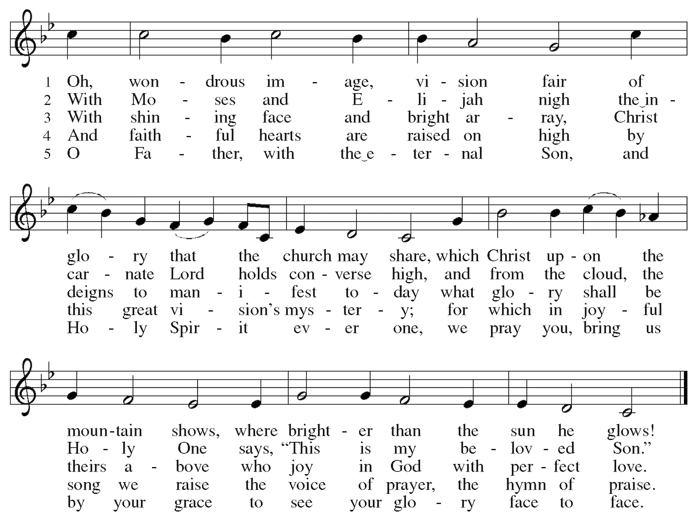
greeting  (2 corinthians 13:14)  hymn of praise  (from Evangelical  Lutheran Worship)  prayer of  the day | The grace of our Lord Jesus Christ, the love of God, and the communion  of the Holy Spirit be with you all.    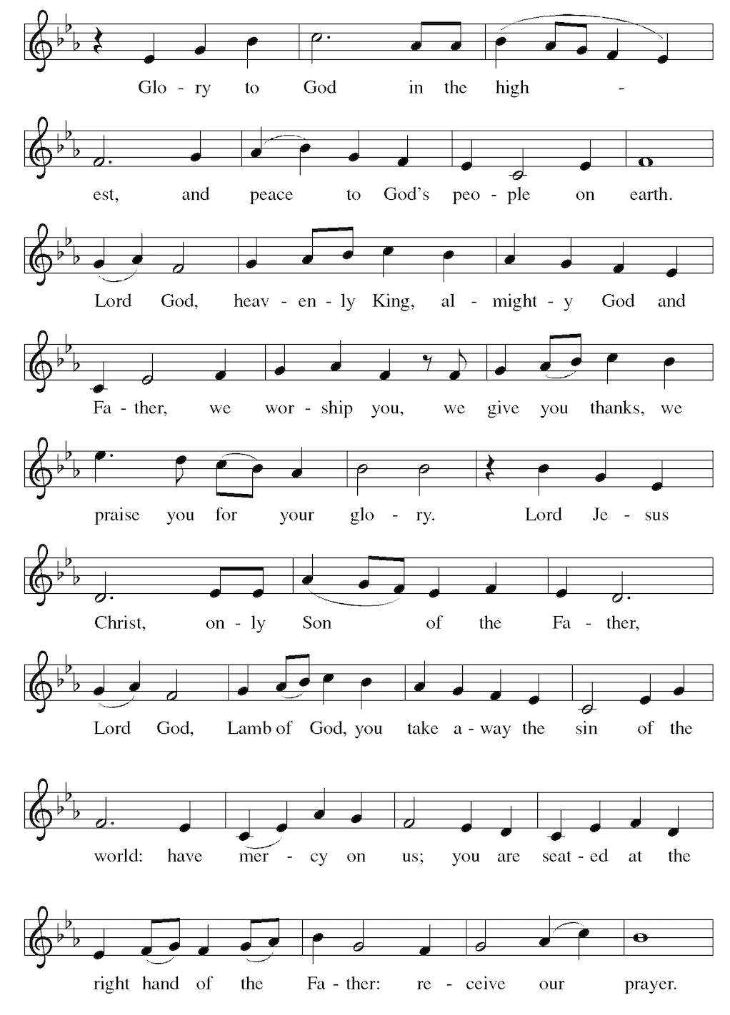  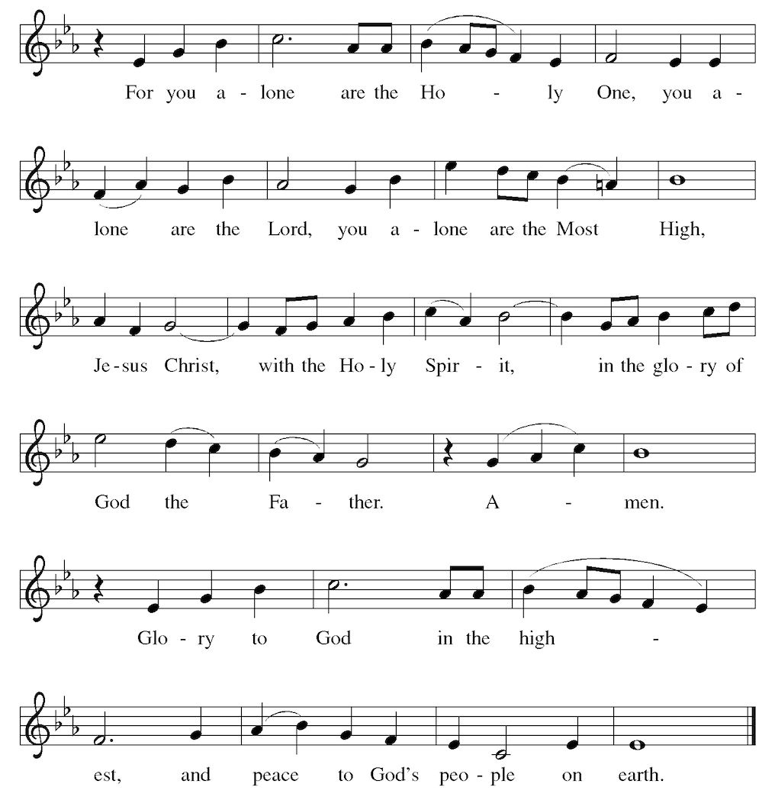  Let us pray. Silence is kept. O God, in the transfiguration of your Son you confirmed the mysteries of the faith by the witness of Moses and Elijah,  and in the voice from the bright cloud declaring Jesus your beloved Son,  you foreshadowed our adoption as your children. Make us heirs with Christ  of your glory, and bring us to enjoy its fullness, through Jesus Christ, our  Savior and Lord, who lives and reigns with you and the Holy Spirit, one God,  now and forever.  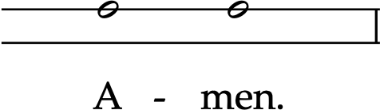  The assembly sits.

W O R D  from the  hebrew  scriptures  psalm 2  from the  christian  scriptures  gospel acclamation  from the  holy gospels  sermon | Exodus 24:12-18  ¹² The Lord said to Moses, “Come up to me on the mountain and wait there; I will give you the tablets of stone, with the law and the commandment, which I have written for their instruction.” ¹³ So Moses set out with his assistant Joshua, and Moses went up onto the mountain of God. ¹⁴ To the elders he had said, “Wait here for us, until we come back to you. Look, Aaron and Hur are with you; whoever has a dispute may go to them.”  ¹⁵ Then Moses went up on the mountain, and the cloud covered the mountain. ¹⁶ The glory of the Lord settled on Mount Sinai, and the cloud covered it for six days; on the seventh day he called to Moses out of the cloud. ¹⁷ Now the appearance of the glory of the Lord was like a devouring fire on the top of the mountain in the sight of the Israelites. ¹⁸ Moses entered the cloud and went up on the mountain. Moses was on the mountain for forty days and forty nights.  Silence is kept.  Hear what the Spirit is saying to God’s people.  Thanks be to God.  A cantor intones the first verse, then the assembly joins to sing.  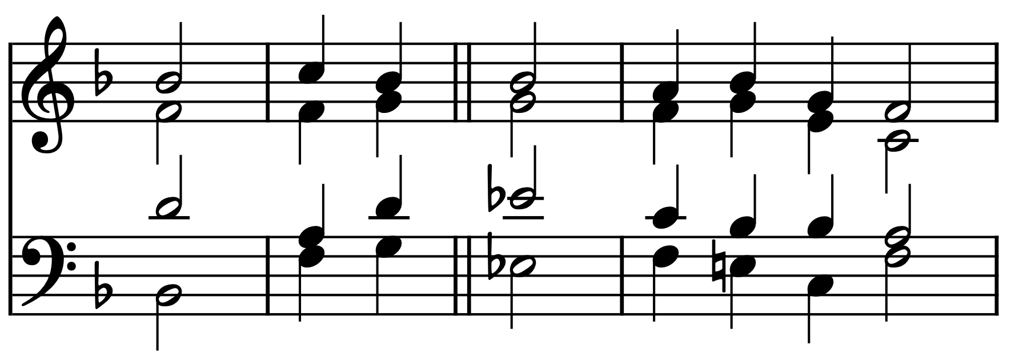  Why are the nations in an | uproar?  Why do the peoples | mutter empty threats?  Why do the kings of the earth rise up in revolt, and the princes | plot together,  against the Lord and against the | Lord’s anointed?  “Let us break their | yoke,” they say;  “let us cast | off their bonds from us.”  God whose throne is in heaven is | laughing;  the Lord holds them | in derision.  Then in wrath God | speaks to them,  and in rage fills | them with terror.  “As for me, I have an- | ointed my king  upon Zion, my | holy mountain.”  Let me announce the decree | of the Lord,  who said to me, “You are my son; this day have | I begotten you.  Ask of me, and I will give you the nations for your in- | heritance  and the ends of the earth for | your possession.  You shall crush them with an | iron rod  and shatter them like a | piece of pottery.”  And now, you | kings, be wise;  be warned, you | rulers of the earth.  Submit to the | Lord with fear,  and with trembling | bow in worship;  lest the Lord be angry, and you perish in a sudden | blaze of wrath.  Happy are all who take | refuge in God!  2 Peter 1:16-21  ¹⁶ We did not follow cleverly devised myths when we made known to you the power and coming of our Lord Jesus Christ, but we had been eyewitnesses of his majesty. ¹⁷ For he received honor and glory from God the Father when that voice was conveyed to him by the Majestic Glory, saying, “This is my Son, my Beloved, with whom I am well pleased.” ¹⁸ We ourselves heard this voice come from heaven, while we were with him on the holy mountain.  ¹⁹ So we have the prophetic message more fully confirmed. You will do well to be attentive to this as to a lamp shining in a dark place, until the day dawns and the morning star rises in your hearts. ²⁰ First of all you must understand this, that no prophecy of scripture is a matter of one’s own interpretation, ²¹ because no prophecy ever came by human will, but men and women moved by the Holy Spirit spoke from God.  Silence is kept.  The Word of the Lord.  Thanks be to God.  The assembly stands to welcome the Gospel.  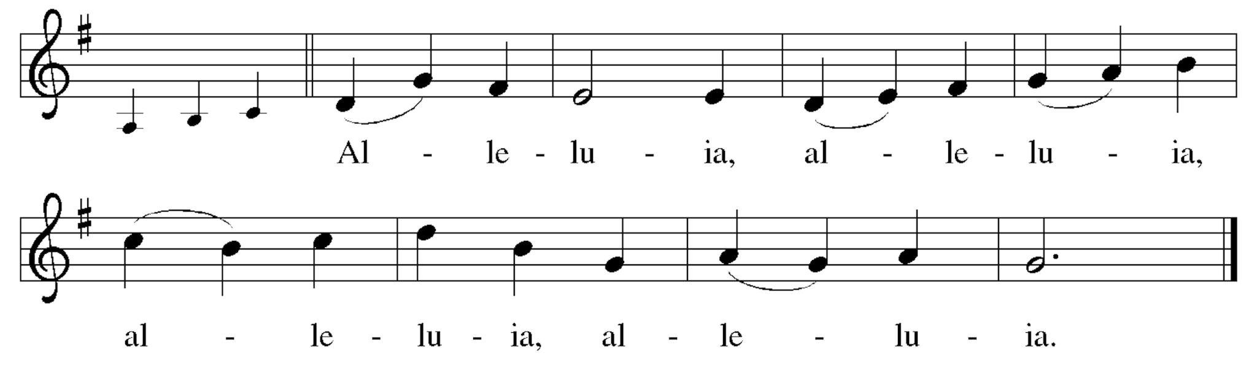  The choir sings: This is my Son, my Chosen, listen to him! (Luke 9:35)  Matthew 17:1-9  The Holy Gospel according to Matthew.  Glory to you, O Lord.  The assembly is invited to make a small cross over your forehead, lips, and chest, inviting Jesus the Word into your heart, mind, and speech.  ¹ Six days later, Jesus took with him Peter and James and his brother John and led them up a high mountain, by themselves. ² And he was transfigured before them, and his face shone like the sun, and his clothes became bright as light. ³ Suddenly there appeared to them Moses and Elijah, talking with him. ⁴ Then Peter said to Jesus, “Lord, it is good for us to be here; if you wish, I will set up three tents here, one for you, one for Moses, and one for Elijah.” ⁵ While he was still speaking, suddenly a bright cloud overshadowed them, and a voice from the cloud said, “This is my Son, the Beloved; with him I am well pleased; listen to him!” ⁶ When the disciples heard this, they fell to the ground and were overcome by fear. ⁷ But Jesus came and touched them, saying, “Get up and do not be afraid.” ⁸ And when they raised their eyes, they saw no one except Jesus himself alone.  ⁹ As they were coming down the mountain, Jesus ordered them, “Tell no one about the vision until after the Son of Man has been raised from the dead.”  The Gospel of the Lord  Praise to you, O Christ.  The Reverend Timothy Weisman  Silence is kept after the sermon. The assembly stands to sing.

hymn of the day  #838 | “Beautiful savior” | SCHÖNSTER HERR JESU
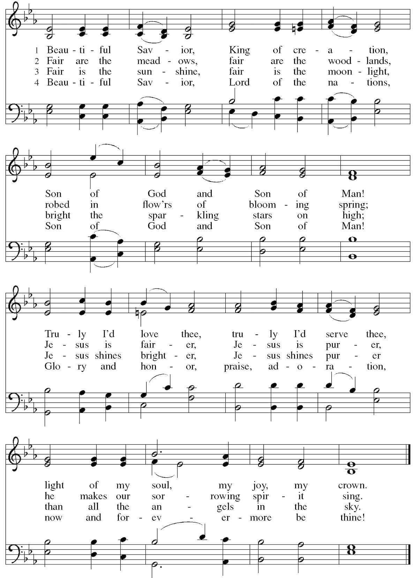
the apostles’  creed  (4th century)  prayers of the people  prayer for  racial justice  (Dr. Martin Luther King, Jr.)  the peace  (john 20:19)  M E A L | I believe in God, the Father almighty,  creator of heaven and earth.  I believe in Jesus Christ, God's only Son, our Lord,  who was conceived by the Holy Spirit,  born of the virgin Mary,  suffered under Pontius Pilate,  was crucified, died, and was buried;  he descended to the dead.  On the third day he rose again;  he ascended into heaven,  he is seated at the right hand of the Father,  and he will come to judge the living and the dead.  I believe in the Holy Spirit,  the holy catholic church,  the communion of saints,  the forgiveness of sins,  the ☩ resurrection of the body,  and the life everlasting.  The assembly kneels or sits to pray.  With the whole people of God in Christ Jesus, let us pray for the church, those in need, and all of God’s creation.  The assembly responds to each petition.  Hear us, O God.  Your mercy is great.  We thank you for your church, founded upon your Word, that challenges us to do more than sing and pray, but go out and work as though the very answer to our prayers depended on us and not upon you. Help us to walk together, pray together, sing together, and live together until the day when all God's children will rejoice in one common band of humanity in the reign of our Lord and of our God, we pray. Amen.  The assembly may bow, mirroring the presider.  The peace of Christ be with you always.  And also with you.  The assembly is invited to pass the peace in whatever way is most comfortable to them. If you, for any reason, wish to avoid physical contact during the peace, please feel free to cross your arms over your chest to indicate your desire for a verbal  greeting. Following the peace, the assembly sits.    In addition to giving toward the ministry of Holy Trinity  as the offering plates are being passed, you can  • Scan the QR code to the right;  • Venmo @holytrinitynyc;  • Send a Zelle to office@holytrinitynyc.org;  • Give to Holy Trinity through a Donor-advised Fund  by searching for our EIN: 13-1685538.

offertory  offertory  prayer  the great thanksgiving  the proper  preface  sanctus  eucharistic  prayer  the lord’s  prayer  (Matthew 6:9–13)  the invitation  (psalm 34:8)  communion music | The Transfiguration Richard Shepherd (1949-2001)  After six days Jesus tooketh Peter, James, and John his brother  and bringeth them up to a high mountain apart,  and was transfigured before them.  And his face did shine as the sun.  And his raiment was white as the light.  And behold a bright cloud overshadowed them,  And behold a voice out of the cloud which said:  “This is my beloved Son in whom I am well pleased. Hear ye him.”  Let us pray. Silence is kept. Merciful God, we offer with joy and thanksgiving what you have first given us: our selves, our time, and our possessions, signs of your gracious love. Receive them for the sake of him who offered himself for us, Jesus Christ our Lord. Amen.  The assembly may bow, mirroring the presider.  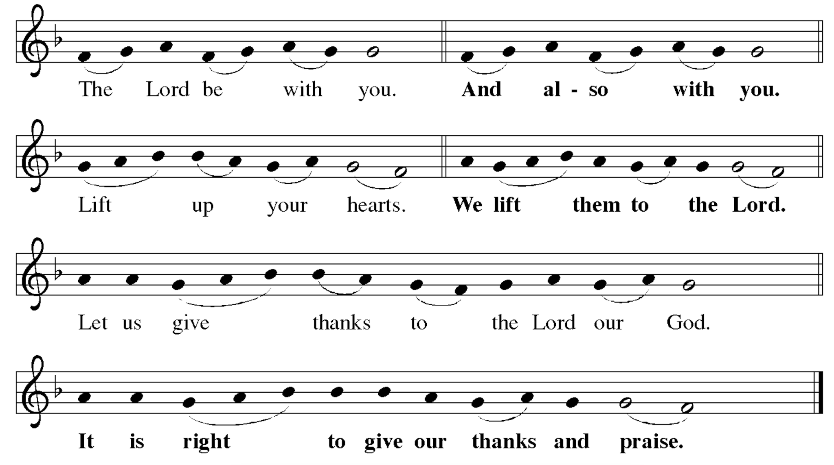  The presider continues: It is indeed right, our duty and our joy, that we should at all  times and in all places give thanks and praise to you. . . and so, with all the choirs  of angels, with the church on earth and the hosts of heaven, we praise your name and join their unending hymn. . .  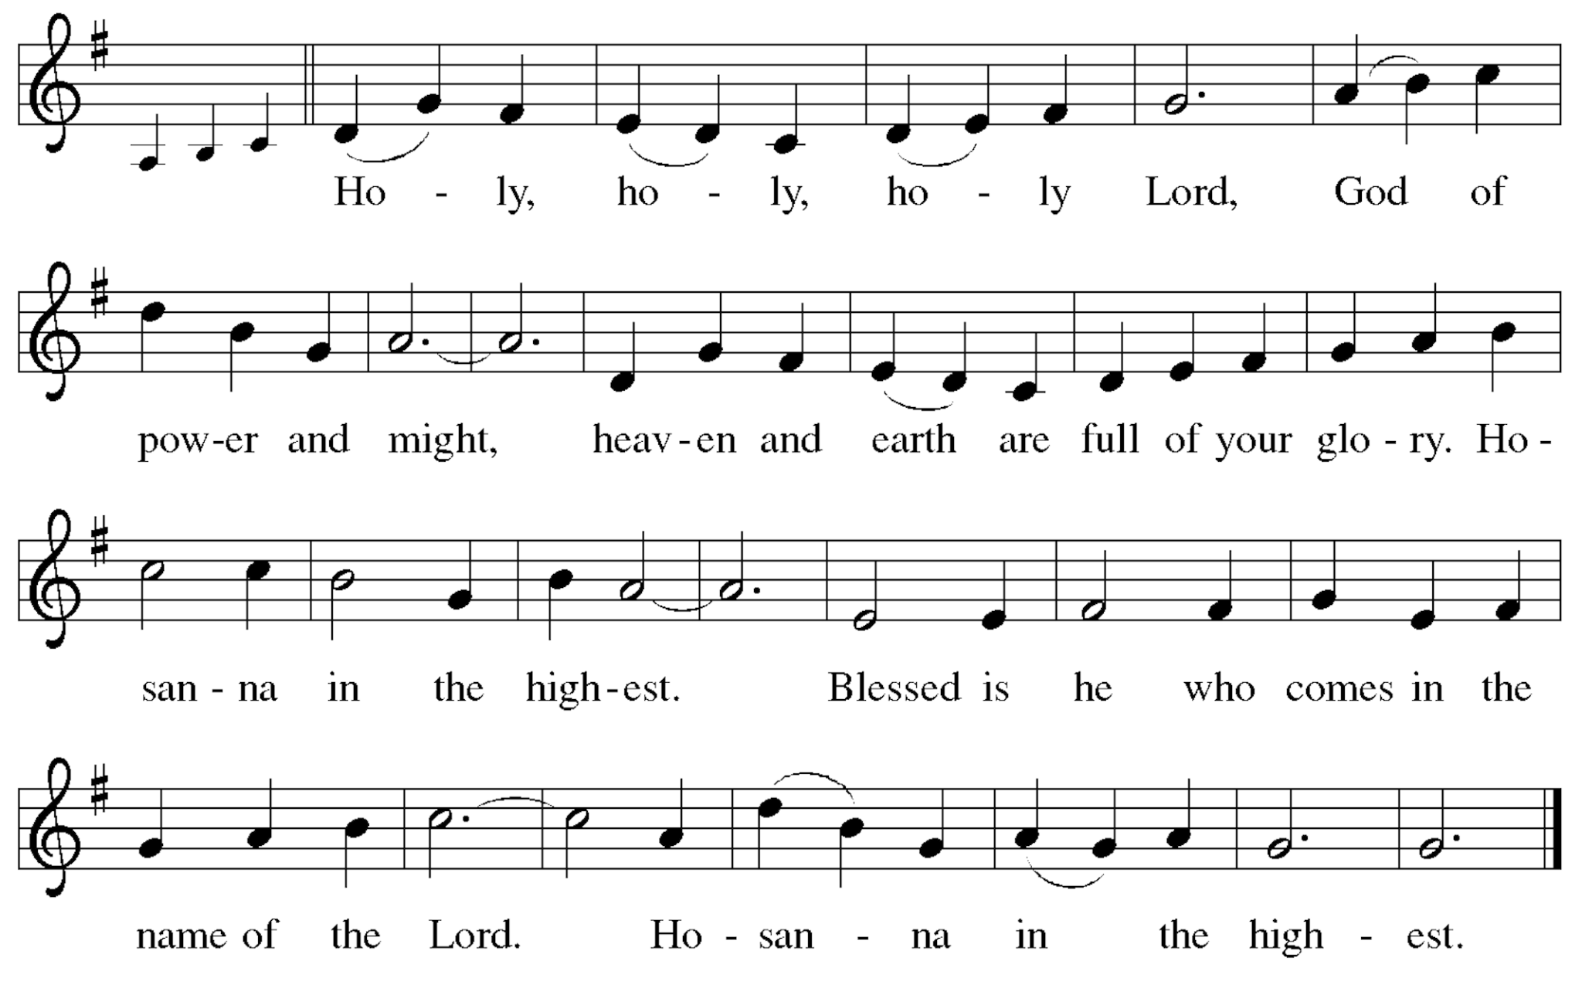  It is our joy to bless you, Creator of all, for you made us, and before us, you made the world we inhabit, and before the world, you made the eternal home in which, through Christ, we have a place. All that is spectacular, all that is plain, have their origin in you; all that is lovely, all who are loving point to you as their fulfillment.  And grateful as we are for the world we know and the universe beyond our sight, we especially praise you, whom eternity cannot contain, for coming to earth and entering time in Jesus.  For his life that informs our living, for his compassion which changes our hearts, for his clear speaking which contradicts our generalities, for his disturbing presence, his innocent suffering, his fearless dying, his rising to life breathing forgiveness, we praise and worship you.  In the night in which he was betrayed,  our Lord Jesus took bread, and gave thanks;  broke it, and gave it to his disciples, saying:  Take and eat; this is my body, given for you.  Do this for the remembrance of me. The assembly may bow.  Again, after supper, he took the cup, gave thanks,  and gave it for all to drink, saying:  This cup is the new covenant in my blood,  shed for you and all people for the forgiveness of sin.  Do this for the remembrance of me. The assembly may bow.  Let us proclaim the mystery of faith:  Christ has died. Christ is risen! Christ will come again.  And now, lest we believe that our praise alone fulfills your purpose, we fall silent and remember him who came because words were not enough.  Setting our wisdom, our will, our words aside, emptying our hearts, and bringing nothing in our hands, we yearn for the healing, the holding, the accepting, the forgiving that Christ alone can offer.  Merciful God, send now, in kindness, your Holy Spirit to settle on this bread and wine, and fill them with the fullness of Jesus. And then let that same Spirit rest on us, reforming us from the patterns of this passing world, as we become the living body of the one whose food we now share.  Through Christ, with Christ, and in Christ, all glory and honor is yours, Almighty God, with the Holy Spirit, in your holy church, both now and forever. And let the church say, Amen!  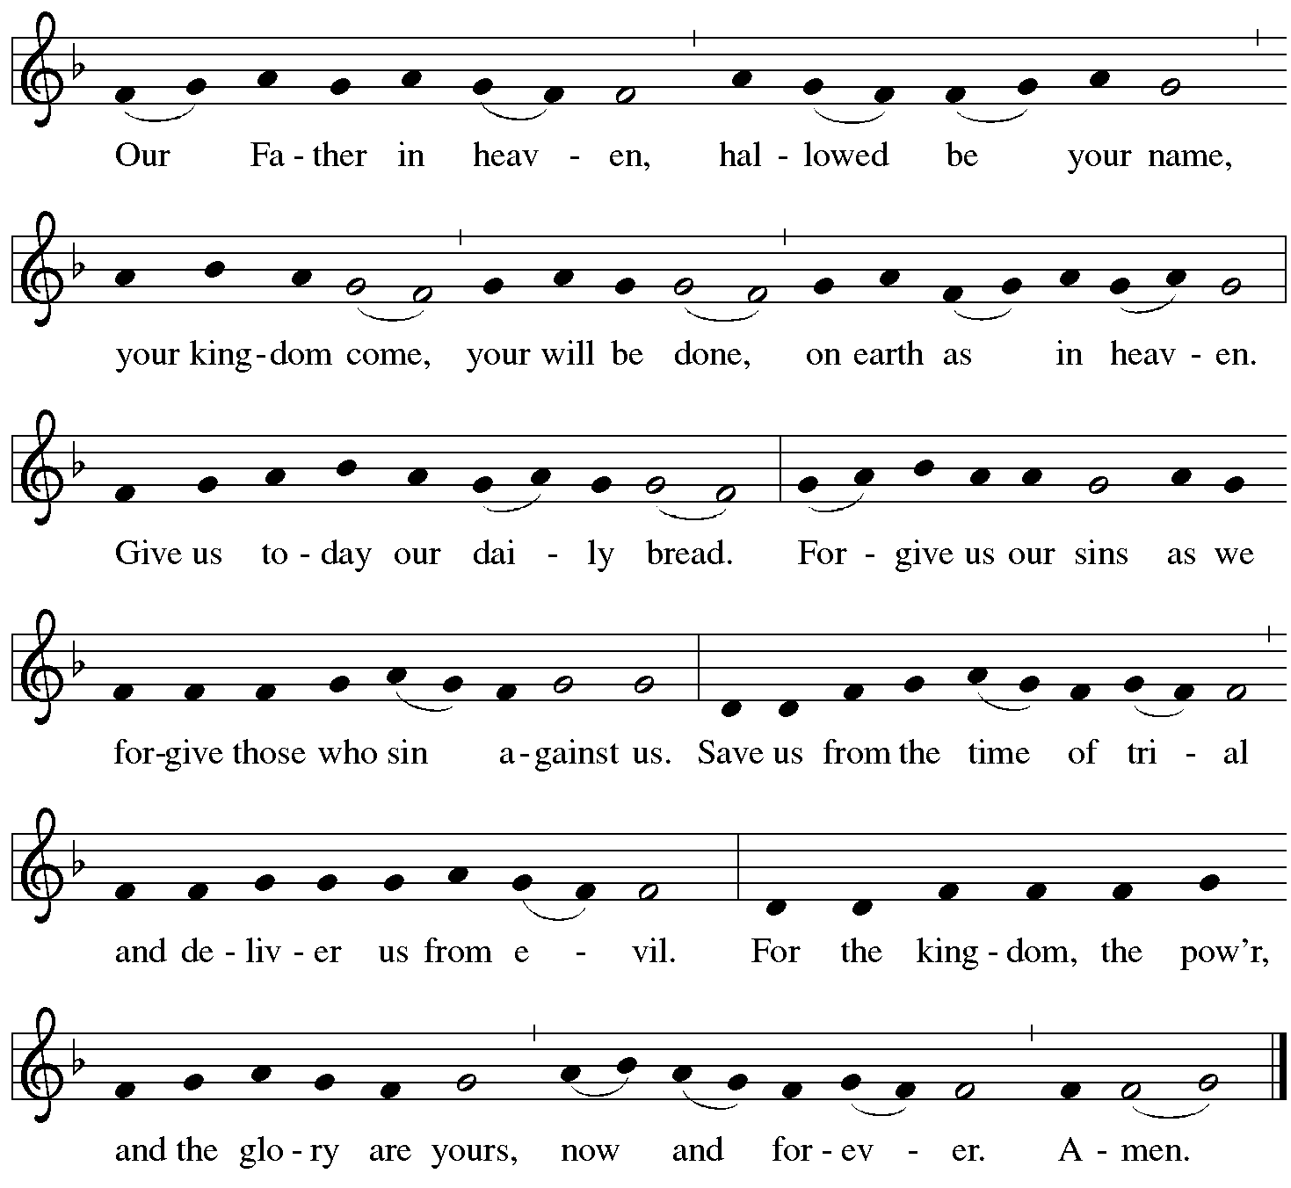  These are the gifts of God for the people of God. Taste and see that the Lord  is good. Thanks be to God!  The assembly sits until invited forward by an usher.  All are welcome at this table. This is not a Lutheran, Episcopal, or a Roman Catholic table; it is God’s table and all are invited to receive. The small cups contain either white wine or red grape juice. Gluten-free wafers are also available, just ask. After receiving, you may leave your empty cup on the table near the side aisle. If you do not wish to receive communion, you may come forward for a blessing, and you may indicate that by crossing your arms over your chest. You may also remain in your seat during distribution, knowing that this table is open when you are ready.  O nata lux Thomas Tallis (1505-1585)  O light born of light, Jesus, Redeemer of the world, mercifully deign to hear our prayers and supplications which we raise. You who once did accept the covering of flesh for the sake of the lost, grant that we may become members of your blessed body.

communion hymn  #317 | “Jesus on the mountain peak” | BETHOLD
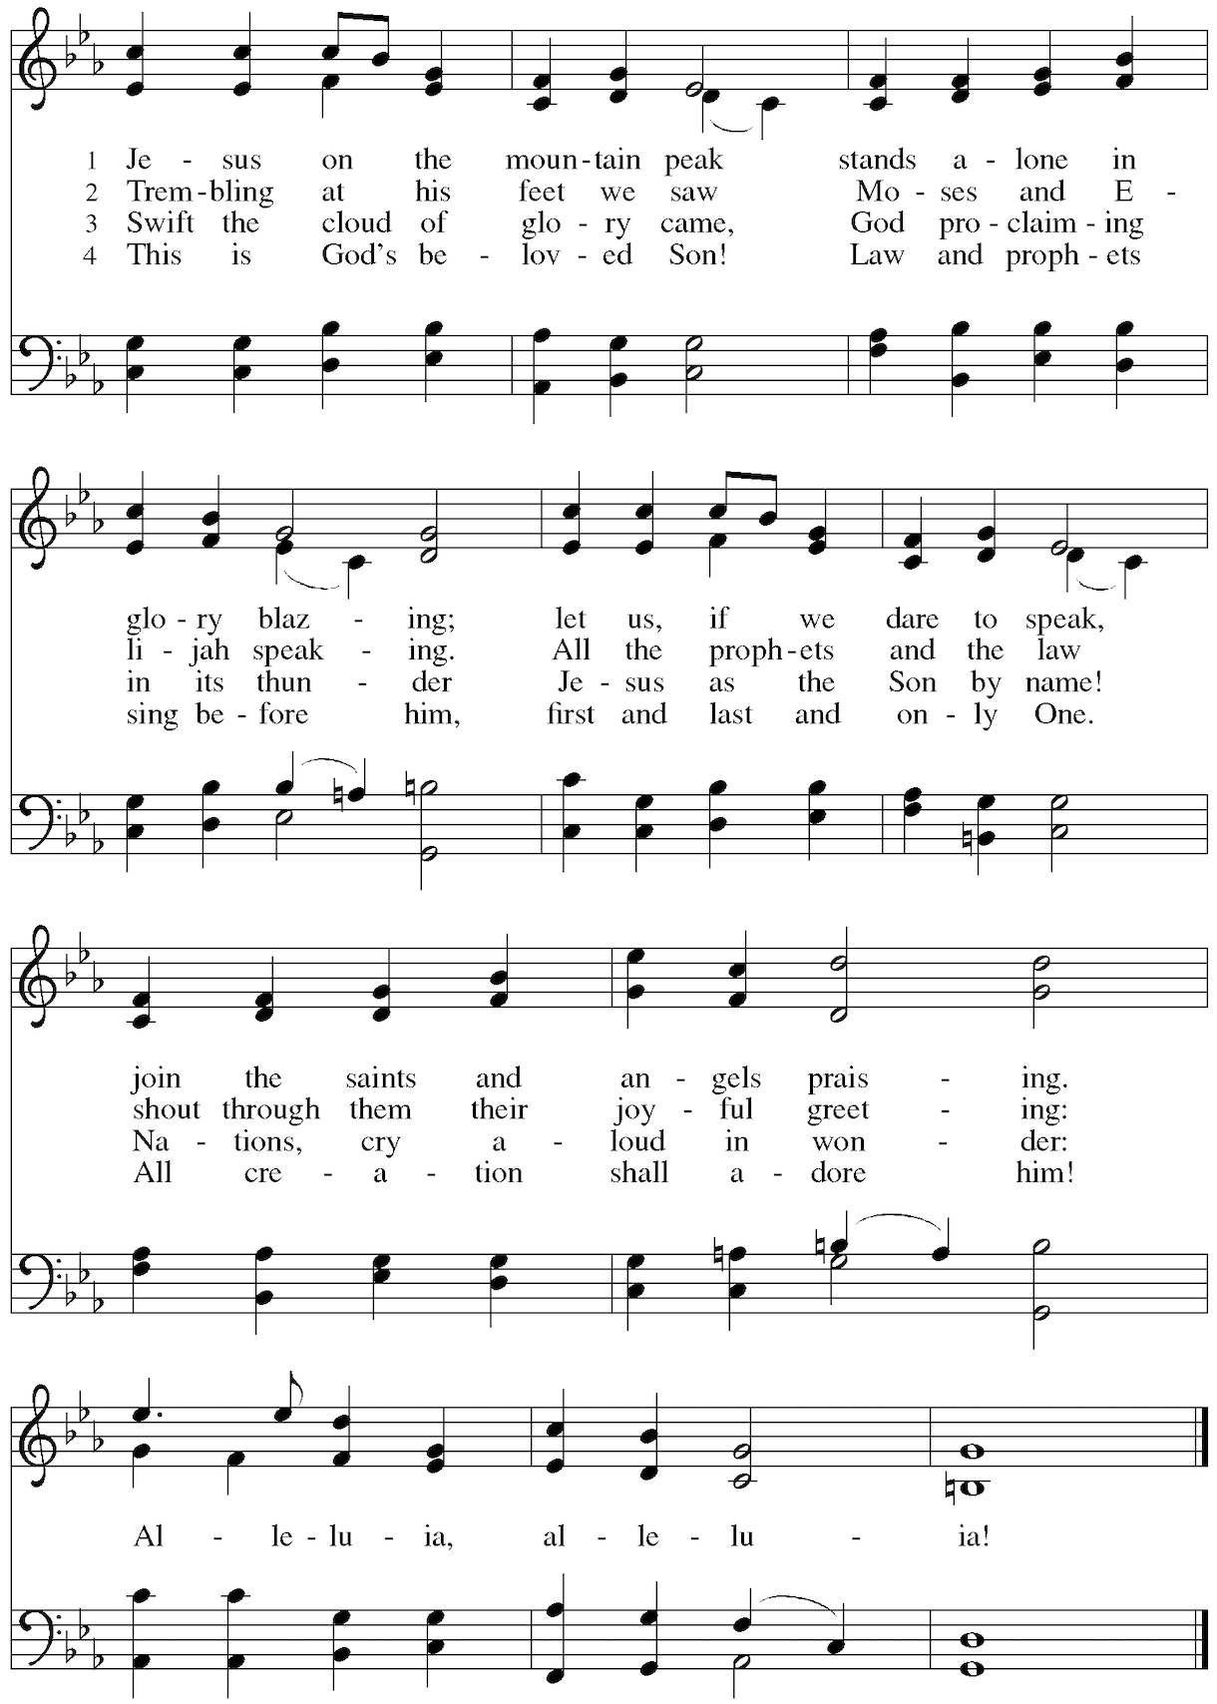
prayer after communion | The assembly stands.  Let us pray. God of our ancestors, as the broken bread was gathered into one loaf, you have gathered and healed your people throughout all generations. Send us forth in peace, keep us from danger, order our steps, and guide our feet as we run this race of faith, through Jesus Christ our Lord. Amen.

S E N D I N G  final blessing  (1 Thessalonians 5) | Go out into the world in peace. Have courage. Hold onto what is good. Return no one evil for evil. Strengthen the faint-hearted. Support the weak. Help the suffering. Honor everyone. Love and serve God, rejoicing in the power of the Spirit. And may the blessing of almighty God, Father, ☩ Son, and Holy Spirit, be with you now, and remain with you always. Amen.

sending hymn  #867 | “In thee is gladness” | IN DIR IST FREUDE
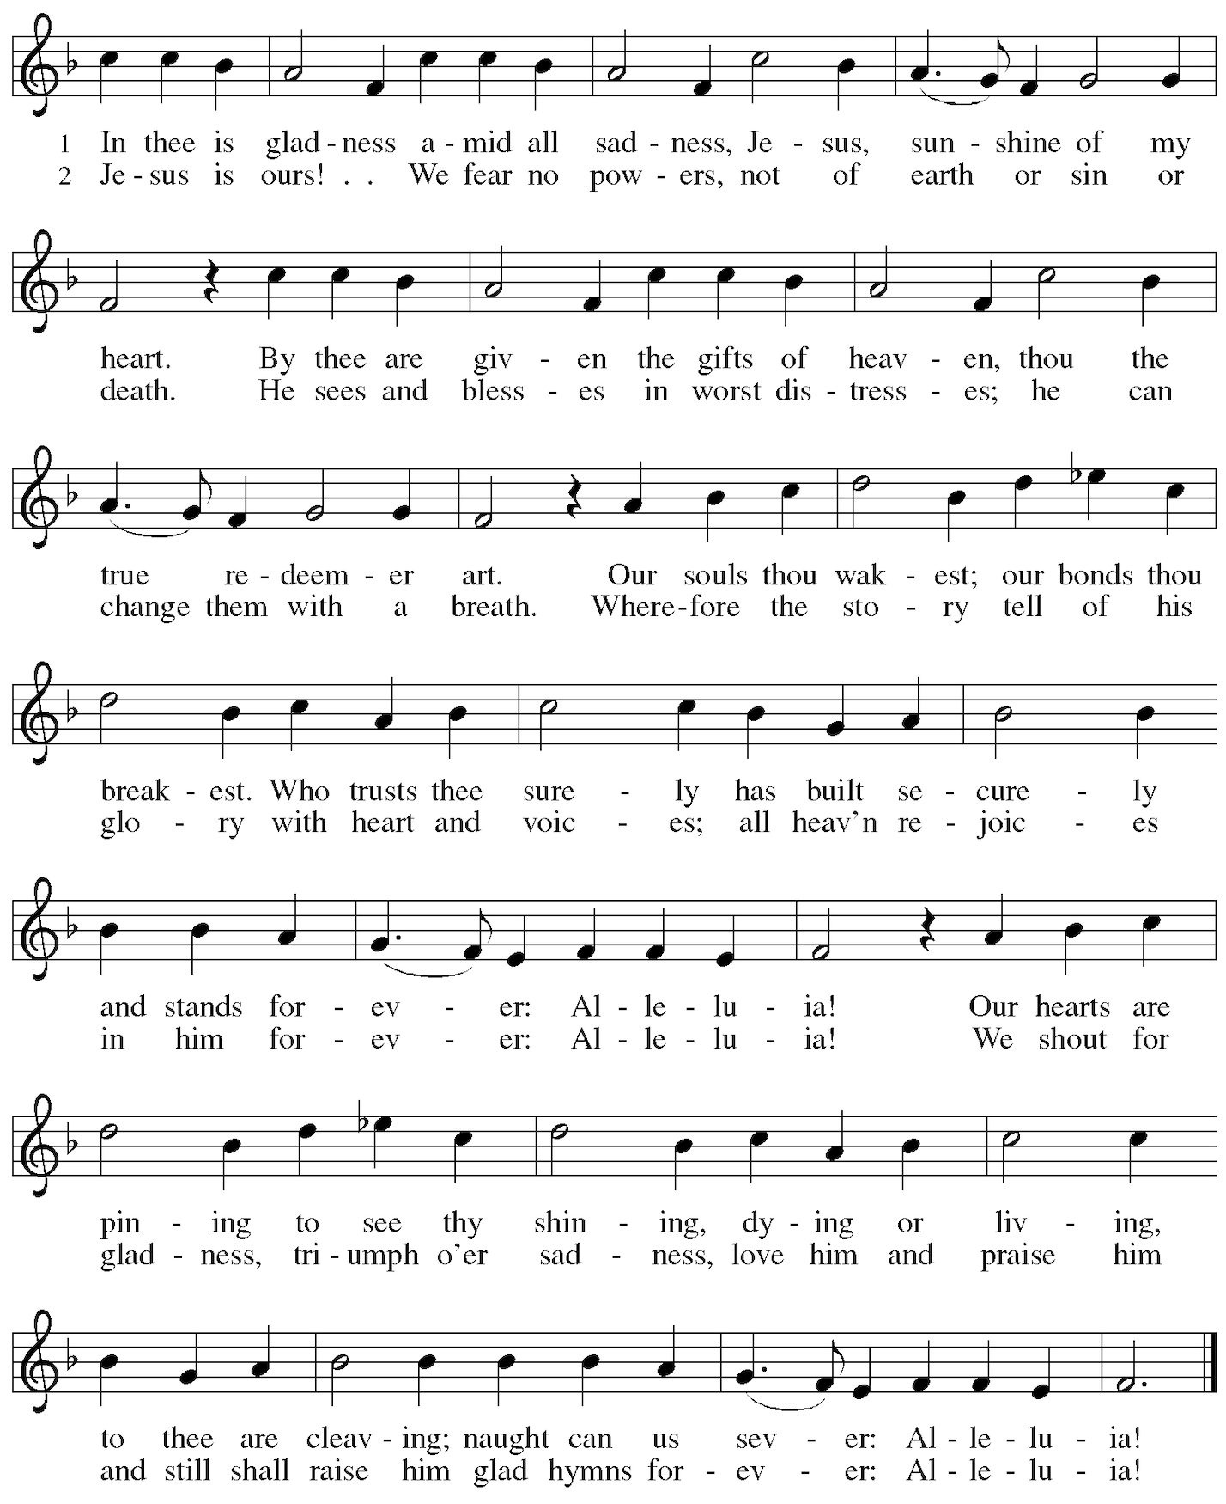

dismissal  postlude | The Mass is ended.  Go in peace to love and serve the Lord.  Thanks be to God.  The assembly sits for the postlude.  Mad Rush Philip Glass (b. 1937)
The liturgical texts and music are from Sundays and Seasons copyright © 2026 Augsburg Fortress. Our Augsburg Fortress Liturgies Annual License number is SAS003217. The scriptures are from the New Revised Standard Version Updated Edition, copyright © 2021, National Council of Churches of Christ in the United States of America. Hymnody made available through One License Annual License with
Podcasting Renewal A-732983. Used by permission. All rights reserved.

PLEASE REMEMBER IN YOUR PRAYERS  Dorothy Barritt  Dolores Fernandez  John Senig  Stephen Shea  Bonnie Minger  John and Joe K.  Tim Seboldt  Dick Baumann  Rachel Boccio  Raphael Ruiz  Dean Weisman  Thorvald Slater  Mike Rodriguez  Barbara Taylor  Carol Harnett  Kathy VanBlarcum  Angel Luis  Paul Schmidt  Ruth Farrell  Louise Printz  Marilyn Johnson  Jeremy Lee  Nancy McCloskey  Amy Clare Whitaker  If you would like to give altar flowers in memory of a loved one or in commemoration of  an event, email office@holytrinitynyc.org | WELCOME TO HOLY TRINITY  If you are new to Holy Trinity, we are glad you’re here. Whether you’ve worshiped here a thousand times or today is your first time, there will always be a place for you here.  Restrooms are located on the lower level.  Please follow safe church practices during worship and other activities at Holy Trinity. Parents and guardians, please do not allow children to go anywhere in the building unattended. Thank you for your help in keeping Holy Trinity a safe place for all people.  During the passing of the peace, you may greet those around you in whatever way is most comfortable to you. If you, for any reason, wish to avoid physical contact during the peace, you may cross your arms over your chest to indicate your desire for a verbal greeting.  After Mass, please join us for Coffee Hour in the Community Room located on the lower level.  Find all our news and announcements in our e-newsletter:    Sign up for our weekly newsletter at tinyurl.com/signupHT. And reach out to Pastor Tim and let him know you’re here today. His email is pastortim@holytrinitynyc.org.

A Reconciling in Christ congregation of the Evangelical Lutheran Church in America
3 W. 65th Street at Central Park West, New York, NY 10023
(212) 877-6815 | holytrinitynyc.org

