  WELCOME TO BACH VESPERS  WELCOME TO HOLY TRINITY  LIVE STREAMING AT HOLY TRINITY | BACH VESPERS | ESTOMIHI  Sunday, February 15th 2026  For at least the last eighteen centuries, some formula for prayer at the end of the day has been part of the Christian tradition. We don’t know precisely what the earliest Vespers looked like or sounded like, but certain themes have endured, including confession, gratitude, and light. While Vespers never quite became a significant part of Lutheran piety, that it is still kept at all in the Lutheran tradition may be thanks to one church: the Thomaskirche in Leipzig.  For twenty-seven years Johann Sebastian Bach served as the Kantor of the Thomaskirche, where most of his cantatas were composed—and though Bach’s cantatas were generally performed at a Sunday morning liturgy, our practice at Bach Vespers imagines what can happen when we juxtapose the ancient tradition of Vespers with the cantatas of the principal musician of the city that helped it endure.  The Evangelical Lutheran Church of the Holy Trinity is a congregation of the Evangelical Lutheran Church in America (ELCA), the largest progressive Lutheran body in the United States. As Lutherans, we go about Christianity in a Lutheran way, emphasizing that we are reconciled with God (justified) not by anything we do, but through and because of God’s love, freely given (grace). We love questions more than quick fixes (paradox), and we read the Bible in a way that honors it as the source and norm of faith, but not as a literal handbook. As Lutherans, we also lift up the gifts and capacity for ministry (vocation) that every person unquestionably holds.  As a Reconciling in Christ (RIC) congregation (and the first in the Metropolitan New York Synod), Holy Trinity welcomes all persons, including all sexual orientations, gender identities, and gender expressions. Holy Trinity is also committed to practicing racial equity, learning anti-racism, and modeling radical hospitality and inclusion across age, class, national origin, physical and mental health and ability, family configuration, and language. With a heart for the city, a passion for justice, and a commitment to the arts, we seek to be a place where all God’s people will know they are loved. Welcome. We’ve been waiting for you. There is a place for you here.  Please be aware that worship this evening is being filmed, photographed, and live streamed on our YouTube channel. Your likeness and/or voice may be captured by our equipment. Please alert an usher at the entrance if you have any concerns. Selections may be used on our website and in our public relations materials.

ASSISTING MINISTERS  USHERS  DIGITAL SACRISTAN  VIOLINS  VIOLAS  CELLO  BASS  OBOES  BASSOON  RECORDERS  TRUMPET  SOPRANOS  ALTOS  TENORS  BASSES  VIOLIN SOLOIST  GUEST CONDUCTOR  BACH VESPERS DIRECTOR  MUSIC DIRECTOR & ORGANIST  PASTOR | SPECIAL THANKS TO  Tim Cage and Robert Crumb  Anne & Marlin Kinzey  Tom Barritt  Tatiana Daubek, Dongmyung Ahn, Kiyoun Jang, Francis Liu, Jessica Park, & Anna Parks  Dan McCarthy & Jessica Meyer  Oliver Weston & Nathan Whittaker  Dara Bloom  Gonzalo Ruiz & Pablo O’Connell  Clay Zeller-Townson  Rachely Begley & Dirk Wels  Dean Oaks  Maura Tuffy*, Aani Bourrassa, Elizaveta Kozlova, Kristin Sands  Catherine Hedberg, Clifton Massey, & Luke Paulino  AJ Rodriguez*, Matt Krenz, & Stephen Sands  Anicet Castel*, Jonathan Harris, & Max Parsons  *soloist  Kelly Hall-Tompkins  Dylan Sauerwald  Robby Meese  Austin Philemon  The Reverend Timothy Weisman

Tonight’s cantata is generously sponsored in memory of Bonnie Eggers by her family

V E S P E R S  prelude | Sonata no. 1 in b minor, BWV 1014: I. Adagio | J.S. Bach  (1685-1750)

 | When invited by the presider, the assembly stands and faces the rear doors.
blessing of  the incense | Let us pray. Silence is kept. Let our prayers rise before you as incense, O God, and let your lovingkindness descend upon us, that with the church on earth and the whole heavenly host we may sing your praises, through your Son Jesus Christ, our Savior  and Lord. Amen.
You may light your candle from one of the aisle candles or from your neighbor. When holding
a lit candle, please ensure that it remains completely upright at all times.

entrance hymn | “Evening and morning” | DIE GÜLDNE SONNE
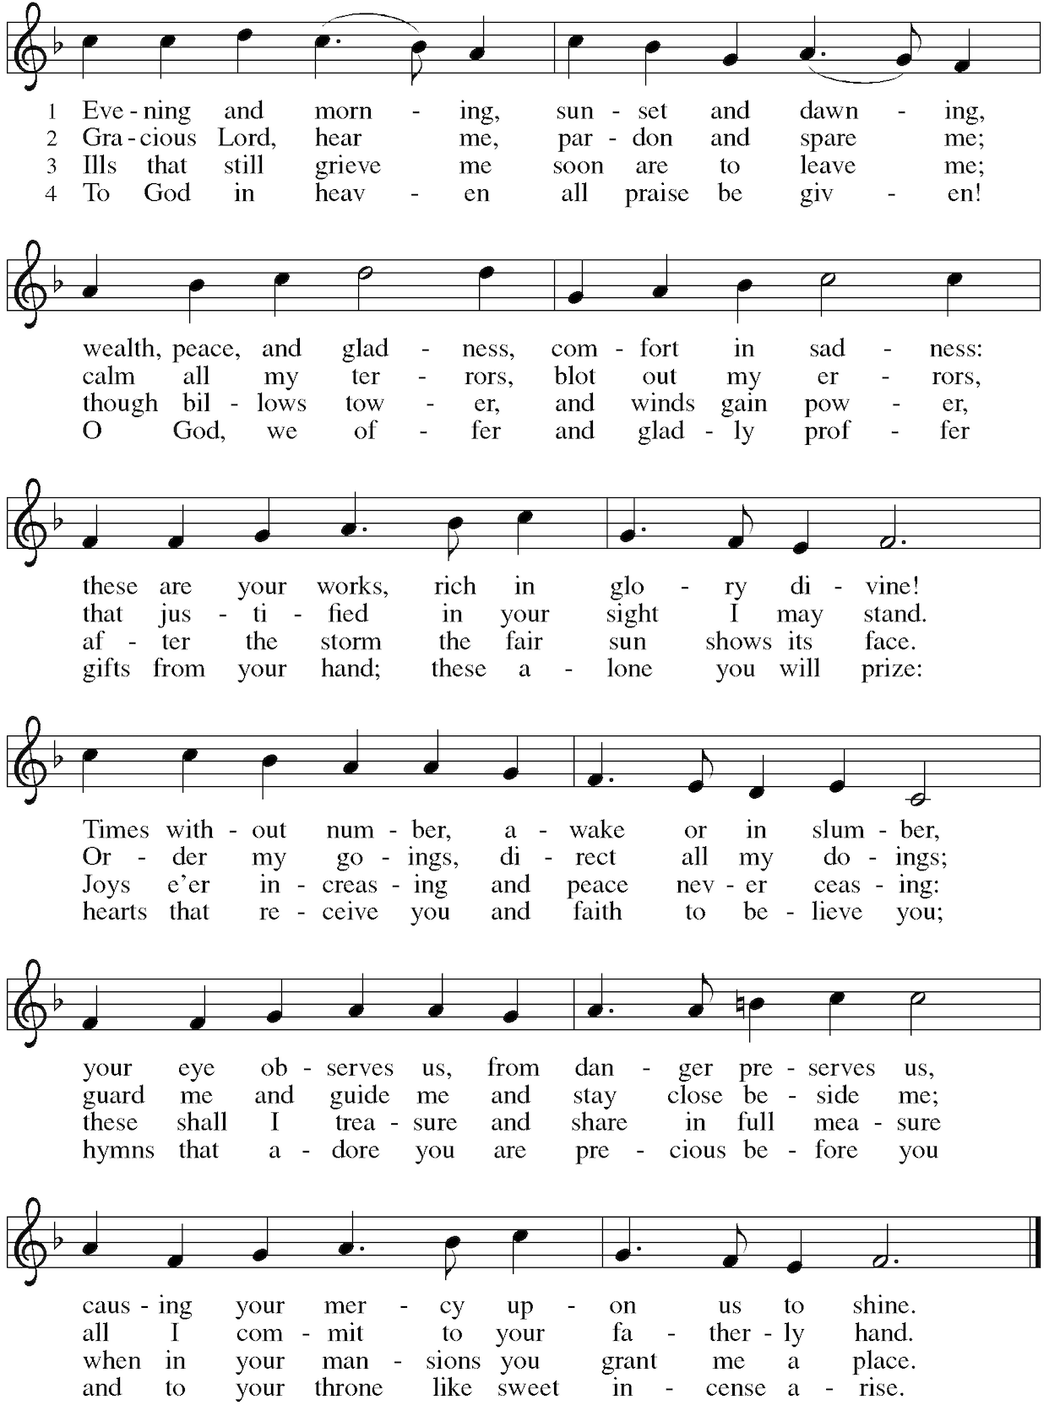

The assembly sits. Please ensure that your candle remains completely upright at all times.
psalm 146  psalm  prayer | from The New Becker Psalter  by Austin Philemon (b. 1994)  Let us pray. Silence is kept. Blessed indeed are they who put their trust in you,  O God, our sure rock and refuge. Guard us from giving to any other the allegiance that belongs only to you. Shine upon us with the brightness of your light, that we  may love you with a pure heart and praise you forever; through Jesus Christ, our Savior and Lord. Amen.
  My soul shall praise God the Lord,  I will gladly praise Him with all my heart,  I will sing praises to my God,  As long as I live, until death.  Do not put your trust in princes,  Do not place your confidence in them,  For they are nothing more than men,  In whom no help can be found.  The spirit of man must depart,  He returns to the earth,  For his plans are lost  And all that he chose for himself.  The Lord makes the blind see,  He loves and protects righteousness,  His mighty hand quickly lifts up  All who are downcast.  He protects the orphan and the stranger,  Shows His faithfulness and goodness  On poor widows burdened with hardship,  He turns back the wickedness.  On this rests our confidence,  The Lord is King forever,  Your God, O Zion, for all time,  Hallelujah we sing with joy. | Mein Seel soll loben Gott den Herrn,  Ich lob ihn ja von Herzen gern,  Ich will lobsingen meinem Gott,  Solang ich leb bis in den Tod.  Verlasst euch doch auf Fürsten nicht,  Setzt nicht auf sie eur Zuversicht,  Denn sie nichts mehr als Menschen sind,  Bei denen man kein Hilfe findt.  Des Menschen Geist muss doch davon,  Er wird zur Erde wiederum,  Alsdenn sein Anschläg sind verlorn  Und alles, was er ihm erkorn.  Der Herr macht sehend blinde Leut,  Er liebt und schützt Gerechtigkeit,  Sein starke Hand richt auf geschwind  Alle, die niedergschlagen sind.  Waisen und Fremdling er behüt,  Erweiset seine Treu und Güt  An armen Witwen hoch beschwert,  Gottloses Tun zurück er kehrt.  Darauf steht unser Zuversicht,  Der Herr ist König ewiglich,  Dein Gott, o Zion, alle Zeit,  Halleluja singn wir mit Freud.

from  the holy gospels  sermon | Luke 18:31-43  ³¹ Then he took the twelve aside and said to them, “Look, we are going up to Jerusalem, and everything that is written about the Son of Man by the prophets will be accomplished. ³² For he will be handed over to the gentiles, and he will be mocked and insulted and spat upon. ³³ After they have flogged him, they will kill him, and on the third day he will rise again.” ³⁴ But they understood nothing about all these things; in fact, what he said was hidden from them, and they did not grasp what was said.  ³⁵ As he approached Jericho, a blind man was sitting by the roadside begging.  ³⁶ When he heard a crowd going by, he asked what was happening. ³⁷ They told him, “Jesus of Nazareth is passing by.” ³⁸ Then he shouted, “Jesus, Son of David, have mercy on me!” ³⁹ Those who were in front sternly ordered him to be quiet, but he shouted even more loudly, “Son of David, have mercy on me!” ⁴⁰ Jesus stood still and ordered the man to be brought to him, and when he came near, he asked him, ⁴¹ “What do you want me to do for you?” He said, “Lord, let me see again.” ⁴² Jesus said to him, “Receive your sight; your faith has saved you.” ⁴³ Immediately he regained his sight and followed him, glorifying God, and all the people, when they saw it, praised God.  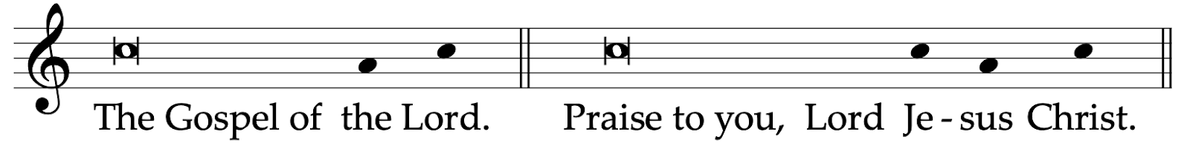  Please extinguish your candle.  The Reverend Timothy Weisman

C A N T A T A  coro  recitativo tenore  aria soprano  recitativo e aria basso  corale | Herr Jesu Christ, wahr Mensch und Gott  BWV 127
  Lord Jesus Christ, true human and God,  You who suffered agony, fear, and mockery,  Who ultimately also died for me on the cross  And purchased for me your father’s favor,  I ask through your bitter suffering:  May you be gracious to me, a sinner.  When in the end everything horrifies,  And when a cold death-sweat  Drenches the limbs already paralyzed,  When my tongue speaks  through sighs alone  And this heart breaks:  It is enough that faith then knows  That Jesus stands by me,  He goes with patience to his suffering,  And along this difficult path  He also guides me,  And prepares for me rest.  The soul will rest in Jesus’ hands,  When earth covers this body.  Ah, summon me soon, you death bells;  I am unafraid of dying,  Because my Jesus will resurrect me.  When one day the trumpets sound,  And when the edifice of the world,  Along with those vaults of the skies,  Will fall into ruin, dashed to pieces,  Then think of me, my God, for the best;  When your servant one day  appears for the judgment,  Where thoughts accuse themselves,  Then may it be your will, however,  O Jesus, to be my advocate  And say consolingly to my soul:  In truth, in truth, I say to you:  When skies and earth  pass away in the fire  Then a believer shall abide eternally.  He will not come into the judgment  And he will not eternally taste death.  Just cleave yourself,  My child, to me:  I will break, with mighty  and saving hand,  Death’s powerfully tautened bond.  Ah, Lord, forgive all our transgressions,  Help, that we may wait with patience  Until our hour of death draws near;  And that our faith be ever vigilant,  Trusting your word steadfastly,  Until we blessedly fall asleep. | Herr Jesu Christ, wahr Mensch und Gott,  Der du littst Marter, Angst und Spott,  Für mich am Kreuz auch endlich starbst  Und mir deins Vaters Huld erwarbst,  Ich bitt durchs bittre Leiden dein:  Du wollst mir Sünder gnädig sein.  Wenn alles sich zur letzten Zeit entsetzet,  Und wenn ein kalter Todesschweiss  Die schon erstarrten Glieder netzet,  Wenn meine Zunge nichts  als nur durch Seufzer spricht  Und dieses Herze bricht:  Genug, dass da der Glaube weiss,  Dass Jesus bei mir steht,  Der mit Geduld zu seinem Leiden geht  Und diesen schweren Weg  auch mich geleitet  Und mir die Ruhe zubereitet.  Die Seele ruht in Jesu Händen,  Wenn Erde diesen Leib bedeckt.  Ach ruft mich bald, ihr Sterbeglocken,  Ich bin zum Sterben unerschrocken,  Weil mich mein Jesus wieder weckt.  Wenn einstens die Posaunen schallen,  Und wenn der Bau der Welt  Nebst denen Himmelsfesten  Zerschmettert wird zerfallen,  So denke mein, mein Gott, im besten;  Wenn sich dein Knecht einst  vors Gerichte stellt,  Da die Gedanken sich verklagen,  So wollest du allein,  O Jesu, mein Fürsprecher sein  Und meiner Seele tröstlich sagen:  Fürwahr, fürwahr, euch sage ich:  Wenn Himmel und Erde  im Feuer vergehen,  So soll doch ein Gläubiger ewig bestehen.  Er wird nicht kommen ins Gericht  Und den Tod ewig schmecken nicht.  Nur halte dich,  Mein Kind, an mich:  Ich breche mit starker  und helfender Hand  Des Todes gewaltig geschlossenes Band.  Ach, Herr, vergib all unsre Schuld,  Hilf, dass wir warten mit Geduld,  Bis unser Stündlein kömmt herbei,  Auch unser Glaub stets wacker sei,  Dein’m Wort zu trauen festiglich,  Bis wir einschlafen seliglich.

word of  welcome  offertory  magnificat  collect  for the day  (Veit Dietrich)  collect  for guidance  (Olive Wyon)  collect  for peace  (Julian of Norwich)  benedicamus  benediction | Robby Meese    In addition to giving towards the ministry of Bach Vespers  as the offering plates are being passed, you can  • Scan the QR code to the right;  • Venmo @holytrinitynyc;  • Send a Zelle to office@holytrinitynyc.org.  • Give to Bach Vespers through a Donor-advised Fund  by searching for our EIN: 13-1685538.  Sonata no. 2 in A major, BWV 1015 J.S. Bach  I. [Andante]  II. Allegro  The assembly stands when invited by the celebrant.  Meine Seele erhebt den Herren Michael Praetorius (1571-1621)  Let us pray.  Lord God, with your voice you directed us to your Son who would bear our sins that we might receive grace and the forgiveness of sins. Keep us in the true faith, strengthen  us by your Holy Spirit, and lead us to eternal life and salvation; through your Son, Jesus Christ our Lord, who lives and reigns with you and the Holy Spirit, one true God, now  and forever. Amen.  O Lord Jesus Christ, who in the days of thy flesh didst steadfastly set thy face to go to Jerusalem; didst suffer the Agony in the Garden, and dereliction on the cross; who yet,  for the joy that was set before thee, didst endure the cross, despising the shame, and art set down at the right hand of God: strength us: when we shrink from unknown ways.  Hold us firmly when we are afraid, help us to follow thee without swerving, to the end;  out of weakness, make us strong, lighten our darkness, and beat down Satan under our feet; and bring us unto everlasting life. Amen.  In you, God almighty, we have our preservation and our bliss. In you, Christ, we have our restoring and our saving. In you, our Lord the Holy Spirit, is marvelous and plenteous grace. You are our maker, our lover, our keeper. Teach us to believe that by your grace all shall be well, and all shall be well, and all manner of things shall be well. Amen.  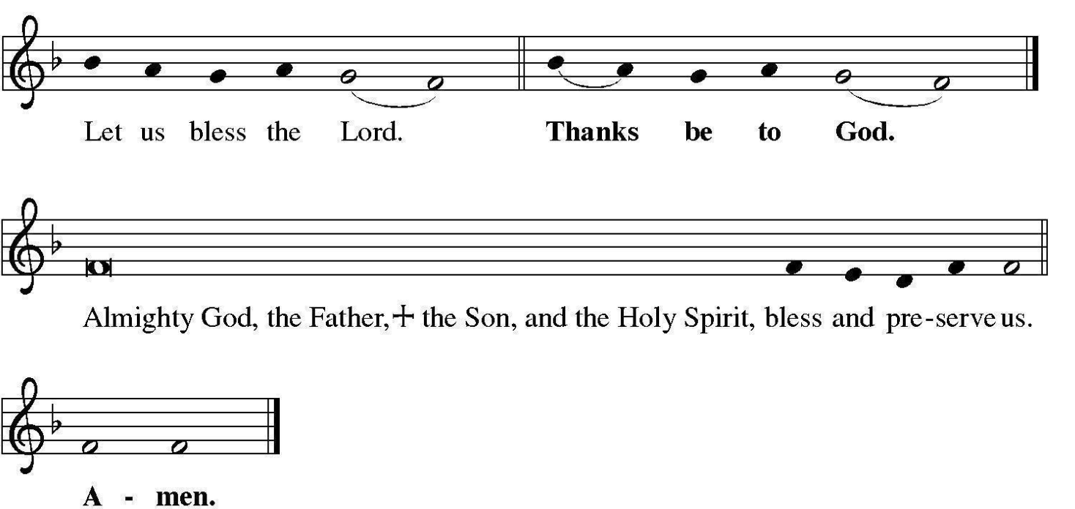
  My soul magnifies the Lord, and my  spirit rejoices in God my Savior,  for he has looked with favor  on the lowly state of his servant.  Surely from now on all generations  will call me blessed,  for the Mighty One has  done great things for me  and holy is his name;  He has shown strength with his arm;  he has scattered the proud  in the imagination of their hearts.  He has brought down the powerful from their thrones and lifted up the lowly;  he has filled the hungry  with good things  and sent the rich away empty.  He has come to the aid of his child Israel,  in remembrance of his mercy, according to the promise he made to our ancestors,  to Abraham and to  his descendants forever.  Glory be to the Father and to the Son,  and to the Holy Spirit,  as it was in the beginning,  is now, and will be  forever and ever, Amen. | Meine Seele erhebt den Herren, und mein Geist freuet sich Gottes, meines Heilandes;  denn er hat die Niedrigkeit  seiner Magd angesehen.  Siehe, von nun an werden mich selig preisen alle Kindeskind;  denn er hat große Ding  an mir getan, der da mächtig ist  und des Name heilig ist.  Er übet Gewalt mit seinem Arm  und zerstreuet, die hoffärtig sind  in ihres Herzens Sinn.  Er stößet die Gewaltigen vom Stuhl  und erhöhet die Niedrigen.  Die Hungerigen füllet er  mit Gütern  und lässet die Reichen leer.  Er denket der Barmherzigkeit und hilft seinem Diener Israel auf,  wie er geredt hat unsern Vätern,  Abraham und  seinem Samen ewiglich.  Ehre sei dem Vater und dem Sohn und auch dem Heiligen Geiste,  wie es war im Anfang,  jetzt und immerdar und von Ewigkeit zu  Ewigkeit, Amen.

During the hymn, the assembly turns to face the cross as the procession passes by,
orienting ourselves towards Central Park West and the world.

sending hymn | “Lord Jesu Christ, true man and God” | JESU CHRIST, WAHR MENSCH

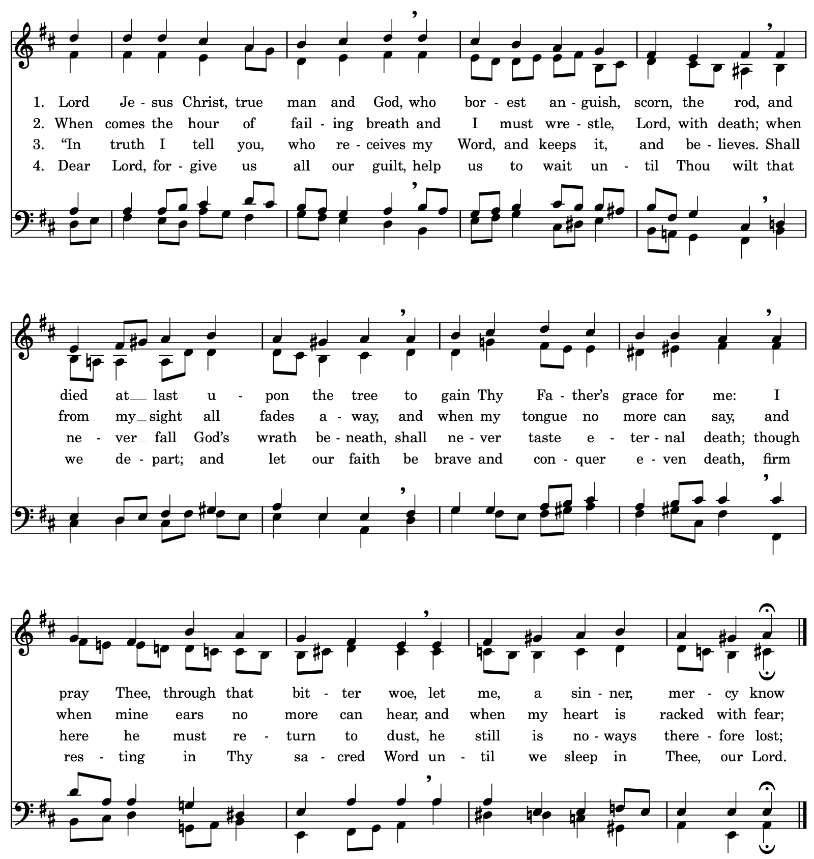
postlude | The assembly sits for the postlude.  Praeludium in C Major, BuxWV 138 | Dieterich Buxtehude
DONORS
Soli Deo Gloria ($20,001 and above)  George Shea  Platinum (up to $20,000)  William Eggers and his Family  in loving memory of Bonnie Eggers  Friends of Bach in the City of New York  Gold (up to $12,000)  Rebecca Brakke  Robert Busch & Richard Dematteis,  in memory of their parents  Tim Cage & Eric Nelson,  in memory of Tony Rand  Silver (up to $5,000)  Dorothy Barritt  Thomas Barritt,  in honor of Dorothy M. Barritt on her 90th birthday  Susan Hannah,  in memory of Edward Hannah  Dr. Nancy Maruyama  John Perlich  Dorothy Scholz-Beyer,  in loving memory of Pastor Bob Scholz  Carol Stein  Supporter (cont.)  Jay & Kelly Myers  Jennifer Nelson  Lori Padua  Paxton Ellis Fund  Dennis Prahl  John & Lynne Richards  Gary & Joyce Roth  Michael Schneiders  Charlie Schreiber  Martha Schultz  Gayle & Douglass Seaton  Avinoam Sharon  Richard Sturm  David Titus-Peng  Kelly Hall-Tompkins  Julie Shea Towell  Tim Wentzlaff  Robert Workoff  Gerry & Beth Yarnall  Friends (up to $150)  Alexandra Altman  Jason & Kim Anderson  Eleanor Applewhaite  Louise Basbas  Frederic C. Beacham III  John Benson  William Benson  Erickson S. Blakney  Janis Blimling  Rich Bornstein  Cord Bruegmann  Julie Brye & Elvira Ortiz  Charles J. O'Byrne  Aaron Cantrell  Sherab Chodron  Cricket Cooper  Margaret W. Crane  Lenore Davis  Laura Dolp  Andrew Fallaize  Randolph Floyd  Kristian & Angela Gevert  Ryan Gottfredson  Elizabeth Grabowski | Bronze (up to $2,500)  James and Suzanne Boccio  Joan Gabel  Anne & Marlin Kinzey  Ricks Family Charitable Fund  Dorothea von Mücke,  in memory of the Reverend Horst von Mücke and  Veronica von Mücke  Irene Schultz  Kathy Yates  Sponsor (up to $1250)  Anonymous  Caroline Bynum  Robert Crumb  Darlene Challberg  Marcus Epstein  Robert Hoglund  Jeff Juliar & Scott Merrell  Allen Lieb  Vera Pavone  Steven Schmidt & Kristine Peterson  Timothy Weisman and Jeremy Friedland  To give to Bach Vespers, please visit tinyurl.com/givebach  Supporter (up to $500)  Al Ahlstrom  Robert Ambaras  Anonymous  William Bassler  Ellen Braaten  David & Peggy Burke  Stephen F. Byrns & Thomas W. Lollar  Rick Coble  Lori & David Damrosch  Donna Doyle  Frances Fairey  Joe Fryer & Peter Brylinke  Julie Green  Kelly Haddle  Nancy Hager  Evelyn Junge  Richard Lefkowitz  Friends (cont.)  Carleen Graham  Cynthia Hanson  Matthew Hummel  Brooks Huston  Paul & Liz Johnson  Dahlia Japhet  Kimberly Jung  Evelyn Junge  Sebastian Kaempf  Babette Krolik  A.I. Kuhn Ritz  Bobby Langdon  Linda Lee  Emily Lemer  Phillip Nichols & Marita Wright  David Nierenburg  Katie Magaziner  Jeanne McComsey  Helene Millar  Lucy Miller  Maria Mei  James Naumann  Rachael Park  Rebecca Peterson  Emmy Potter  Martina Puchta  Bruce Saylor  Tao Radoczy  Philip Reed  Chapman Riedel  Jennifer Rivers  Gonzalo Ruiz & Tatiana Daubek  Karen Ruocco  Erik Ryding  Barbara Scaturro  Emma Scholz  Jessica Schuett  John & Mary Seboldt  MacKenzie Singleton  Edward Todd  Richard Eric Walker  Sonja Weissman  Elizabeth Williamson  Yoshisuke Yamada  Davide Zannoni
  To give to Bach Vespers, please visit tinyurl.com/givebach
  Venmo @holytrinitynyc
  Or mail a check to:
  Bach Vespers at Holy Trinity,
  3 W. 65th St, New York NY 10023.
  To give to Bach Vespers through a Donor-
  advised Fund, our EIN is 13-1685538.

