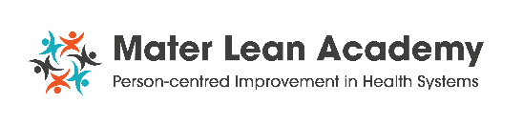
13th Annual National Lean Healthcare Symposium
“Lean forward: putting people at the heart of improvement”

Friday, 27th November 2026

Call for abstract submissions!
Award winners receive a €100 One for All Voucher & Trophy, kindly sponsored by the HSE Spark Innovation Programme.

- The Process Improvement Methodologies Award for the best use of process improvement methodologies in health systems.
- The Professor Jan Dewing Award for Person-centred improvement in health systems.
- The Process/Service innovation Award for the best process or service innovation in healthcare.

ABSTRACT SUBMISSION FORM
Corresponding author | Name:  Email:
Author(s), co-author(s) & affiliations | Names:  Roles:  Organisation:
Presentation title
Presentation type | All accepted abstracts will be presented as posters.  ☐ I/we also willing to deliver an oral presentation if invited
Presentation topic and award eligibility  (Tick the topic that apply) | ☐ A. Process improvement methodologies  ☐ B. Person-centred improvement  ☐ C. Process or service innovation
Background: (100 words max)

Methods (100 words max)

Findings/results (100 words max)

Conclusion/learning (100 words max)
Authors declarations | ☐ No patient, service user or staff identifiers are included  ☐ Appropriate approval was obtained for this work where applicable i.e. QI, audit registration, ethics committee or none was required.  ☐ All authors consent to abstract being published in Symposium materials and online communications
Attendance | ☐ At least one author will attend the Symposium. And register here
How to submit | Email the completed form as a PDF to leansixsigma@mater.ie by 30th October, 2026.  Corresponding authors will be notified of the outcome by email and those accepted will received poster formatting guidelines and some invited to present at the conference.
