
LOBSTER MONITORING
INFO:  Location: Leigh and Tawharanui, New Zealand  Client: Department of Conservation (DOC)  Project Date: 2009  SCOPE OF WORK:  - Lobster abundance assessments within Cape Rodney to Okakari Point Marine Reserve (CROP-Leigh), Tawharanui Marine Park (TMP), and non-reserve (NR)control area  - Compare trends in CROP and NR areas through time.  - Data analysis  - Assist with research on marine ecosystem and marine reserve functioning | PROJECT DESCRIPTION:  The Department of Conservation is charged with promoting conservation of the natural and historic heritage of New Zealand on behalf of, and for the benefits of, present and future New Zealanders.  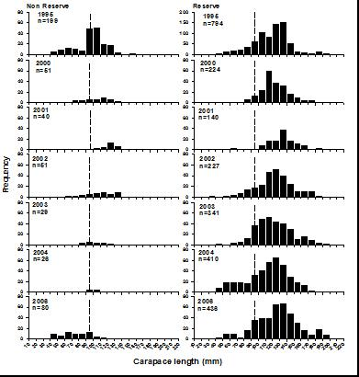  The spiny rock lobster (Jasus edwardsii) is an ideal species to use in exploring and promoting the benefits of marine reserves as Jasus edwardsii responds positively to protection in New Zealand. The CROP and TMP Lobster Monitoring Programme provides the department with information on the current status of the protected lobster population, monitors trends in population parameters through time and is capable of alerting reserve managers to potential problems with the lobster population.
LEIGH & TAWHARANUI, NEW ZEALAND
