
TSUNAMI INUNDATION MODELLING: WHITIANGA, TAIRUA AND PAUANUI
COROMANDEL PENINSULA, NEW ZEALAND
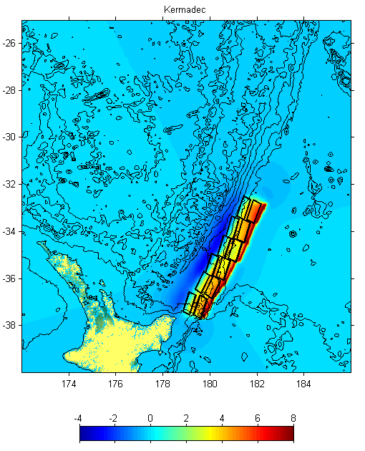
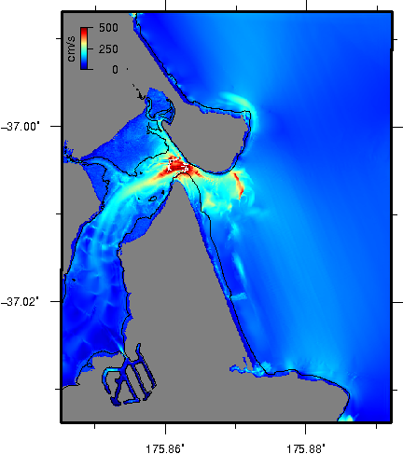
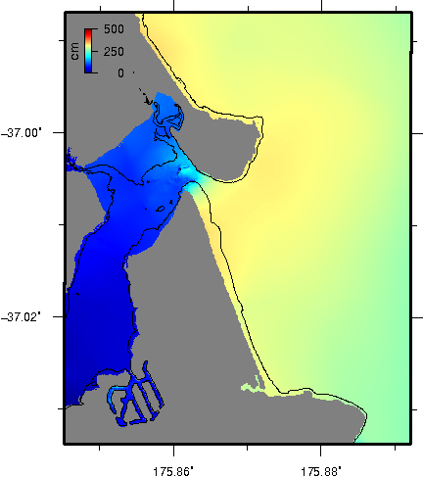
INFO:  Location: Whitianga, Tairua and Pauanui, Coromandel Peninsula, New Zealand  Client: Waikato Regional Council  Project Date: 2012  SCOPE OF WORK:  - Assessment of tsunami sources  - Numerical modelling of tsunami inundation and currents  - Comparison to historical events  - Multi-scenario sensitivity testing  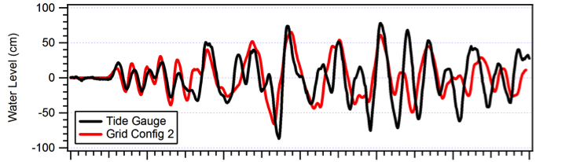 | PROJECT DESCRIPTION:  This study focused on a tsunami inundation modelling for sites on the Coromandel Peninsula. The latest scientific literature on tsunami sources and high resolution bathymetry grids were used to produce inundation predictions for Whitianga and Tairua – Pauanui. Model results were calibrated against historical data including the 1960 and 2010 Chile tsunamis and the 2011 Japan event.  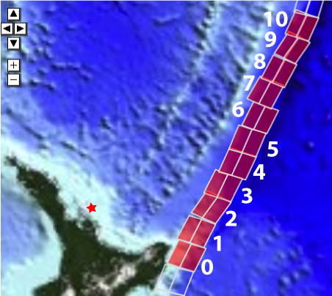  Forward modelling of hypothetical tsunami sources include earthquakes positioned along the Kermadec Trench subduction zone and a large subduction zone event located on the southern coast of Peru in South America. These sources were considered as they represent a significant hazard from both the near and far field. The Kermadec Trench poses a significant hazard in that this faulting zone lies adjacent to New Zealand.
