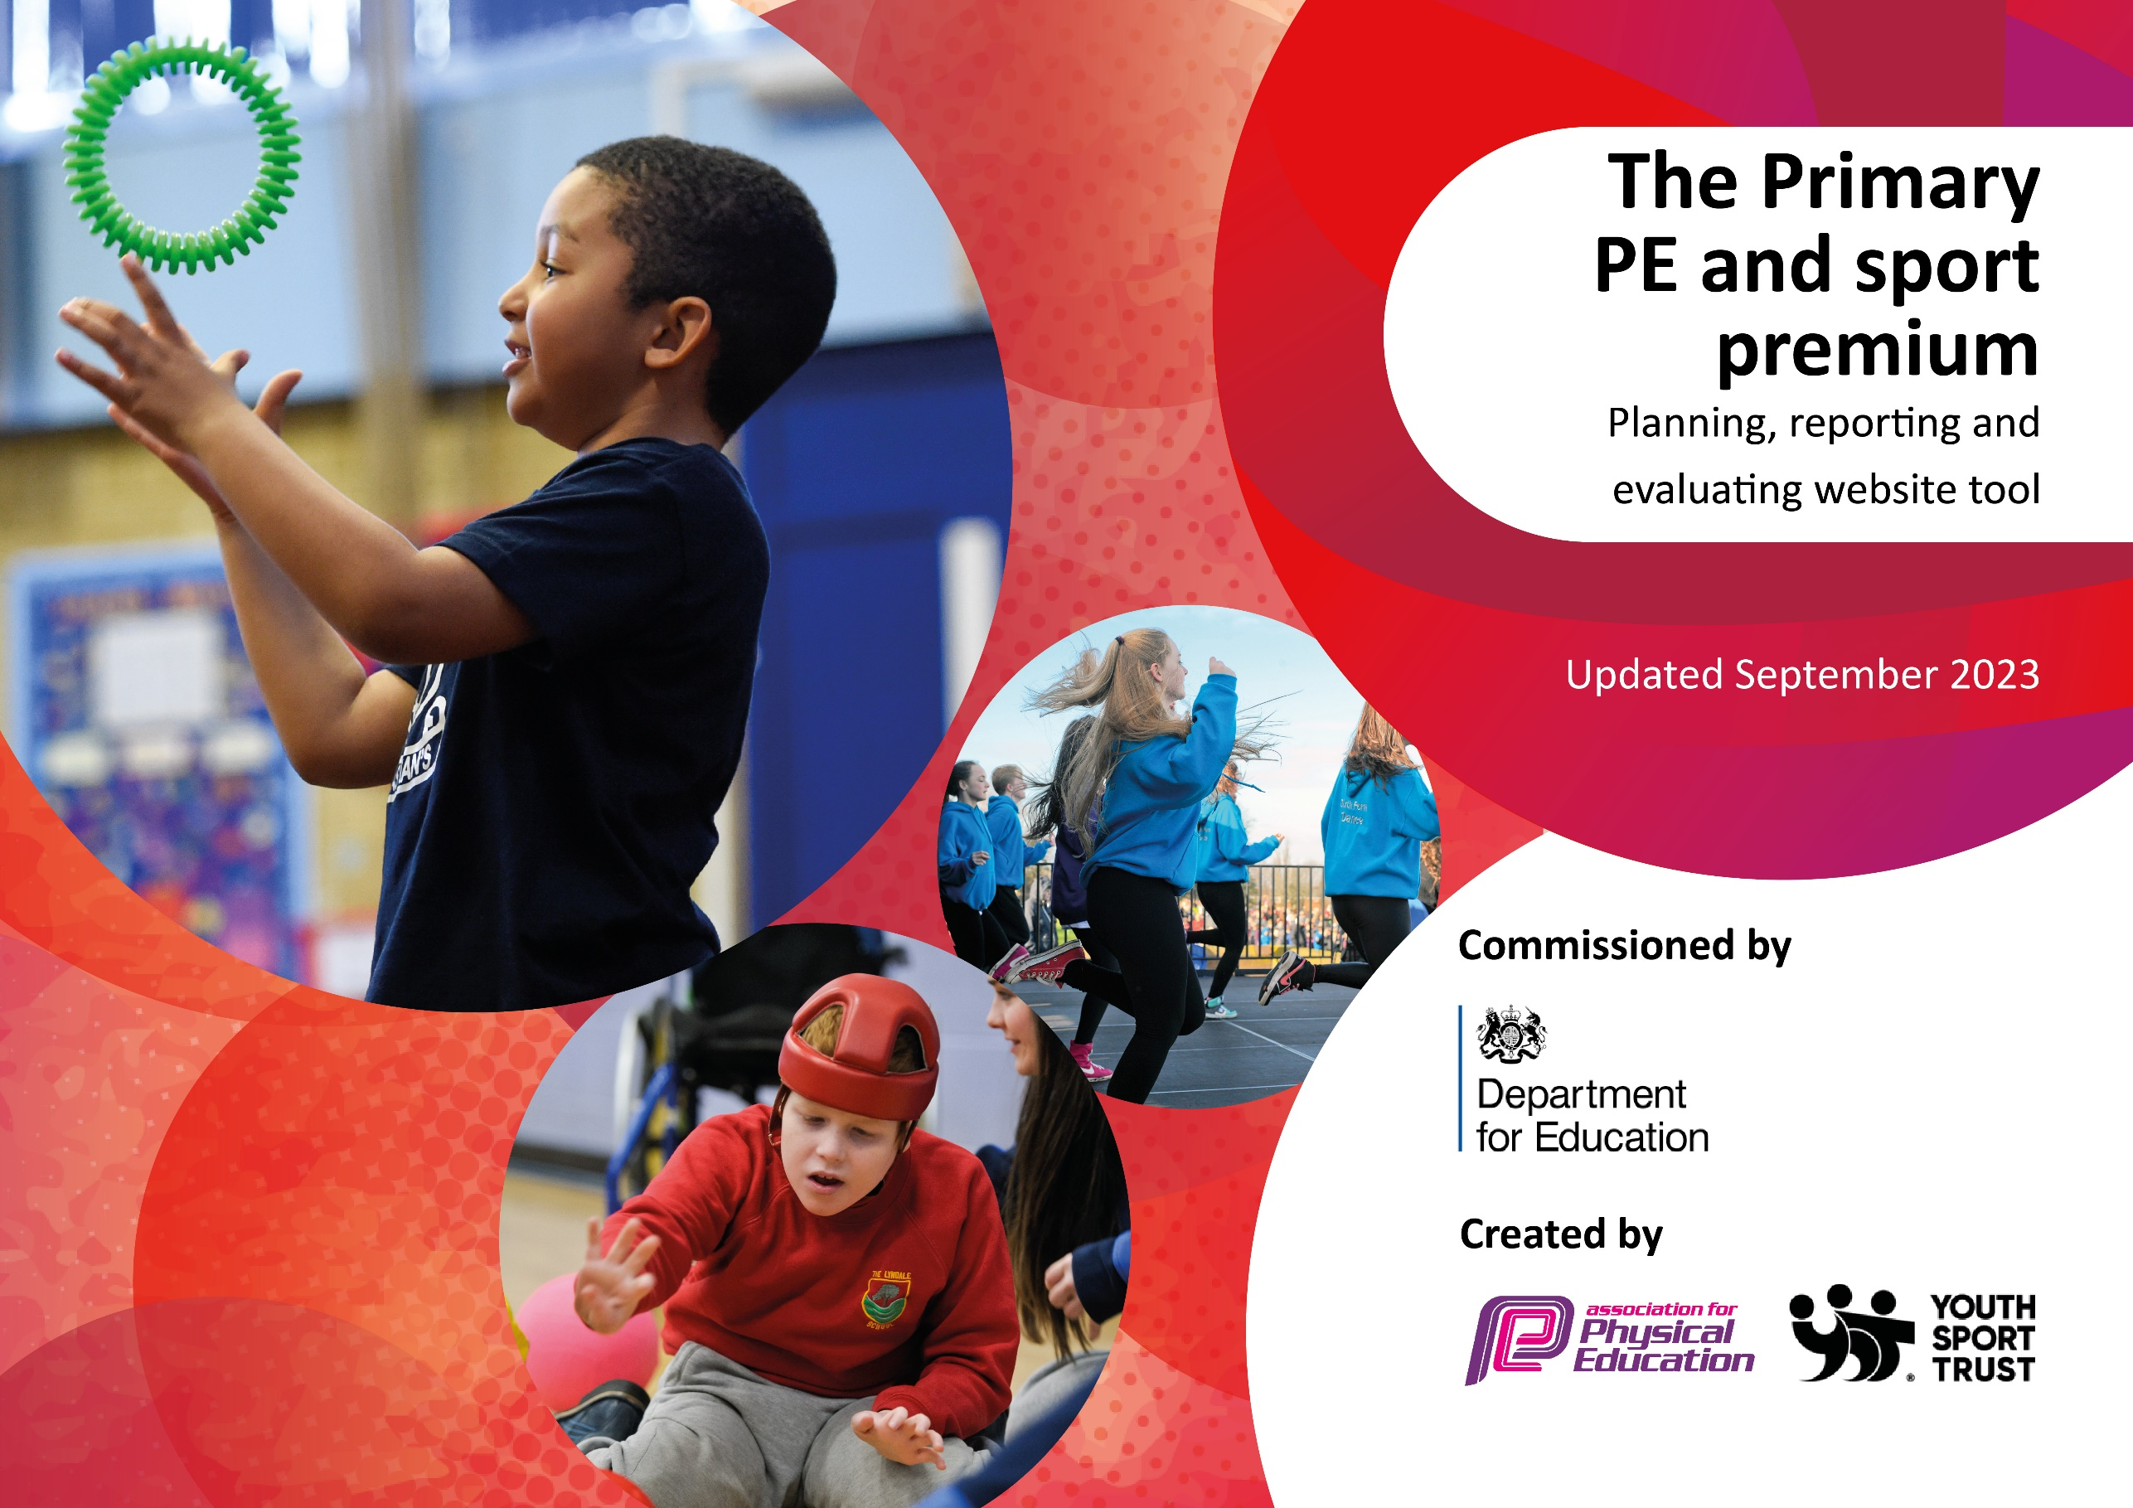

Kippax Ash Tree Updated July 15, 2025

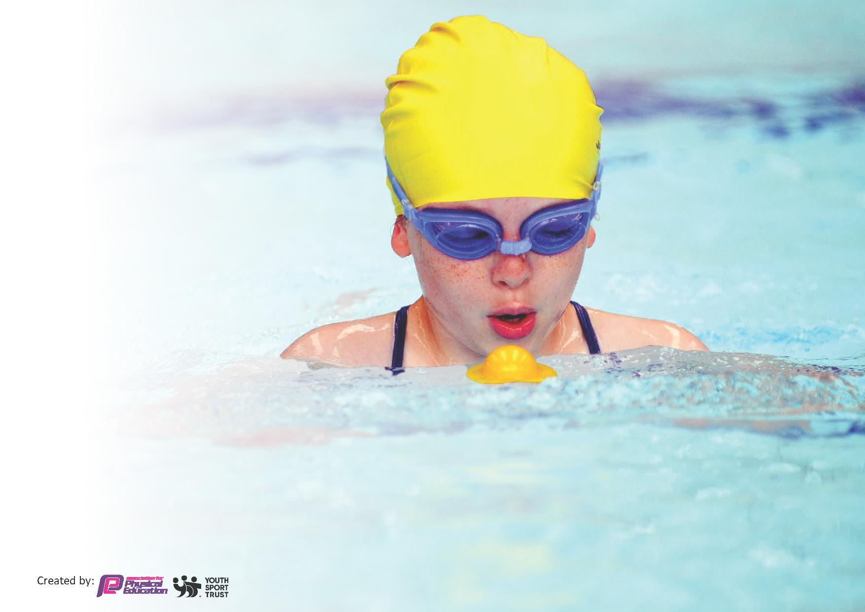
This template can be used for multiple purposes:
by:
- It enables schools to effectively plan their use of the Primary PE and sport premium
- It helps schools to meet the requirements (as set out in guidance) to publish information on their Primary PE and sport premium
- It will be an effective document to support Ofsted inspections enabling schools to evidence progress in Physical Education (PE) and evidence swimming attainment, which forms part of the PE National Curriculum. We would recommend schools consider
the Intent, Implementation and Impact of any spend, as examined within the Education Inspection Framework.

It is important that your grant is used effectively and based on school need.

Schools must use the funding to make additional and sustainable
improvements to the quality of the PE, School Sport and Physical Activity (PESSPA)
they offer. This means that you should use the Primary PE and sport premium to:

- Build capacity and capability within the school to ensure that improvements made now will benefit pupils joining the school in future years
- Develop or add to the PESSPA activities that your school already offers.

The Primary PE and sport premium should not be used to fund capital spend projects; the school’s core budget should fund these. Further detail on capital expenditure can be found in the updated Primary PE and sport premium guidance.

The Primary PE and sport premium guidance, outlines 5 key priorities that funding should be used towards. It is not

necessary that spending has to meet all the key priorities, you should select the priorities that you aim to use any funding towards.

Although completing this template is not a requirement for schools, schools are required to publish details of how they spend this funding. Schools must also outline what the impact this funding has had on pupils’ PE and sport participation and attainment and how any spending will be sustainable in the future. All funding must be spent by 31st July 2024.

Text in Green is 30% of premium invested in the BLP PE and Sport Offer | Text in Blue is the Primary School Specific Spend
The Department for Education has worked closely with the Association for Physical Education (afPE) and the Youth Sport Trust (YST) to develop this template and encourages schools to use it. This template is an effective way of meeting the reporting requirements of the Primary PE and sport premium.
Review of last year’s spend and key achievements (2024/2025)

We recommend you start by reflecting on the impact of current provision and reviewing your previous spend.

Activity/Action | Impact | Comments
A variety of intra school sports competitions  Targeted after school sports clubs provision to engage hard to reach/inactive pupils.  Girl’s participation in a variety of sports  Girls only events  Sports awards evening for primary schools across the trust  High Quality PE checklist  PE Leader meetings on a half-termly basis  Joint observations / feedback  1:1 PE leader meetings regarding curriculum | Hard to reach pupils accessed extra-curricular sport  Inter school competitions were accessed by all children in years 2,4,5, and 6  Improved participation and confidence within intra school sport. Uptake at Girls only events were high.  Raised the profile of PE and Sport / engage with community  Ensuring progression of PE over the years and key stages.  Improving confidence of PE leader in leading the subject and supporting staff in their delivery. | Continue with the same wide range of competitions -extend to be even more inclusive. Repeat a come and try / inclusive sports festival.  Additional girls only competitions/ events  for 2025/2026  Repeat again.  Further embed this work within 2025/26 to ensure a high-quality PE curriculum and high-quality PE lessons using most recent OFSTED reports/publications on PE.
Enrichment clubs  A survey completed by all children allows the identification of clubs they would like to attend.  A weekly enrichment program runs throughout the year offering a wide range of different sports.  Identifying pupils who do not engage in sports and activity outside of school and invite directly to before and after school clubs through engagement with parents.  Brain break activities throughout the day.  Playtime/lunchtime resources to promote active playtimes. Adults and play leaders to set up equipment/activities to encourage children to take part.  Coach-led sports for 45 minutes at lunchtimes (3 times per week) which is available to all children.  Coach-led sports are also available in an after-school club each week. | Key indicator 1: The engagement of all pupils in regular physical activity.  *The Chief Medical Officers guidelines recommend that primary school children undertake at least 30 minutes of physical activity a day in school. | Continue surveys giving pupils a voice in which sports and activities they would like to try/take part in each half-term.  Promote enrichment sports clubs (across KS1 And KS2) to ensure a good uptake. Continue to offer a wide range of sports for children to experience, enjoy and participate in.  Continue to identify pupils not engaging in sports/activities outside school and invite to join before/after school provisions.  Children are more active at playtimes and lunchtimes – continue to resource these to ensure active breaktimes.  Good uptake of children participating in sports led by the coach both during lunchtime and after school. Sports coach booked to continue these provisions in the next academic year.  Children from Y2 and Y4 participated in the trust wide skipping competition (including some who had never skipped before) and are now engaging in skipping during break times and lunch times.  Y4 children won their competition and participated in the final.

Key priorities and Planning
This planning template will allow schools to accurately plan their spending.

Action – what are you planning to do | Who does this action impact? | Key indicator to meet | Impacts and how sustainability will be achieved? | Cost linked to the action
Sports competitions  Big Sports day for all year 4,5,6 pupils covering handball, tag rugby, dodgeball, athletics, relay races.  Provision of inter school competitions and festivals in  Netball X 5, Football X 2  Tag Rugby X1, Skipping X 2, Cross Country X 2  Sportshall athletics X 2, Rounders X1, Multi Skills X 2, Badminton X 1, Dance X 1, Girls only competition X 2. Inclusive Festival X 1 | Gavin Parkinson (PE Lead BLP) to arrange and run events,  PE leaders in each school to arrange teams / promote / risk assessments / responsible for team at the fixture  Teachers allocated responsibility for own class and teams within it  All pupils in year 2,4,5,6 & pupils in year 1 and 3 as they will take part  Increased impact on Girls, with two girls only events this acacemic year. | KPI 5: Increased participation in competitive sport  KPI 2: Raising the profile of PE and Sport across the school to support whole school improvement. | Engage all pupils in inter school sport.  Increase accessibility targeting girls / inclusive events  Pupils motivated to take part in school sport in future years. | Part of the 30% (£5,240) of PE & Sport Premium invested in the Brigshaw Learning Partnership PE & Trust offer.
Girls only sports sessions in each school engage girls  Cycling & Skipping sessions on school site with specialist provider.  6 weeks of after school alternative sports clubs targeting less active pupils – activities such as tchoukball, fencing, archery, ultimate Frisbee | Gavin Parkinson (PE Lead BLP) to deliver girls only sessions.  Gavin Parkinson (PE Lead BLP) to liaise with providers to arrange.  PE Leader / Class Teacher selecting and promoting.  Pupils taking part | KPI 4: Offer a broader and more equal experienced of a range of sports and physical activities to all pupils  KPI 1: Increasing engagement of all pupils in regular physical activity and sport. | Increased confidence from girls in taking part in school sport to ensure they continue to take part in sports activities in future years.  Allow pupils to experience a wider range of sports to develop their confidence in engaging in physical activity in future years. Willingness to sign up to sports clubs next academic year | Part of the 30% of PE & Sport Premium invested in the Brigshaw Learning Partnership PE & Trust offer.
Refining of High Quality PE checklist (based on 2022 Ofsted review) for PE leaders to use to aid monitoring and development of PE lessons.  Production of a Curriculum planning checklist to support PE leaders.  1:1 PE leader meetings with BLP PE lead to review and discuss curriculum PE and progression of PE across the key stages.  PE leader meeting on curriculum planning PE  Half termly PE leader meetings to provide support and guidance for PE leaders to discuss / share / support good practice.  Joint observations and supportive feedback. | Gavin Parkinson (PE Lead BLP) to produce key documents.  PE Leader to use documents to self-check their PE curriculum and ensure PE is progressive within the school and use HQ PE checklist to guide what PE should look like in their school.  PE Leader to work with BLP PE lead to identify areas to improve and areas of strength.  Class teachers – progressive curriculum to follow for year to year.  Class teachers receive feedback from observations. | KPI 3: Increasing all staff’s confidence, knowledge and skills in teaching PE and Sport.  KPI 2: Raising the profile of PE and Sport across the school to support whole school improvement. | .
Gymnastics CPD session (requested through a staff survey)  Membership of AfPE  Access to AfPE online CPD including amongst others live webinars on high quality PE, Physical Literacy, and Health and safety within PE. | Gavin Parkinson (PE Lead BLP) to plan and lead session based on needs to schools.  PE leaders to attend  Key Stage two class teachers to attend  Gavin Parkinson (PE Lead BLP) to also highlight and direct staff to relevant CPD. | KPI 3: Increasing all staff’s confidence, knowledge and skills in teaching PE and Sport.  KPI 4: Offer a broader and more equal experienced of a range of sports and physical activities to all pupils | Increasing staff confidence, knowledge and skills in the delivery of OAA on the school site.  This knowledge can be used in future years to ensure effective deliver of this aspect of the National Curriculum.  Knowledgeable subject leaders in schools to sustain effective PE. | Part of the 30% of PE & Sport Premium invested in the Brigshaw Learning Partnership PE & Trust offer.
Primary school Sports awards evening. | Gavin Parkinson (PE Lead BLP) to plan.  PE leaders to select and notify pupils.  Different categories allow a range of abilities to be selected to receive an award. | KPI 2: Raising the profile of PE and Sport across the school to support whole school improvement. | Increased motivation for pupils to engage with sport activities and sports leadership | Part of the 30% of PE & Sport Premium invested in the Brigshaw Learning Partnership PE & Trust offer
Playleader training for pupils to run structured activity during break and lunch times. | Gavin Parkinson (PE Lead BLP) to lead sessions.  PE leaders / class teacher / other staff to select and monitor playleaders | KPI 1: Increasing engagement of all pupils in regular physical activity and sport. | More pupils taking part in structured play at breaks and lunchtimes, improving physical skills, enjoying being active, enjoying working with others. Improving motivation to engage in PE and Sport in the future. | Part of the 30% of PE & Sport Premium invested in the Brigshaw Learning Partnership PE & Trust offer
.CPD for teachers. | Teachers  Pupils as they will have higher quality lessons | KPI 1: Increasing engagement of all pupils in regular physical activity and sport.  KPI 5: Increased participation in competitive sport | Primary teachers more confident to deliver effective PE supporting pupils to undertake extra activities inside and outside of school, including teaching water safety and swimming and as a result improved % of pupil’s attainment in PE. | Part of the 30% of PE & Sport Premium invested in the Brigshaw Learning Partnership PE & Trust offer
Purchase / Renewal of subscription with primary PE planning to allow access to individual sequential lesson plans and videos.  Use of specialist staff delivering PE lessons, and staff observing to develop their knowledge.  Arrange joint observations with Brigshaw Learning Partnership (BLP) | Teachers  Pupils as they will have higher quality lessons | KPI 3: Increasing all staff’s confidence, knowledge and skills in teaching PE and Sport. | Improved staff confidence in delivering PE and ability to challenge more able and support developing students  Staff are aware of how certain activities progress over the key stages and have a variety of activities they can use to challenge students at different levels & ages.  Pupil progress with lessons and across the key stages  Individual sequential lesson plans and videos.  Non specialist staff can learn how best to deliver specific sports skills via the videos and ‘teaching points’ within lessons. | £395 for Primary PE resource
School kits introduced to raise the profile and status of those taking part: football, dance, hoodies, netball. | Pupils | KPI 2: Raising the profile of PE and Sport across the school to support whole school improvement.
Provision of year long school enrichment clubs through Premier Sport to widen the range of activities. These include fencing, archery and tchoukball including an increased provision for KS1.  A broad range of activities taught within the PE curriculum.  A range of after school sports clubs and activities available to all children. | Pupils | KPI 1: Increasing engagement of all pupils in regular physical activity and sport.  KPI 4: Offer a broader and more equal experienced of a range of sports and physical activities to all pupils | All pupils in KS1 and KS2 given access to new sports activity beyond normal lessons – inactive children targeted and personal invites given.  Pupils enthused by sport and given the chance to find a sport and activity that they enjoy.  Children will be enjoying a range of sports, competitions and activities | .  £450 entry and transport to GBDO national competition  Linked to cheerleading and dance after-school clubs
£

Key achievements 2024-2025
This template will be completed at the end of the academic year and will showcase the key achievements schools have made with their Primary PE and sport premium spending.

Activity/Action | Impact | Comments
Y4,5,6 Sports hall athletics  Y3/4 Sports hall athletics  Y5/6 football competition  Dance in a Day  Y2 skipping workshop and festival  Y4 skipping workshop and festival  BLP academy sports day – Y4,5,6  Play leader training  Y6 Cycling events x2  6 weeks of after-school events led by Premier sports – Y4,5,6  Y5/6 Girls only sports festival  Kippax Ash Tree sports days – Nursery, KS1, KS2  Further opportunities:  After-school football club  After-school cheerleading/dance club by dance teacher. Sports coach leads different games at lunchtime  Enrichment every week covers a variety of different sports – archery, rounders, football, athletics, touch rugby, cricket, gymnastics, dance. | Opportunity to try a variety of new/different athletic events.  1.5 hours of extra activity/fitness. Collaborated as a team with children from different schools.  Personal challenge element – improved their own skills.  Opportunity for extra activity outside of school.  Competitive – inter schools – competed against 6 other primary schools.  Developed defending/attacking skills. Opportunity to play in different positions.  Several girls were part of the team.  Developed skills of being a gracious winner as well as accepting losses – sportsmanship.  Developed a range of dance skills. Had input into the choreography. Performed as part of a large show – audience of 200.  Boys and girls attended  Learned and developed new skipping techniques. Opportunity for personal challenge/personal best as well as working as a team in group skipping.  Inter – school competition. Competed against 6 other primary schools.  Inter school competition – 7 primary schools involved. Gained experience and skills in handball, tag rugby, dodgeball and relay track racing.  Healthy competition and good sportsmanship skills gained.  All children from y4,5,6 participated.  Leadership skills. Learned a variety of new games to lead. Built confidence. Increased activity levels at break and lunch times.  Event 1 – promoted competitive cycling and developed skills in this.  Event 2 – promoted safe cycling.  Experienced new sports. Gained skills in archery and fencing. Targeted less active pupils and girls.  Increased girls’ confidence. Gained skills and understanding of different sports. Inspired girls to get involved – more girls now joining in sports during break/lunch.  Intra school competition.  KS2 – track races, throwing, long jump, tug of war.  Inclusion – all children participated.  Gain new skills/ build on skills  Increased weekly activity levels.  Teamwork and sportsmanship skills. | Attend event again next year. Good uptake of children. Worked well for those who are not as interested in typical team games (football, rugby) as they got to work as a team in a different way (adding points they scored to their team total).  Children were included in deciding the format of the team – encouraged tactical thinking.  Raised interest in football for girls – many continued to play in breaks and lunches after the event.  Shook hands and congratulated other teams on their wins.  Modern music and modern dance moves engaged children. Enjoyed making contributions/suggestions. Excellent for team-work and supporting each other.  Good opportunity to experience performing to a large audience.  Raised the profile of dance for boys.  Raised profile of skipping for fitness.  Children continued to build on these skills during play and lunch times which supported an increase in activity levels throughout the day.  Excellent opportunity to imagine the possibilities – the competition was held in a sports stadium with excellent facilities.  Children in the stands supporting team members. Wide variety of events – something for everyone. Great event for inclusion – every child participated and competed for their school.  Good variety of non-contact games. Quieter children grew in confidence at leading the games. Organisation skills – setting up the games/equipment placement.  Encouraged children to ride more – some now riding to and from school.  Allowed children to imagine the possibilities – to see cycling as a competitive sport.  Raised awareness of different sports available to them – built capital. Suited children who dislike traditional sports in this area – football, rugby, dance.  Gave girls a voice – openly spoke about their experience of sports. Allowed them to imagine the possibilities.  Great opportunities for children to either do more of a sport they are familiar with and enjoy or learn new skills/sports. Opportunity for children to work with new people from other classes/year groups – social aspect.  Children have developed physical skills, built on their own personal best, contributed to team performances, competed in inter and intra sports events, tried new sports, build skills of teamwork and sportsmanship and performed to large audiences.  They have developed social skills – turn-taking, working with new people, and communicating.  They have imagined the possibilities and built on their cultural capital by experiencing stadiums, theatres and participating in sports that are not well-known in our area.

Swimming Data
Meeting National Curriculum requirements for swimming and water safety.
Priority should always be given to ensuring that pupils can perform safe self-rescue even if they do not fully meet the first two requirements of the National Curriculum programme of study

Question | Stats: | Further context  Relative to local challenges
What percentage of your current Year 6 cohort can swim competently, confidently and proficiently over a distance of at least 25 metres? | 30 | Regular assemblies on water safety
What percentage of your current Year 6 cohort can use a range of strokes effectively [for example, front crawl, backstroke, and breaststroke]? | 27

What percentage of your current Year 6 cohort are able to perform safe self-rescue in different water-based situations? | 30 | Regular assemblies on water safety
If your schools swimming data is below national expectation, you can choose to use the Primary PE and sport premium to provide additional top-up sessions for those pupils that did not meet National Curriculum  requirements after the completion of core lessons. Have you done this? | Yes | KS2 children unable to swim 25m were provided with a voucher entitling them to a one week top-up session during the summer holidays.
Have you provided CPD to improve the knowledge and confidence of staff to be able to teach swimming and water safety? | No | Swimming coaches teach the lessons each week therefore no CPD has been required for staff.

Signed off by:

Head Teacher: | Mark Cahill
Subject Leader | Rose Jay
Date: | 15/07/2025

