5 Ways to Be the Best in Water Mitigation

As Accuserve recruits restorers daily to join our vendor network, it is interesting to see what separates the average restorers from the good ones and the good ones from those that are great. See 5 ways below to separate yourself from your competition by focusing on these key measures of success:

 Great Customer Service – show up on time, if not early, and look and sound like a professional. This starts with a clean, well-logoed vehicle parked on the street in front of the house and continues with the technicians wearing clean, neat uniforms, with photograph ID badges and wearing shoe protectors when in the home. Introduce all the technicians that will be working on that project and be sure to show their IICRC certification cards to provide a level of comfort about their expertise in the services to be provided. Take great care of the homeowner’s structure & contents and look for ways to “WOW” your customer!

 Technical Knowledge – “You can’t outperform your own knowledge” as the late Kurt Bolden used to say. You must hold your technicians to a high technical standard that surpasses the normal WRT certification everyone expects.


The technician must think critically when investigating how to utilize the least invasive drying strategy on every water mitigation project. The IICRC Applied Structural Drying course focuses on the same information learned in the WRT course, but adds the component of having to think critically in real world terms in determining category and class of water, how many airmovers and dehumidifiers will be needed, whether to use an air filtration device (AFD) or not, placing containment effectively, and how to save as many materials as possible with the least amount of demolition and disruption. The goal is to return the home to pre-loss conditions as quickly as possible to give the occupants their lives back and to avoid lengthy build backs and hassles of having workers in your home for extended periods. If you want to be considered a water mitigation professional, you MUST have an ASD certification!

Click on the following link to check out IICRC approved courses offered by Accuserve - https://www.accuserve.com/flood-house-training#courses

 Equipment – restorers must invest in the latest drying technology, including airmovers, dehumidifiers, hardwood floor drying equipment, specialty extraction tools, diagnostic equipment (e.g., penetrating & non-penetrating moisture meters, thermo-hygrometer, IR camera & thermometer, manometer, anemometer, and air particulate counter). The technician can have all the knowledge in the world, but if they don’t have the proper equipment & tools utilizing the latest technology then being successful will be that much harder. This includes utilizing mobile apps to document properly and share that documentation as quickly and accurately as possible. Get great at utilizing water mitigation mobile apps! Work Smarter, NOT Harder! Learn to be profitable renting equipment vs. getting paid for labor. The more materials you can dry, the less demolition you do, the more money you make! It is as simple as that!
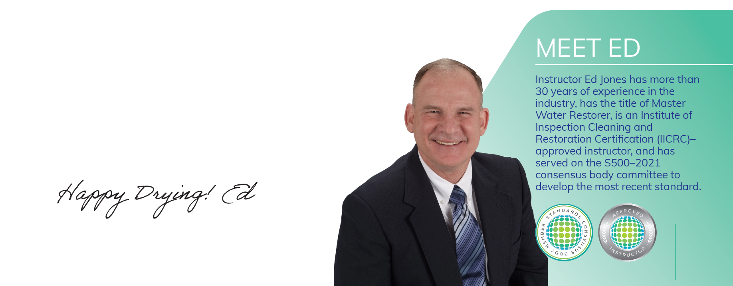
 Documentation – learn to tell your drying story with great photos that are accurately labeled, drying logs that show you provided good conditions for drying and dried as much as possible, as quickly as possible, and a Moisture Map that correlates with the photos and readings to prove you left all materials dried at an acceptable moisture level that will prevent the growth of mold.
As a water damage mitigation expert witness in lawsuits, I get to see what happens when there is poor documentation that could leave you and your company liable for incomplete drying, cross-contamination, or poor workmanship. The best way to prevent allegations of negligence is to have the best documentation possible that tells a story of expertise and attention to detail. A little extra time creating good documentation can save you thousands of dollars!
Good documentation provided in a timely manner will get you paid more quickly!
 Attention to Detail – take special pains to pay attention to the smallest details and leave an immaculate work site. Take photos to document all affected areas initially and upon completion of drying showing everything left in a spotless and safe condition and don’t forget to take photos of your final moisture content readings taken with a penetrating moisture meter, if possible, to prove you left all affected materials that you were drying in an acceptable moisture content.
“Being great at the little things are the steppingstones to accomplishing big things.”
