  Global Packaging  We want to thank our Corporate Sponsor, Global Packaging, who has been on this journey with us for several years. It is because of their generosity that we have been able to confidently go forth with our tournament each year.  We say thank you to all the management, staff and workers at Global Packaging for their generous sponsorship and for showing up at our tournament each year!  ****************************************************  Acknowledgments from the  Mary L. Quick Memorial Golf Tournament Committee  We want to thank our many friends who gave of their time and advice to help with this tournament and make this scholarship fund a reality. We thank all of our friends in the business community for their generous contributions and important support for our cause. We want to thank our family members who came together and helped with the vision. Most importantly, we thank our Heavenly Father for blessing us with our dear mother, grandmother, aunt, confidant, friend, pastor and overseer.  We will continue to strive to follow in the footsteps of our visionary leader to help young people of our community and to “Just be real!”  .
  Tournament Sponsorship
  Corporate Sponsor $3,000
  2 Foursomes
  Hole Signage
  Sponsor Banner Display
  Named Sponsor
  Lunch Sponsor $1,000
  1 Foursome
  Hole Signage
  Sponsor Banner
  Photo Sponsor $1,000
  1 Foursome
  Hole Signage
  Name/logo on group photo
  Business Sponsor $500
  1 Foursome
  Sponsor Banner
  Hole Sponsor $100
  Hole Signage
  Seeds of Mary is a 501(c)(3). Donations are tax deductible!
  Contact us at:
  Phone: 336-906-9597
  Email: seedsofmary@yahoo.com
  Website: seedsofmary.org
  Seeds of Mary
  122 Cecil Lane
  Rockingham, NC 28379
  
  8th ANNUAL
  MARY L. QUICK MEMORIAL GOLF TOURNAMENT
  Sponsored by
  Friday, July 3, 2026
  Seven Lakes Country Club
  126 E. Devonshire Ave
  West End, NC 27376
  8:30 Shotgun Start
  Mary L. Quick Memorial Scholarship Fund
    - Friday, June 30, 2023
    - Seven Lakes Country Club
    - West End, NC 27376

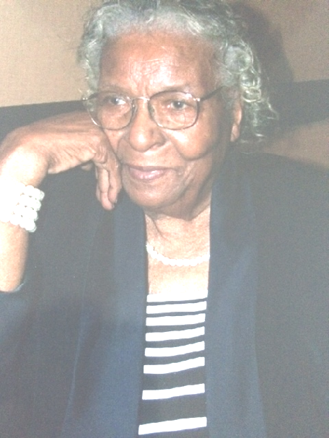  Mary L. Quick  This tournament is a great opportunity to memorialize a wonderful woman of God. As Pastor of St. Mary’s Holiness Church, in Hamlet, she was a strong, quiet leader who led by example. She was parent to 10 children in the immediate family, all who have made their marks in their community and world. She was a true advocate for education, pursuing and completing her high school diploma well into her adult years, and going on to earn certification as a Nurse’s Aide, and worked in this role for many years. She supported and encouraged her children and grandchildren in their educational pursuits. She always recognized the life-changing value of education. This scholarship honors her legacy of caring! |  |  | WHAT’S IN IT FOR YOU?  By participating in the Mary L. Quick Memorial Golf Tournament, you will:  - Help children from our community have an opportunity to attend college or university.  - Play 18 holes of golf on a picturesque and challenging golf course.  - Receive a gift bag and a chance at winning a door prize.  - Have drinks and snacks available to you while on the golf course.  - Receive a nice hot meal after your round of golf.  - Have a great day of fun, food, and fellowship!  Chances to Win  Cash prize for a hole-in-one  Prizes for 1st, 2^{nd,} and 3rd place finishers  Closest to the pin  Longest Drive  Raffle for golf equipment  Silent Auction |  |  | 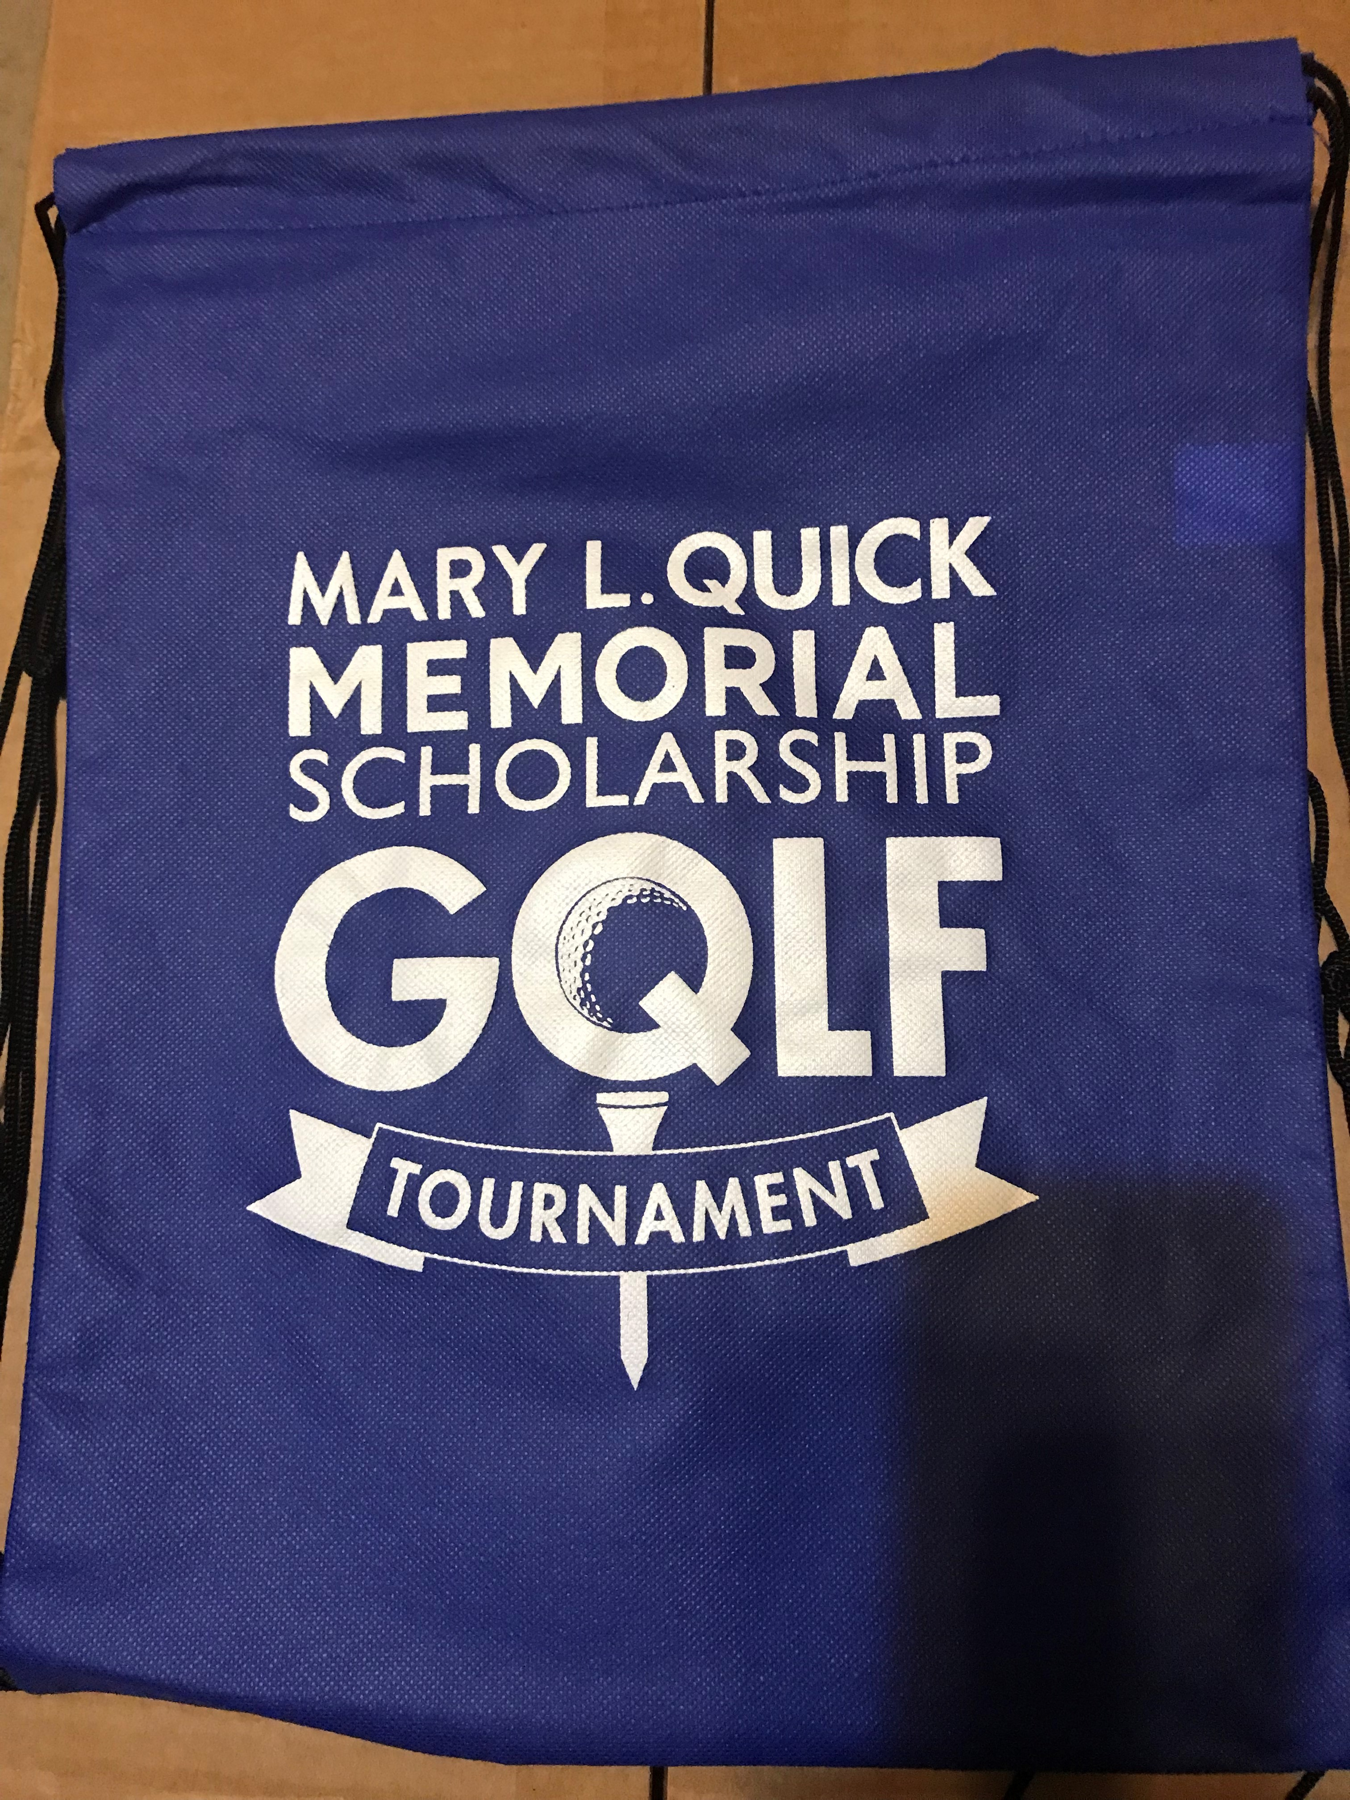  [  Captain’s Choice Format  Print your name and contact information and list those who will be playing on your team. Only the first 18 PAID teams can be guaranteed a spot in the tournament.  Name ____________________________________  Phone ____________________________________  My team will consist of:  1._________________________________________  2. ________________________________________  3. ________________________________________  4. ________________________________________  Cost: $85 per player/$340 per team.  Please mail entry or donation to the address below:  SEEDS OF MARY  122 Cecil Lane  Rockingham, NC 28379

