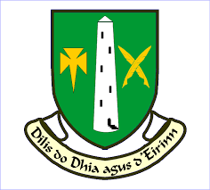

St. Colmans College, Fermoy
2nd Year Book List 2025 – 2026

Mathematics | Active Maths 1 and 2  3rd Edition Folens
Irish | Mol an Oige 2 and 3  2nd Edition EDUCATE
English | Kingdom 2  2nd Edition EDUCATE
History | Making History  2nd Edition Gill
Geography | Living Geography  CJ Fallon
Science | Exploring Science  2nd Edition EDCO
SPHE | You’ve Got This 2  EDUCATE
CSPE | Make A Difference  Folens
Religion | Inspire  EDUCATE
Music | Music Maker  Gill
Wood Technology | Design Roots  2nd Edition Gill
Graphics | World of Graphics  EDUCATE
Art | Art Pack
French | Bienvenue en France 2  Folens
German | Alles Klar  EDUCATE
Applied Technology | Applied Technology Theory and Practice
Business | Time for Business  3rd Edition EDCO

