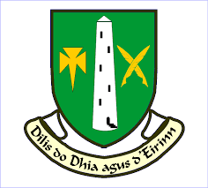
St. Colman’s College Fermoy 1st Year Book List 2026 – 2027

Mathematics | Active Maths 1 3rd Edition Folens
Irish | Turas 1  2nd Edition EDUCATE
English | Kingdom 1  2nd Edition EDUCATE
History | Making History 2nd Edition Gill
Geography | Living Geography CJ Fallon
Science | Exploring Science 2nd Edition EDCO
SPHE | You’ve Got This 1  EDUCATE
CSPE | Make A Difference– CSPE for Wellbeing  Folens
Religion | Inspire  2nd Edition EDUCATE
Music | Pitch Perfect EDCO
Wood Technology | Design Roots 2nd Edition Gill
Graphics | World of Graphics EDUCATE
Art | Art Pack

French | Tous Ensemble Folens
German | Alles Klar EDUCATE
Applied Technology | Applied Technology Theory and Practice
Business | Time for Business 3rd Edition EDCO

