THE UNITED REFORMED CHURCH - SYNOD OF SCOTLAND
Minutes of Hybrid Spring Synod Meeting held at Grahamston United and on Zoom
Saturday 14 March 2026
Theme “Scotland’s Four Words of Hope”

See attached list for attendance and apologies

Welcome: The Synod Moderator, Rev Lindsey Sanderson formally and warmly welcomed everyone to the one day Spring meeting of Synod.
Synod commenced with opening worship.
During worship Synod noted and welcomed new Elders ordained since the Autumn meeting namely: Robert Logan and David Stocks (Park United, Airdrie)
The Moderator welcomed our Ecumenical Guests: Revd. Martin Keene (Moderator of General Assembly, United Free Church), Mr Daniel Jack (Scottish Episcopal Church), Revd. Alistair Weightman and Revd. Lynne Robertson (Congregational Federation of Scotland), Mary Woodward (Religious Society of Friends - Quakers) Revd. Adam Stevenson ((Methodist Church), Rev. Ross Blackburn (Church of Scotland), Major David Cavanagh (Salvation Army), Revd. William Russell (Roman Catholic Church)
The Moderator welcomed ministers who had moved into the Synod as retired ministers: Revd. George Gibson, Revd. Trevor Jamieson.
Synod said goodbye to ministers leaving the Synod: Rev. Maureen Wilson (moving to Wessex Synod), Rev. Helen Garton (moving to North West Synod), Rev. Craig Jenson (retired).
The Moderator and Synod celebrated with two ministers both reaching the significant milestone of 50 years since ordination: Rev. Derek Corner, Revd. Dr. Jack Dyce.
As an opening to the meeting, a conversation was shown: the Moderator talked to Frank Strang about the Four Words of Hope project ( the words written on the Mace which has to be present when the Scottish Parliament meets): Compassion, Integrity, Justice, Wisdom. Survey link will be on the website.
Table groups discussed
What does restoring trust in public life mean for me and my community?
What three words come to mind for each of the values?
Feedback submitted through QR code to Mentimeter to create word clouds.

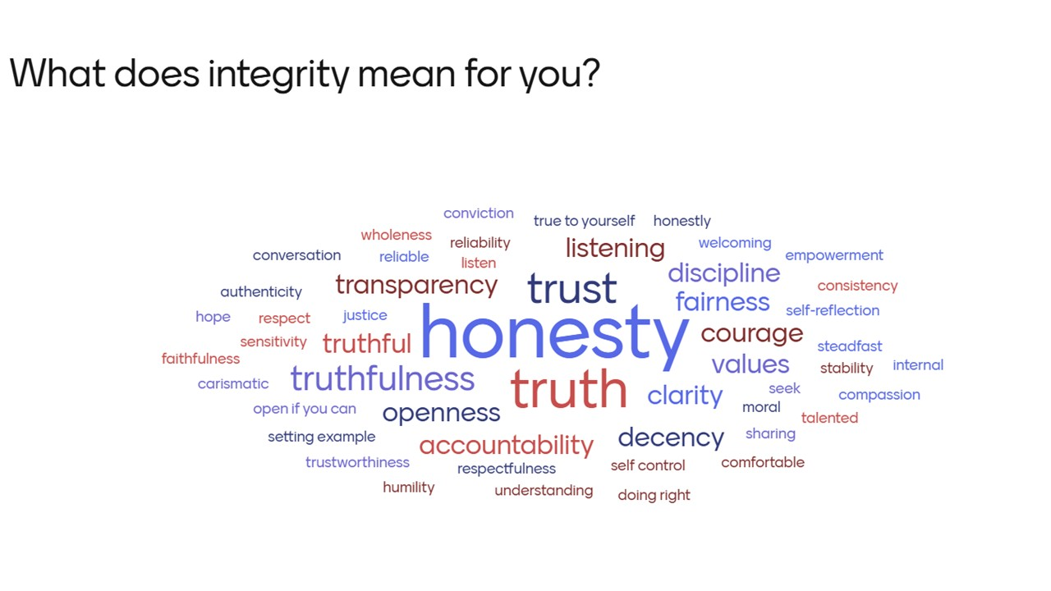
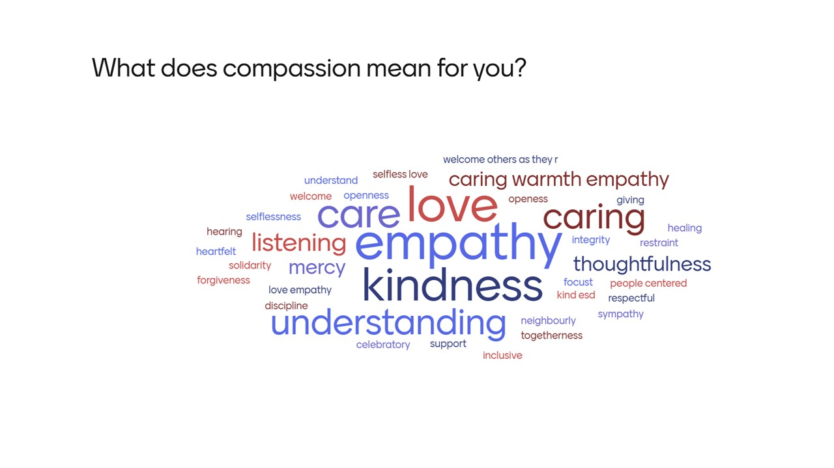
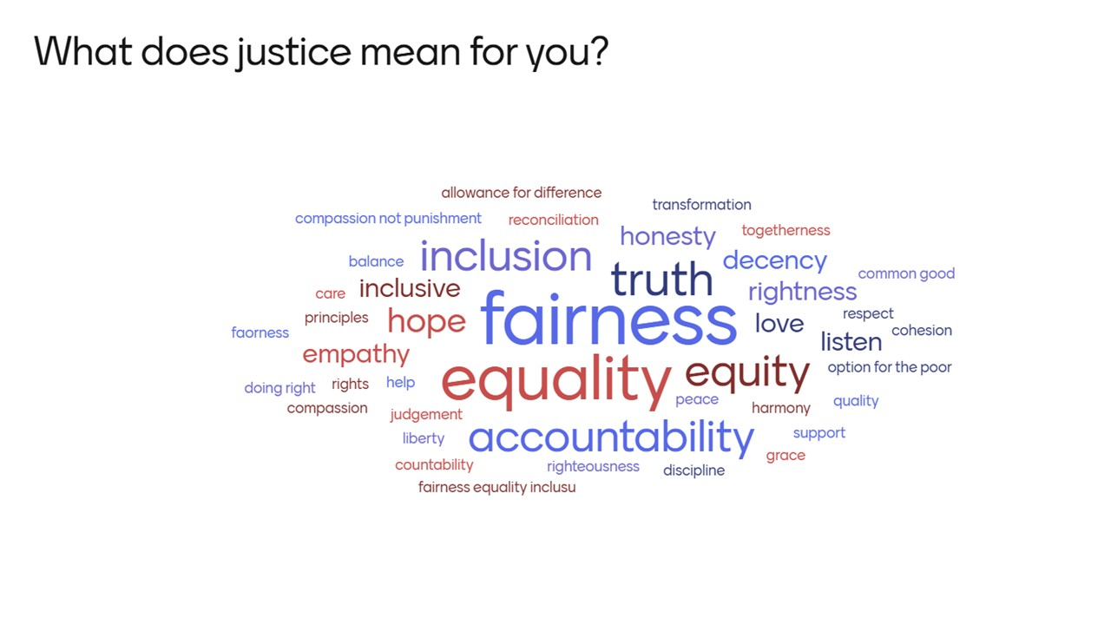
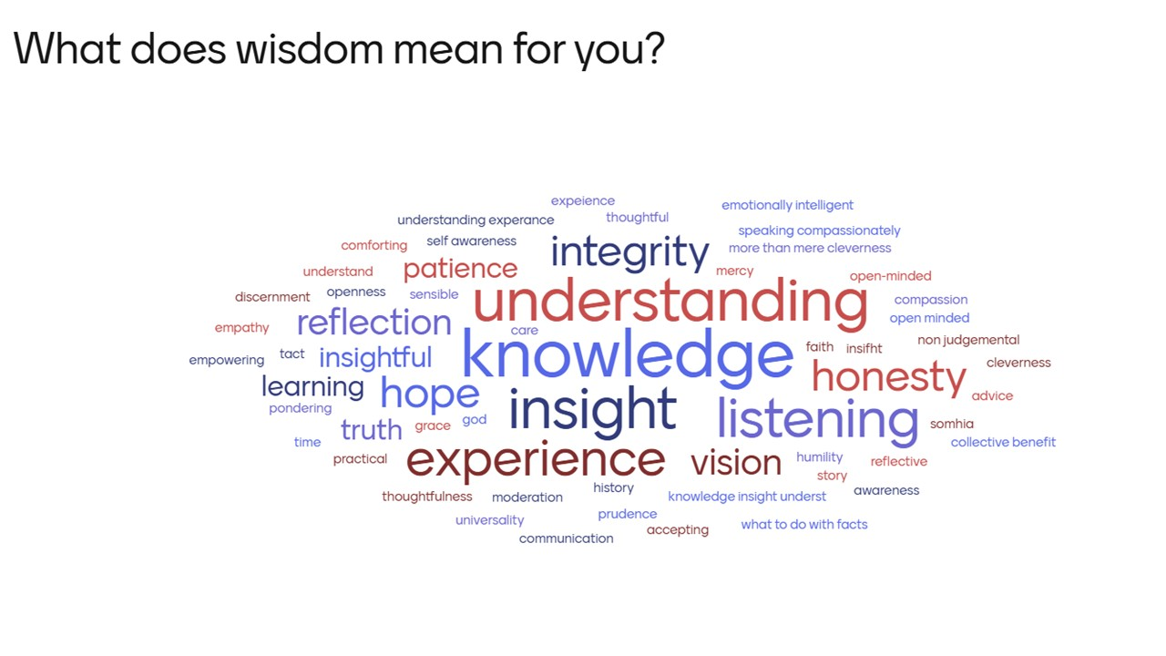

Susan Henderson, Chair of Synod Executive supported the Moderator during the absence of a Synod Clerk.
Reports for this Synod meeting can be found at Synod Meetings (urcscotland.org.uk).
- The Minutes from Autumn Synod 25 held at Livingston United and on Zoom on 4 October 2025 were presented by the Moderator. These were unanimously accepted by Synod.
- The Minute from the 12 November meeting of Synod (held online) were unanimously accepted by Synod.
- Synod agreed that Jackie Kyle (Convenor), Gemma Walker and Elisabeth Jones be appointed as Tellers for Synod 2026.
Paper A | The Synod Executive Report was presented by the Susan Henderson.  All were encouraged to share widely the roles of Synod Clerk and Synod Treasurer.  An additional name was shared for those going to General Assembly - Steven Smillie (Augustine United Church)
Comments | None
Decision | Report accepted
Table Talk | Discussion on possible residential for Spring 2027:  Other than business what would people like to see?  Mary Woodward - loved the residential experience – it is an opportunity to get to know people and talk business (and other things)  Lesley Thomson – discussion was about residential verses the day away (Perth) the latter being more inclusive (and less expensive)  Lis Johnson Blythe – asked for clarification about what the day in Perth was about.  Margaret Higton – a single day does not allow travellers from more distant churches  Morag Donaldson – consider not having business discussions after evening meal – too late to concentrate?  Babs Paterson – supports the social side as being important for a lot of people and importance of inclusion for those travelling from a distance.
Resolution 1 | Synod Executive propose the nomination of Rev’d Sue Kirkbride and Mr Bill Robson to the Synod Executive Committee
Decision | The Resolution was agreed.
Resolution 2 | The National Synod of Scotland approves the list of representatives to the General Assembly for 2026
Decision | The Resolution was agreed.
Resolution 3 | The National Synod of Scotland resolves to meet residentially in March 2027 at the Stirling Court Hotel and asks Resources Committee to determine the costs to local churches and a mechanism of financial support to enable all churches to send at least one representative.
Clarification | Derek Macdonald – could the Friday start be later to allow working people to attend?
Decision | The Resolution was carried by substantial majority.
Paper B | Synod Pastoral Committee Report was presented by Ewen Harley  Points highlighted:  Para 3 – vacancy declared in Caithness: a new way forward for our Synod.  A lot of conversation going on about future of pastorates and thanks for those engaging.  Safeguarding – SLA between Church of Scotland and URC has been signed off. A major achievement.

Table Talk | Para 10: Wider Fold membership  Who might appreciate option of being a Wider Fold member (types of people)?  What do you think any congregation designated as Wider Fold would need to support their work?  Concept of Wider Fold – Feedback via tick of good idea, cross if not good idea, question is significantly more work needed.  More thoughts to be brought to October Synod meeting.
LMMR | Sarah Moore outlined the Local Ministry and Mission Review scheme (from 2008) and presented the new revised version which has been tested in some churches.  The original scheme (and its Lite successor) became a burden to administer rather than the positive tool it was intended to be.  Synod will be encouraging local churches to look at the new LMMR questions regularly (annually) but expects that on a 5 yearly basis there may be a pastoral visit from Synod to discuss the Living Document. Synod is already using the process to help provide information for decisions on funding or vacancies for example.  The Living document (revised LMMR process) is based on:  What do we do?  How do we do it?  For whom do we do it?  What value are we bringing?  Don’t overthink within congregations – this is supposed to support the work of the church.  Questions/Comments/Opinions (responses)  Lis Johnston-Blythe – what link is there between the Living document and Joint Pastorate requirements? each congregation to have its own but could share with others in the pastorate  Liz Wilson – Saughtonhall had to prepare a Living document to support its movement towards declaring a vacancy. It was very difficult to do without a minister to facilitate.  Anne Kennedy – we have prepared a profile for vacancy – is this the same? The questions will be available on the website. Pastoral profile is not the same thing as it is written for a different audience and intention and to a different timescale. Encourages the churches to each prepare their Living Document.  Sarah McGrory – with few people, how do you empower people to be more missional?  Brian Kirkbride – is the Living document for each congregation? Yes, it’s for individual churches, but encouraged to share within the pastorate  Morag Donaldson – as part of previous LMMR team she has seen the difficulties. This is a kind of report card to allow churches the time to reflect on how they are doing.
Questions | No questions on the report
Decision | The report was accepted.
The Synod has moved to using URC safeguarding material, but making use of the Church of Scotland referral system and training to ensure a Scotland specific version.
The Moderator introduced Kerry Baker to talk about Good Practice 6 Scotland – Safeguarding for everyone (online).
This presentation will be made again at a future online meeting for Safeguarding co-ordinators and this part of the meeting was recorded for the website.
There will be a published document with additional resources available online.
Vicky Royle, Synod Safeguarding Administrator, is now with Synod three days a week and available to all.
NB: the contents of a church purple safeguarding folder is now out of date and should be recycled.
Questions | Ben Forsyth – what consideration has been given to Scottish legislation – this is exactly why this document has been written so that legislation in Scotland is the basis of the information
Paper C | Synod Mission Committee Report was presented by Sarah Moore.  Esther Moodie was welcomed to talk about the work of Scottish Faiths Action for Refugees – an ecumenical and interfaith organisation set up to support refugees and asylum seekers. Currently there are around 6,000 asylum seekers in Scotland.  Christian Nationalism is a growing phenomenon with bigotry and harmful rhetoric that is not founded on the words of Christ. There is a toolkit available to tell you more on the JPIT website.  Compassion – activities for people, but has to go beyond the day to day and recognise shared humanity. Giving people a reason to continue, to restore dignity.  Integrity – living out our values even when costly. A lot of previous actions have now taken on ‘political’ status and are much less easy to support, but we need to continue speaking out.  Justice – for all but especially for those in need. We need to refuse to be silent.  Wisdom – look to the future to discern where we can have an input. Churches have a role in creating communities that are welcoming.  Questions to ponder:  How can we connect with and better understand the needs of New Scots in our community?  How can we support New Scots not only by meeting their needs, but by discovering their unique gifts and callings?  How can our churches become not just welcoming, but places of true integration and shared life?  How can we use our collective voice to advocate for a more humane and fair system?  URC Churches who work with refugees in their community include:  Drumchapel – Friendship House includes a food bank, household goods, help with forms. Support is much appreciated.  Inverclyde has a hotel for male refugees – a befriending service has been set up to meet and talk and provide friendly support.  Questions  Daniel Jack – how do we find out where there are New Scots in our localities? Scottish Refugee council has co-ordinators; Council may have a local team. It differs in different places. How do we learn how to welcome people properly? Training on cultural issues; think about what it thinks about to be new somewhere.  David Coleman – conscious about how much applies to other major issues such as the climate crisis and the choices we make on other things.  Esther would be happy to talk to anyone that is looking for more information rmoodie@churchofscotland.org.uk  The Moderator thanked Esther and announced that the Synod will be providing a financial donation to support the work of the organisation for the next three years.
Questions | None
Decision | The report was accepted.
 | The Ecumenical Reference Group Report was presented by David Scott.
Comment | Helen Mee – thanks to Synod for the report on the World Day of Prayer (which will be 100 years old in 2027). There is a vacancy for someone to represent Synod on this committee.
Resolution 4 | Synod appoints Revd. Mrs. Lesley Thomson as a member of the Ecumenical Reference Group, to serve alongside Mr. Johnnie Burgoyne, Revd. Mrs. Lindsey Sanderson, Revd. Mr. David Scott (Convenor) and the Ecumenical Officer.
Decision | The Resolution was agreed.
Resolution 5 | Synod sends greetings to Mr. Darren Philip (Livingston United Parish Church) on his appointment as Moderator of the Presbytery of Edinburgh and West Lothian (Church of Scotland) and wishes him every blessing during his year of service in this role.
Decision | The Resolution was agreed.
Resolution 6 | Synod welcomes the invitation from the United Reformed Church Ecumenical Reference Group to be the ‘Lead Synod’ in the relationship between the United Reformed Church and the Waldensian Church (Union of Methodist and Waldensian Churches) in Italy and encourages members of Synod churches to become actively involved in this relationship.
Decision | The Resolution was agreed.

Children’s and Intergenerational Ministry Development Worker Report was presented by Jess Poole.
Jess is available to visit churches and offers a workshop on intergenerational ministry – what it is and what it might look like in your setting. She can also talk about what Family Film Night is all about.
Recharge Plus – Scotland’s Intergenerational Ministry Conference – Saturday 5 September – book now.
The Moderator reminded Synod that the small grant scheme can be used towards purchase of items for children’s and intergenerational ministry.
Synod Youth Assembly Report was presented by Michael Smith.
The Moderator intimated that discussions will take place on how Michael can be more involved in the life of Synod.
Paper D | Synod Resources Committee Report was presented by John Collings.  This committee is in need of a Convenor and another member.  Ministry and Mission fund – contributions from churches have exceeded expectations.  It was noted that funds are now available to churches for the costs of pulpit supply and disclosures.
Questions | Helen Mee – para 15: language is important - the toilets are accessible (not disabled). There are no accessible toilets that meet full requirements in the Synod.  David Coleman – look at ways in which your premises can be welcoming to other creatures. It’s an aspect of the way the church views itself in the world.
Decision | The report was accepted.

The Moderator thanked both Kerry and Esther for their presentations today.
Thanks was also extended to Sanctus Media for their work and to all those who had been involved in the preparation of this meeting, including Synod staff and all who serve on Committees.
The Moderator also thanked the minister and members of Grahamston United for their warm welcome and hospitality.
Thanks to all for joining the meeting.
The Moderator led closing worship which included a Memoriam prayer to remember those from Synod who had died since the last meeting: Rev Robert (Bob) Freeland Philip who served in Forsyth Memorial, Glasgow; Mastrick, Aberdeen and Avonbridge and Grahamston United Church and Deacons/Elders – Miss Ruth Gould (Priesthill URC), Mrs Nancy Dyer (Augustine United Church), Mrs Erna Mathers, (Shawlands URC) Mr Brian Walker (Nairn URC)
Closing worship included the commissioning of Sarah McGrory as a General Assembly Accredited Lay Pioneer.
March 2026

