
Newsletter
June 2026

Golden Pond Retirement Community | 1270 N Ford St. | 303-271-0430 |
Celebrating June  Great Outdoors Month  Women’s Golf Month  Audiobook Appreciation Month  Say Something Nice Day  June 1  Corn on the Cob Day  June 11  World Blood Donor Day  June 14  Men’s Health Week  June 15–21  Father’s Day  June 21  Day of the Seafarer  June 25  Take Your Dog  to Work Day  June 26  “Happy Birthday  to You” Day  June 27 | Golden Pond Retirement Community  Welcome to June!  Summer is officially on the horizon, and June is bringing plenty of opportunities to get out, connect, and make the most of the beautiful weather! This month, we're embracing longer days and sunshine with exciting outings to some of the area's most beautiful patios, where residents can enjoy great company, fresh air, and delicious refreshments.  We're also thrilled to introduce our brand-new Walking Club! Whether you're looking to stay active, enjoy the outdoors, or simply spend time with friends, the Walking Club offers a fun and energizing way to do all three.  In addition, we're launching a new immersive activity experience designed to engage the senses, spark creativity, and provide meaningful opportunities for connection and exploration. We can't wait for everyone to experience this exciting new addition to our activity calendar.  June also brings a special opportunity to celebrate the fathers, grandfathers, and father figures in our community. Join us for a relaxed Father's Day gathering featuring backyard favorites like cornhole and other lawn games, great conversation, and live music playing throughout the afternoon. It's the perfect way to enjoy the summer weather, share laughs with friends and family, and create lasting memories together.  Be sure to join us for our Fraud Prevention Class, where we'll learn valuable tips and tools to help protect ourselves from scams and financial fraud.  And don't miss one of the most anticipated events of the season—our Grand Staff Talent Show at the end of the month! Our talented team members will take center stage to share their unique skills, creativity, and personalities in what promises to be an entertaining and memorable event for all.  Here's to a month filled with sunshine, laughter, friendship, and new experiences. We look forward to making wonderful memories together this June!  .
  Intro To Mynd Immersive:  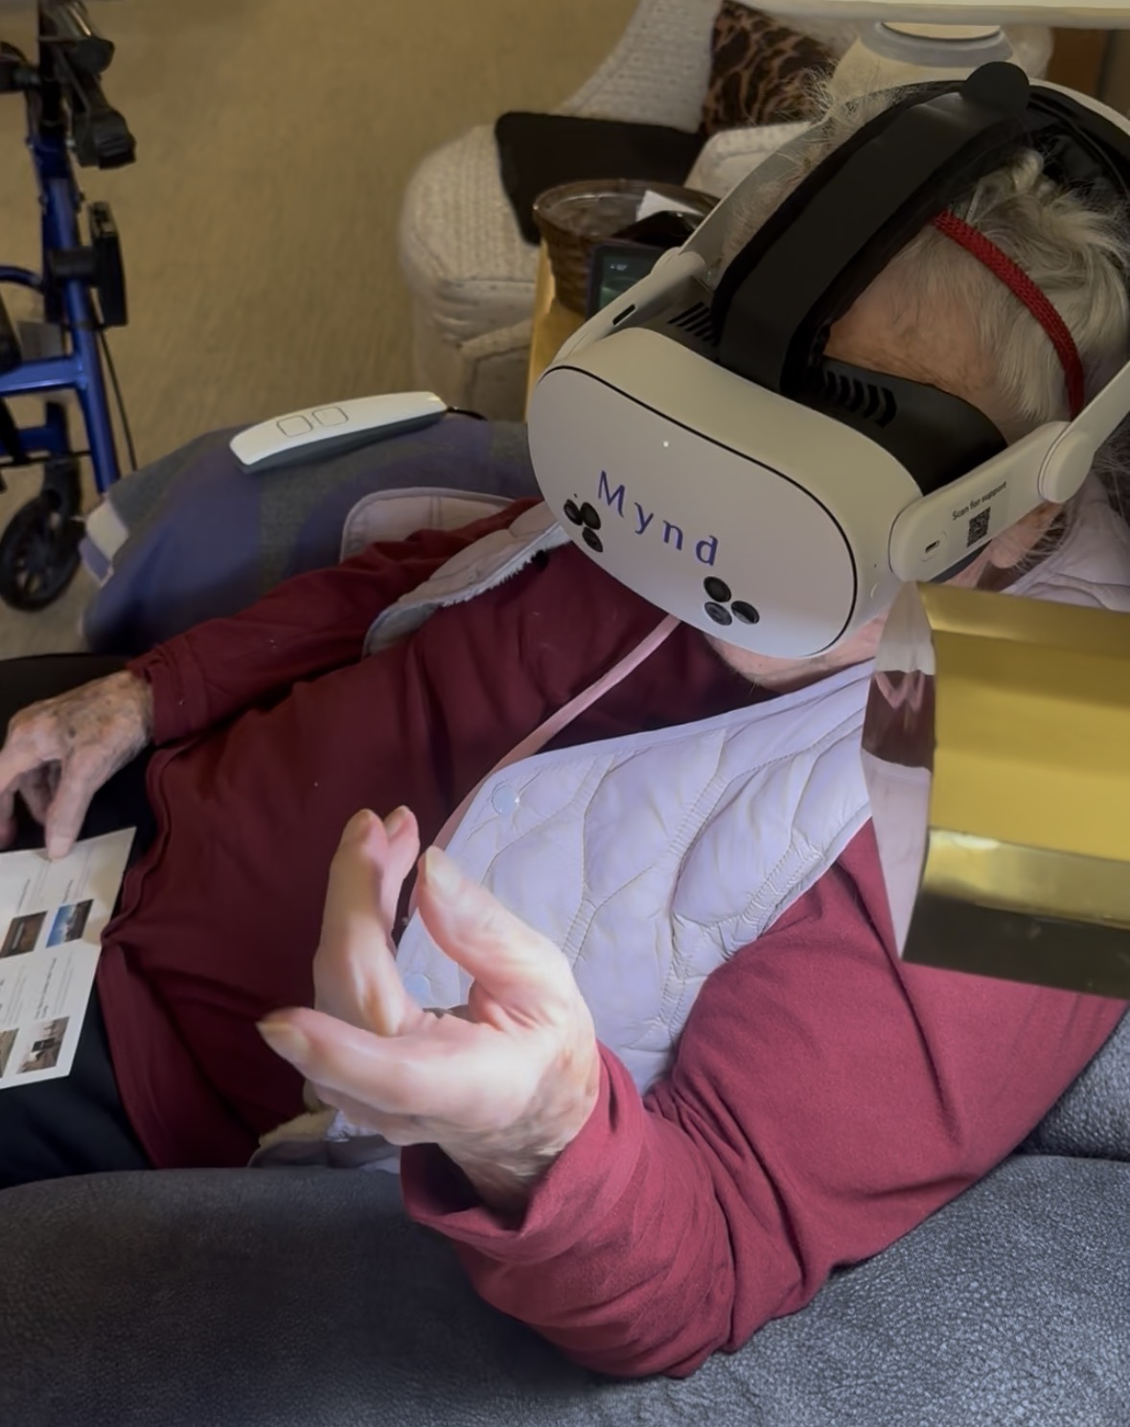We are excited to introduce one of our newest and most immersive activities, Virtual Reality! This innovative experience allows residents to step into amazing new worlds without ever leaving the comfort of our community. Whether you're looking to relax, explore, learn, or simply have fun, Virtual Reality offers something for everyone.  Imagine sitting peacefully on a tropical beach while listening to the sound of ocean waves, meditating beside a tranquil waterfall, or taking a calming walk-through beautiful forests and gardens. For those with a sense of adventure, Virtual Reality can transport you across the globe to visit famous landmarks and monuments, explore breathtaking landscapes, and experience destinations you may have always dreamed of seeing.  The fun doesn't stop there! Residents can enjoy interactive games and activities such as fishing in scenic lakes, catching colorful butterflies in beautiful meadows, and even spending time with adorable puppies that are sure to bring a smile to your face. Looking for a little more excitement? If you're feeling adventurous, you can experience the thrill of skydiving, soaring through the clouds, and taking in incredible views—all while safely seated in your chair.  Virtual Reality is more than just entertainment. It can promote relaxation, spark memories, encourage conversation, and provide opportunities to experience new places and activities in a fun and engaging way. Whether you're seeking a peaceful escape, a chance to travel the world, or an exciting adventure, we invite you to put on a headset and discover all the possibilities waiting for you in our new Virtual Reality program. The world is at your fingertips—where will your next adventure take you? | Beautiful Scenic Drives  One of the greatest joys of living in Colorado is being surrounded by some of the most breathtaking scenery in the country, and this month we're excited to take advantage of it with a series of scenic drives through the mountains. Residents will have the opportunity to sit back, relax, and enjoy the spectacular views as we visit some of Colorado's most charming and picturesque destinations, including Idaho Springs, Nederland, and the stunning Mount Blue Sky area.  These outings offer a wonderful chance to experience winding mountain roads, towering pine forests, sparkling streams, and incredible panoramic vistas without having to do any of the driving. Along the way, we'll enjoy the unique character of mountain communities, spot local wildlife, and take in the natural beauty that makes Colorado so special. Whether you've lived here for years or are seeing these sights for the first time, our scenic drives are the perfect way to spend a relaxing day enjoying the fresh mountain air and unforgettable landscapes. Be sure to sign up and join us as we explore some of the best views Colorado has to offer!  Celebrating Golden Pond Grads    This month, we would like to extend our heartfelt congratulations to the graduating students of Golden Pond: Leidy Emeterio, Clara Hail, Larissa Hastings, Kamila Korowajska, Liam Braun, and Daniel Murray.  Graduation is a significant milestone that reflects years of dedication, perseverance, and hard work. Each of these individuals has demonstrated commitment to their education and personal growth, overcoming challenges and achieving goals along the way. As they turn the page to an exciting new chapter, we are proud to celebrate their accomplishments and the bright futures that lie ahead. We wish them continued success, happiness, and fulfillment as they take their next steps, whether that means continuing their education, beginning a new career, or pursuing new opportunities. Congratulations, graduates—your Golden Pond family is proud of you!  Society Museum.
Employee of the Month  June 2026  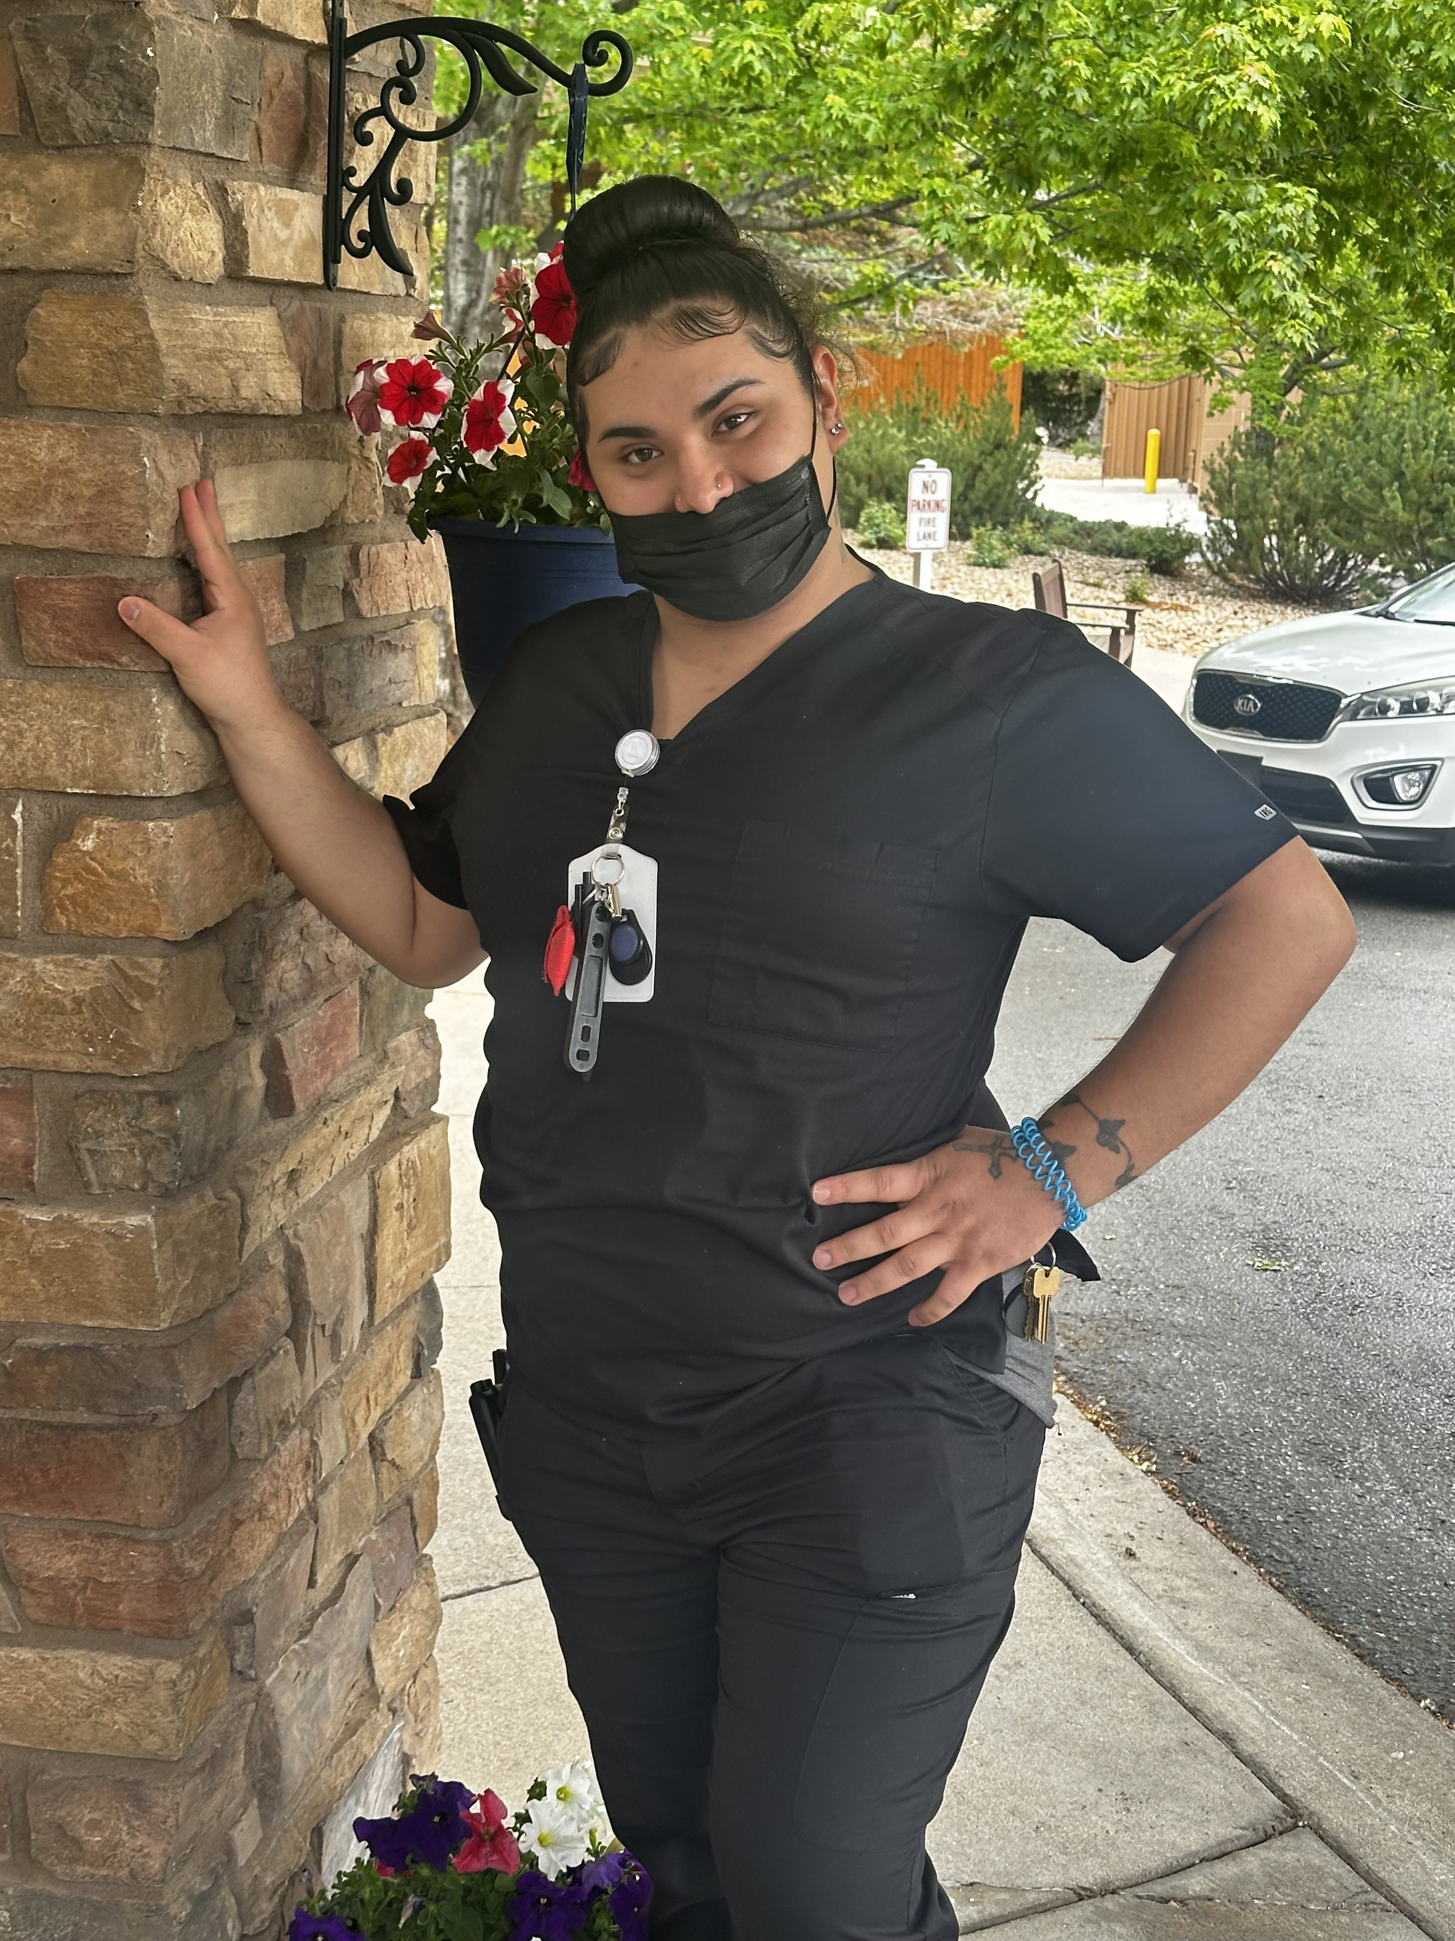 This month, we are proud to recognize Jocelyn Swan as our Employee of the Month. Jocelyn is the definition of dedication and teamwork. No matter the task, she is always willing to jump in and help wherever she is needed, often without hesitation and always with a positive attitude.  Jocelyn's commitment to our residents is truly remarkable. She consistently goes above and beyond to ensure their comfort, happiness, and well-being, and the care she provides never goes unnoticed. There are times we joke that Jocelyn must live here because of the countless hours she dedicates to our community, but that only speaks to the level of passion and heart she brings to her work every day.  Her reliability, compassion, and willingness to serve others make her an invaluable member of our team. We are incredibly grateful for everything Jocelyn does and are honored to celebrate her this month. Congratulations, Jocelyn, and thank  June 2026 | Out to Lunch!  Summer is the perfect time to go out, enjoy the sunshine, and share a great meal with friends. This month, our Monday lunch outings will take us to several wonderful local restaurants where residents can relax, socialize, and take in some beautiful Colorado scenery. On June 15th, we'll be visiting Genesee Pub & Grill, a local favorite nestled in the foothills. We'll also be heading to The Flats Lounge, where residents can enjoy a delicious meal while taking in the stunning outdoor views of the Flatirons.  In addition to these scenic destinations, we'll be stopping by favorites such as Black-eyed Pea and Olive Garden for some classic comfort food and great company. Whether you're looking forward to the food, the views, or simply spending time with friends, our Monday lunch outings are a wonderful way to enjoy the best of the summer season.  Golden Pond’s First Staff Talent Show!  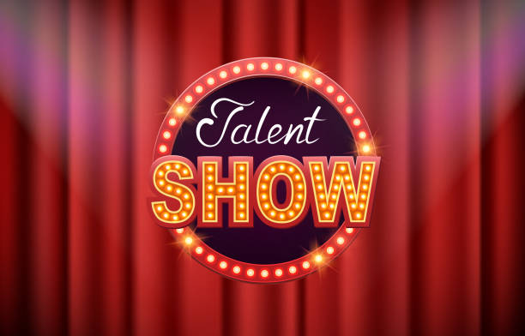You Be the Judge!  Get ready for one of the most entertaining events of the year! On June 30th, our talented staff members will take the stage to showcase their hidden talents in a fun-filled Staff Talent Show. From singing and dancing to comedy, magic, and other surprise performances, you never know what you might see!  The excitement doesn't stop there—you, our residents, will have the important job of serving as the judges. Cheer on your favorite acts, score each performance, and help decide who will earn bragging rights as this year's talent show champion. With plenty of laughs, friendly competition, and unforgettable entertainment, this is an event you won't want to miss. Mark your calendars and join us for an afternoon of fun, surprises, and community spirit!
World Cup Coming to USA    Get ready, sports fans, the biggest sporting event in the world is coming to North America in 2026! The FIFA World Cup will be hosted across the United States, Canada, and Mexico, making history as the first World Cup ever hosted by three countries together. Millions of fans from around the globe will be traveling to cheer on their teams, creating an unforgettable atmosphere filled with excitement, culture, and celebration.  The 2026 tournament will also be the largest World Cup ever played. For the first time, 48 teams will compete instead of 32, leading to an incredible 104 matches throughout the tournament. Games will be played in 16 different host cities, with the championship match taking place in New York/New Jersey on July 19, 2026.  Here are a few fun facts about the upcoming World Cup:  - The United States will host the majority of the matches, making it one of the largest sporting events ever held in the country.  - Mexico's famous Estadio Azteca will become the first stadium in history to host World Cup matches in three different tournaments.  - FIFA expects more than 5 million fans to attend matches in person throughout the tournament.  - The event is expected to be watched by billions of viewers worldwide, making it one of the most viewed events on the planet.  - Four nations are expected to make their World Cup debut, showing how much the sport continues to grow around the world.  Whether you're a lifelong soccer fan or simply enjoy the excitement of major sporting events, the 2026 World Cup is sure to bring unforgettable moments, incredible athletic performances, and plenty of reasons to cheer. As the countdown continues, it's exciting to know that the world's biggest soccer tournament will soon be taking place right here in North America!  should occur every four years and competition should be in modern sports rather than ancient ones. Two years later, the first modern Summer Olympics was held in Athens, Greece.  June 2026 | June Birthdays  In astrology, those born between June 1–21 are Gemini’s Twins. The Twins represent energetic communication and interaction. Curious Geminis love to collect and share information. Witty and intellectual, they attract many friends, mentors, and colleagues. Those born between June 22–30 are Crabs of Cancer. Kind and protective, Crabs love to nurture others. While they may be emotional, they are never soft. Cancers are tenacious in their pursuit of domestic harmony.  Frani Bickart – June 3rd  Colene Cooper – June 5th  Bea Jennings – June 6th  Karen Bartos – June 6th  Jim Reed – June 7th  Silvia Grotes – June 16th  Paul Herzberg – June 21st  Rita Posner – June 25th  HAPPY FATHER’S DAY    Join us as we celebrate Father's Day with an afternoon full of fun, laughter, and summertime favorites! Residents, families, and friends are invited to enjoy backyard games, friendly competition, and plenty of opportunities to relax and socialize while enjoying the beautiful Colorado weather.  We'll be serving delicious root beer floats to help everyone stay cool while enjoying live music from Ellis Marcel. To make the day even more exciting, we're also working on bringing a special attraction to the community that is sure to add an extra element of fun and surprise to the celebration. Whether you're coming for the music, the games, the treats, or the company, Father's Day promises to be a wonderful afternoon filled with great memories and community spirit.


