PRESS RELEASE
Corporate objective: Security of supply

Klingele optimises its energy strategy in Delmenhorst with battery storage
Remshalden, 3 November 2026 – Klingele, a leading manufacturer of containerboard and packaging solutions made from corrugated and solid board, is consistently advancing the development of its energy supply across its sites. Through investments in modern energy infrastructure, the company aims to further optimise its use of renewable energy and strengthen long-term security of supply. A current example is the planned deployment of a battery storage system from technology partner MegaLion Europe at the Delmenhorst site. The system is intended to temporarily store surplus electricity from the on-site photovoltaic installation and make it available for use at the site when needed.
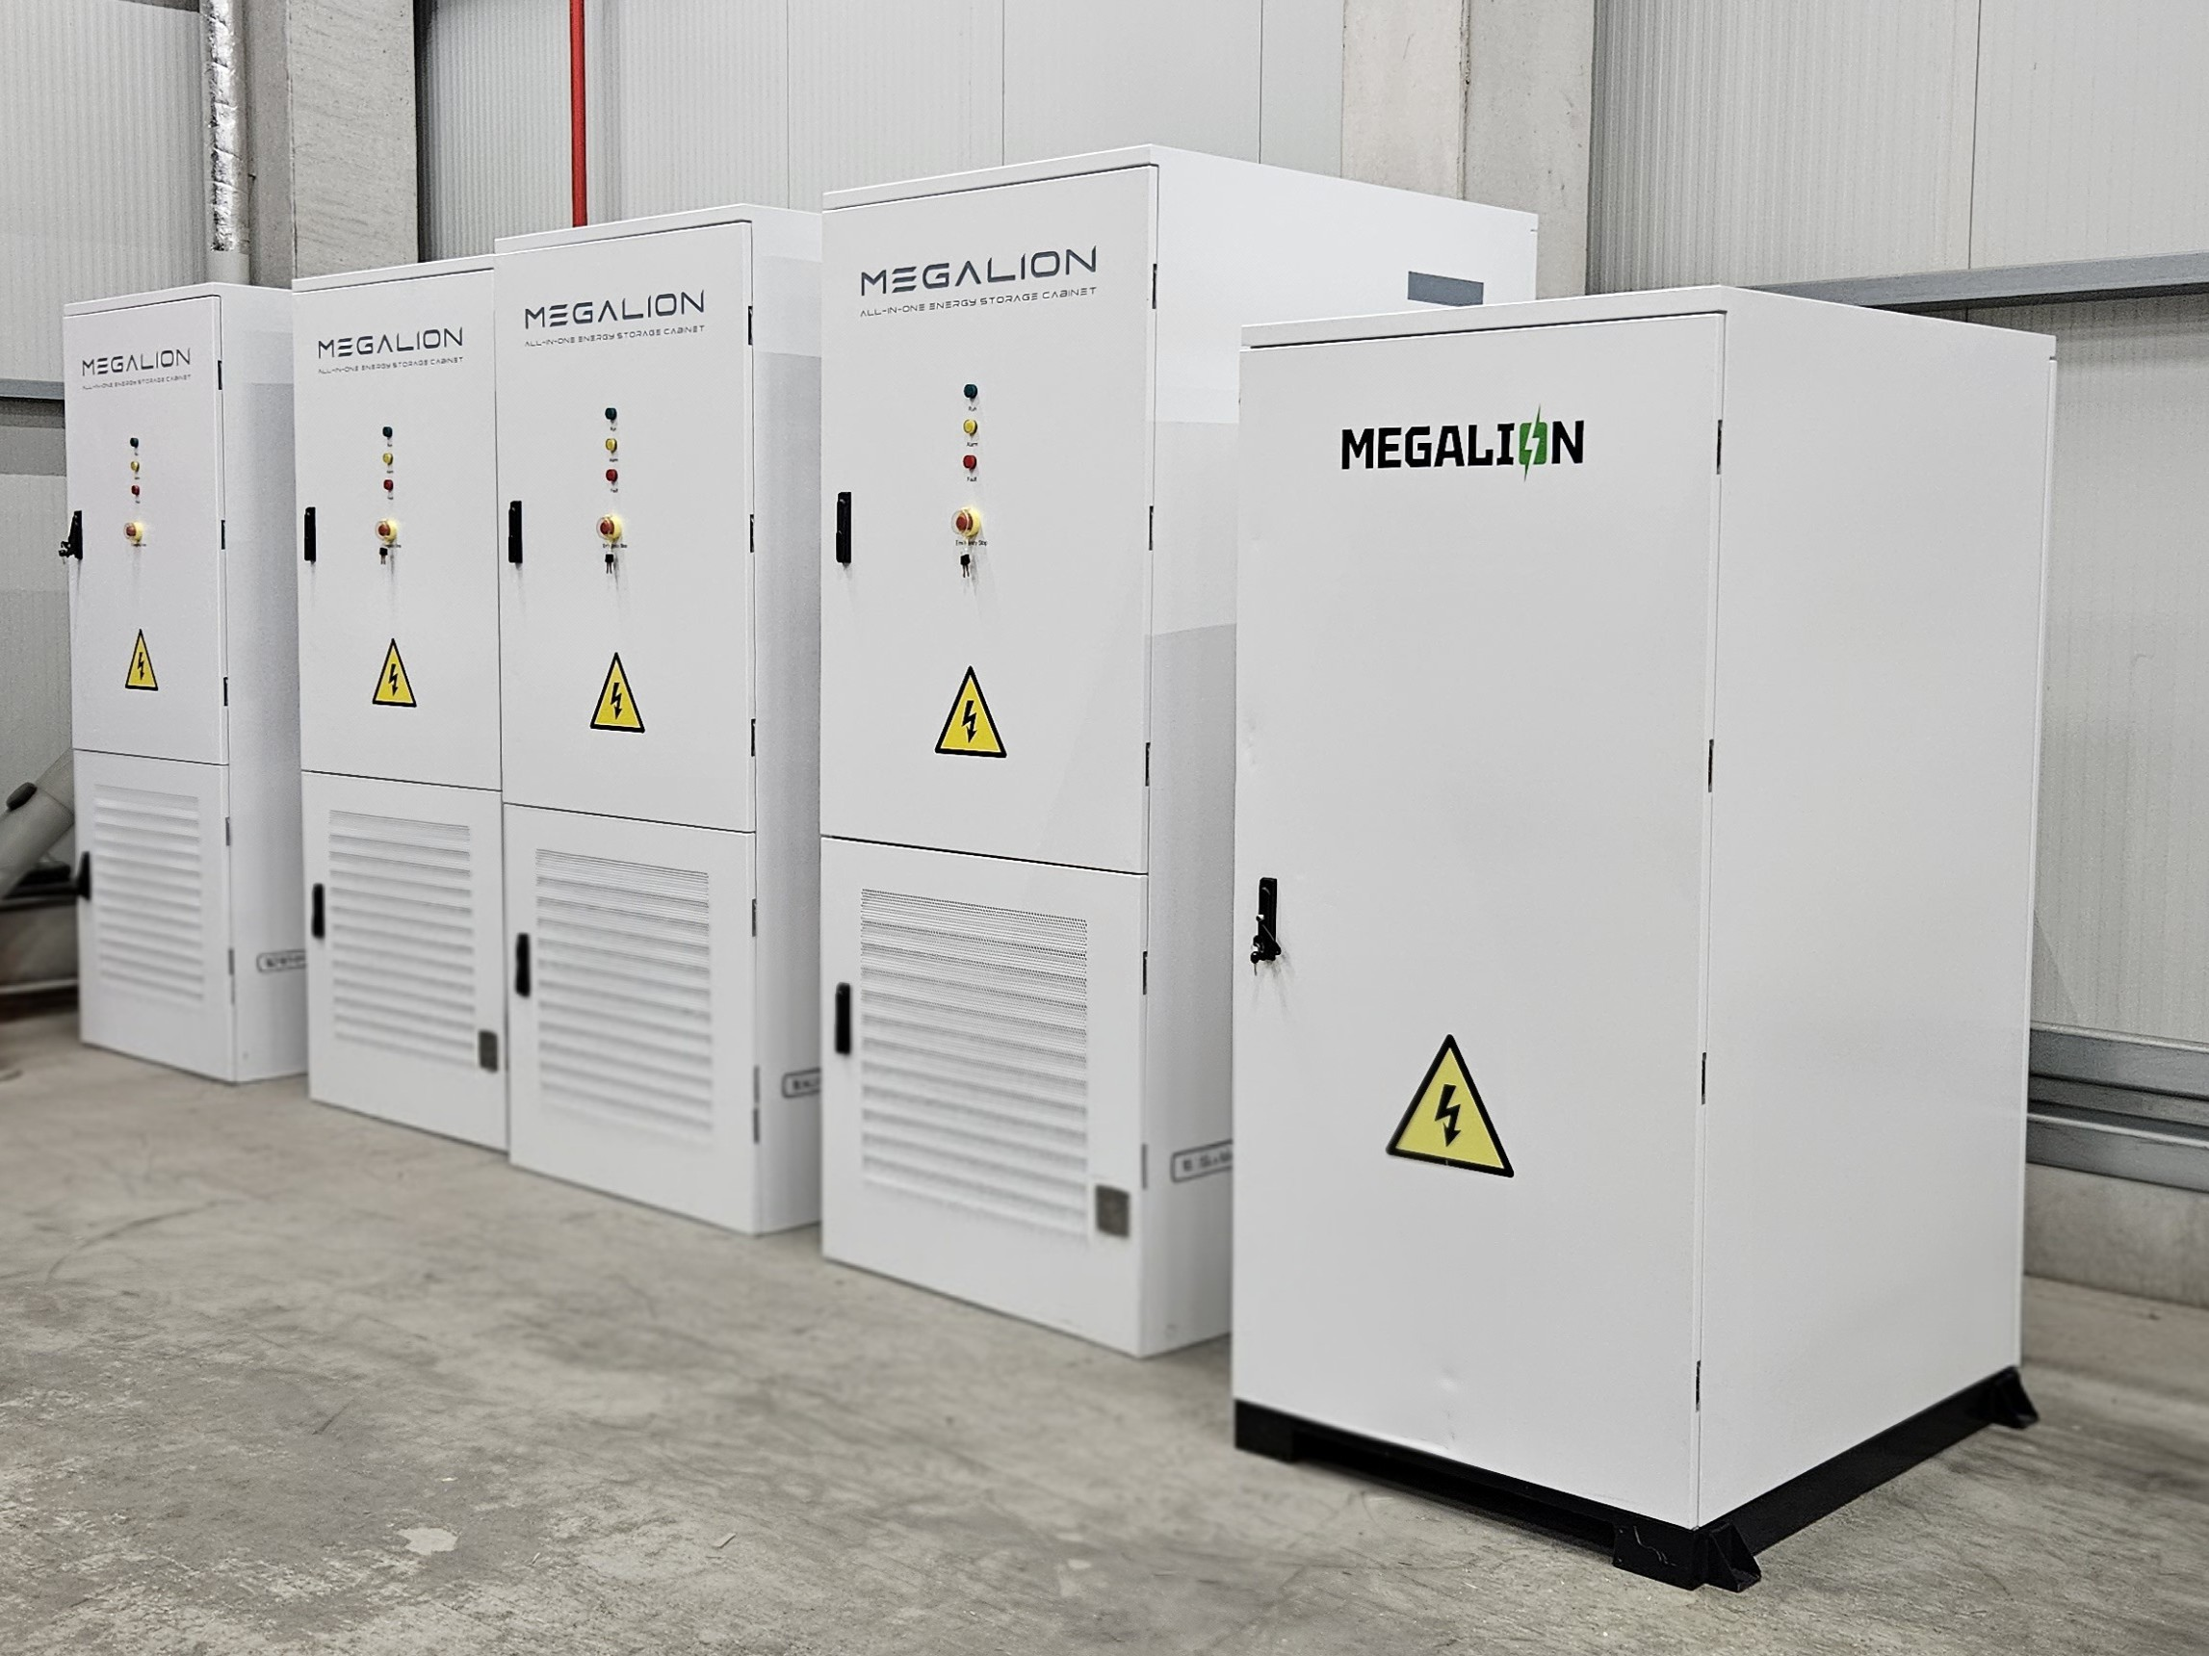
As part of Klingele’s energy strategy, a new battery storage system from technology partner MegaLion Europe is planned for the Delmenhorst site (source: Klingele Paper & Packaging).

People, Planet, Progress: In line with the three pillars guiding its business activities, Klingele Paper & Packaging has been investing for years in expanding and optimising renewable energy at its own sites. The aim is to reduce dependence on external energy sources and the resulting fluctuations in supply, ensuring reliable production and a high level of delivery reliability for customers over the long term. These efforts are also intended to reduce site-related CO₂ emissions and support the Klingele Group’s sustainability goals.

On-site energy generation as part of the energy strategy
In 2025, Klingele already generated more than half (57.6 per cent) of the electricity consumed within the company itself. Of the energy it generated, 81.9 per cent was used at its own sites, while 18.1 per cent was fed into the public grid.
Klingele’s energy portfolio combines a range of generation and utilisation approaches:
- Refuse-derived fuels: Weener
- Biogas: Weener and Strasbourg
- Residual materials: Strasbourg
- Biomass: Strasbourg and Nova Campina
- Hydropower: Catas Altas
- Wind power: Weener and Werne
- Photovoltaics: eight sites
As paper production accounts for 90.7 per cent of total electricity consumption, the paper mills are a key focus of energy and efficiency measures.

Targeted investments across the sites
Several projects implemented or initiated in the recent past demonstrate that Klingele takes an integrated approach to energy supply and resource use:
- Grunbach: An adiabatic cooling system operating since September 2024 uses evaporative cooling to lower temperatures in the production halls. The system runs largely on solar power generated on site.
- Hilpoltstein: A battery storage system and an energy management system reduce peak loads at the corrugated board plant. The peak load recorded at the site is intended to fall from 1,452 to 1,027 kW.
- Nova Campina, Brazil: Since October 2024, a fluidised bed boiler has been generating steam and electricity from biomass. The project is part of a multi-stage programme to further develop the site’s energy supply.
- Climate targets: The Science Based Targets initiative has validated Klingele’s near- and long-term emissions reduction targets for its four German corrugated board plants. This validation provides a verifiable framework for further emissions reductions; it does not mean that these targets have already been achieved.

MegaLion battery storage in Delmenhorst
Klingele’s latest investment in security of supply as part of its energy strategy is a battery storage system from technology partner MegaLion Europe, which is planned for installation at the Delmenhorst site.
The storage system consists of four battery energy storage system (BESS) cabinets, each with a storage capacity of 261 kWh and a power rating of 125 kW. In total, the installation therefore has a storage capacity of approximately 1.044 MWh and a power rating of 500 kW. It is based on semi-solid LFP cells with hybrid electrolyte technology. This combines solid and liquid electrolyte components to provide high thermal stability and an enhanced level of safety.
The battery system is intended to temporarily store surplus electricity from the photovoltaic installation. This electricity can then be used at the site at a later time, rather than being fed directly into the public grid. The storage system is also planned to be used for peak shaving. This is intended to enable more targeted management of the site’s energy infrastructure and limit costly peaks in power demand.
“In an energy-intensive sector such as the packaging industry, energy supply is a core strategic issue for security of supply. As a family-owned company, we align our investments with long-term perspectives and the next generation. We combine different approaches rather than relying on a single technology. The battery storage system in Delmenhorst and the storage of the energy we generate ourselves are logical next steps on this path – in the spirit of People, Planet, Progress,” says Dr Jan Klingele, Managing Partner of Klingele.
“For industrial production sites, battery storage offers the opportunity to use self-generated solar electricity more flexibly over time and to address peak loads in a targeted way. The Delmenhorst project demonstrates how a storage system can be integrated into existing energy infrastructure. We are delighted to support Klingele with our technology,” says Markus Korsten, CEO of MegaLion Europe.

Klingele Paper & Packaging Group
The Klingele Paper & Packaging Group combines the expertise of more than 100 years as a family business with a bold approach to innovation, an awareness of sustainability, and passion and responsibility for its employees. Headquartered in Remshalden near Stuttgart and led by Dr Jan Klingele in the third generation, the company is an international provider of paper and corrugated packaging solutions. Since 1920, it has supported its customers as a knowledgeable partner committed to the highest quality standards. Klingele actively works to meet its energy needs from renewable sources and has a presence in Europe, Africa, Central America and South America, with three paper mills, thirteen corrugated board plants and nine converting plants, including shareholdings. Its broad product range includes containerboard made from recovered paper and sustainable virgin fibre, corrugated board sheets, and recyclable, innovative packaging solutions for numerous industries and applications.
Klingele offers its current workforce of 3,100 employees an attractive working environment with long-term prospects. In 2024, the Group generated total revenue of one billion euros. As a founding member of Blue Box Partners, Europe’s largest alliance for corrugated packaging solutions, Klingele is one of the industry’s driving forces.
Further information about the Klingele Paper & Packaging Group: https://www.klingele.com/
Instagram: https://www.instagram.com/nextgen_klingele/
Facebook: https://www.facebook.com/klingelegroup/
YouTube: https://www.youtube.com/user/KlingelePapierwerke
LinkedIn: https://www.linkedin.com/company/klingele-group/

Contact for further information
Klingele Press Office
c/o follow red GmbH Klingele Paper & Packaging SE & Co. KG
Markus Schaupp Fridolin Schmidt
Waldburgstraße 17/19 Alfred-Klingele-Str. 56-76
70563 Stuttgart 73630 Remshalden
Tel.: +49 (0)711 90140-549 Tel.: 07151 701 0
Email: klingele@followred.com Email: marketing@klingele.com

MegaLion Europe
MegaLion is an integrator of energy storage solutions, specialising in the next generation of semi-solid-state lithium and sodium-ion batteries that combine the highest safety standards, long service life, high efficiency and a wide temperature tolerance. Its offering ranges from mobile storage systems, wall-mounted residential storage and complete high-voltage systems to DC charging solutions, integrated commercial and industrial storage, and large-scale container solutions.
MegaLion Europe is a joint venture between Enperium, a leading European specialist in green energy technologies, and MegaLion China, a pioneering battery manufacturer. As a Europe-based company, MegaLion Europe has an experienced team of experts and a strong industry network, enabling seamless system integration, dependable service and direct local support.
Website: www.megalion.eu

