GenieMD iVisit
Provider training

Introduction
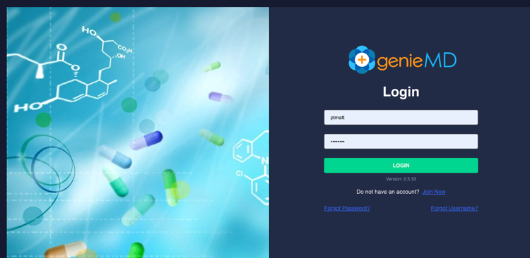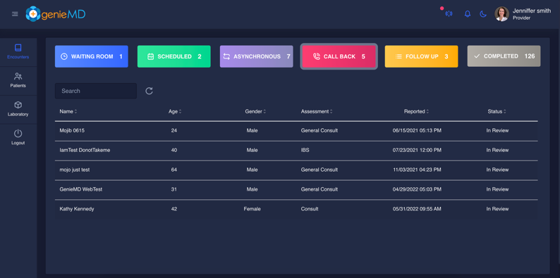
This document describes all steps necessary to attend a new patient case or review and modify a completed encounter. You can view and attend these cases using a Google Chrome desktop browser or by downloading the GenieMD iVisit App from Apple iTunes or Google Play Store. To use the provider portal visit:

https://geniemd.com/doctor

and login with username and password provided during your onboarding. If you prefer to use the iOS or Android apps on your smartphone or tablet, tap “Already a member” and login with the same credentials.

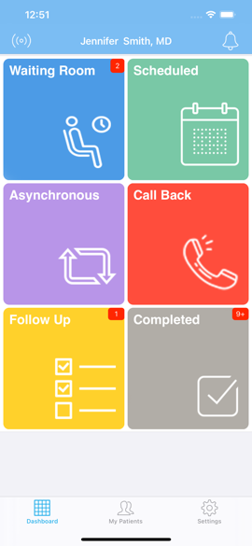
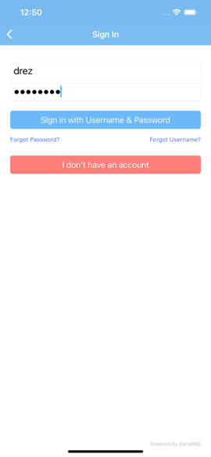
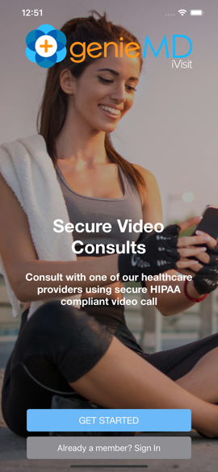

How GenieMD iVisit works

When a patient completes an assessment, the case is submitted to all providers who:

- Are licensed where the patient is physically located
- Provider has selected the condition for treatment during onboarding

When a new case is available, you will receive notifications based on the setting in your profile. For example, you will receive an SMS text message or email or Push Notifications if you have download the GenieMD iVisit App.

Follow these steps:

- Login to desktop or smartphone
- Tap on Call Back Bucket (Red)
- Tap on the case you would like to accept
- When prompted accept the case
- Review patient demographics, allergy, conditions and medications and the intake questionnaire
- Call the patient using built-in secure video (This is a requirement)
- Discuss the case with the patient. If you are planning on prescribing, please discuss the benefits and side effects of the medication
- End the call
- Tap on Visit Summary
- Type or select from Smart Note List notes you want to send to patient
- Tap ePrescribe and prescribe medications
- Select any educational material you wish to send to the patient.
- Tap Done
- When prompted with additional options, select Mark as Completed.

Note: Our promise to our patients is that we respond within 4 hours. Please call the patient as soon as you take the case.

Accept the case

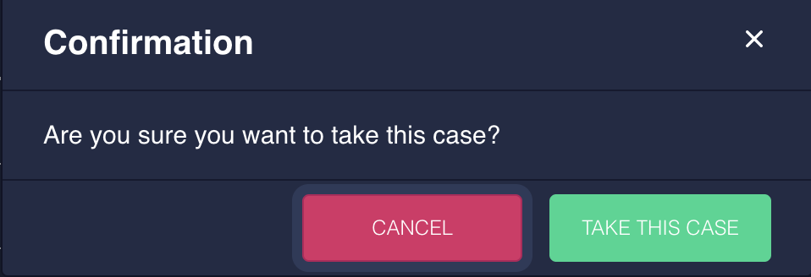

Review the patient intake questionnaire

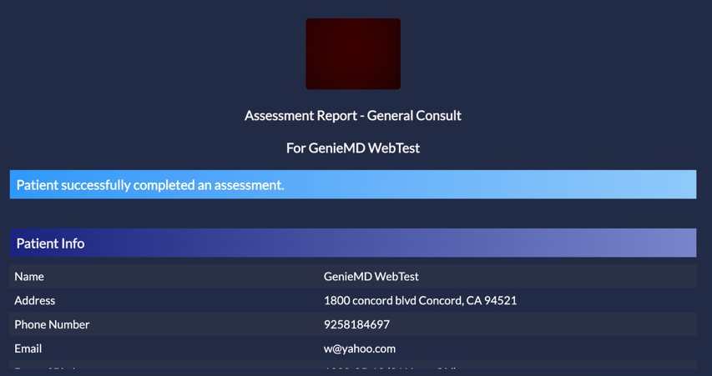

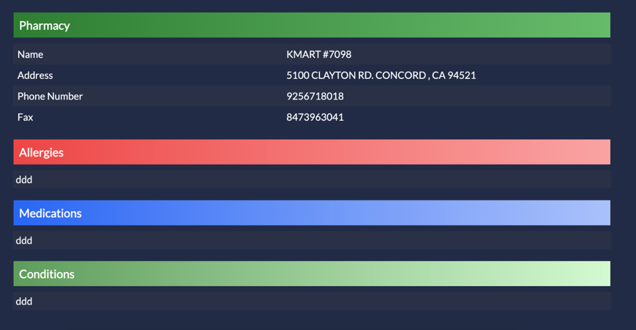

Action menu

Call Patient using built-in video – Tap Call Back
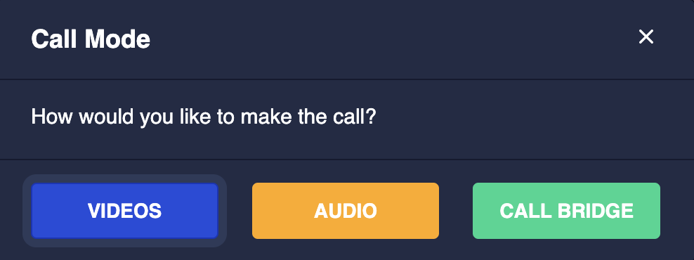

If patient does not answer, please send a message and ask patient for his availability. When patient responds you will get a notification that you can review in your notification center.
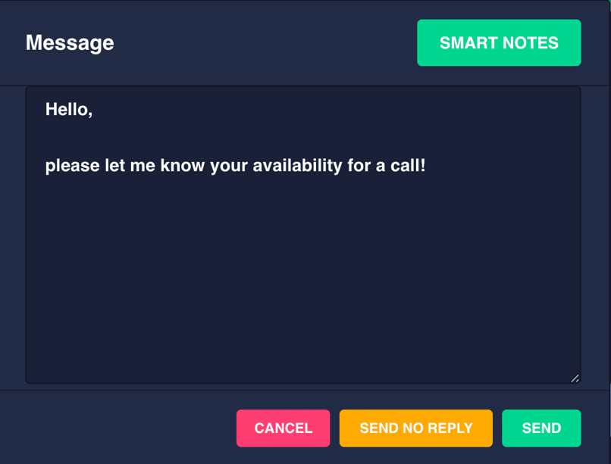

Please try calling patient three times, allowing time between calls. If you cannot connect to patient after three attempts, please email customercare@geniemd.com and specify your name and the first name of the patient.

What is call bridge?
In rare cases if patient video connection is choppy or unavailable, by selecting this option, your phone will ring and upon answering you are connected to the patient phone without your caller ID showing. Please make sure you specify the end of call bridge by clicking on End Call on the screen when call is ended. This is important for our system analytics.

After Visit Summary
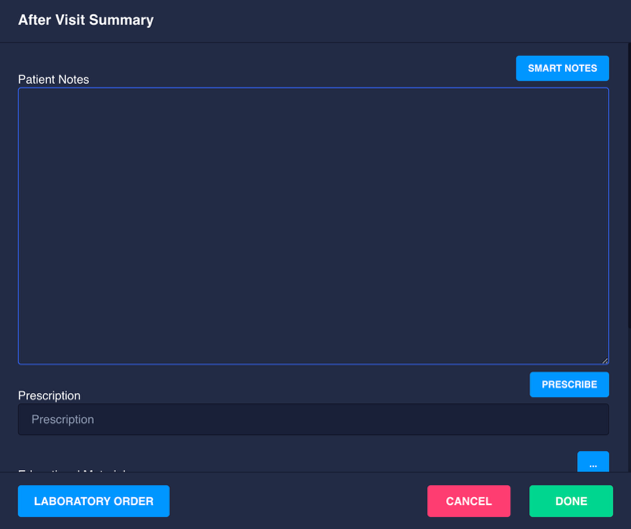
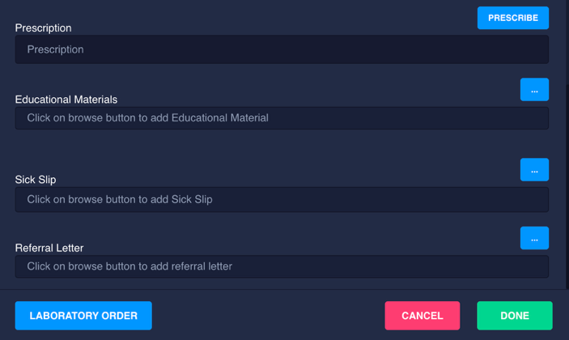

Using Smart Notes
Smart notes are an easy way to populate patient note with pre-defined notes. You can use system wide notes provided by GenieMD or create your own smart notes.
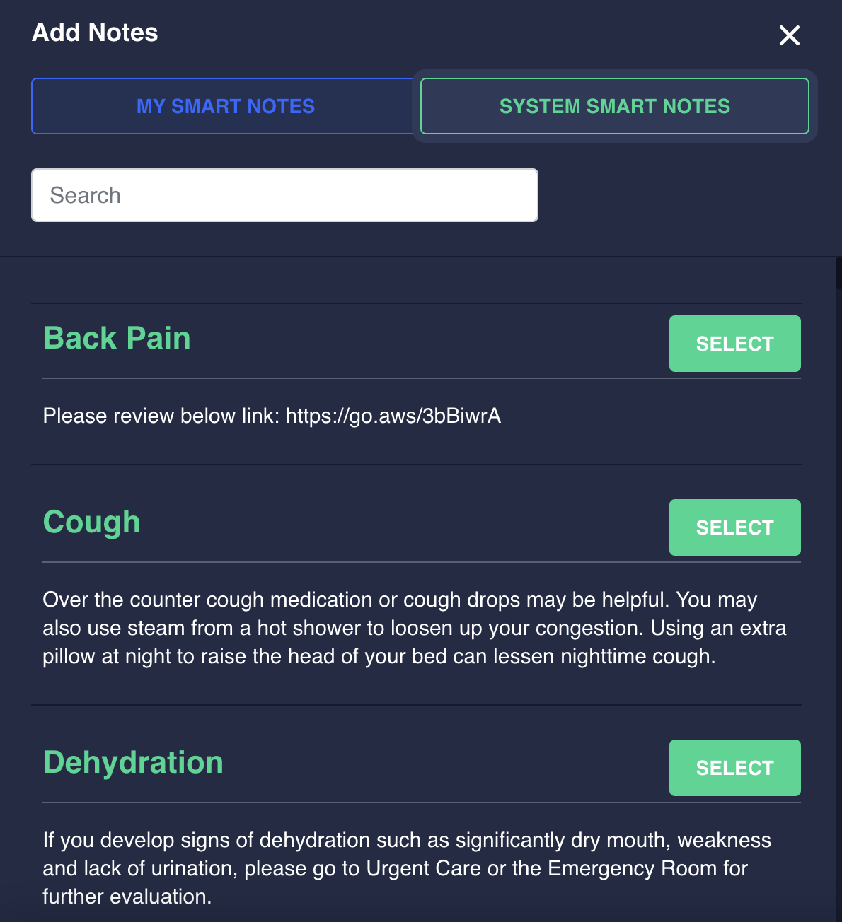

ePrecription

GenieMD ePrescription software allows for US FDA Approved medications and DMEs. We currently do not support controlled substances due to federal and state restrictions.

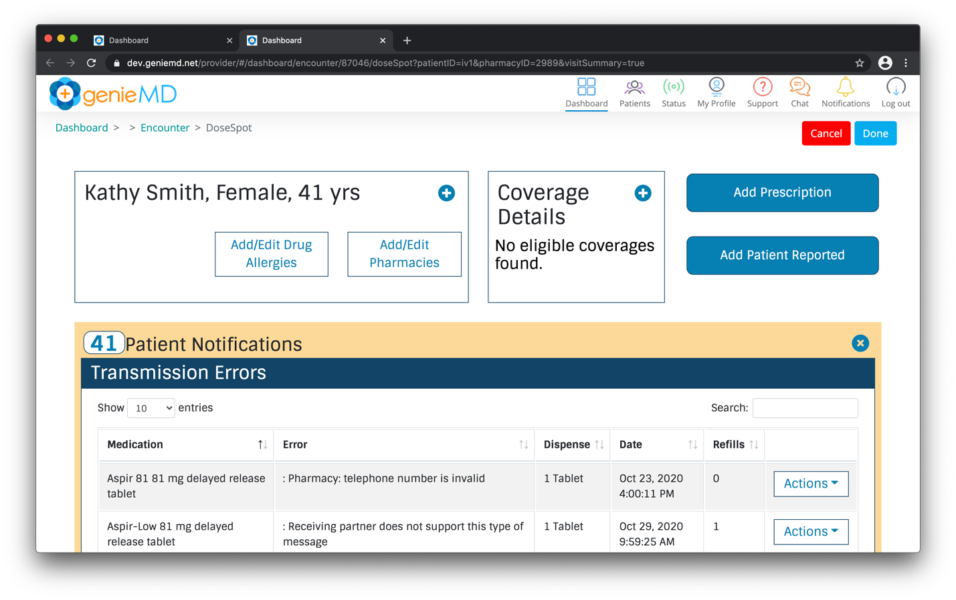

Educational Material

GenieMD licenses high quality, curated, peer reviewed educational material. You can search for a specific condition, review and if desired add to the note sent to the patient.
