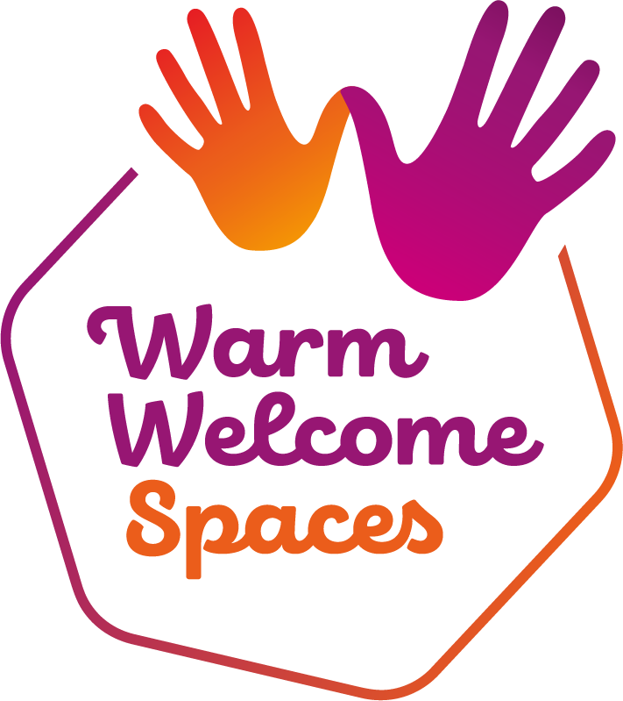

Warm Welcome Spaces
Inclusion Toolkit
Practical guidance and ready-to-use resources
for creating spaces where everyone belongs
This is our Large Print version, if you need the document in other formats please visit the Warm Welcome Dashboard

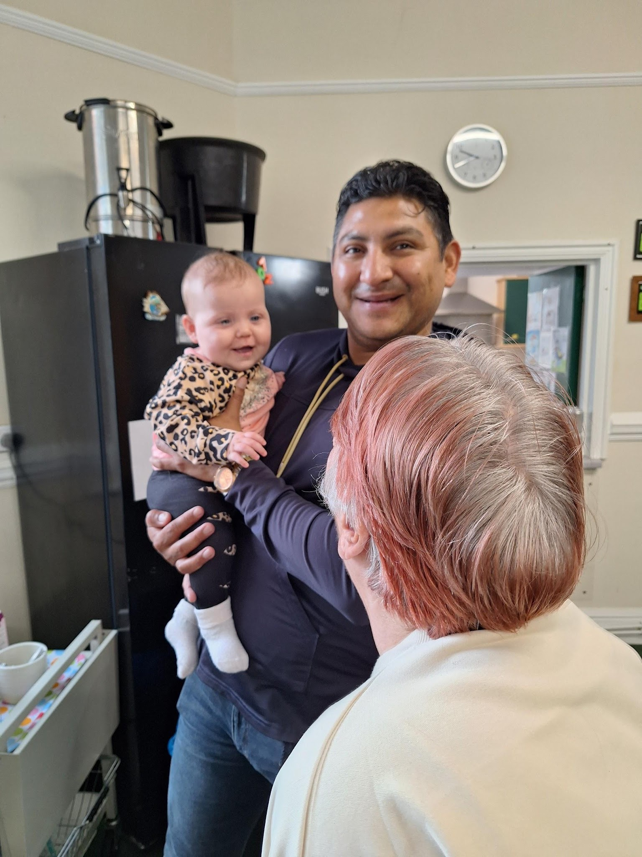

Developed through co-production with the Warm Welcome Campaign

"We are open and welcoming to everyone…we've folks from all walks of life…wealthy and homeless, young and old… professional and others with learning disabilities…all the colours of the neurodiverse spectrum, adults and children…all faiths and no faith…there's pancakes and cakes, teas and good coffee for everyone. We don't charge…there's games and crafts and telly and endless talking." Warm Welcome Spaces Volunteer.


Introduction
We’re delighted to launch this Inclusion Toolkit which provides practical, actionable guidance and ready-to-use digital resources to help Warm Welcome Spaces become more inclusive and accessible to all. Inclusion is at the heart of Warm Welcome and this Toolkit is an important step in strengthening that commitment. Every recommendation has been shaped by the people who run these spaces across the country, ensuring it addresses real needs in our local communities.
The content draws on extensive consultation with local leaders across the network who generously gave up their time, including over 200 participants and survey respondents. Through this co-production process, we learned about the barriers Warm Welcome Spaces face, successes they have achieved, and the resources they need most.
By working together, we can unlock the power of community spaces made by and for everyone, creating a thriving network of hope and reconnection fuelled by human warmth. There has never been a more important time than now to build connections in our communities for those who feel most isolated.
Thank you for everything that you do.

David Barclay
Director of the Warm Welcome Campaign

How to Use This Toolkit
First things first: you don’t need to do everything at once.
If you’re looking at this Toolkit and feeling a bit overwhelmed by all the suggestions, take a breath. You’re already doing important work by running a Warm Welcome Space. This Toolkit is here to support you, not to add to your to-do list or make you feel like you’re not doing enough.

🌐The toolkit is supported by digital templates, training and guides that are in the Digital Resource Bank which accompanies the Inclusion Toolkit in your Warm Welcome Dashboard. You’ll see a web symbol 🌐 wherever there is a resource online to accompany the toolkit. This resource is designed to be read alone, but you can deepen your knowledge with the digital resources, and find tools for implementation like checklists, organisations that can help and other resources.

The truth is, it can be hard to do everything it takes to make a space truly inclusive- it takes time to get right. Inclusion is a journey, not a destination. Some adaptations are expensive, and resources are an issue for many community groups.
Every small change you make - a welcome sign in another language, remembering someone’s name, moving a chair so there’s more space for a wheelchair user to get in easily - these all make a real difference to someone. Small actions like these let your community know you care.
The Three-Tier Approach
This Toolkit is organised into three tiers, designed to meet you where you are in your inclusion journey, while also considering what’s achievable with your current resources.
Tier | Focus | Characteristics
ESSENTIALS | Getting started | Low/no cost, single-person decisions, immediate implementation. Foundational practices that any space can implement today.
INTERMEDIATE | Building capacity | Moderate cost/time, requires some coordination or training. Moving from reactive to proactive inclusion.
ADVANCED | Leading practice | Time to develop partnerships, ongoing development, and improving your own policies and procedures in the wider organisation to bring more inclusive practice into your organisation.

Start with Essentials - these are the foundations that make everything else work. Then build from there as your capacity grows.
TIER 1: ESSENTIALS
These are the foundations of inclusive practice; things any space can do immediately with little or no cost. They require only a decision and commitment to act.
🌐 You’ll find Training Videos and Train the Trainer resources you can adapt to your space in the Digital Resource Bank for the Inclusion Toolkit, on the Warm Welcome Spaces Dashboard. These cover the essentials of why inclusion is important, and how to start being more inclusive, and cover the general help staff and volunteers in warm spaces need to think more inclusively in their day to day practice.
1.1 Creating a Warm Welcome
Voice from the Network: "We are genuinely open to all. A big part of our success is showing how effective a very simple approach to supporting people ’where they are’ can be - helping them be part of a growing community where they are welcomed and where they feel true belonging."
“The very genuine welcome is what makes the difference. People know straight away whether it’s real.” - Warm Welcome Spaces Volunteer.
The power of friendliness and smiles are the most important factors in making people feel truly welcomed.
The role of the welcomer
The person who greets visitors as they arrive sets the tone for their entire experience. A dedicated welcomer should:
- Meet people at the door and introduce themselves.
- Show them how the space works.
- Help them connect with others.
- Remember things about new people, such as their names, and ask about them at their next visit.
This role is about more than just saying hello; it’s about making people feel they belong from the moment they step through the door. People with mental health issues (and everyone) can be anxious visiting anywhere for the first time- this helps people put their mind at rest.

First impressions matter
Voice from the Network: "Smile a lot and greet everyone as they arrive and say goodbye as they leave. When we sit down to eat we all share a big table, which makes for a family atmosphere."

Small actions make a big difference
- Genuine smiles and open body language.
- Learning and correctly pronouncing people’s names.
- Making eye contact.
- Showing new visitors where everything is - toilets, refreshments, activities etc.
- Explaining whether an optional donation is needed
Creating welcoming entrances
- Keep doors open when weather permits - closed doors can feel intimidating.
- Use welcoming signage in multiple languages where relevant.
- Ensure the entrance is well-lit and easy to find.
- Add plants, bright décor and keep it uncluttered so people can come in with wheelchairs/pushchairs/rollators.
- Display clear information about what the space offers.
Reducing anxiety for first-time visitors
Walking into a new space can feel daunting. Help ease anxiety by:
- Having someone greet people immediately.
- Offering a tour.
- Introducing them to at least one other person.
- Checking in on them during their visit.
- Having a buddy system where experienced volunteers are paired with new visitors.
- If someone arrives alone, ask whether they would like to be introduced to others. Some people welcome that connection straight away, while others prefer time to settle in. Giving them the choice helps avoid anyone feeling pressured.
- Wrist bands saying ‘I’m okay’ in green which you can turn inside out to say ‘I’m not okay’ in red, which means a volunteer will go over and check on them can be a great way of checking in on people’s mental health non-verbally.

CASE STUDY: Thursdays Together, Southampton
This church-based space noticed people waiting outside rather than coming in because the community room felt overwhelming when busy. They expanded seating into the main church, creating a quieter corner with sofas away from the busiest areas. Now visitors can choose what suits them best. In their survey, visitors highlighted that “the welcome, inclusion, and being accepted just as you are” set Thursdays Together apart from other spaces.
Following up with people who stop attending
When regular visitors stop coming, reaching out shows you notice and care about them. A simple phone call or message to check they are okay can mean a lot. Be sensitive, there may be reasons they have stopped attending, but caring matters more than we sometimes think.
1.2 Simple Physical Adjustments

Voice from the Network: “We get to know our guests well; who needs a chair with arms, who needs to be sat close to someone they know so they don't feel confused, who needs a two handled cup to drink, who is on a special diet."

These changes require no budget - just thoughtful arrangement of your existing space:
- Keep pathways clear and wide enough for wheelchair users and prams.
- Arrange furniture to allow easy movement through the space.
- Have a quieter area within your space, or specific quiet times.
- Provide space for pram/buggy storage that doesn’t block pathways.
- Walk through your space imagining you are using a wheelchair, have a visual impairment, or are managing three young children.
1.3 Basic Communication Essentials
Voice from the Network: "Treat everyone as an individual, take the time to talk to them and get to know their story (if they want). Read the room, some people just want to be left alone but to have the background noise of other people."
Plain language
Use clear, simple language in all your communications. Avoid jargon, acronyms, and complex sentences. This benefits everyone, not just those with English as an additional language, but also people with learning difficulties or cognitive differences. Using inclusive language helps those with different identities (such as the LGBTQI+ community) to feel they belong.
Inclusive language
- Use gender-neutral terms where appropriate.
- Ask people for their preferred pronouns when you meet them.
- Include pronouns on volunteer name badges.
- It can feel increasingly difficult for people to be open about their gender/ or sexuality and talk about it openly - make sure that you create safe spaces.
- One way you can do this is to openly display a LGBTQ+ Ally flag, or Love is Love Poster, with a rainbow symbol.

🌐Social media templates are available In the Digital Resource Bank for the Inclusion Toolkit, on Warm Welcome Dashboard

Translation tools
Technology can help bridge language gaps. Google Translate and Breeze Translate (breezetranslate.com) are free and can translate text, speech, and images. Keep a tablet or phone available specifically for translation.
Top Tip: Be warm and good-humoured when struggling with apps and translation. It breaks the ice and shows you’re trying.
1.4 Establishing Values and Safety
Communicating community values
Be clear about what your space stands for. Develop a simple statement of values that emphasises respect, kindness, and inclusion. Display this prominently and refer to it regularly. One fun way a space asks people to sign their community agreements is to draw around their hand on their agreement instead of signing, great for those who might have poor literacy

🌐 You’ll find a poster and sample community agreement you can adapt to your space you can use in the Digital Resource Bank for the Inclusion Toolkit, on the Warm Welcome Spaces Dashboard.

Responding to discriminatory behaviour
Prepare volunteers to respond to discriminatory comments or behaviour. Key approaches include addressing the behaviour not the person, referring to shared values, redirecting conversation, and following up privately.
Example responses:
- “In this space, we treat everyone with respect. Let’s change the subject.”
- “I hear you have concerns. This isn’t the place for that conversation, but I’m happy to chat privately.”
- “Everyone here is welcome. That’s one of our core values.”

CASE STUDY: Bishop Auckland Baptist Church, Co Durham
This church sees around 30 different people each week with varying needs. When someone is distressed or displaying challenging behaviour, they work within their capabilities - offering the garden as a calmer space, or briefly separating someone for others’ safety. Their approach: allow space and time, listen before acting, share concerns within the team, and don’t try to solve everything at once. They have training in mental health and learning disabilities, and an excellent relationship with local Police Community Support Officers who provide support when needed.
Creating social contracts
Consider developing a community agreement with visitors and volunteers. This helps neurodivergent people and others understand how the space operates and explains the rules. For example, how they donate (if they need or want to), how they get food, when they can leave. Keep it simple and positive, focusing on what we do rather than what we don’t do.
1.5 Reducing Stigma

Voice from the Network: "Making it clear that there’s no cost, no referral needed, and no expectations has been key to encouraging people who might otherwise feel self-conscious. People often say they came ’just for a cuppa’ but then stay for conversation and connection."
Creative naming
Consider how you describe your space. Terms like ‘community hub’, ‘drop-in’, ‘connect café’, or ‘community lounge’ may feel less stigmatising than ‘warm space’ for some people. The name should reflect what you offer, not imply who needs it, for example a Warm Space in Bolton uses snazzy names like Natty Knitters.

CASE STUDY: Snitterfield Warm Hub, Warwickshire
Snitterfield calls its space “The Hub” rather than “The Warm Hub” - a small change that has helped some people avoid the stigma they associate with attending. The space welcomes visitors with dementia and neurodivergent visitors with learning difficulties. New friendships have formed as people discover common interests, and barriers between different parts of the village have broken down.

Framing around community and connection
Focus messaging on what people can gain - community, connection, activities, company - rather than what they might lack. Avoid words like ‘vulnerable’, ‘disadvantaged’, or ‘in need’. Everyone benefits from community connection.
Enabling reciprocity
Many people feel uncomfortable always being on the receiving end. Create opportunities for people to contribute:
- Pay-it-forward schemes. Some of your community may not be in financial hardship but may be isolated. Giving them the opportunity to pay-it-forward can help them feel like they are not taking advantage of help. Consider having card machines on site for those who can afford to pay it forward discreetly.
- Volunteering opportunities.
- Bringing a skill or story to share.
1.6 Volunteer and Leader Training
We provide train the trainer training, and training videos in the Digital Resource Bank that covers inductions for inclusion, which cover the following topics:
Volunteer inclusion briefing (30 minutes)
A short session covering the basics every volunteer needs to know:
- What inclusion means in practice at your space.
- Welcoming and talking to diverse guests.
- Recognising and responding to different barriers that may exist.
This briefing can be delivered to new volunteers as part of their induction, or run as a refresher for existing teams.

🌐 You’ll find a volunteer briefing 30 minute video you can use you can use in the Digital Resource Bank for the Inclusion Toolkit, on the Warm Welcome Spaces Dashboard. as well as train the trainer resources for you to deliver the session yourself

Leader briefing (2 hours)
A more in-depth session for coordinators, managers, and lead volunteers covering:
- Setting the culture of inclusion.
- Supporting volunteers to handle challenging situations.
- How to respond to exclusionary or inappropriate comments.
- Responding to difficult situations.
🌐 You’ll find a leader briefing training video you can use and train the trainer resources you can use in the Digital Resource Bank for the Inclusion Toolkit, on the Warm Welcome Spaces Dashboard.
Top Tip: Provide volunteers with lunch to encourage them to attend training. This could be funded by local authority, other grant funders or individuals.

Essentials Checklist
Five things you could do this week:
- Assign someone to be the ‘welcomer’ who greets every person at the door.
- Print a ‘Welcome’ sign in two or three languages spoken in your community.
- Walk through your space as if you were a first-time visitor - what would confuse you?
- Ask a regular visitor what made them feel welcome when they first came.
- Run or schedule the volunteer inclusion briefing for your team.

Celebrate Your Wins
Don’t forget to celebrate what you’ve achieved each week! Ensure your team knows what they’ve achieved too. Below are some examples to inspire you to continue:

- By greeting everyone with a smile, you’ve helped a nervous first-timer feel safe and welcome, so they’re likely to return.
- By using clear signage, you’ve helped people feel included and know exactly where to go without having to ask.
- By keeping the entrance tidy and calm, you’ve reduced overwhelm for guests who find busy or cluttered spaces stressful.
- By arranging simple, clear seating, you’ve made the space easier to navigate for someone with a walking aid, a pram, or someone who needs a bit more room.
- By having a friendly chat, you’ve made someone feel seen and valued, perhaps for the first time that week.

TIER 2: INTERMEDIATE
These actions require moderate investment of time, coordination, or resources. They build on the ‘Essentials’ and help you move from reactive to proactive inclusion.
2.1 Accessibility Audits and Improvements

Voice from the Network: "Many people said they struggled to hear in the hall. We commissioned a report on acoustics and used it to apply for grant funding. The church match-funded and we installed acoustic panels. The impact has been dramatic - people who would never come into the hall because it hurt their ears now come regularly."
Conducting accessibility audits
Start by honestly assessing your current accessibility. Better yet, invite people with lived experience to help with your audit. You can find an access and inclusion self-led review tool on the Warm Welcome Spaces Dashboard, which will help you to assess what changes are most important to your organisation right now.
🌐 You’ll find an Access, Inclusion and Diversity Self Review you can use in the Digital Resource Bank for the Inclusion Toolkit, on the Warm Welcome Spaces Dashboard.
Step-free access and layout
- Ensure there is step-free access to the main space and toilets.
- Provide portable ramps if permanent ones are not possible.
- Consider different seating heights and types.
- Have larger tables available for families to sit together.
Managing noise
Noise levels can be a significant barrier for many people, including those with hearing difficulties, autism, or anxiety. Consider:
- Having a quieter area within your space.
- Specific quiet times.
- Simple measures like soft furnishings, rugs, and acoustic panels.
CASE STUDY: Wellesbourne Warm Welcome Space, Warwickshire
The Sports and Community Centre was very echoey - guests struggled to hear and couldn’t join in conversations, with games echoing around the room. They approached this as a partnership with the venue, offering support rather than just presenting demands. The Centre installed soundproofing panels on the walls, and the group now uses mats on tables to reduce sound from games even further. The difference has been transformative for conversation and connection.
Sensory-friendly environments
Voice from the Network: "Red and green mug coasters - red means ’I need some space’ and green means ’open to having a chat’."

- Avoid harsh fluorescent lighting where possible - natural light or warm bulbs are gentler.
- Be mindful of strong smells from cleaning products or air fresheners.
- Create calm zones away from the busiest areas.
- Have sensory tools available (fidget toys, ear defenders).
- Consider creating sensory bags or boxes, filled with sensory toys to keep neurodivergent adults and children regulated. Sensory equipment can help people with sensory processing issues feel calmer and safer in new environments.

CASE STUDY: Wroughton Library, Swindon
The library team took advice from the Roxi Foundation, a local neurodivergent charity. Based on their guidance, they introduced a coloured tissue paper window display to reduce glare, a “safe space” teepee, a sensory fish tube, birdsong music, a puppet theatre, and a toy oven for imaginative play. Several volunteers are neurodivergent, and one volunteer in her twenties has grown hugely in confidence - her mum says the library is the only place she feels able to come to on her own.

🌐 You’ll find a Neurodiversity Awareness Resource in the Digital Resource Bank for the Inclusion Toolkit, on the Warm Welcome Spaces Dashboard.

Inclusive toilets
Toilet provision sends a message about who is welcome:
- Ensure you have accessible toilets with adequate space and grab rails.
- Consider gender-neutral options where possible.
- Use clear signage, including ‘Not all disabilities are visible’ signs.
- Consider trans-inclusive signage.
- Provide sanitary products in all toilets, if budgets allow.
2.2 Family-Friendly Facilities
Making small, simple changes can help families to feel more welcome. For those with larger facilities, you may also think about specific family friendly programming.

🌐 You’ll find a Family Friendly Checklist, you can use in the Digital Resource Bank for the Inclusion Toolkit, on the Warm Welcome Spaces Dashboard.

Voice from the Network: "We try to create a community that welcomes children joyfully, so parents don’t feel on edge about their children’s behaviour, so they can sit and chat with other adults and not worry."
- Ensure baby changing facilities are available (ideally not only in female toilets).
- Have child-friendly furniture, toys, and books - a good selection of age-appropriate toys.
- Create a safe area for children to play within sight of parents.
- Consider breastfeeding-friendly signage and comfortable seating.
- Have two-handled mugs with lids available for toddlers.
2.3 Creating Multilingual Materials
Welcome signs, posters, and basic information in multiple languages signal that speakers of those languages are expected and valued. Focus on the most common languages in your local community.
Key Resources:
🌐 You’ll find a Multilingual Welcome Sheet you can use in the Digital Resource Bank for the Inclusion Toolkit, on the Warm Welcome Spaces Dashboard.

CASE STUDY: Translated Digital Flyers
The International Feast event (ebe.org.uk/internationalfeast) provides an excellent example of translated digital flyers that can be shared across different community networks. Having flyers on your website in different languages makes it easy for community members to share with their networks.
Visual communication
Symbols and images can communicate across language barriers:
- Use visual signs for toilets, exits, refreshments, and activities.
- Consider picture-based menus and visual guides.
- Pictures Exchange Communication System (known as PECS) boards can make spaces accessible to non-verbal autistic people. They allow non-verbal communication by pointing at pictures. These can be printed and laminated in large posters. These can support a non-verbal autistic person to talk to their carer or volunteers.
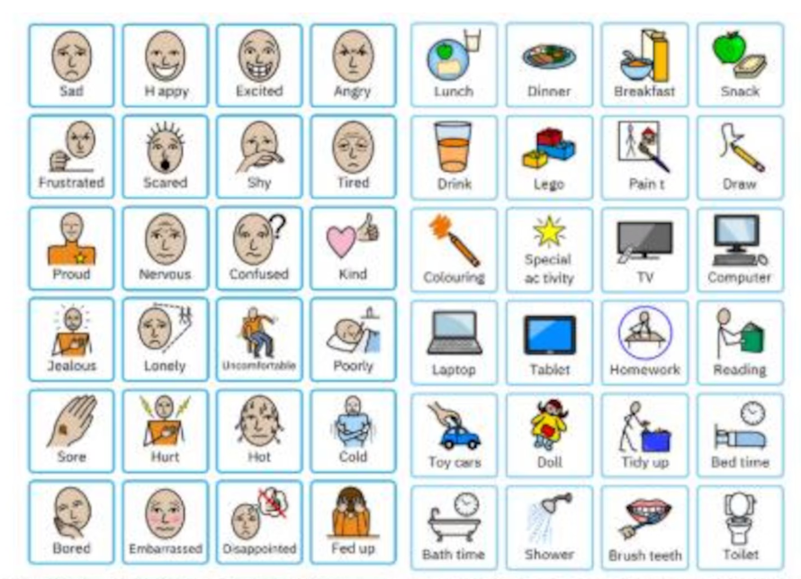An example of a PEC Communication Board, you could make up your own for your space with commonly used words. Etsy offers very cheap PEC resources for just a few pounds, that you can download and print yourself.
2.4 Representation and Belonging
Warm Welcome Spaces that have volunteers representing the communities they are trying to reach are better able to build relationships with community members from those communities least likely to access a community space.
Recruiting diverse volunteers
When visitors see volunteers who look like them or share their background, it sends a powerful message of welcome. It can be particularly useful to have an elder or leader from a marginalised group, which helps draw in others. Actively reach out to recruit volunteers from the communities you want to serve.

CASE STUDY: Visible Role Models
"Our chef has Parkinson’s and this has been really important in showing guests that everyone is valued and welcome. When our chef welcomed a new couple at Warm Welcome they asked about his tremor and were really pleased to meet him. It turned out that their son has had young-onset Parkinson’s and rarely goes out to anything social. The next week they brought their son to WW to introduce him. The whole family have been coming every week for the last two years." - Warm Welcome Space Volunteer.
Visibly sharing values through symbols
A church in Bristol displays flags from around the world all around the building, making them visible from outside, as well as displaying the trans flag prominently. These open and welcoming symbols spoke volumes to people that they would be welcome, and can feel safe in your setting.
Top Tip: When buying flag sets online, check that all countries are included. Make sure UK and USA flags don’t end up being the only ones visible from outside- this can give negative messages about who the space is ‘for’.
2.5 Inclusive Activities and Services
Food as inclusion
Shared meals bring people together like little else. Offering food from diverse cuisines celebrates different cultures and helps everyone feel represented. Always consider dietary requirements - religious, cultural, health-related, and preference-based.
Activities for all ages and abilities
Design activities that are genuinely accessible. Offer a range so there is something for everyone. Remember that some people may just want to sit and chat. Note that some groups, including some neurodivergent people, may struggle with events or activities early in the morning.
CASE STUDY: Fozzy’s Craft and Chatter, Lincolnshire
In this rural area, loneliness was a real issue. Rather than running activities for people, they built their sessions around the crafting skills visitors already have - asking and encouraging them to share what they know. At Christmas, they themed sessions around tree decorations, a simple project that everyone could join whatever their skill level. People weren’t just making things - they were sharing ideas, teaching each other techniques, and chatting while they worked.
Ideas from across the network
- Board games, puzzles, and conversation card games
- Craft sessions
- Gentle exercise classes
- Open mic events for poetry sharing and talent
- Gardening projects
- Digital skills and IT classes
- Language classes
- Book clubs and storytelling
- Intergenerational activities
- Culturally-specific games like Mah Jong
Practical support services
Form-filling support is very helpful for a variety of community groups. One space runs ‘Form Filling Friday’ sessions which are popular and much needed. Consider offering support for job applications, benefits forms, and other paperwork.
2.6 Marketing and Reaching People
One of the main barriers to participation is lack of awareness, which demonstrates that marketing spaces are important.
Word of mouth
Personal recommendation remains the most powerful form of marketing. Encourage satisfied guests to tell others. Ask people to bring their friends, or if they know anyone that might benefit from coming. Give them materials they can share.
CASE STUDY: Warm Welcome Wednesdays, Burton-in-Kendal, Cumbria
This village hall space started with just 4 attendees and now regularly welcomes over 20 people each Wednesday. While they used the village magazine and social media, the real difference came from talking to people at village events and personally inviting them. Visitors describe the space as “a life saver” and “a true lifeline”. Donations now cover their food costs each month.
Social media
- Use the most relevant communication platform for your audience.
- Make your posts accessible with alternative text for images.
- Show new people what the space is like before they visit.
Reaching digitally excluded audiences
Be aware that lots of the audience for Warm Welcome Spaces are digitally excluded. Make sure other forms of communication are still used: local radio, newspapers, community posters, parish magazines, and leafleting.
Inclusive imagery and messaging
- Include the word ‘accessible’ in flyers.
- Use visual representations that reflect the communities you want to reach.
- Use creative, appealing names for groups and activities.
- Always add alt-text for images on social media and websites.

2.7 Additional Volunteer Training
Mental health awareness
Basic mental health awareness helps volunteers recognise when someone might be struggling and respond appropriately. There are still people who haven’t left their homes since the pandemic, some are shielding, some suffer with health anxiety, some with social anxieties. Mental Health First Aid is an excellent course for staff, volunteers or Space leaders. Some Mind services offer suicide prevention first aid which provides great advice for organisations who deal with adults in mental health crisis. Calm Harm, Papyrus and Samaritans, all offer excellent support for suicide prevention. Calm even have a mental health app.
Samaritans offer 24/7 hour help on 116123,
All emergency crisis team services can be contacted 24/7 via 111, or 999 for emergency help if there is an immediate threat to life.
Neurodiversity awareness
Understanding that people think and process information differently helps volunteers adapt their approach.
🌐 You’ll find a Neurodiversity Awareness Resource you can use in the Digital Resource Bank for the Inclusion Toolkit, on the Warm Welcome Spaces Dashboard.
De-escalation skills
Occasionally, situations may become challenging. Equip volunteers with skills for de-escalating tension, setting boundaries respectfully, and knowing when to seek support. Here are four top tips for responding to situations where things are getting heated:
- Intervene early: when you can see people starting to get annoyed.
- Separate, and redirect to lighter subjects.
- Ask someone to leave if they continue to make trouble, and tell them they can come back another time when they are calmer.
- Don’t be afraid to call the police if they refuse to leave calmly, or begin to pose a threat to other visitors.
Local police will often provide help or advice on de-escalation strategies.
Key resources:
🌐 You’ll find a List of Training Providers you can use in the Digital Resource Bank for the Inclusion Toolkit, on the Warm Welcome Spaces Dashboard.
Intermediate-Level Checklist
Five things you could do this week:
- Download and complete the worksheet ‘Access, inclusion and diversity self-led review’ from the Digital Resource Bank, in the Inclusion Toolkit on the Warm Welcome Dashboard
- Rearrange a few chairs in a quieter part of the room, add a small table with a puzzle or colouring books, and put up a hand-drawn "Quiet Zone" sign. This immediate, low-cost adaptation shows neurodivergent visitors and anyone feeling overwhelmed that their need for calm has been anticipated.
- Create a recipe-share box so you can start collecting ideas for international holiday meals/treats.
- Hold a ‘bring-a-friend day’ to encourage more visitors.
- Assess your volunteers’ level of training needs, including de-escalation, mental health, neurodiversity etc.

Celebrate Your Wins
Have your team note down your progress each week! Below are some examples to inspire you to continue:

- By creating quiet zones and managing noise, you’ve made people with sensory issues feel more comfortable and will likely refer others.
- By improving physical access, you’ve created a safer, more usable space for people with disabilities, and therefore more enjoyable.
- By adding family-friendly facilities, families feel less stressed, able to unwind and thus participate in group activities.
- By investing in inclusive volunteer training, you’ve nurtured capable volunteers to make LGBTQ+ visitors, refugees, and people struggling with mental health feel welcome and understood.
- By using visual guides and clear signage, you’ve helped neurodivergent guests, people with learning difficulties, and non-English speakers navigate your space with confidence and independence.

TIER 3: ADVANCED
These actions require significant investment, partnership development, or sustained effort. They are for spaces ready to champion inclusion and partnership work.
3.1 Strategic Partnership Working
Working with other organisations can help you reach communities that your organisation doesn’t ordinarily
Key resources:
🌐 You’ll find a Partnerships for Inclusion Guide in the Digital Resource Bank for the Inclusion Toolkit, on the Warm Welcome Spaces Dashboard.
Working with councils and statutory services
Local councils, family hubs, and other statutory services can be valuable partners. They may be able to refer people to your space, provide resources, or include you in local directories.
Connecting with social prescribers and health services
Social prescribers through local GP Practices can be good at referring people to your space.
Building relationships with refugee and asylum support organisations
Specialist organisations can help you understand needs and build trust.
Hosting partner services
Inviting other services to deliver sessions in your space can bring new visitors and add value. Consider hosting:
- Citizens Advice Bureau
- Debt advice services
- Benefits support
- Health checks
- Comprehensive signposting resources
CASE STUDY: Holy Trinity Coffee Bar, Warrington
Partnership working transformed this community café, which has been welcoming people for almost 40 years. Other organisations now meet their service users here because people find it easier to cross their threshold than more “official” doorways. Partners include Warrington Borough Council Adult Social Care, Merseycare NHS teams, and addiction charities. They also host Creative Remedies mental health outreach classes. Their volunteer base grew from six hospitality volunteers in 2020 to around 100 today.
3.2 Involving People with Lived Experience
The best way to understand what different communities need is to ask them. Involve people with lived experience in shaping your space, activities, and approach. This allows for genuine participation in decision-making.
Voice from the Network: "We worked with a group of neurodiverse young people who were not in mainstream education. They suggested more muted paint colours, soft cushions and throws for harder seating, charging points in quieter areas. We had a small budget and were able to implement the majority of their ideas."
- Invite local residents to advise and give feedback about accessibility.
- Support volunteers with additional needs to contribute.
People are always experts of their own experiences of your setting.
3.3 Developing Inclusive Volunteering
Support volunteers with additional needs to contribute. This might mean adapting roles, providing extra support, or being flexible about how volunteering works. Some spaces work specifically with volunteers who have additional learning needs. Volunteering itself can be a powerful tool for inclusion.
"We've been able to reach and include people from a wide range of communities by making our Space genuinely inclusive and accessible to all. Having staff and volunteers who can offer bilingual support has been key in helping visitors feel understood and welcomed. We've also created a non-judgemental environment where people can simply come and be – there's no pressure to take part in activities unless they want to." Warm Welcome Spaces volunteer.
CASE STUDY: Go-Woman! Alliance (GOAL)
"We ensured that staff and volunteers could provide bilingual support in the home languages of the community. The space was designed to be informal and flexible, allowing women to attend for as little as five minutes, an hour, or the whole day, with no prior commitment required. It took three years to develop the group and build trust within the community. It’s important to build trust over time, and for us, being able to build relationships between different communities in our locality was key. They wouldn’t have been in the same room even ten years ago, persistence has paid off and they are all now sharing space together. Today, over 30 women attend each week." - Yasmin Akhtar, Director.
3.4 Digital Presence and Accessibility
- Make it easy for people to find you on Google.
- Provide clear guidance online about how to use your service with step-by-step information.
- Upload a video tour to your website and social media and help people know the layout before attending.
- Add accessibility questions and answers on Google blogs about your organisation.
3.5 Trauma-Informed Practice
Many visitors may have experienced trauma. Understanding basic trauma-informed principles helps create a genuinely welcoming environment:
- Safety - physical and emotional.
- Choice - giving people options.
- Collaboration - working with people, not doing to them.
- Trustworthiness - being consistent and transparent.
3.6 Sustained Culture Change
Building trust with marginalised communities
Trust takes time to build and moments to break. Be consistent in your inclusion efforts, follow through on commitments, and respond appropriately when things go wrong.
CASE STUDY: Breaking Down Assumptions - Bolton Mosque
A mosque in Bolton shared how they initially struggled to get people through the door. However, once people visited, they quickly realised it wasn’t all about Islam - it was simply community provision for everyone. The key was getting that first visit, after which word of mouth did the work.
Creating inclusion champion volunteers
Consider identifying and developing inclusion champion volunteers who can support others and promote good practice towards inclusion. Learn from other spaces; both in person and online.

Community development approach
Have a good community development strategy operating in your immediate neighbourhood and beyond into the wider community, targeting those you want to attract.

Advanced-Level Checklist
Five things you could do this year:
- Create a community-design group, inviting members to help you move from consultation to shared ownership of your space's design and activities.
- Offer your space to other charities as a monthly outreach venue for services like family or education support, school events, youth services, employment or benefits support. This will expand your reach and build partnerships.
- Perform a search of your organisation on Google and other search engines. Is your online presence as welcoming and accessible as your physical space? Is it easy to find your organisation on Google Maps?
- Choose one group you've struggled to reach and co-design a strategy with their trusted leaders, prioritising trust-building over the next month(s).
- Audit your volunteers’ strengths and capabilities to create a knowledge sharing group. A consistent experience shared in the consultation was volunteers often have a broad range of prior experiences.

Celebrate Your Wins
Have your team note down your progress each week! Below are some examples to inspire you to continue:

- Community members are now co-designing the space: those with lived experience of disability or exclusion are now informing design decisions, ensuring the space works for them first.
- People facing poverty, debt, or immigration challenges now access trusted support in your welcoming setting, breaking down institutional barriers.
- Older adults, people with limited digital literacy, and those without mobile phones can now find your space through clear, multi-format information.
- Guests who have experienced trauma, including refugees and survivors, feel genuinely safe because of your team's trauma-informed approach.

Downloadable Resources Overview
Alongside this guide, the Toolkit includes a suite of ready-to-use, downloadable resources. You will find these on the Digital Resource Bank in the Inclusion Toolkit in the Warm Welcome Spaces Dashboard
Posters and Signage
- Welcome posters in multiple languages - Template with editable language options.
- Accessible toilet signage - Including gender-neutral, trans-inclusive, and ‘not all disabilities are visible.’
- Values and community agreement posters - Editable template.
- Promotional poster templates - Featuring inclusive imagery and the word ‘accessible.’
Communication Tools
- Social media templates - Graphics and suggested text for common posts.
- Multilingual welcome sheet.
Guides and Checklists
- Accessibility and sensory-friendly self-assessment checklist.
- Family-friendly facilities checklist.
- Partnership development guide - Who to approach and how to build relationships.
- Diversity audit template
- External Training Signposting Sheet for other training organisations that can help.
Training Materials
- Volunteer inclusion briefing - 30-minute session plan with slides. (ESSENTIALS)
- Leader briefing - 2-hour session including responding to difficult situations. (ESSENTIALS)
- Neurodiversity awareness resource - What volunteers need to know.
- External training provider list - Mental Health First Aid, safeguarding, and other important training providers.
Templates and Forms
- Community values/agreement template - Editable document.
- Visitor welcome card - For greeters to use with new visitors.

Acknowledgements
This Toolkit would not have been possible without the generous contributions of Warm Welcome Spaces across the network. We are grateful to:
- The 139 people who completed our survey
- The 70+ participants who joined our workshops
- And everyone that shared their case studies and stories!
Your insights, honesty, and practical wisdom have shaped every aspect of this Toolkit. Thank you for your commitment to creating spaces where everyone feels welcome.

Research and development by NeuroAdvantage CIC
on behalf of the Warm Welcome Campaign.
Some blurb about us for the back page:
Founded in 2022, the Warm Welcome Campaign wants to turn the tide on loneliness and poverty by connecting communities and giving people a place of belonging in a Warm Welcome Space close to home. We resource, connect, and champion a network of 6,000+ Warm Welcome Spaces and bring together a growing coalition of local, regional, and national partners representing the worlds of charity, faith, business, government, and philanthropy.
Warm Welcome Spaces come in all shapes and sizes, from libraries, community centres, faith-based spaces to cafes, sports centres, businesses, museums, and so many more. These spaces are full of energy and vibrancy, where people of all ages, all cultures, and all walks of life can come together. The difference Warm Welcome Spaces bring to communities is remarkable; they bring human and physical warmth, helping people feel less isolated and boosting wellbeing.
The Warm Welcome Campaign has a bold ambition to enable a more deeply connected society where we all have free access to welcoming community spaces. By working together, we can unlock the power of community spaces made by and for everyone, creating a thriving network of hope and reconnection fuelled by human warmth.

www.warmwelcome.uk
info@warmwelcome.uk
Facebook: https://www.facebook.com/profile.php?id=61551212483119
LinkedIn: https://www.linkedin.com/feed/update/urn:li:activity:7186680511723974656
Instagram: https://www.instagram.com/warmwelcomeuk/
Bluesky: @warmwelcomeuk.bsky.social
The Warm Welcome Campaign is hosted by the Good Faith Foundation, a charity focused on cross-sector collaboration for social inclusion. Registered Charity No 1188639
Registered office: Warm Welcome, The Courtyard, High Street, Ascot, Berkshire SL5 7HP

