PR Guidance: Cool Spaces
You can use this template press release to contact local/regional media in your area. This could include sending it to newspapers and community and regional radio stations. You can send it to your regional ITV/BBC channels, but this may require filming to go with the story.
You can search for your local media outlets online or via an AI tool. You could also send a press release to your local council press office and MP and local newsletters so they know about your offer.
Also share a story on your social media channels and website so your online community knows about your offer.
Before you send out the press release, check that your space is already listed as a cool space on our online map. We’ve created a quick video guide on how to list your space as a cool space.
If you want to develop your space as a ‘cool space,' please read our guidance and tips here.

Regional Press Release for Warm Welcome Spaces offering a cool space

Headline: ‘Cool spaces’ offer a safe refuge to all in [add location]
In heatwaves, ‘cool spaces’ can be a lifeline to communities seeking refuge from extreme temperatures. [your space name] offers a cool space to people living in [add location]. It’s a place where people can get a cold drink, sit, rest, and escape the heat.
[add details of any heat alert for example: A red warning for extreme heat will come into force in parts of England and Wales today, lasting until 21:00 on Thursday.]
Cool spaces can help reduce health risks during hot weather, offering shelter from the sun, free water and cold drinks, a place to cool down, and resting areas. Many also have air conditioning and fans and offer advice on how to stay safe and well during heatwaves.
[add details about your cool space offer, location and opening time]
Thousands of Warm Welcome Spaces, like ours, double up as cool spaces during heatwaves, offering a safe haven to those struggling to keep cool. Cool Spaces can help people stay safe and connected during periods of hot weather, particularly those most affected by heat in their homes or local environment.
Anyone seeking shelter from the heat can find [your space name] and other cool spaces in their region via the Warm Welcome interactive map. You can search your local area and filter by a “cool space” icon to find what’s available in your local area.
https://www.warmwelcome.uk/find-a-space
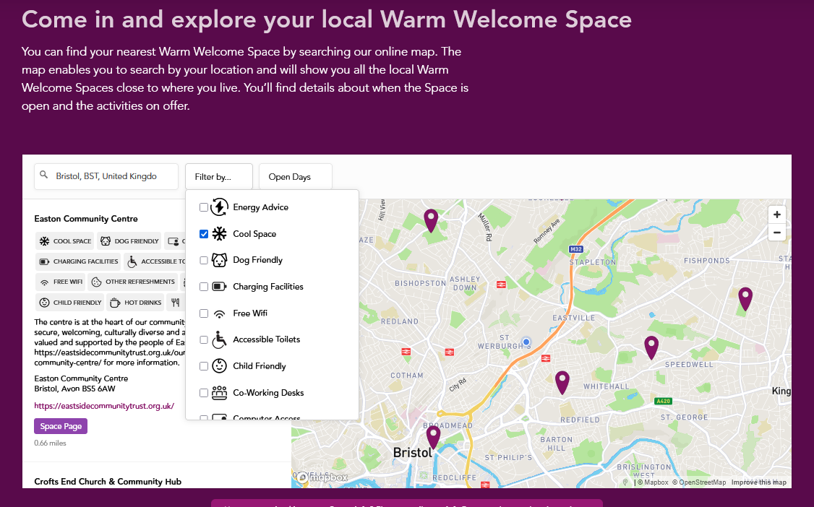

Add quote from your space:

“XXXXX”
David Barclay, Warm Welcome’s Campaign Director, said:
“Community spaces are a lifeline during extreme weather, offering cool spaces in summer and warm spaces in winter. We are currently under the most severe heat alert, meaning the weather could pose a risk to life. Cool Spaces can help people stay safe and connected during hot weather, particularly those most affected by heat in their homes or local environment. We encourage everyone, especially older people, families with babies and young children, and people with long-term health conditions, to take a moment to find their nearest cool space.”
Find your local “cool space” via a UK-wide online map
ENDS

Contact details
About [your space name]
[Add information about your space]
About the Warm Welcome Campaign
Founded in 2022, the Warm Welcome Campaign wants to turn the tide on loneliness and poverty by connecting communities and giving people a place of belonging in a Warm Welcome Space close to home.
We resource, connect, and champion a network of 6,400+ Warm Welcome Spaces and bring together a growing coalition of local, regional, and national partners representing the worlds of charity, faith, business, government, and philanthropy.
We have a bold ambition to enable a more deeply connected society where we all have free access to welcoming community spaces. By working together, we can unlock the power of community spaces made by and for everyone, creating a thriving network of hope and reconnection fuelled by human warmth.
Find your local Warm Welcome Space by visiting our online map: https://www.warmwelcome.uk/find-a-space#map
The Warm Welcome Campaign is hosted by the Good Faith Foundation, a charity focused on cross-sector collaboration for social inclusion: Registered Charity No 1188639

