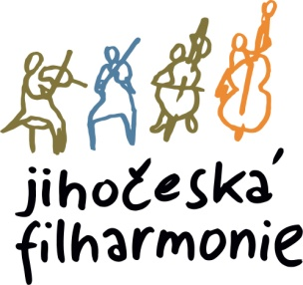
The director of the South Bohemian Philharmonic announces an audition for the position

1. OBOE
WITH THE OBLIGATION OF 2. OBOE
(replacement for the maternity leave until 2.9.2027, start immediately)

Place and time:
The audition will take place on Tuesday, February 16, 2026 at 10:30 a.m. in the building of the South Bohemian Philharmonic, Kněžská 411/6, 370 01 Č. Budějovice

Mandatory repertoire for the audition:
W.A. Mozart: Concerto in C Major for oboe (1st and 2nd movements)
Orchestral parts for oboe:
1. G. Rossini: The Italian Girl in Algiers – overture
2. L.v. Beethoven: Symphony No. 3, 6
3. A. Dvořák: Concerto for Violin and Orchestra in A minor, Op.53
4. A. Dvořák: Symphony No. 9 New World
5. M. Ravel: Couperin's Tomb
6. I.F. Stravinsky: Pulcinella
7. F. Mendelssohn Bartholdy: Symphony No. 3 Scottish

The score can be downloaded at : https://www.jfcb.cz/jihoceska-filharmonie/volna-mista
Appointments will be provided for the participants of the audition.

Applications with a brief artistic biography, address and phone number should be sent no later than 2.2.2026, to the e-mail: postlova@jfcb.cz

17.12.2025 Otakar Svoboda, acting director of the JF

