\
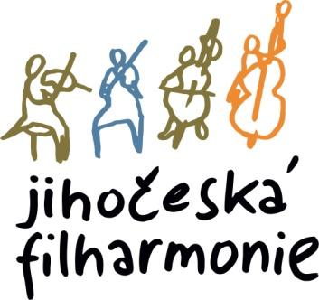
The director of the South Bohemian Philharmonic announces an audition for the position of
1ST FRENCH HORN with the duties of 3rd French horn
Place and time:
The audition will take place on February 16, 2026 at 10:30 a.m. in the South Bohemian Philharmonic building, Kněžská 411/6, 370 01, Č. Budějovice.
Compulsory repertoire for the audition:
• W.A.Mozart - Concerto No. 2 or No. 4 - 1st and 2nd movements
• Richard Strauss - Horn Concerto No. 1 - 1st and 2nd movements
Orchestral parts:
1. L. in Beethoven No. 3
2. L. in Beethoven No. 6
3. L. in Beethoven No. 7
4. Dvořák No. 9
5. Dvořák - Cello Concerto,
6. Dvořák - Czech Suite
7. J. Brahms No. 3
8. P. I. Tchaikovsky No. 5
9. G.Rossini - The Barber of Seville
Parts can be downloaded at: https://www.jfcb.cz/jihoceska-filharmonie/volna-mista

Audition participants will be provided with piano accompaniment.

Applications with a brief artistic CV, address and telephone number should be sent no later than 2.2.2026 to the e-mail: postlova@jfcb.cz

Please indicate in the application what repertoire you will play.

18.12.2025 Otakar Svoboda, director of JF

