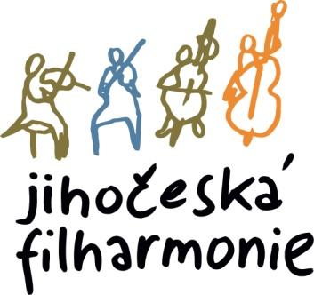
Managing director of the South Czech Philharmonic announces audition for
First trumpet with the duty of the second
( start from September 1, 2026 )

Venue and time:

The audition takes place on, June 9, 2026 at 2 p.m. in the building of the South Bohemian Philharmonic, Kněžská 411/6, 370 01 Č. Budějovice

Mandatory repertoire for the audition:

• Joseph Haydn – Concerto in E flat major ( The 1st and 2nd movements require playing on the B trumpet)

Orchestral part (we require only checked passages):

1. Korsakov-Ravel – Cards ( Promenade )
2. Korsakov – Scheherazade ( 4th movement )
3. Moris Ravel – Piano concerto in G major (1st movement to No. 3)
4. Igor Stravinsky – Pulcinella (Toccata, Finale)
5. L.v. Beethoven - Symphony No. 9 in D minor (4th movement, bars 164-203)
6. J.S. Bach – No. 3 Orchestral Suite in D Major (Gigue)

Download : https://jfcb.cz/jihoceska-filharmonie/volna-mista

Piano participants will be provided with piano accompaniment.

Send applications with a brief artistic CV, address and telephone contact no later than May 26, 2026, to e-mail postlova@jfcb.cz

March 17,2026 Otakar Svoboda, Director

