\
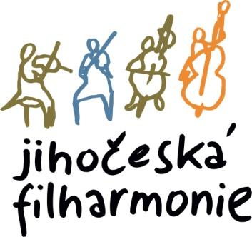
The director of the South Bohemian Philharmonic announces an audition for the position of
1ST FRENCH HORN with the duties of 3rd French horn
Start from September 1, 2026
Place and time:
The audition will take place on June 9, 2026 at 15:00 p.m. in the South Bohemian Philharmonic building, Kněžská 411/6, 370 01, Č. Budějovice.
Compulsory repertoire for the audition ( one of them ):
• W.A.Mozart - Concerto No. 2 or No. 4 - 1st and 2nd movements
• Richard Strauss - Horn Concerto No. 1 - 1st and 2nd movements
Orchestral parts:
1. L. in Beethoven No. 3
2. L. in Beethoven No. 6
3. L. in Beethoven No. 7
4. Dvořák No. 9
5. Dvořák - Cello Concerto,
6. Dvořák - Czech Suite
7. J. Brahms No. 3
8. P. I. Tchaikovsky No. 5
9. G.Rossini - The Barber of Seville
Parts can be downloaded at: https://www.jfcb.cz/jihoceska-filharmonie/volna-mista
Audition participants will be provided with piano accompaniment.
Applications with a brief artistic CV, address and telephone number should be sent no later than 26.5.2026 to the e-mail: postlova@jfcb.cz

Please indicate in the application what repertoire you will play.

24.3.2026 Otakar Svoboda, director of JF

