Analog To digital converter ( ADC ) Simplified
An ADC converts a continuous-time and continuous-amplitude analog signal to a discrete-time and discrete-amplitude digital signal.

To convert any analog signal into digital there are three conceptual steps that occur:
- The signal is sampled.
- The sampled signal is quantized.
- The quantized signal is digitally coded.

1-Sampling
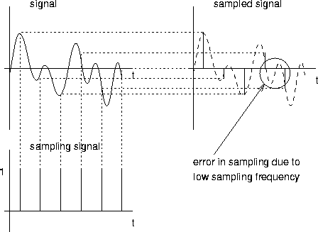

2-Qunantaization
Is to Match the input signal to the correct quantum so we can get the nearest accurate value .
–

3- Encoding ( signal is digitally coded)
–Assigning a unique digital code to each quantum.
–Matching the digital code to the input signal.

Sample analog signal with range of 0-15 V
–Partition into a range of 16 quantization levels.
–Using 4-bit binary encoding.

