Template social media copy for voter registration
The following posts can be used to encourage people in Scotland to register to vote.

Template copy to use with the graphics
They’re registered to vote, are you?
Register now: gov.uk/register-to-vote
They’re registered to vote, are you?
All you need to register to vote online is your National Insurance number.
Register now: gov.uk/register-to-vote
Are you registered to vote too?
Register now: gov.uk/register-to-vote
Are you registered to vote too?
Register now if you’ve never registered before, have moved house, or changed your name: gov.uk/register-to-vote

Template copy to use with or without the graphics
Register to vote now if you’ve never registered before, have moved house, or changed your name.
Register now: gov.uk/register-to-vote
#YourVoteMatters. Don’t lose it.
Recently moved house? [house emoji] You need to register at your new address to vote in elections
Visit gov.uk/register-to-vote
#YourVoteMatters. Don’t lose it
Just turned 14? [celebration emoji]
Make sure you’re registered to vote so that you can vote in elections when you’re old enough.
All you need is your National Insurance number.
Register online today: gov.uk/register-to-vote

Alt text for use with the graphics
Example graphic | Alt text
 | Two young students are walking through a library chatting happily. One student is wearing a t-shirt with a logo on it which says “I’m Registered To Vote”. The other student is holding a laptop which has a sticker of the same “I’m Registered To Vote” logo on it.
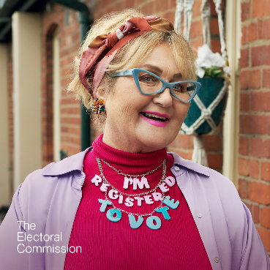 | An older lady is standing outside her flat, looking happy. She is wearing a necklace with “I’m Registered To Vote” spelt out on it.
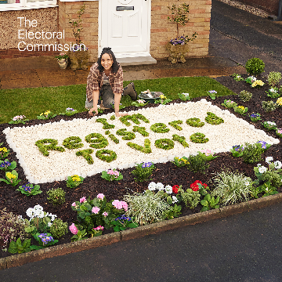 | A young disabled woman is in her front garden, crouching over a flower bed. In the flower bed she has spelt out “I’m Registered To Vote” in grass.
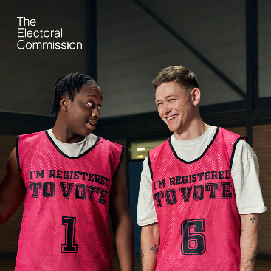 | Two young male basketball players are wearing red practice vests which say “I’m Registered to Vote” on them. One player is looking at the other, who is smiling.
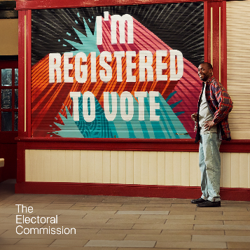 | A shopkeeper is standing outside his market shop. The shutters have been pulled down, and “I’m Registered to Vote” has been painted on them in a street art style.

