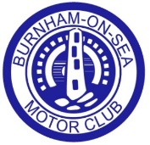
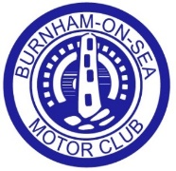
Burnham-on-Sea Motor Club
Annual Dinner & Presentation of Awards- Batch Country House Hotel, Lympsham
Sunday 1st of March Luncheon- 12.30 for 1pm Sit-down.
One year only- Sunday lunch with Presentation of awards, with good food and good company with Raffle and possible guest speaker or small quiz.

 | Person 1. | Person 2. | Person 3. | Person 4.
Starters
Homemade Tomato and Basil Soup
Breaded Camembert Croquettes with Redcurrant Sauce and Salad
Roasted Tomato, Olive and Basil on Bruschetta served with a Salad Garnish
Salmon, Prawn and Dill Terrine
Main Courses*
Rolled Leg of Lamb Roosted with garlic and Rosemary served with Red Win Jus
Roast Beef with Yorkshire Pudding
Fillet of Cod with a Parmesan and Herb Crust with a Fresh Parsley Sauce
Mushroom Stroganoff (Vegan)
Dessert
Fresh Fruit Salad
Trio of Puddings- Mini Chocolate Brownie, Mini Fresh Fruit Pavlova and Mini Lemon Cheesecake
Rhubarb and Pear Crumble
Individual Cheese & Biscuit Platter
*All served with a selection of seasonal vegetables and potatoes.
If possible we would like to sit with:
Please post your application forms to: Natalie Puddy, Whitehouse Farm, Cocklake, Wedmore BS28 4HE
Payment can be made to our HSBC account, Burnham-on-sea motor club Ltd, using account number 51091360 and sort code 40-22-07 PLEASE ENTER YOUR NAME IN THE REFERENCE BOX. This is most important as we won’t know who you are!
Applications close: Friday 20th February 2026
If you have any questions please email Natalie.bosmc@gmail.com or call 01934 351444 (6pm - 9.00pm)
Name of person ordering tickets:
Evening Contact Number: Email Address:
Number of tickets required at £38.00 per person:
Please list the names of all of the members of your party below along with their menu selections. If more than 4 in your party please use two forms.

