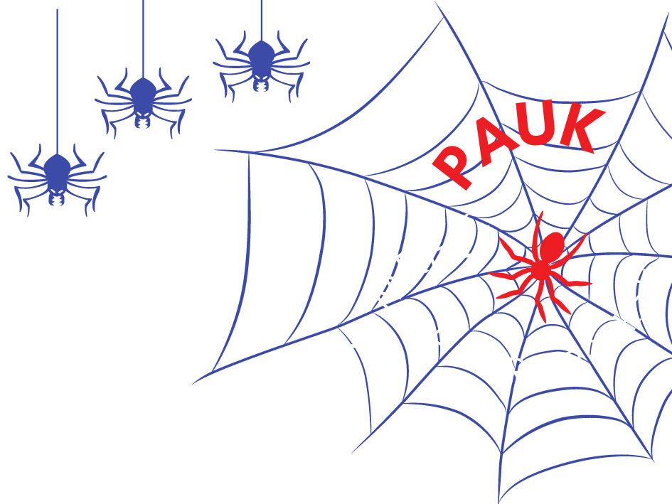
Dear colleagues,
Below you will find the application form for submitting a presentation for the educational event “Spider – In the Web of Good Practice.”
Each presentation lasts 15 minutes, and the goal is to share practical experiences, ideas, and solutions from work with children – from early childhood education, schools, or other educational and creative contexts.
PAUK is a space for exchanging examples of good practice: projects, activities, approaches, and programs that enrich work with children.
It does not matter whether your example is “big” or “small” – what matters is that it comes from real practice and can serve as inspiration for others.

The completed application form should be sent to info@kohopedagogija.com no later than April 28, 2026.

The presenter fee is €20. The registration fee includes access to the full Spider program. In addition to the certificate of presentation, presenters will also receive a certificate of attendance as participants of the Spider event.
Presenters are also required to register through the KoHo platform - here.
Incomplete application forms will not be considered.
If you have any questions, feel free to contact us!

General Information

Full name of presenter(s):
Title of presenter(s):
Place of employment:
Title of presentation:
Which area is the presentation submitted for? (kindergarten, primary school, workshops for children)
Have you already presented this topic elsewhere?
Do you currently apply or have you applied the content of your presentation in practice?
When was the example implemented? Please enter the year.
Email address(es) of the presenter(s)
(enter both emails if presenting in a pair)
Please indicate the contact person for communication with the organizer
(full name, email and phone number)

Presenter/-s Information

Short biography for each presenter
– up to 100 words
– written in third person

Presentation Information

Presentation abstract
– 100 to 120 words
– written in third person
– the abstract will be used in materials for participants

Practice Photographs | Please send up to 5 photographs that best illustrate your example from practice. The photos may show the environment, materials, activities or stimuli.  Submitting photographs is mandatory. They help us better understand and appreciate your work.  If children are visible in the photos, we recommend protecting their identity by blurring their faces or avoiding clear shots (e.g., profile or back views, or taking photos from a distance).
* Additional information (if any)

If you have any questions or concerns regarding the application, feel free to contact us at info@kohopedagogija.com

Photographs:

