**CLASSROOM ENTRIES INSTRUCTIONS**

**Graham County Fair 2025**

**DEPARTMENT - Y - (Pre-K & Elementary)**

**Preschool & Elementary School Teachers entering artwork as a class**- please read & follow the rules for this department as explained below & in the Fair Book. Art Entries that do not follow the rules will be disqualified & will not be judged or displayed by Graham County Fair Staff (Disqualified entries may be hung by the teacher as a class wall display)

Reminder- Our objective for this department is to provide opportunities for young students in our community to learn how to create and display artwork as a class, with the hope that their experience will inspire them to make more art and enter it into the Fine Arts Divisions where they can earn premiums. *(No premiums or fair entry tickets will be distributed to Classroom Entries)*

**Classroom Entries Requirements**

* No coloring pages, printed templates, or “minimal effort” entries will be accepted *(Exceptions- Pre-k, Kindergarten, the Special Needs Division, and Collage Projects may use templates as a layout)*
* Artwork should take time and demonstrate each student’s effort and ability
* Student exhibitors can only enter one piece of art into the Classroom Entries Department
* Each class in this department will be judged as a class and the top 3 pieces of art will be awarded a 1st, 2nd, & 3rd place ribbon. (Participation ribbons will be given out to all participants.)
* Artwork must be mounted onto a background using a glue stick **(Do not tape or staple artwork to the background)**
* Backgrounds must have a 1/2 inch border on the top & both sides & a 1.25 inch border on the bottom
* Each piece of art must be labeled with an address label (1” x 2 5/8”) that is mounted on the bottom right side of the border, with the following information typed out- school name, teacher’s name, student’s name, & grade level. **Please use Times New Roman Font- size 14 (see example below)**
* Mounted work (including the background) cannot be bigger than 12x15

**Preparing Classroom Folders**

* All classroom entries should be placed in a manila folder & secured with a binder clip.
* Write the following information on the front of the manila folder- Teacher name, School name, grade level, and the number of pieces of art.
* Manila folders that are ready in the office by Wed., Sept 24th @ 3:00 pm will be picked up by the GCF

**Additional Instructions for Teachers Entering Several Classes**

* On each art entry label, also include the class period next to the Grade Level (i.e. Grade 3 - Period 5).
* Compile each class period in it’s own manilla folder.
* Include the class period on the front of each manilla folder.

**Important Dates & Deadlines**

**Online Registration Deadline:** Sunday, September 21, 2025 11:59 pm

**Labeled Folders in Office Ready for GCF Pick-up**: Wednesday, September 24th by 3:00 pm

**Late Drop Off**: You may drop off Classroom Entries to GC Fairgrounds by 12:00 pm, Friday, September 26th

**Retrieve Classroom Entries After the Fair:** Sunday, October 12th, 2025 5:00-7:00 pm

**Mounting Help**

* Look at the examples below- The left example is correct. The right example shows the mounting errors.
* Amply apply a glue stick onto the back of the artwork, center the artwork holding it above the background, and then press and mount it to the background.

**CORRECT INCORRECT**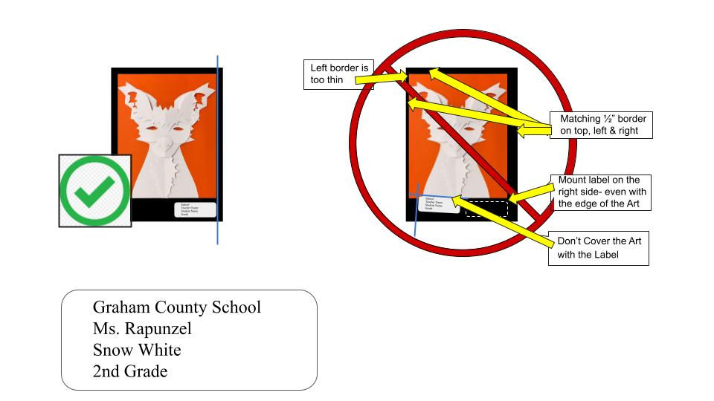

**Label Example**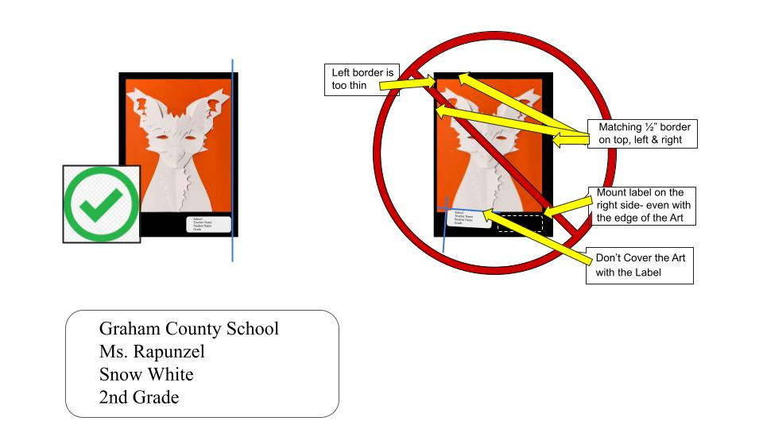

**Mediums for Classroom Division**

* Pencil
* Colored Pencil
* Marker
* Crayon
* Watercolor
* Oil Pastel
* Soft Pastel
* Tempera of Acrylic Paint
* Scratchboard
* Collage
* Charcoal
* Relief Paper Sculpture (As seen in the mounting example)
* Mixed Media (When 2 or more mediums are used to create the art)
* Other (Only select if the medium is not listed above)

**Classroom Displays Information**

* Teachers, you may hang a classroom display of work created by your class.
* Your displays will not be judged (no ribbons awarded) and they do not need to be registered or labeled.
* Hanging space is limited and is on a first come first serve basis, after all the judged art is hung.
* Include the following information on the back of your display: Teacher’s first and last name, the name of your school, and grade level.
* You are responsible for bringing the display to the fairgrounds and hanging it up on Thursday, October 9th from 9:00 – 11:00 am.
* You are responsible for picking it up from the fair on Sunday, October 12th from 6:00 – 7:00 pm

**If you have questions, please call/text Aubrey 208-403-8083 or email aubreyzaugg@gmail.com**