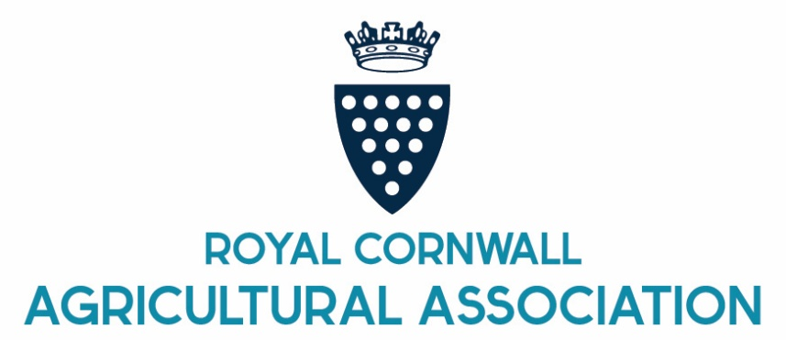

**THE DUKE OF CORNWALL'S AWARD 2026**

**FOR FARM BUSINESS SUSTAINABILITY**

**IN CORNWALL AND THE ISLES OF SCILLY**

**INTRODUCTION**

Applications are invited for this prestigious award, initiated by the Duchy of Cornwall. The award will be made to the farm business that is judged to have delivered a successful, sustainable approach to farming, forestry and / or food production within the county of Cornwall and the Isles of Scilly.

The Duke of Cornwall's Award will be presented at the 2026 Royal Cornwall Show (4 – 6 June).

From 2025 the aim of the award changed to reflect the key role of farming and food production in the sustainable stewardship of our land.

The judging panel will take particular account of how farm businesses have risen to the challenge of delivering a creative and balanced approach to farming, whilst also maintaining or enhancing nature and moving towards net zero.

Please note that farm tourism businesses (B&B/holiday cottages etc) are not eligible for this award.

Farm businesses can nominate themselves, or alternatively can be nominated by someone outside of the business.

The award carries with it a perpetual trophy (to be held for the year) and a signed certificate plus a cash prize of £1,000 presented on behalf of His Royal Highness the Duke of Cornwall.

**Award Programme**

**1st March 2026** Closing date for nominations for the award.

Please let us have your submission by this date

**March 2026** A shortlist of finalists will be prepared.  
**April 2026** The judging panel will interview those shortlisted**.**

**June 2026** The award will be presented at the Royal Cornwall Show.

**THE DUKE OF CORNWALL'S AWARD 2026**

**FOR FARM BUSINESS SUSTAINABILITY**

**IN CORNWALL AND THE ISLES OF SCILLY**

**The Nomination Process**

Provide a brief description of the business, and reference clearly how the business demonstrates their achievements across **any** of the sustainability criteria listed below (maximum 500 words),

* Soil health.
* Reducing greenhouse gas emissions and increasing sequestration.
* Water and wetland management.
* Natural habitat management and creation.
* Improved opportunities to benefit mental and physical health among the public / community through access.
* Collaboration on landscape-scale sustainable farming
* Adopting innovative practices that support nature and net zero.
* Commercial viability / sustainability.

Send your nomination by post or email, and with the description of the business include the following details:

* The name of business or business being nominated.
* The business contact
* Address & postcode
* Telephone number
* Email Address
* Agricultural holding number if known

**Completed forms should be sent by 1st March 2026.**

By email to feelunn@royalcornwall.co.uk

Or by post to: Fee Lunn, RCAA at the address below.