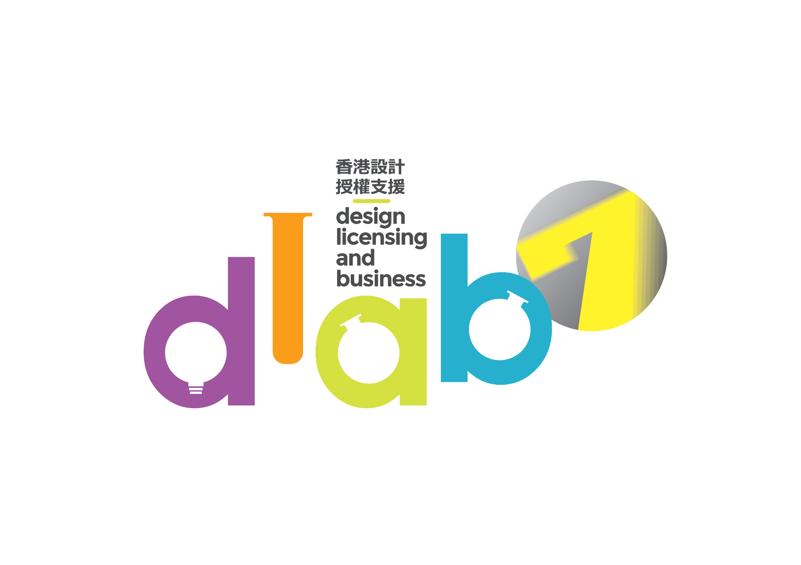

**The 7th Design Licensing And Business (DLAB)**

**Support Scheme**

**Application Form**

Note：

* This application form could be downloaded from the official website of the Design Licensing and Business (DLAB) Support Scheme ([www.dlabhk.com](http://www.dlabhk.com/)).
* Applicants MUST read the “Application Guideline” that could be downloaded from the DLAB’s official website ([www.dlabhk.com](http://www.dlabhk.com/) ) before filling in the form.
* This form must be typed. The completed and signed application forms must be submitted online in word / pdf format via the DLAB’s official website ([www.dlabhk.com](http://www.dlabhk.com/) ).
* Application deadline is **5:30 pm on 5th November 2025 (Wednesday)**. Late applications will not be considered.

**NOTES TO APPLICANT**

* Application deadline is **5:30 pm on 5th November 2025 (Wednesday).**
* This form must be typed. The completed and signed application forms must be submitted online in word & pdf format via the DLAB’s official website ([www.dlabhk.com](http://www.dlabhk.com/)).
* Applicants must upload the completed application forms onto the online submission system of the DLAB’s official website ([www.dlabhk.com](http://www.dlabhk.com/)).
* All attachments (i.e.: Presentation Powerpoint (.ppt), a copy of valid Business Registration Certificate and others related information (i.e. Company Logo, IP Logo, two Promotional Poster…etc) must be uploaded onto a secure cloud storage platform (such as Google drive, Dropbox, 騰訊微雲, 百度雲, etc…) with a URL inserted into the application system for the secretariat to download the files.
* The personal data in the application form and all attachments submitted via the online submission system will only be accessed by the Organizer (Innovative Entrepreneur Association, IEA) and the secretariat to process the application. If applicants wish to amend the stated personal data, please contact the organizer or the secretariat at [dlab.ieacms@gmail.com](mailto:dlab.ieacms@gmail.com).
* Submitting an application will be considered as allowing the organizer to upload the information on the applying company and its designers (applicant) onto the DLAB’s official website.
* For any enquiry, please contact the secretariat by phone (Tel: 2363 6012) or email at [dlab.ieacms@gmail.com](mailto:dlab.ieacms@gmail.com).

**ELIGIBILITY**

|  | Tier 1 | Tier 2 |
| --- | --- | --- |
| Eligibility | * Companies with a history of not more than **6 years**, as at the application deadline (i.e. established within period from **6th Nov 2019– 5th Nov 2025** and with design or licensing as the major business * Registered in Hong Kong with a valid Hong Kong Business Registration Certificate * The applying intellectual property (IP) should be launched in not more than 6 years, as at the application deadline * Have full ownership of the IP right of the creative content, such as original character designs, pattern designs, illustrations, etc. | * Companies with a history of not more than **12 years**, as at the application deadline (i.e. established with period from **6th Nov 2013– 5th Nov 2025** and with design or licensing as the major business * Registered in Hong Kong with a valid Hong Kong Business Registration Certificate * The applying intellectual property (IP) should be launched in not more than 6 years, as at the application deadline * Have full ownership of the IP right of the creative content, such as original character designs, pattern designs, illustrations, etc. |

**APPLICATION FEE**

* No participation fee is needed to join the online trainings, but pre-reservation is needed1
* The 45 applicants selected to participate in the 7h DLAB (participants) could receive sponsorship to set up a 6 square meter booth in the Hong Kong International Licensing Show 2026 at a rental of HK4,000 for new participants or HK$6,000 for past participants (original rental is HK$30,020)

1 Each participant has to pay a reservation fee of HK$2,500 for the online trainings. The reservation fee will be refunded to the participants if their attendance rate at these events reaches 75% and they have full participation in the assigned booth of the DLAB HK pavilion, or else the fee will be forfeited and used as project operational income.

2 The booth will be allocated by ballot. Participants will be notified by separate emails of the balloting arrangement.

**VETTING CRITERIA**

The Vetting Panel members will evaluate the applications in accordance with the below criteria:

* Originality and creativity of submitted character design / licensable IP
* Business potential of submitted character design / licensable IP
* Business track record and business development plan on submitted character design / licensable IP
* Commitment of professional team of start-ups / companies on developing the submitted character design / licensable IP
* Creativity to IP development in the past one year (only applicable to participants of the pervious DLAB which also applies for the 7th DLAB with the same IP submitted to the past DLAB

**VETTING PROCEDURE**

Upon receipt of the applications, the secretariat will check the completeness.

The eligible applications will then be submitted to the Vetting Panel for consideration. All applicants are required to attend an interview of 10-15 minutes on **20 Nov 2025 (TBC)** to present their submitted applications and answer the questions from the Vetting Panel. Applicants should reserve the date for the interview. The schedules and other details of the interviews will be announced by the Organizer in around **Early-November 2025**. The Vetting Panel is comprised of representatives of the Organizer, industry professionals, well-known designers, licensing professionals and representatives of education institutions.

Notification emails of the application result will be sent to all applicants on or before **30 November 2025 (Sunday**), regardless if they are selected or not.

**VETTING MECHANISM**

* The applicants must meet the eligibility requirements.
* A “passing score” subject to the discussion and agreement of vetting committee is set. The applicants who exceed the “passing score” means their IPs / design has market potential and licensable, and these applicants will proceed the next stage of selection process.
* The applicants who had less frequency of joining previous DLAB will have higher priority of being selected. Conversely, the higher frequency of joining previous DLAB will have lower priority of being selected.
* Each company has maximum 3 times of participation in DLAB.

**APPLICATION FORM***All the below sections must be completed*

**SECTION 1：ENTRY INFORMATION**

| **A) Please put a “✔”to indicate the subsidy tier that you would like to apply**  **(You can only choose one tier)** |
| --- |
| ☐ Tier 1(Companies with a history of not more than 6 years with an IP launched in not more than 6 years, as at the application deadline)  ☐ Tier 2 (Companies with a history of not more than 12 years with an IP launched in not more than 6 years, as at the application deadline) |

| **B) Applicant information** | | |
| --- | --- | --- |
| **Company Name (Name used for business registration)** | | |
|  | | |
| **Business Registration Number (please attached the copy of the business registration certificate)** | | |
|  | | |
| **Office Address** | | |
|  | | |
| **Correspondence address (if different from above)** | | |
|  | | |
| **Company Introduction:** | | |
|  | | |
| **Company Establishment Date (DD/MM/YY):** | | **Office phone number:** |
| **Office fax number:** | | **Email address:** |
| **Organization and staff information** | | |
| **Shareholder Name:** | |  |
|  |
|  |
|  |
| **Main Contact Person** | | |
| **Contact Name:** | | |
| **Title:** | **Email address:** | |
| **Office phone number:** | **Mobile phone number:** | |
| **Background Information** | | |
| **Has the applicant participated in the previous DLAB? (Please ☑ in the appropriate box)** | | |
| ☐ Yes, please specify which edition(s) has been participated: ＿＿＿＿＿＿＿＿＿＿＿ ☐ No | | |
| **Have the shareholders of the applying company participated in the previous DLAB?**  **(Please ☑ in the appropriate box)** | | |
| ☐ Yes, please specify which edition(s) has been participated: ＿＿＿＿＿＿＿＿＿＿＿ ☐ No | | |
| **Has the designer of the IP which applying in 6th DLAB participated in previous DLAB?**  **(Please ☑ in the appropriate box)** | | |
| ☐ Yes, please specify which edition(s) has been participated: ＿＿＿＿＿＿＿＿＿＿＿ ☐ No | | |

| **C) IP information** | | | | | |
| --- | --- | --- | --- | --- | --- |
| **IP 1** | | | | | |
| IP name： |  | | Designer name： |  | |
| Launch Date：  (dd/mm/yy) |  | | | | |
| Category： | ☐ Character Design(s) | ☐ Other IPs of creative content*  (Please specify: ______________________）  *\* could be pattern design, illustration design etc.* | | | |
| Target Sector or Customers：  (Can select more than one) | ☐ Toy | ☐ App | | | ☐ Electronics |
| ☐ Houseware | ☐ Shopping malls & Hotels | | | ☐ Publishing & Printing & Education |
| ☐ F&B | ☐ Animation | | | ☐ Entertainment |
| ☐ Glasses | ☐ Finance | | | ☐ Clothing / Garment |
| ☐ Gift | ☐ Licensing & Product Agents | | | ☐ Furniture |
| ☐ Retailers | ☐ PR & Event Management | | | ☐ Marketing |
| ☐ Government Department | ☐ Manufacturers | | | ☐ Distributors |
| IP’s Information | (English) (no more than 80 words) | | | | |
|  | | | | |
| (Chinese) (no more than100 words) | | | | |
|  | | | | |
| ☐ I /We confirm that the above stated IP is original IP and/or our company has the full IP rights of the stated IP. | | | | | |

| **IP 2 (If applicable)** | | | | | | |
| --- | --- | --- | --- | --- | --- | --- |
| IP name： |  | | | Designer name： |  | |
| Launch Date：  (dd/mm/yy) |  | | | | | |
| Category： | ☐ Character Design(s) | ☐ Other IPs of creative content*  (Please specify: __________________________）  *\* could be pattern design, illustration design etc.* | | | | |
| Target Sector or Customers：  (Can select more than one) | ☐ Toy | ☐ App | | | | ☐ Electronics |
| ☐ Houseware | ☐ Shopping malls & Hotels | | | | ☐ Publishing & Printing & Education |
| ☐ F&B | ☐ Animation | | | | ☐ Entertainment |
| ☐ Glasses | ☐ Finance | | | | ☐ Clothing / Garment |
| ☐ Gift | ☐ Licensing & Product Agents | | | | ☐ Furniture |
| ☐ Retailers | ☐ PR & Event Management | | | | ☐ Marketing |
| ☐ Government Department | | ☐ Manufacturers | | | ☐ Distributors |
| IP’s Information | (English) (no more than 80 words) | | | | | |
|  | | | | | |
| (Chinese) (no more than100 words) | | | | | |
|  | | | | | |
| ☐ I /We confirm that the above stated IP is original IP and/or our company has the full IP rights of the stated IP. | | | | | | |

**SECTION 2**

Please fill in the below parts and provide related attachments for vetting purposes. Please use separate sheet(s) if needed.

| 1. **Originality and Creativity of the Submitted IP(s)** |
| --- |
|  |

| 1. **Business Potential of the Submitted IP** |
| --- |
|  |

| 1. **1. The Business Development Plan of the Submitted IP(s) Committed by Your Team** |
| --- |
| Please provide more details of the items listed below:   * Basic information on the Team（e.g. members’ background, relevant experience and roles in developing the submitted IP） * Any licensing / designing related award or nomination received by the applicant and the submitted IP(s) (please also provide the name(s) and year(s) of the award(s) received or nominated, or the competition(s) participated in, etc.） * Past, existing or potential clients in licensing * Licensing fee generated from the submitted IP(s) and any other related information |
|  |
| 1. **2. Innovative Development for the Submitted IP(s) in last 1 year** |
| (Only applicable to past participant of the perviousDLAB which applies for the 6th DLAB with the **same IP(s) submitted to the first and second DLAB (same submitted IP)**)   * Any new creativity for the same submitted IP in last year after participation in the first two DLAB(e.g. in area of branding design, business development, or any new ideas for the same submitted IP, etc.) |

| 1. **Development and Promotion of the Submitted IP(s)** |
| --- |
| * Future development and promotional plan of the submitted IP(s) (e.g. details, methods, expected results, targets of the promotions, etc.) |
|  |

| 1. **Supplementary Information** |
| --- |
| If there is any supplementary information, such as your company logo, IP or product photos, promotion or marketing materials, in-store display and other related information, please save them in a ppt file and upload the file onto the online submission system of the DLAB’s official website.  **Remark: Applicants must read the “Notes for Applicants” before submitting their applications** |

**TERMS AND CONDITIONS**

***General Conditions***

1. Applicants and their respective companies are required to abide by all rules and regulations of the 7th Design Licensing And Business (DLAB) Support Scheme (DLAB).

Once a completed application form is submitted, it implies full understanding and agreement by the applicant of all the terms and conditions as set out in this application form and those prevailing throughout the DLAB.

1. The Organizer reserves the right to amend the terms and conditions of the DLAB without advance notice. For any matters not covered in these terms and condition / any updated news, the Organizer may publish the relevant information on the DLAB’s official website without any notification in advance. In the event of any disputes, the Organizer reserves the right of the final decision.
2. The Organizer, Cultural and Creative Industries Development Agency (CCIDA) of the Government of the Hong Kong Special Administrative Region and the organizer of the Hong Kong International Licensing Show 2026 - Hong Kong Trade Development Council have the right to use all or any of the entries submitted by the companies participating in the DLAB (participants) in any format and reserves the rights to use or allow any party to use the entries for publication, exhibition, and publicity of the DLAB for non-commercial purpose at no extra cost to the respective participants. Such publication, exhibition and publicity need not be limited to organizing and / or promoting of the DLAB only.
3. Any person taking part in the project implicitly agrees with its regulation. For any matters not covered in this regulations / any updated news, the Organizer may publish the relevant information on the DLAB’s official website without further notice. The Organizer reserves the right to grant permission to the media to publish any of the entries submitted by the participants in any format.
4. The Organizer reserves the final right to interpret and amend the terms and conditions.

***Participation***

1. The application deadline is **5:30pm on 5th November 2025 (Wednesday).**
2. Submitting the application means that the applicant allows the Organizer to upload the information on the applicant and its designers onto the DLAB’s official website.
3. The applicant should fully own the IP right of the character design(s) or licensable IP(s) (submitted IP(s)). Any unearthed infringement of any third party will result in disqualification of the application concerned.
4. All entries submitted must be without infringing on the Intellectual Property Rights (IPR)* of any party. The Organizer shall not be held responsible whether directly or indirectly for any liability arising whatsoever or howsoever from any violation of any copyright laws. Applicants shall indemnify the Organizer against all actions, costs, claims and liabilities of whatsoever nature arising out of or in connection with any allegation and / or claim of infringement of any IPR of any party

*\* “Intellectual Property Rights” shall mean patents, trademarks, service marks, trade names, design rights, copyright, domain names, database rights, rights in know-how, new inventions, designs or processes and other intellectual property rights of whatever nature and wheresoever arising, whether now known or hereafter created, and in each case whether registered or unregistered and including applications for the grant of any such rights.*

***Application Fee***

1. Submitting the applications implies that the applicants will attend the project’s trainings when being selected for participating in the DLAB (participants). Participants should send a crossed cheque of HK$2,500 as reservation fee to the Secretariat. The fee will be refunded to the participants if their attendance rate at these events reaches 75% and they have full participation in the assigned booth of the DLAB HK pavilion, or else the fee will be forfeited and used as project operational income.

Cheque payable to: Innovative Entrepreneur Association Company Limited

Cheque submission: In person or Mail to below address:

Attn: Secretariat of DLAB

Address: 9/F, Teng Fu Commercial Bldg, 333 Queen’s Road Central, Sheung Wan, Hong Kong.

The booth will be allocated by ballot. Participants will be notified by separate emails of the balloting arrangement. Final decision on the allocation of the booths will be made at the discretion of the Organizer. Applications for next edition of DLAB may be affected if the participants give up the assigned booths. All paid fees will not be refunded to the participants concerned.

***Result Announcement***

1. The list of participants will be announced on the DLAB’s official website. The participants will receive separate written notifications by mails or emails from the Organizer.
2. The final result is subject to the decision of the Vetting Panel and the Organizer. Applicants shall raise no objection.

***Typhoon and Black Rainstorm Signal Arrangement***

1. The applicants should attend an interview in person. If Typhoon Signal No. 8 or above is hoisted or Black Rainstorm Warning is in force on or after 7:00 am on the day of interview, all interviews on that day will be cancelled.
2. If the Interview is cancelled due to weather or other reasons, the Organizer will notify the invited applicants. The Organizer reserves the final decision of the alternative arrangement and assessment and is not required to disclose the reasons for thereof.

***Disqualification***

1. Incomplete application forms submitted will be disqualified. The Organizer reserves the right to refuse any application or disqualify any applicant to any entry without advance notice.
2. The applicants should fully own the IP right of the submitted IPs, if not, their applications will be disqualified without advance notice.
3. The information provided in the application form should be accurate and complete and the content in all forms (including but not limited to the textual and visual materials of the submitted IPs) in the application form does not infringe the copyright or any other rights of any person. Otherwise, the application will be disqualified without advance notice.
4. If applicants violate the listed terms and conditions, the Organizer reserves the right to disqualify their applications.

***Personal Information Collection Statement***

1. Personal data provided by the applicants is for record, and for the purpose of correspondence and promotion of the project by the Organizer and the organizer of Hong Kong International Licensing Show 2026 - Hong Kong Trade Development Council. By submitting the application, applicants agree that the personal information provided will be kept and used by the Organizer and the organizer of Hong Kong International Licensing Show 2026 - Hong Kong Trade Development Council for this project.
2. Applicants have the right to request access to and the correction of personal data as stated in the application forms in accordance with the Personal Data (Privacy) Ordinance. For inquiry, please contact the project secretariat, at [dlab.ieacms@gmail.com](mailto:dlab.ieacms@gmail.com).

**DECLARATION**

1. I / the company hereby agree to abide by all the rules and regulations of the Design Licensing And Business Support Scheme (DLAB) and agree that all decisions made by the Organizer and the Vetting Panel are final.
2. I hereby confirm that
3. I am / We are the person(s) in charge of the applying company.
4. All submitted IP(s) stated in this application is / are original, and/or I / Our company have the full IP right of this/these IP(s).
5. The information provided hereby and attached is accurate and complete and that the content in this application form does not infringe the copyright or any other rights of any person.

1. I / the company agree to fulfill the "Rights and Obligations" under DLAB. The relevant content is subject to the "Application Guidelines" published on the official website of DLAB, and the company must check it by itself.
2. If our company is selected as one of the 45 companies participating in 7th DLAB, I / the company agree to attend all the activities organized by DLAB, including but not limited to the Kick-off ceremony, trainings, “DLAB Hong Kong Pavilion” in Hong Kong International Licensing Show 2026.
3. I agree that the Organizer, the project implementation agent and the organizer of Hong Kong International Licensing Show 2026 - Hong Kong Trade Development Council could disclose and save the below listed information as stated in the application form for promotion purpose
4. Name of Designer; (b) Introduction to the Character design(s) / licensable IP(s); (c) Company Name;

(d) Email; and (e) Company introduction

6. I agree that if our company is selected as one of the 45 companies participating in the 7th DLAB, I will rent the exhibition booth at the “Hong Kong International Licensing Show 2026” at the discounted rate under the DLAB to become one of the exhibitors of the DLAB. The relevant discount rate is subsidized under the sponsorship of Cultural and Creative Industries Development Agency (CCIDA) of the Government of Hong Kong Special Administrative Region (HKSAR). In the light of the principle of no double funding, I understand that our company will not be entitled to other funding supports from the HKSAR Government that are applicable to the “Hong Kong International Licensing Show 2026”.

7. I / the company agrees that the organizer and the vetting panel have the right to make the final decision on the application review of DLAB under any circumstances.

The information provided in the application form should be accurate and complete and the content in all forms (including but not limited to the textual and visual materials of the submitted IPs) in the application form does not infringe the copyright or any other rights of any person. Otherwise, the application will be disqualified without advance notice.

| Authorized signature with company chop： |
| --- |
| Name： |
| Date： |