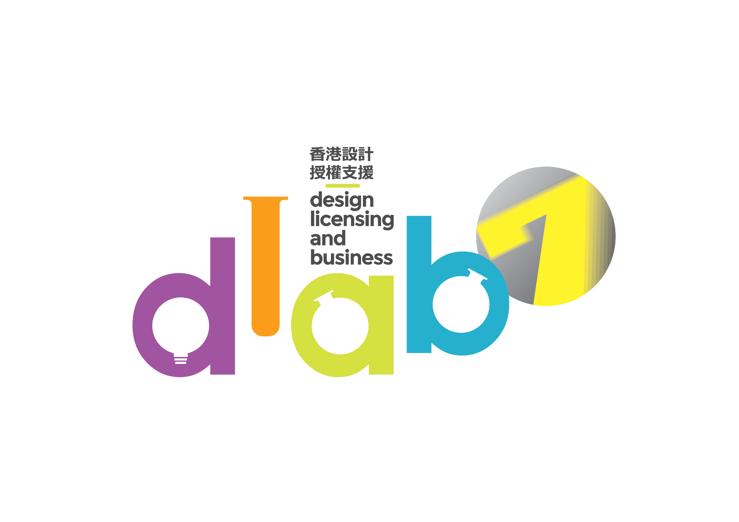

The Innovative Entrepreneur Association (IEA) (the Organizer) will launch the 7th *Design Licensing And Business* (DLAB) Support Scheme (DLAB), under the sponsorship of Cultural and Creative Industries Development Agency (CCIDA) of the Government of the Hong Kong Special Administrative Region, to help young character designers and owners of other young intellectual properties (IPs) promote their IPs and grow their businesses with training, business matching, sales pitching and exhibition promotion in the Hong Kong International Licensing Show 2026.

*DLAB* is the acronym of “Design Licensing and Business”. We hope designers can fully utilize the Support Scheme to learn more about licensing their design IPs with a view to growing their businesses successfully. *DLAB* can also be read as “*D”esign “Lab”*, a pun with association of meaning that when *Design* meets *Business*, collaboration will be fostered and positive chemistry will be inspired with unlimited potentials. In this “Lab”, designers can share their bright ideas freely and let their creative synergies collide here.

**In order to fully support the industry and fight the virus together, the organizer continuously provides the waiver of exhibition rental fee to participants to reduce financial burdens. Detail as below:**

**BENEFITS OF JOINING THE SUPPORT SCHEME**

* Local character designers/ designers and companies with licensable design IPs are eligible.
* The 45 applicants selected to participate in the 7th DLAB (participants) could receive sponsorship to set up a 6 square meter booth in the Hong Kong International Licensing Show 2026 at a rental of HK4,000 for new participants or HK$6,000 for past participants of the 6th DLAB (original rental is HK$30,020)1
* Free participation in the comprehensive trainings, and workshops on marketing, business operations and brand building, etc.2
* Free consultation by programme advisors who are industry experts.
* Free business matching and sales pitching sessions
* Free promotion of the participants’ designs in the channels under the DLAB (such as advertisements/ advertorials in newspapers, internet, social platforms and websites, etc.)
* Join the study mission to Greater Bay Area at special price.

1 The booth will be allocated by drawing lots by the Organizer. Participants will be notified by separate emails on the arrangement of the ballot.

2 Each participant has to pay a reservation fee of HK$2,500 for the workshops and trainings. The reservation fee will be refunded to the participants if their attendance rate at these events reaches 75% and they have full participation in the assigned booth of the DLAB HK pavilion, or else the fee will be forfeited and used as project operational income.

**ELIGIBILITY**

|  | Tier 1 | Tier 2 |
| --- | --- | --- |
| Eligibility | * Companies with a history of not more than **6 years**, as at the application deadline (i.e. established within period from **6th Nov 2019– 5th Nov 2025**) and with design or licensing as the major business * Registered in Hong Kong with a valid Hong Kong Business Registration Certificate * The submitted intellectual property (IP) should be launched in not more than 6 years, as at the application deadline * Have full ownership of the IP right of the creative content, such as original character designs, pattern designs, illustrations, etc. | * Companies with a history of not more than **12 years**, as at the application deadline (i.e. established with period from **6th Nov 2013– 5th Nov 2025**) and with design or licensing as the major business * Registered in Hong Kong with a valid Hong Kong Business Registration Certificate * The submitted intellectual property (IP) should be launched in not more than 6 years, as at the application deadline * Have full ownership of the IP right of the creative content, such as original character designs, pattern designs, illustrations, etc. |

**VETTING CRITERIA**

The Vetting Panel members will evaluate the applications in accordance with the below criteria：

| * Originality and creativity of the submitted IP |
| --- |
| * Business potential of the submitted IP |
| * Business track record and business development plan of the submitted IP |
| * Commitment of the applying company’s professional team to developing the submitted IP * Creativity to IP development in the past one year (only applicable to participants of the either 1-6 DLAB which also applies for the 7th DLAB with the same IP submitted to the past DLAB) |

**VETTING PROCEDURES**

Upon receipt of the applications, the secretariat will check the completeness.

The eligible applications will then be submitted to the Vetting Panel for consideration. All applicants are required to attend an interview of 10-15 minutes on **20 Nov 2025 (TBC)** to present their submitted applications and answer the questions from the Vetting Panel. Applicants should reserve the date for the interview. The schedules and other details of the interviews will be announced by the Organizer around **Early-Nov 2025**. The Vetting Panel is comprised of representatives of the Organizer, industry professionals, well-known designers, licensing professionals and representatives of education institutions.

Notification emails of the application result will be sent to all applicants on or before **30 Nov 2025 (Sunday)**, regardless if they are selected or not.

**VETTING MECHANISM**

* The applicants must meet the eligibility requirements.
* A “passing score” subject to the discussion and agreement of vetting committee is set. The applicants who exceed the “passing score” means their IPs / design has market potential and licensable, and these applicants will proceed the next stage of selection process.
* The applicants who had less frequency of joining previous DLAB will have higher priority of being selected. Conversely, the higher frequency of joining previous DLAB will have lower priority of being selected.
* Each company has maximum 3 times of participation in DLAB.

**APPLICATION METHOD**

* Application deadline is **5:30 pm on 5th November 2025 (Wednesday)**.
* The application form must be typed. The completed and signed application forms must be submitted online in word / pdf format via the DLAB’s official website ([www.dlabhk.com](http://www.dlabhk.com) ).
* Applicants must upload the completed application forms onto the online submission system of the DLAB’s official website ([www.dlabhk.com](http://www.dlabhk.com) ).
* All attachments (i.e.: Presentation Powerpoint (.ppt), a copy of valid Business Registration Certificate, other related information) must be uploaded onto a secure cloud storage platform (such as Google drive, Dropbox, 騰訊微雲, 百度雲, etc…) with a URL inserted into the application form for the secretariat to download the files.
* The personal data in the application form and all attachments submitted via the online submission system will only be accessed by the Organizer (Innovative Entrepreneur Association, IEA) and the secretariat to process the application. If applicants wish to amend the stated personal data, please contact the Organizer or the secretariat at [dlab.ieacms@gmail.com](mailto:dlab.ieacms@gmail.com)
* Submitting the application means that the applicant allows the organizer to upload the information on the applying company and its designer onto the DLAB’s official website.

**Key Dates**

NOTE：The below dates are subject to change. Please refer to the website for the latest information.

| **Event** | **Date** |
| --- | --- |
| Call for Applications | 22 September 2025 |
| Project Briefing (Online) | 10 October & 17 October 2025 |
| Deadline of Applications | 5 November 2025 |
| Announcement of Interview Details | 11-13 November 2025 |
| Interviews to Select Participants | 20 November 2025 (Tentative) |
| Announcement of Vetting Results | 24 November 2025 |
| Briefing to 45 Selected Participants | 28 November 2025 (Tentative) |
| Kick-Off Ceremony | 15 December 2025 |
| GBA study mission (2 days) | January 2026 |
| Drawing of Ballots for Allocation of Booths at Hong Kong International Licensing Show 2026 | February 2026 |
| Trainings and Workshops | February 2026 |
| Program Advisor Network Service to Participants | February – April 2026 |
| “Hong Kong International Licensing Show 2026”  (Business Matching will be arranged during the physical show period from 27 to 29 April 2026) | Physical Exhibition  27 – 29 April 2026 |

**ENQUIRY**

Secretariat of *Design Licensing And Business (DLAB) Support Scheme*

Contact: Ms. Mercury Chung

Tel: 2363 6012

Email: [dlab.ieacms@gmail.com](mailto:dlab.ieacms@gmail.com)